Supplementary Materials
Normal gastrointestinal mucosa at biopsy and overall mortality: Nationwide population-based cohort study
Jonas F. Ludvigsson, Jiangwei Sun, Ola Olén, Mingyang Song, Jonas Halfvarsson, Bjorn Roelstraete, Hamed Khalili, Fang Fang

Contents
Supplementary Table 1. The Swedish-version International Classification of Diseases (ICD) codes for cause-specific mortality
Supplementary Table 2. Definitions of endoscopy, colectomy, and proctocolectomy
Supplementary Table 3. Mortality in individuals with a GI biopsy result of normal mucosa and their matched references, follow-up time: 0-5 y
Supplementary Table 4. Mortality in individuals with a GI biopsy result of normal mucosa and their matched references, follow-up time: >5 y
Supplementary Table 5. Characteristics of individuals with a GI biopsy result of normal mucosa and their siblings, a nationwide matched cohort study in Sweden, 1965-2016
Supplementary Table 6. A selection of guidelines and studies on prognosis of a number of GI diseases
Supplementary Figure 1. Subgroup analyses of the temporal pattern of the risk of all-cause mortality
Supplementary Figure 2. Subgroup analyses of normal mucosa with risk of all-cause mortality among those underwent upper or lower GI biopsy
Supplementary Figure 3. Sensitivity analyses of the associations between normal mucosa and risk of mortality

Supplementary Table 1. The Swedish-version International Classification of Diseases (ICD) codes for cause-specific mortality
Cause-specific mortality | ICD-7 (1964-1968) | ICD-8 (1969-1986) | ICD-9 (1987-1996) | ICD-10 (1997-)
Cardiovascular disease | 400-468 | 391-458 | 391-459 | I00-I99
Cancer | 140-209 | 140-209 | 140-209 | C00-C99
Gastrointestinal disease | 530-587 | 520-579 | 520-579 | K00-K99
Other | Remaining | Remaining | Remaining | Remaining

Supplementary Table 2. Definitions of endoscopy, colectomy, and proctocolectomy
Endoscopy | Esophagogastroduodenoscopy | 2861, 2880, 2881, 4480, 4483, 4486, 4487, 4488, 4489, 4490, 9021, 4686, 4687, 9003, 9004, 9021, UJC, UJD, UJF02, UJF05
Endoscopy | Colonoscopy or sigmoidoscopy | 9011, 9012, 9023, 4685, 4688, 4689, 4674, 4684, UJF32, UJF35, UJF42, UJF45
Colectomy | Sixth revision | 4650, 4651
Colectomy | Seventh revision | JFH10, JFH11, JFH96, JFH00, JFH01, JFC40, JFC41, JFG29, JFG26
Proctocolectomy | Sixth revision | 4652, 4653, 4654
Proctocolectomy | Seventh revision | JFH30, JFH33, JGB50, JGB60, JFH40, JFH20

Supplementary Table 3. Mortality in individuals with a GI biopsy result of normal mucosa and their matched references, follow-up time: 0-5 y
 | No. of events |  |  | Incidence rate (95% CIs), per 10,000 Pys |  |  | Incidence rate difference (95% CIs), per 10,000 Pys |  | HR (95% CIs)
Events | Normal mucosa | References |  | Normal mucosa | References |  | Incidence rate difference (95% CIs), per 10,000 Pys |  | Model 1 | Model 2
All-cause mortality | 32869 | 108740 |  | 156.12 (154.45-157.80) | 102.47 (101.86-103.07) |  | 53.65 (51.87-55.43) |  | 1.63 (1.61-1.65) | 1.34 (1.32-1.36)
CVD mortality | 9966 | 44689 |  | 47.33 (46.41-48.27) | 42.11 (41.72-42.50) |  | 5.22 (4.22-6.23) |  | 1.22 (1.19-1.25) | 1.01 (0.99-1.04)
Cancer mortality | 12928 | 27868 |  | 61.40 (60.35-62.47) | 26.26 (25.95-26.57) |  | 35.14 (34.04-36.24) |  | 2.48 (2.43-2.53) | 2.21 (2.16-2.26)
GI disease mortality | 1776 | 3321 |  | 8.44 (8.05-8.84) | 3.13 (3.02-3.24) |  | 5.31 (4.90-5.71) |  | 2.87 (2.71-3.04) | 1.93 (1.82-2.05)
Other mortality | 8199 | 32862 |  | 38.94 (38.11-39.79) | 30.97 (30.63-31.30) |  | 7.98 (7.07-8.88) |  | 1.33 (1.30-1.36) | 1.05 (1.03-1.08)
CIs, confidence intervals; CVD, cardiovascular disease; GI, gastrointestinal; HR, hazard ratio
Model 1: conditioned on family and adjusted for birth year, gender, and calendar period
Model 2: Further adjusted for country of birth, educational attainment, number of healthcare visits, Charlson comorbidity index, and history of GI diseases

Supplementary Table 4. Mortality in individuals with a GI biopsy result of normal mucosa and their matched references, follow-up time: >5 y
 | No. of events |  |  | Incidence rate (95% CIs), per 10,000 Pys |  |  | Incidence rate difference (95% CIs), per 10,000 Pys |  | HR (95% CIs)
Events | Normal mucosa | References |  | Normal mucosa | References |  | Incidence rate difference (95% CIs), per 10,000 Pys |  | Model 1 | Model 2
All-cause mortality | 52990 | 268913 |  | 142.71 (141.51-143.93) | 142.17 (141.63-142.70) |  | 0.55 (-0.77-1.87) |  | 1.14 (1.12-1.15) | 1.03 (1.02-1.05)
CVD mortality | 18639 | 101084 |  | 50.20 (49.48-50.92) | 53.44 (53.11-53.77) |  | -3.24 (-4.03--2.45) |  | 1.09 (1.07-1.11) | 0.99 (0.97-1.01)
Cancer mortality | 11432 | 61269 |  | 30.79 (30.23-31.36) | 32.39 (32.14-32.65) |  | -1.60 (-2.22--0.98) |  | 1.05 (1.03-1.08) | 1.00 (0.98-1.02)
GI disease mortality | 2043 | 7801 |  | 5.50 (5.27-5.75) | 4.12 (4.03-4.22) |  | 1.38 (1.12-1.63) |  | 1.55 (1.47-1.64) | 1.29 (1.22-1.37)
Other mortality | 20876 | 98759 |  | 56.22 (55.47-56.99) | 52.21 (51.89-52.54) |  | 4.01 (3.19-4.84) |  | 1.21 (1.19-1.23) | 1.08 (1.06-1.10)
CIs, confidence intervals; CVD, cardiovascular disease; GI, gastrointestinal; HR, hazard ratio
Model 1: conditioned on family and adjusted for birth year, gender, and calendar period
Model 2: Further adjusted for country of birth, educational attainment, number of healthcare visits, Charlson comorbidity index, and history of GI diseases

Supplementary Table 5. Characteristics of individuals with a gastrointestinal (GI) biopsy result of normal mucosa and their siblings, a nationwide matched cohort study in Sweden, 1965-2016
 | No. (%)
Characteristics | Normal mucosa (n=273,681) | Reference (n=505,076)
Age at cohort entry, years ª
Mean ± SD | 37.90 ± 17.36 | 39.27 ± 17.48
Median (IQR) | 37.13 (23.95-51.30) | 39.48 (25.44-52.86)
<18 y | 30590 (11.18) | 61679 (12.21)
18-<40 y | 119943 (43.83) | 195567 (38.72)
40-<60 y | 89902 (32.85) | 180257 (35.69)
≥60 y | 33246 (12.15) | 67573 (13.38)
Gender
Male | 104448 (38.16) | 256593 (50.80)
Female | 169233 (61.84) | 248483 (49.20)
Country of birth
Nordic country | 267073 (97.59) | 489147 (96.85)
Other country | 6608 (2.41) | 15929 (3.15)
Biopsy location ^{b}
Upper GI | 162715 (59.45) | 301918 (59.78)
Lower GI | 110966 (40.55) | 203158 (40.22)
Start year of follow-up
1969-1989 | 18518 (6.77) | 38704 (7.66)
1990-1999 | 64163 (23.44) | 123912 (24.53)
2000-2009 | 108657 (39.70) | 197757 (39.15)
2010-2016 | 82343 (30.09) | 144703 (28.65)
Educational attainment
0-9 y | 48588 (17.75) | 102794 (20.35)
10-12 y | 111584 (40.77) | 200939 (39.78)
≥13 y | 74171 (27.10) | 117693 (23.30)
Missing | 39338 (14.37) | 83650 (16.56)
Number of healthcare visit
0 | 170416 (62.27) | 365856 (72.44)
1 | 42341 (15.47) | 64568 (12.78)
2-3 | 32643 (11.93) | 43421 (8.60)
≥4 | 28281 (10.33) | 31231 (6.18)
Charlson comorbidity index
0 | 221790 (81.04) | 437517 (86.62)
1 | 41062 (15.00) | 54938 (10.88)
≥2 | 10829 (3.96) | 12621 (2.50)
History before start of follow-up
GI disease | 127274 (46.50) | 105666 (20.92)
Endoscopy | 90507 (33.07) | 27167 (5.38)
GI cancer | 707 (0.26) | 1938 (0.38)
Colectomy or protocolectomy | 200 (0.07) | 699 (0.14)
Follow-up years, Median (IQR) | 11.73 (6.20-18.77) | 12.24 (6.64-19.35)
<5 y | 51994 (19.00) | 87158 (17.26)
5-<10 y | 65219 (23.83) | 117674 (23.30)
10-<25 y | 129750 (47.41) | 244675 (48.44)
≥25 y | 26718 (9.76) | 55569 (11.00)
No. of event
All-cause mortality | 18881 (6.90) | 32139 (6.36)
CVD mortality | 3519 (1.29) | 7519 (1.49)
Cancer mortality | 7037 (2.57) | 10846 (2.15)
GI disease mortality | 1003 (0.37) | 1155 (0.23)
Other mortality | 7322 (2.68) | 12619 (2.50)
IQR, interquartile range; SD, standard deviation
ª Cohort entry: date of first biopsy record for individuals with a gastrointestinal biopsy result of normal mucosa, and date of selection for their siblings
^{b} Siblings were assigned a value of biopsy location based on the exposed sibling

Supplementary Table 6: A selection of guidelines and studies on prognosis of a number of GI diseases
Disease | Recommended follow-up | Mortality | Other prognosis/comorbidity
Gastritis | Treat Helicobacter pylori, examine B12 levels, and endoscopic surveillance every 3 yrs. | Standardized mortality ratio=1.28 (personal communication, Weimin Ye, 2021) | HR for gastric cancer=2.6 compared with normal mucosa
Celiac disease | Follow-up of clinical symptoms and celiac serology | HR=1.21 | HR for CRC=1.1 (non-significant) beyond the first year of follow-up)
Diverticulosis/diverticulitis | Follow-up colonoscopy after 4-6 weeks and then surveillance similar to IBD | No available data on relative risks but 8.7% 30-day-mortality after hospital admission for diverticulitis | No association between diverticulosis and CRC (odds ratio=0.98)
Colorectal polyps | Small hyperplastic polyps<10 mm: new examination in 10 yrs  3-10 adenomas: new examination in 3 yrs | No available data on relative risks | Hyperplastic polyps: Risk of CRC: HR=1.12
CRC | New examination 1 year after CRC surgery | Highly varying data, but 5-year-mortality in Sweden is 40%. | -
Inflammatory bowel disease (IBD) | CRC screening after 8 yrs with IBD or presence of primary sclerosing cholangitis. | Adulthood IBD, HR = 1.5 | HR for CRC=1.6 in ulcerative colitis (and similar in Crohn’s disease)
Microscopic colitis | New colonoscopy on deterioration or suspected complications | HR=1.17 | HR for CRC=0.52 (i.e. a lower risk)
Normal mucosa (no guidelines) | Adults without polyps often re-screened every 10yrs. | No published data | HR 0.62 for CRC incidence and 0.56 for mortality of incident CRC

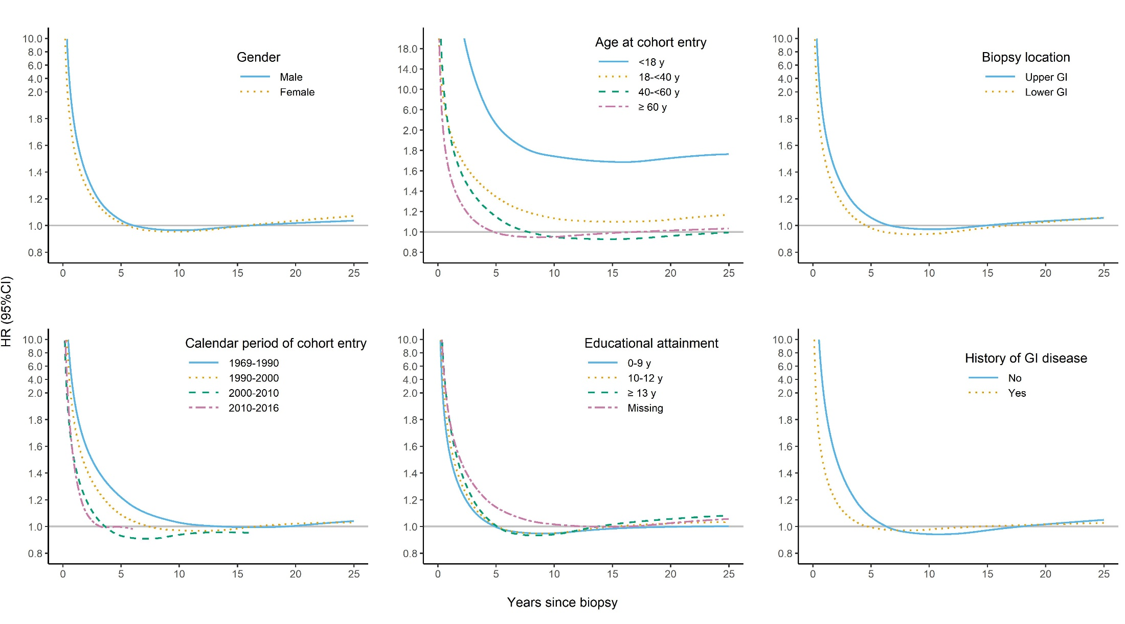
Supplementary Figure 1. Subgroup analyses of the temporal pattern of the risk of all-cause mortality, estimated by the flexible parametric model that conditioned on matching set (birth year, gender, county of residence, and calendar period) and further adjusted for country of birth, educational attainment, number of healthcare visits, Charlson comorbidity index, and history of GI diseases.

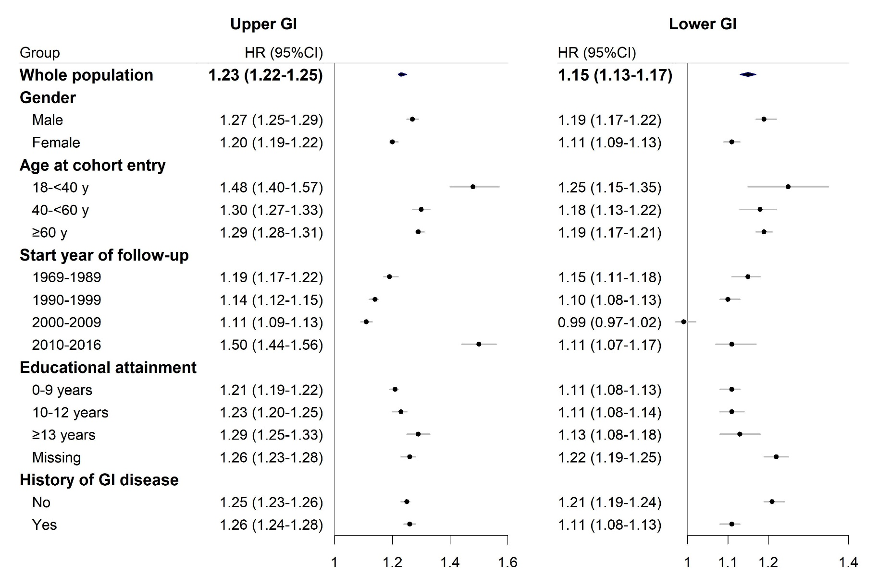
Supplementary Figure 2. Subgroup analyses of normal mucosa with risk of all-cause mortality among those underwent upper or lower GI biopsy. Individuals with an upper GI biopsy in childhood (age at cohort entry <18 years) demonstrated a higher risk for all-cause mortality (HR=2.47; 95%CI: 2.10-2.90), as well as individuals with a lower GI biopsy in childhood (HR=2.23; 95%CI: 1.85-2.69). Estimated by the flexible parametric model that conditioned on matching set (birth year, gender, county of residence, and calendar period) and further adjusted for country of birth, educational attainment, number of healthcare visits, Charlson comorbidity index, and history of GI diseases.

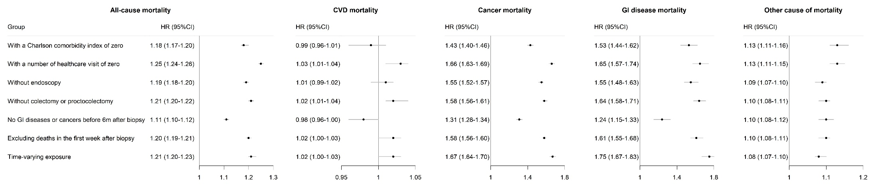
Supplementary Figure 3. Sensitivity analyses of the associations between normal mucosa and risk of mortality. Estimated by the flexible parametric model that conditioned on matching set (birth year, gender, county of residence, and calendar period) and further adjusted for country of birth, educational attainment, number of healthcare visits, Charlson comorbidity index, and history of GI diseases.

