Supplementary Material

Calculation of reduction in progression from myopia to high myopia as a result of treatment

At least two researchers have independently calculated the impact of reducing the rate of progression of myopia on the incidence of high myopia (Fabian Conrad,¹ confirmed in personal communication 24 Feb 2021; and Noel Brennan²). The method involves taking the distribution data for myopic spherical equivalents and applying corrections as follows. For example, for a -3.50D data point:
- -3.50D +1.00D (to account for the fact that myopia management would probably not start at 0.00D and assuming everyone would start at -1.00D) = -2.50D
- Apply control factor to the -2.50D (the progression between -1.00D and -3.50D) as if myopia management had been worn by everyone during the entire time they progressed with a constant control factor of X%, say 50% here
- Add 50% of the progression (-2.50D) to the -1.00D = -1.00D + -1.25D = -2.25D.
- So a -3.50D patient that had used hypothetical myopia management at 50% efficacy stating at -1.00D would end up being -2.25D
- Do the above to all data points and then average (for the average degree of myopia) and compare to a threshold (for the reduction in high-myopia)
The results obtained by Conrad suggest that 50% reduction in rate of progression will reduce incidence of high myopia by 97% and those obtained by Brennan suggest that for the same 50% reduction in rate of progression, incidence will decrease by over 90%.² On the basis of these two estimates we conservatively modelled a 90% reduction in transition to high myopia on the basis of the 50% reduction in rate of progression on atropine reported by Chia et al.³

Age distribution of transition probabilities derived in model calibration

Distribution of transition probabilities across ages was assumed to be bell-shaped, with peaks at published ages or expert reported ages. For example, the SAVES study reported an annual incidence of 2.2% for myopia in a younger cohort of children and 4.1% in an older cohort (see Figure S1).⁴

Supplementary Figure 1: Probability of progressing from emmetropia to myopia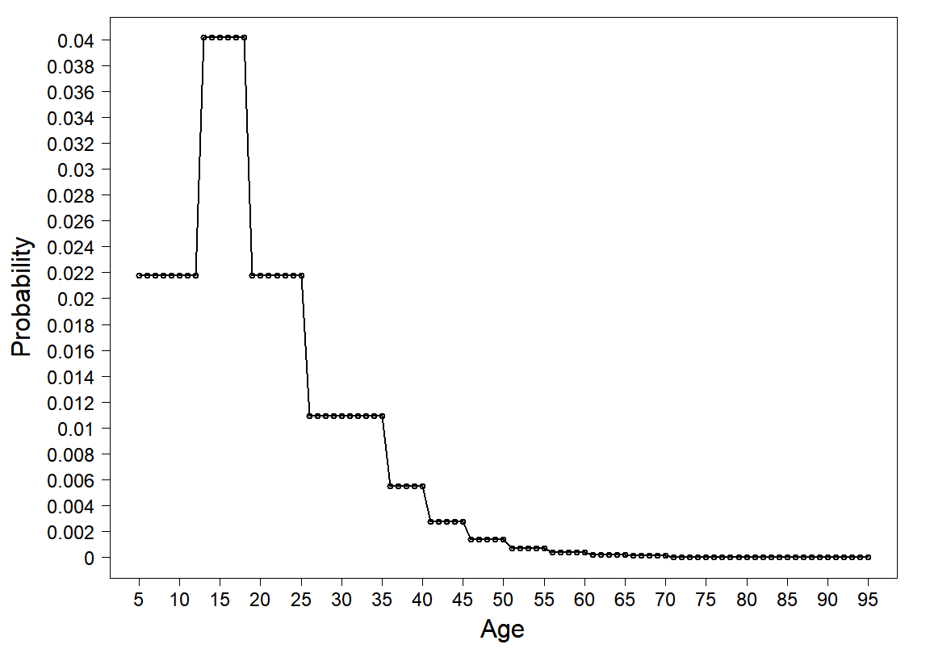
Myopia progression is typically between 6–17 years old,⁵ with mean age of stabilisation at 15.6 years.⁶

Uncertainty around treatment and retreatment in probabilistic sensitivity analysis

Treatment effect (0.76, 0.38–0.92)
In ATOM2 24% of the overall population needed retreatment, but only 8% of 10–13-year-olds needed retreatment. Given that we modelled screening of 11-year-olds, we used a distribution for response to treatment anchored by the overall ATOM2 result, but skewed towards the right.

Supplementary Figure 2: Modelled uncertainty around initial response to treatment

Retreatment effect (0.52, 0.00-0.84)
We assumed that retreatment for one year was only half as effective as retreatment for two years (i.e. 48% will fail to respond). However, we modelled wide uncertainty around this assumption (0–86%).

Supplementary Figure 3: Modelled uncertainty around response to retreatment

Supplementary Table 1: Model parameters and values (including additional detail & justifications)

Parameter | Estimate | Source/rationale | Distribution for PSA
Myopia epidemiology
Prevalence myopia at time of screening | 2.27% [5 years]  9.24% [11 years]  Model transition probabilities calibrated to produce prevalence of  43.8% [lifetime] in standard care pathway | Global estimates of myopia prevalence by ethnicity.⁷  We conservatively apply the age 10 published rate to our age 11 screening population to account for those that might not screen or might not choose treatment.  We assumed the following ethnic distribution for the New Zealand context:  70% European  20% Maori/Pasifika  10% east Asian.⁸  Lifetime prevalence is consistent with estimates for Australasian region.⁹ | NA
Prevalence high myopia [lifetime] | 4.8% (model-generated in standard care pathway) | Consistent with 2.4–8.2% for older adults reported by Matsumura.¹⁰  This is a conservative estimate as Matsumura et al note that prevalence of high myopia is rising among younger people and is up to 21.6% in some East Asian groups. | NA
Prevalence pathological myopia [lifetime] | 2.0% (model-generated in standard care pathway) | Consistent with 0.9–3.1% reported by Wong et al (systematic review).¹¹ | NA
Prevalence blindness [lifetime] | 0.11% (model-generated in standard care pathway) | Consistent with projections for prevalence of myopic blindness in Australasian population aged 80 years in 2050.¹² | NA
Screening efficacy
Age screened | 11  5 (scenario analysis) | Assumed hypothetical screening programme | NA
Sensitivity | 0.67 – 0.97 | PlusOptix S08 0.73  PlusOptix S09/A09 0.86  PlusOptix S04 0.67  PlusOptixA09 0.97  ¹³⁻¹⁶ | Mean = 0.818  SD = 0.119  Beta (7.78, 1.73)
Specificity | 0.93 – 0.98 | PlusOptix S08 0.98  PlusOptix S09/A09 0.95  PlusOptix S04 0.97  PlusOptix S09 0.98  ¹³⁻¹⁶ | Mean = 0.962  SD = 0.022  Beta (71.7,0 2.83)
Transition probabilities
Normal to myopia | Varies by age, e.g. 2.2% per annum at age 10, and 4.1% per annum at age 15 | Known prevalence across ages, and known incidence at some ages, ⁴ was used to derived transition probabilities across all ages that reproduce lifetime prevalence, using the formula:  1 – exp(-rate of disease development) = 1 – exp (-IR) | NA (model calibrated to these point estimates)
Myopia to high myopia | Varies by age | Model calibrated to produce observed/predicted prevalence | NA
High myopia to pathological myopia | Varies by age | Model calibrated to produce observed/predicted prevalence | NA
Normal to blindness | Varies by age | Model calibrated to produce observed/predicted prevalence | NA
Myopia to blindness | Varies by age | Model calibrated to produce observed/predicted prevalence | NA
High myopia to blindness | Varies by age | Model calibrated to produce observed/predicted prevalence | NA
Pathological myopia to blindness | Varies by age | Model calibrated to produce observed/predicted prevalence | NA
Effect of atropine
Reduction in progression myopia to high myopia | 0.9 | 0.01% atropine prescribed in Asia shows a reduction of 50% in the rate of progression of myopia across 5-year follow-up.¹⁷  This 50% reduction in rate leads to a 90–97% reduction in the incidence of high myopia.^{2, 18} | Mean = 0.90  SD = 0.02  Beta (202, 22)
Treatment effect (2-year atropine course) | 0.76  Range: 0.38–0.92 (depending on age) | ATOM2 study found that 24% of all children needed retreatment with atropine after 2 year course.^{3, 19}  The range around the midpoint reflects that in ATOM2 more younger children (62%) and fewer older children (8%, age 10–13 years) needed retreatment.  Other studies have shown similar response to treatment (e.g. 21% non-response ²⁰). | Mean = 0.760  SD = 0.138  Beta (6.5, 2.1)
Re-treatment effect (additional 1-year atropine course) | 0.52  Range: 0–0.84 (depending on age) | We assume that the retreatment for 1 year is only half as effective as the initial treatment for 2 years (i.e. 48% non-responders to retreatment, instead of 24% responding to initial treatment as above).  The range of 0–0.84 is estimated by doubling the proportion of non-responders in the youngest and oldest age groups in ATOM2. i.e. rather than 8% of children aged 10–13 non-responding 16% are non-responders to retreatment. Zero is the lower bound because more than half of younger children did not respond to the first treatment (i.e. doubled = >100%).  Note that Chia 2016 ²¹ found retreatment for 2 years, after a one year washout, to be just as effective as the initial treatment, so our assumptions about re-treatment are conservative. | Mean = 0.520  SD = 0.214  Beta (2.3, 2,1)
Utility (DWs)
Normal | 0 | Assumes no disability in those that have not developed myopia | NA
Myopia | 0.003 (0.001–0.007) | Global Burden of Disease Study 2015, ‘mild impairment distance vision’ ²² | Mean = 0.003  SD = 0.0015  Beta (3.8, 1272)
High myopia | 0.031 (0.019–0.049) | Global Burden of Disease Study 2015, ‘moderate impairment distance vision’ ²² | Mean = 0.031  SD = 0.0077  Beta (0.2, 51.6)
Pathological myopia (additional DW for those with visual impairment) | 0.184 (0.125–0.258) | Half of those with pathological myopia merely accrue the DW for high myopia above. The other half accrue the Global Burden of Disease Study 2015, ‘severe impairment distance vision’ 0.184 (0.125–0.258). ²²  Halving is because only ‘50% of those who develop pathological myopia may develop visual impairment.’¹⁰ | Mean = 0.184  SD = 0.034  Beta (23.8, 105.6)
Blindness | 0.187 (0.124–0.260) | Global Burden of Disease Study 2015, ‘blindness’ ²² | Mean = 0.187  SD = 0.035  Beta (23.4, 101.9)
Costs
Incremental cost of screening (one-off cost in year of screening) | $2.33 ($1.64–$3.01) | The proposed autorefraction check at age 11 years should be quicker than the current Year 7 acuity check. However, the model is comparing (screening with autorefraction + atropine for those with screen-detected myopia + standard corrective lenses) to (no screening + standard corrective lenses for those who develop myopia), therefore we have costed the screening at 5min of technician time (including paperwork/referral).  Technician salary: $41,000–$75,000 per annum = $19.70–$36.10 per hour.²³  Pro rata to 5min per screen (including admin) = $1.64–$3.01 | Normal ($2.33, $0.35)
Initial optometry visit prior to atropine treatment | $65.00 | Standard optometry appointment cost.²⁴ | Normal ($65.00, $6.50)
Atropine treatment (initial 2 years) | $1204.72 | Includes: Cost of drug, dispensing cost (3, 6, 9, 12, 15, 18, 21,24 months) = $150.59*8.²⁵ | Normal ($1204.70, $120.00)
Retreatment for 1 more year (if progression > 0.5D after initial treatment) | $602.36 | Defined as half the cost of initial 2 years atropine treatment. | Normal ($602.00, $60.20)
Monitoring while on atropine | $529.00 | Includes 3, 6, 18 month standard check-up ($65*3) PLUS 12, 24 month comprehensive check-up to check length of eye ($167*2).²⁴ | Normal ($529.00, $52.90)
Monitoring while retreated | $264.50 | Defined as half the cost of initial 2 years monitoring while on atropine | Normal ($264.50, $26.50)
Myopia state (per annum) | $264.00 | Cost includes: annual optometry visit ($65), annual corrective lenses ($199).²⁶  Note, these are conservative assumptions, many patients will not need new lenses each year. Also, some lenses for myopia may cost as little as $120–$170. Therefore, we err on the side of higher cost of myopia, which will reduce the apparent cost-effectiveness of the intervention (i.e. the excess cost of transition to high-myopia will be less) | Normal ($264.00, $26.40)
High myopia state (per annum) | $364.00 | Cost includes: annual optometry visit ($65), annual corrective (progressive) lenses ($299).²⁶  Some high-myopes may require lenses costing $300–$500, however, they may not require them every year (so the annual assumption of $299 accounts for both the cost and frequency). | Normal ($364.00, $36.40)
Pathological myopia state (per annum) | $1923.00 | Cost includes: direct medical costs, productivity losses and indirect costs of visual impairment (Clear Focus Study, $3206 pp in NZD2009, inflated to 2021),²⁷  Halved as above for DWs | Normal ($1923.00, $385)  SD = 20% of mean
Blindness (per annum) | $3846.00 | Cost includes: direct medical, productivity losses and indirect costs of visual impairment (Clear Focus Study, $3206 pp 2009).²⁷ | Normal ($3846.00, $769)  SD = 20% of mean
Discount rate | 3%  6% | 6% modelled in sensitivity analysis | NA
DW: disability weight, NA: not applicable, NZD: New Zealand dollar, PSA: probabilistic sensitivity analysis
Note: all costs are converted to NZD2021 using the Reserve Bank CPI calculator: https://www.rbnz.govt.nz/monetary-policy/inflation-calculator

References

1. Conrad F, Conference Presentation on Myopia. Orthokeratology of Oceania Conference; 2016; Gold Coast, Australia.
2. Brennan NA. Predicted reduction in high myopia for various degrees of myopia control. Cont Lens Anterior Eye. 2012;35:e14-e5.
3. Chia A, Lu QS, Tan D. Five-Year Clinical Trial on Atropine for the Treatment of Myopia 2: Myopia Control with Atropine 0.01% Eyedrops. Ophthalmology. 2016;123(2):391-9.
4. French AN, Morgan IG, Burlutsky G, et al. Prevalence and 5- to 6-year incidence and progression of myopia and hyperopia in Australian schoolchildren. Ophthalmology. 2013;120(7):1482-91.
5. Lin LL, Shih YF, Hsiao CK, et al. Prevalence of myopia in Taiwanese schoolchildren: 1983 to 2000. Ann Acad Med Singap. 2004;33(1):27-33.
6. COMET Group. Myopia stabilization and associated factors among participants in the Correction of Myopia Evaluation Trial (COMET). Invest Ophthalmol Vis Sci. 2013;54(13):7871-84.
7. Rudnicka AR, Kapetanakis VV, Wathern AK, et al. Global variations and time trends in the prevalence of childhood myopia, a systematic review and quantitative meta-analysis: implications for aetiology and early prevention. Br J Ophthalmol. 2016;100(7):882-90.
8. StatsNZ. [Available from: https://www.stats.govt.nz/infographics/major-ethnic-groups-in-new-zealand
9. Holden BA, Fricke TR, Wilson DA, et al. Global prevalence of myopia and high myopia and temporal trends from 2000 through 2050. Ophthalmology. 2016;123(5):1036-42.
10. Matsumura S, Ching-Yu C, Saw S-M. Global Epidemiology of Myopia. In: Ang M, Wong TY, editors. Updates on Myopia: A Clinical Perspective. Singapore: Springer Singapore; 2020. p. 27-51.
11. Wong TY, Ferreira A, Hughes R, et al. Epidemiology and disease burden of pathologic myopia and myopic choroidal neovascularization: an evidence-based systematic review. Am J Ophthalmol. 2014;157(1):9-25.e12.
12. Fricke TR, Jong M, Naidoo KS, et al. Global prevalence of visual impairment associated with myopic macular degeneration and temporal trends from 2000 through 2050: systematic review, meta-analysis and modelling. Br J Ophthalmol. 2018;102(7):855-62.
13. Paff T, Oudesluys-Murphy AM, Wolterbeek R, et al. Screening for refractive errors in children: the plusoptiX S08 and the Retinomax K-plus2 performed by a lay screener compared to cycloplegic retinoscopy. J Aapos. 2010;14(6):478-83.
14. Rajavi Z, Sabbaghi H, Baghini AS, et al. Accuracy and Repeatability of Refractive Error Measurements by Photorefractometry. J Ophthalmic Vis Res. 2015;10(3):221-8.
15. Yan XR, Jiao WZ, Li ZW, et al. Performance of the Plusoptix A09 photoscreener in detecting amblyopia risk factors in Chinese children attending an eye clinic. PLoS One. 2015;10(6):e0126052.
16. Sanchez I, Ortiz-Toquero S, Martin R, et al. Advantages, limitations, and diagnostic accuracy of photoscreeners in early detection of amblyopia: a review. Clin Ophthalmol. 2016;10:1365-73.
17. Chia A, Chua WH, Cheung YB, et al. Atropine for the treatment of childhood myopia: safety and efficacy of 0.5%, 0.1%, and 0.01% doses (Atropine for the Treatment of Myopia 2). Ophthalmology. 2012;119(2):347-54.
18. Wilkinson B, Wilson G. Does screening for myopia in New Zealand meet screening programme criteria? N Z Med J. 2020;133(1509):9-4.
19. Chia A, Chua WH, Wen L, et al. Atropine for the treatment of childhood myopia: changes after stopping atropine 0.01%, 0.1% and 0.5%. Am J Ophthalmol. 2014;157(2):451-7.e1.
20. Sacchi M, Serafino M, Villani E, et al. Efficacy of atropine 0.01% for the treatment of childhood myopia in European patients. Acta Ophthalmol. 2019;97(8):e1136-e40.
21. Chia A, Lu Q-S, Tan D. Five-year clinical trial on atropine for the treatment of myopia 2: myopia control with atropine 0.01% eyedrops. Ophthalmology. 2016;123(2):391-9.
22. Salomon JA, Haagsma JA, Davis A, et al. Disability weights for the Global Burden of Disease 2013 study. Lancet Glob Health. 2015;3(11):e712-23.
23. Payscale.com. 2021 [Available from: https://www.payscale.com/research/NZ/Job=Audio%2FVisual_Technician/Salary
24. ocula.co.nz. [Available from: https://www.ocula.co.nz/my-treatment/atropine-for-myopia-control/
25. Optimus Healthcare. Atropine Costs. In: Wilson G, editor. 2021.
26. nvision.co.nz. [Available from: https://www.nvision.nz/our-eyewear/spectacles-pricing.
27. Access Economics. Clear Focus - The economic impact of vision loss in New Zealand 2009. Canberra: VISION 2020 Australia in support of the VISION 2020 New Zealand Trust; 2010.

