Supplementary Figure 1 Flow diagram of the screening and enrollment of study participants.
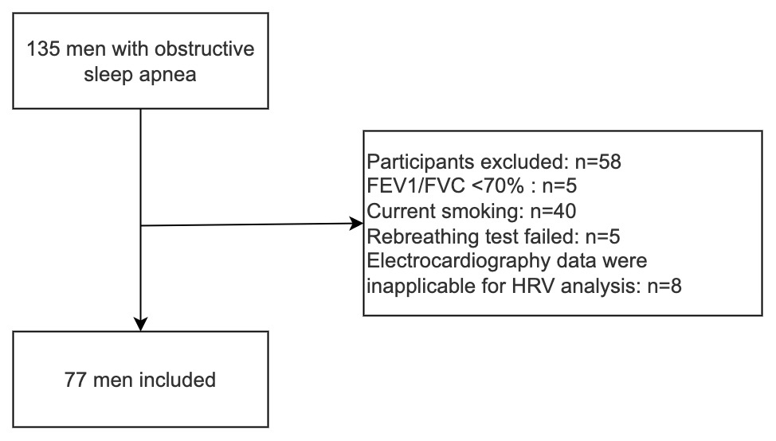
Abbreviations: FEV1, forced expiratory volume in 1s; FVC, forced vital capacity; HRV, heart rate variability.

Supplementary Table 1 Correlative factors of HCVR in OSA patients with hypertension
 | Statistics | β (95%CI) | P value
Age, years | 43.87 ± 9.56 | 0.04 (0, 0.07) | 0.055
BMI, kg/m² | 28.91 ± 4.38 | 0.03 (-0.05, 0.11) | 0.489
BMI ≥ 28kg/m², % | 20 (51.3%) | -0.41 (-1.11, 0.3) | 0.250
Neck circumstance, cm | 41 (39, 42.5) | 0.01 (-0.11, 0.13) | 0.884
WC, cm | 100.55 ± 11.16 | 0.02 (-0.02, 0.05) | 0.296
WC ≥ 90cm, % | 34 (87.2%) | 0.71 (-0.33, 1.76) | 0.174
FEV1 % predicted, % | 94.32 ± 10.29 | 0.03 (-0.01, 0.06) | 0.087
FVC % predicted, % | 95.84 ± 10.31 | 0.03 (-0.01, 0.06) | 0.112
FEV1 / FVC, % | 80.65 ± 4.69 | -0.02 (-0.10, 0.06) | 0.631
AHI, /h | 43.3 (21.2, 62.7) | -0.01 (-0.03, 0) | 0.063
AHI ≥ 15/h, % | 32 (82.1%) | 0.02 (-0.91, 0.95) | 0.965
OAI, /h | 28.1 (10.1, 56.2) | -0.01 (-0.02, 0) | 0.113
CAI, /h | 0 (0, 0.35) | -0.28 (-1.10, 0.54) | 0.492
ODI, /h | 37.7 (14.5, 63.6) | -0.01 (-0.03, 0) | 0.083
LSpO₂, % | 81 (73, 85.5) | 0.02 (-0.02, 0.05) | 0.375
T₉₀,% | 1.8 (0.25, 10.5) | -0.01 (-0.03, 0.02) | 0.622
ESS ≥ 11, % | 21 (53.8%) | 0.13 (-0.59, 0.85) | 0.718
PSQI > 5, % | 28 (71.8%) | -0.24 (-1.03, 0.56) | 0.548
DM, % | 8 (20.5%) | -0.13 (-1.02, 0.76) | 0.769
Mean heart rate, bpm | 74.62 ± 10.00 | -0.03 (-0.06, 0.01) | 0.119
RMSSD, ms | 15.34 (10.24, 22.49) | -0.02 (-0.05, 0.02) | 0.303
SDNN, ms | 21.27 (14.69, 29.09) | -0.02 (-0.05, 0.01) | 0.271
pNN50, % | 0.31 (0, 2.51) | -0.04 (-0.09, 0.01) | 0.150
ln VLF, ms² | 3.63 ± 1.16 | 0.08 (-0.23, 0.39) | 0.615
ln LF, ms² | 5.34 ± 1.19 | -0.06 (-0.36, 0.25) | 0.703
ln HF, ms² | 4.40 ± 1.27 | -0.08 (-0.36, 0.21) | 0.596
LFnu | 68.81 ± 20.02 | 0 (-0.02, 0.02) | 0.900
HFnu | 26.03 (16.49, 45.65) | 0 (-0.02, 0.02) | 0.899
LF/HF ratio | 2.84 (1.19, 5.06) | 0.03 (-0.09, 0.15) | 0.575
ApEn | 1.12 ± 0.08 | -4.09 (-8.13, -0.04) | 0.048
SampEn | 1.51 ± 0.23 | -1.13 (-2.66, 0.4) | 0.144
Beta-blocker, % | 4 (10.3%) | 0.25 (-0.93, 1.43) | 0.672
ACEI/ARB, % | 12 (30.8%) | 0.57 (-0.18, 1.33) | 0.130
CCB, % | 6 (15.4%) | 0.59 (-0.39, 1.56) | 0.228
Diuretic, % | 2 (5.1%) | 0.68 (-0.93, 2.29) | 0.395
Abbreviations: HCVR, hypercapnic ventilatory response; OSA, obstructive sleep apnea; CI, confidence interval; BMI, body mass index; WC, waist circumference; FEV1, forced expiratory volume in 1s; FVC, forced vital capacity; AHI, apnea-hypopnea index; OAI, obstructive apnea index; CAI, central apnea index; ODI, oxygen desaturation index; LSpO₂, lowest values of peripheral blood oxygen saturation; T_{90,} percent of time spent at peripheral blood oxygen saturation beneath 90%; ESS, Epworth Sleepiness Scale; PSQI, Pittsburgh Sleep Quality Index; DM, diabetes mellitus; SDNN, standard deviation of R-R intervals; RMSSD, square root mean squared differences between successive R-R intervals; pNN50, the percentage of adjacent R-R intervals with a difference greater than 50 ms; VLF, very low-frequency range; LF, low-frequency range; HF, high-frequency range; LFnu, normalized LF power; HFnu, normalized HF power; ApEn, approximate entropy; SampEn, sample entropy; ACEI, angiotensin-converting enzyme inhibitor; ARB, angiotensin receptor blocker ;CCB, calcium channel blocker

