Supplementary materials

Table S1 Distribution of score with diagnostic cut-off performance
Cut point | Sensitivity (%) | Specificity (%) | LR+ | LR-
9 | 91.3 | 47.7 | 1.74 | 0.18
10 | 80.4 | 51.2 | 1.65 | 0.38
12 | 78.3 | 58.1 | 1.87 | 0.37
13 | 69.6 | 75.6 | 2.85 | 0.40
14 | 63.0 | 84.9 | 4.17 | 0.44
15 | 47.8 | 87.2 | 3.74 | 0.60

Figure S1 Calibration plot of prediction model performance
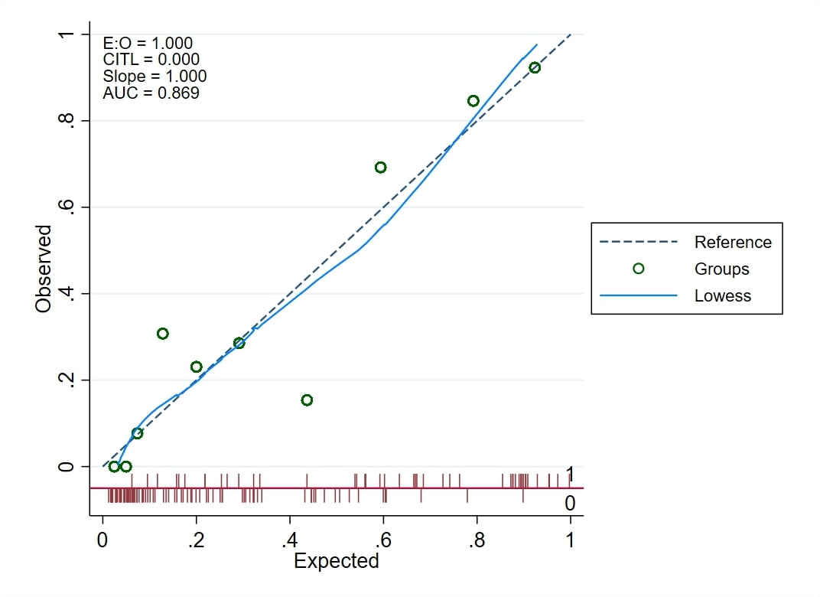
Figure Legend: Pmcalplot includes lowess smoother, risk score distribution, and agreement in tenths of risk type.

