Differential regional vulnerability of the brain to mild neuroinflammation induced by systemic LPS treatment in mice

Hyeji Jung¹, Hyojeong Lee¹, Dongwook Kim¹, Eunji Cheong², Young-Min Hyun³, Je-Wook Yu⁴ and Ji Won Um^{1*}

Supplementary Figures and Figure Legends

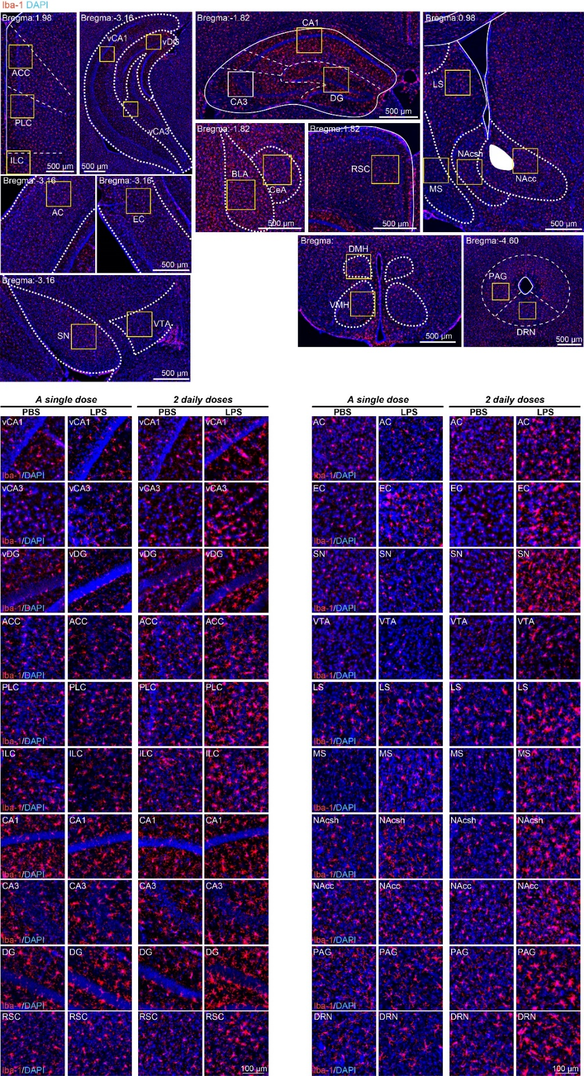
Figure S1. Representative images of various brain regions and immunostaining for the microglial marker Iba-1 in mice injected with saline or i.p.-administered a single or 2 daily doses of LPS.
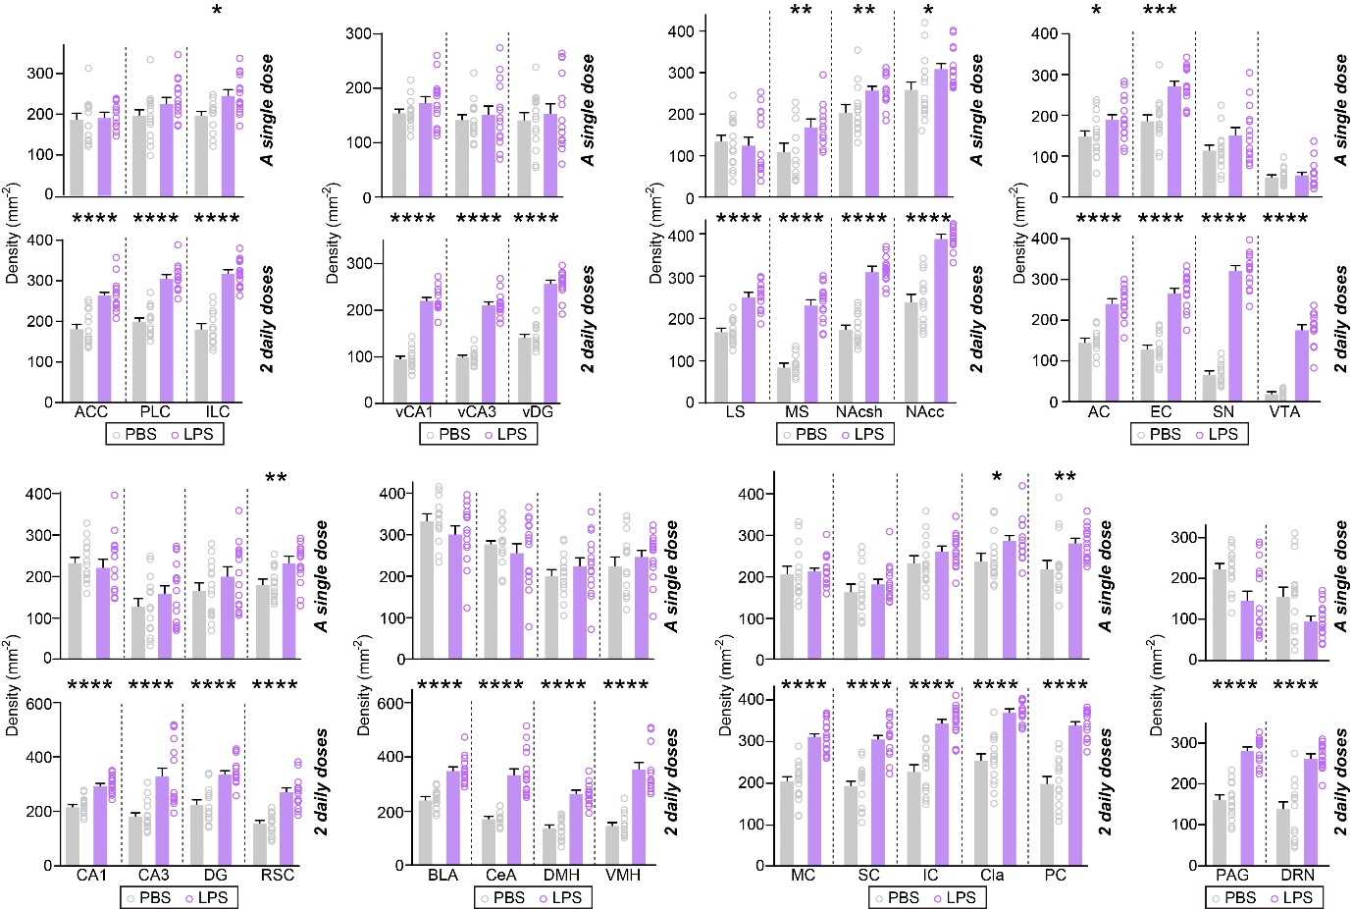

Figure S2. Quantification of the density of Iba-1+ cells presented in Figure S1.
Data are means ± SEMs (n = 12~15 sections from 4~5 mice; *p < 0.05, **p < 0.01, ***p < 0.001, ****p < 0.0001; Mann-Whitney U test).
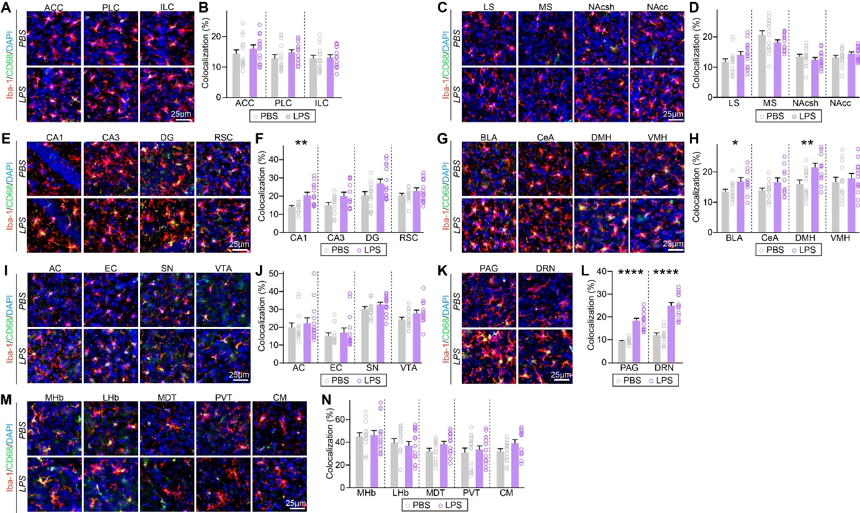
Figure S3. Specific brain regions exhibit microglial activation following mild, LPS-induced inflammation.
(A, C, E, G, I, K, M) Representative images of vCA1, vCA3, vDG, MC, SC, IC, Cla or PC brain regions and immunostaining for the microglial marker Iba-1 and CD68 in mice injected with saline or i.p.-administered a single dose of LPS.
(B, D, F, H, J, L, N) Quantification of the colocalization percentage of Iba-1⁺/CD68⁺ cells. Data are means ± SEMs (n = 12~15 sections from 4~5 mice; * p < 0.05, **p < 0.01, ****p < 0.0001; Mann-Whitney U test).

