Appendix – 1: Introducing Research into practice matrix - Best practice barriers identification and designed strategies to handle the barriers of post-anesthesia discharge score practice at post anesthesia care unit in the Jimma Medical Center, South West Ethiopia, 2021.
Barriers | Strategies | Outcome
Knowledge and skill gaps regarding post anesthesia care unit discharge score | 1. Training was given to PACU nurses  2. Demonstrations, role modeling and reminders  3. Making post anesthesia care unit discharge score a discussion point every morning | There is a significant change in compliance to post anesthesia care unit discharge score
Negligence and forgetfulness | 1. Posting post anesthesia care unit discharge score  2. Setting group norms  3. Making a discussion point every morning
  The attitude and perception change can be implied from the increment in compliance
Work load/time constraint | Engaging surgical residents, Anesthesia, Medical and nursing graduates  Assigning the Nurse staffs fairly based on work load in each time | Student shared load
Shortage of PACU equipment (pulse-oximetry, BP cuff, ECG monitor) | Timely purchasing and delivering them to the point of care  Ensuring continuous material supply | Monitoring equipment were availed and supply was made continuous throughout the project
The changing shifts of nurses posed difficulty in data collection and onsite demonstration | Working during duty hours | Data collectors and the team contacted the nurses during their respective shifts.

Appendix – 2; a-b: Posters and documentation of post-anesthesia care unit discharge score criteria practice among PACU nurses at PACU in the Jimma Medical Center, South West Ethiopia, 2021
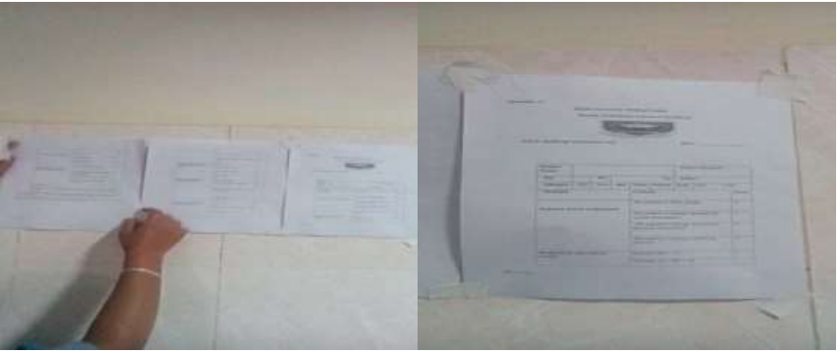
Appendix - 2a. PACU discharge score criteria was posted on post-anesthesia care unit room wall
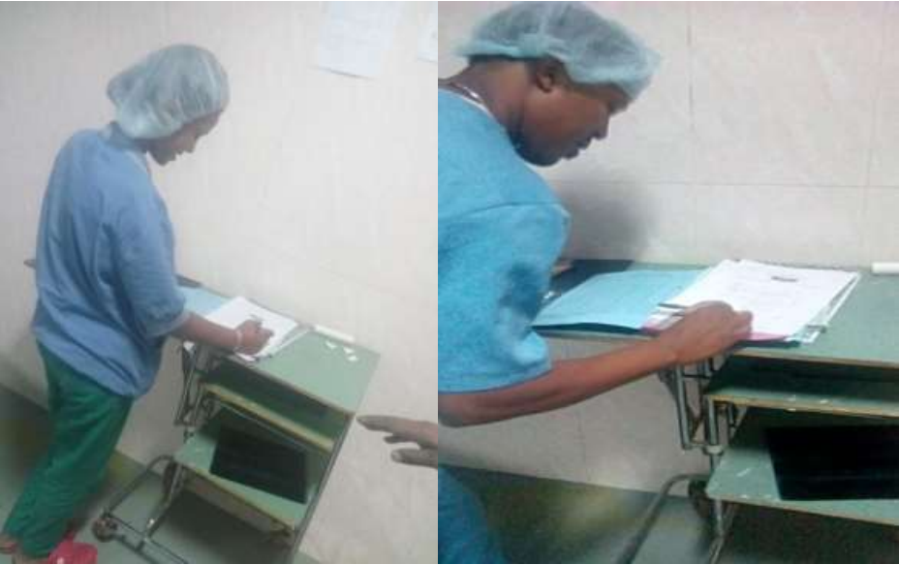
Appendix - 2b. Documentation of post-anesthesia care unit discharge score criteria practice in post PACU before discharging patient among PACU nurses in the JMC, South West Ethiopia, 2021
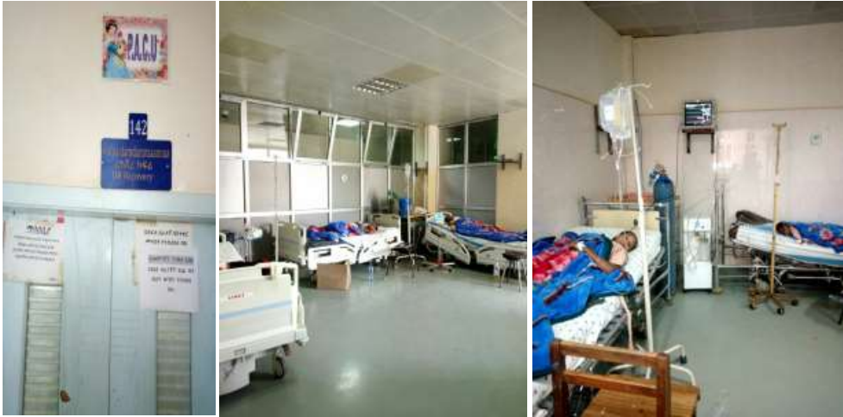
Supplementary figure – 1. Post-anesthesia care unit, equipment in the PACU in Jimma Medical Center

