Supplementary Material:

Supplementary Table 1: Diagnosis codes for Type 2 Diabetes and Type 1 Diabetes categorized by ICD-9 and ICD-10
Diagnosis | ICD-9 | ICD-10
DIABETES TYPE II | 25000;25002;25010;25020;25022;25030;25032;25040;  25042;25050;25052;25060; 25062;25070;25072;25080; 25082;25090;25092 | E119;E1100;E1101;E1110;E1111;E1121;E1122;E1129;E11311;E11319;E11321;E113211;E113212;  E113213;E113219;E11329;E113291;E113292;E113293;E113299;E11331;E113311;E113312;  E113313;E113319;E11339;E113391;E113392;E113393;E113399;E11341;E113411;E113412;  E113413;E113419;E11349;E113491;E113492;E113493;E113499;E11351;E113511;E113512;  E113513;E113519;E113521;E113522;E113523;E113529;E113531;E113532;E113533;E113539;  E113541;E113542;E113543; E113549;E113551;E113552;E113553;E113559;E11359;E113591;  E113592;E113593;E113599;E1136; E1137X1;E1137X2;E1137X3;E1137X9;E1139;E1140;E1141;  E1142;E1143;E1144;E1149;E1151;E1152; E1159;E11610;E11618;E11620;E11621;E11622;E11628;  E11630;E11638;E11641;E11649;E1165; E1169;E118
DIABETES TYPE I | 25001;25003;25011;25012; 25013;25021;25023;25031; 25033;25041;25043;25051; 25053;25061;25063;25071;  25073;25081;25083;25091;  25093 | E109;E1010;E1011;E1021;E1022;E1029;E10311;E10319;E10321;E103211;E103212;E103213;  E103219;E10329;E103291;E103292;E103293;E103299;E10331;E103311;E103312;E103313;  E103319;E10339;E103391;E103392;E103393;E103399;E10341;E103411;E103412;E103413;  E103419;E10349;E103491;E103492;E10349;E103499;E10351;E103511;E103512;E103513;  E103519;E103521;E103522;E103523;E103529;E103531;E103532;E103533;E103539;E103541;  E103542;E103543;E103549;E103551;E103552;E103553;E103559;E10359;E103591;E103592;  E103593;E103599;E1036;E1037X1;E1037X2;E1037X3;E1037X9;E1039;E1040;E1041;E1042;E1043;  E1044;E1049;E1051;E1052;E1059; E10610;E10618;E10620;E10621;E10622;  E10628;E10630;E10638;E10641;E10649;E1065

 | US Population Age Distribution | T2D US | T2D w/HF | T2D w/HF HFrEF | T2D w/HFrEF Metformin + NO SGLT-2i | T2D w/HFrEF Metformin + SGLT-2i
Source | 2019 CENSUS | CDC | MarketScan 2018 | MarketScan 2018 | MarketScan 2018 | MarketScan 2018
Age 30-44 | 19.40% | 3.00% | 1.5% | 40.4% | 84.8% | 15.2%
Age 45-54 | 12.60% | 13.8% | 2.6% | 40.5% | 80.9% | 19.1%
Age 55-64 | 12.80% | 13.8% | 4.1% | 40.3% | 83.0% | 17.0%
Age 30-64 | 44.80% | 7.52% | 3.2% | 40.3% | 82.6% | 17.4%
Supplementary Table 2: Population demographics by age group

CDC, Centers for Disease Control; SGLT-2i, sodium glucose cotransporter-2 inhibitor; T2D, type 2 diabetes

Supplementary Table 3: Individuals with T2D and HFrEF and metformin use, by year - percentage with SGLT-2i use, and age distribution of those with SGLT-2i use
 | 2013 | 2014 | 2015 | 2016 | 2017 | 2018
N Study Subjects | 3392 | 4064 | 4137 | 5491 | 5691 | 5905
Percentage with SGLT-2i use, age 30-64 | 1.1% | 5.4% | 9.8% | 10.4% | 14.6% | 17.4%
Age group distribution for individuals with SGLT-2i use,
30-44 | 2.8% | 10% | 8.6% | 8.0% | 8.3% | 6.7%
45-54 | 33.3% | 33.2% | 33.4% | 31.2% | 32% | 29.9%
55-64 | 63.9% | 56.8% | 58.0% | 60.8% | 59.7% | 63.4%
SGLT-2i, sodium glucose cotransporter-2 inhibitor; T2D, type 2 diabetes

Supplementary Table 4: Benefit-to-Cost ratio for the base case scenario, by and across all age categories, from a payer and societal perspective.
Model | 30-44 | 45-54 | 55-64 | SUM 30-64
MarketScan
Total Costs | $ 165,634 | $ 820,322 | $ 1,341,571 | $ 2,327,527
Direct Medical Benefit | $ 37,802 | $ 353,776 | $ 210,191 | $ 601,769
Societal Benefit | $ 1,004,573 | $ 5,058,355 | $ 2,261,451 | $ 8,324,378
Direct medical Benefit: Cost Ratio | 0.23 | 0.43 | 0.16 | 0.26
Societal Benefit: Cost Ratio | 6.07 | 6.17 | 1.69 | 3.58
CANVAS
Total Costs | $ 165,634 | $ 820,322 | $1,341,571 | $ 2,327,527
Direct Medical Benefit | $ 76,096 | $ 352,940 | $ 474,774 | $ 903,810
Societal Benefit | $ 1,349,640 | $ 4,902,956 | $ 3,305,366 | $ 9,557,961
Direct medical Benefit: Cost Ratio | 0.23 | 0.43 | 0.16 | 0.26
Societal Benefit: Cost Ratio | 8.15 | 5.98 | 2.46 | 4.11
DECLARE-TIMI
Total Costs | $ 165,634 | $ 820,322 | $1,341,571 | $ 2,327,527
Direct Medical Benefit | $ 58,485 | $ 271,261 | $ 357,270 | $ 687,016
Societal Benefit | $ 1,354,214 | $ 4,883,898 | $ 3,211,682 | $ 9,449,794
Direct medical Benefit: Cost Ratio | 0.35 | 0.33 | 0.27 | 0.30
Societal Benefit: Cost Ratio | 8.18 | 5.95 | 2.39 | 4.06
EMPA-REG
Total Costs | $ 165,634 | $ 820,322 | $ 1,341,571 | $ 2,327,527
Direct Medical Benefit | $ 57,131 | $ 264,977 | $ 348,232 | $ 670,340
Societal Benefit | $ 1,261,811 | $ 4,555,915 | $ 2,995,162 | $ 8,812,888
Direct medical Benefit:Cost Ratio | 0.34 | 0.32 | 0.26 | 0.29
Societal Benefit:Cost Ratio | 7.62 | 5.55 | 2.23 | 3.79

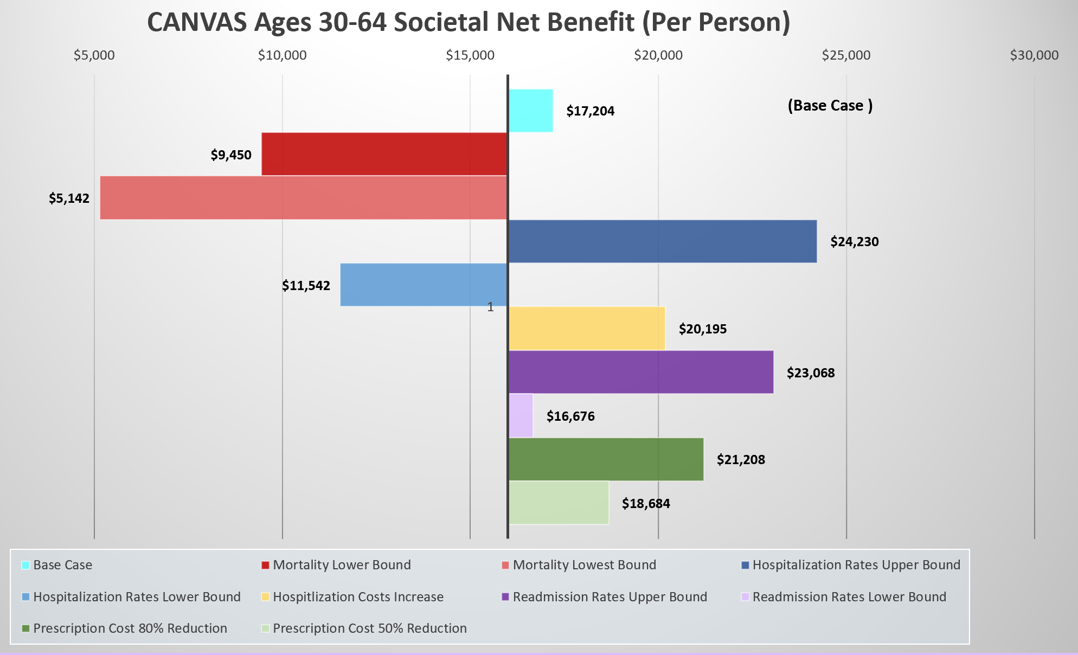
Supplementary Figure 1: CANVAS Ages 30-64 Societal Net-benefit (per person). Results of sensitivity analysis for CANVAS trial model.

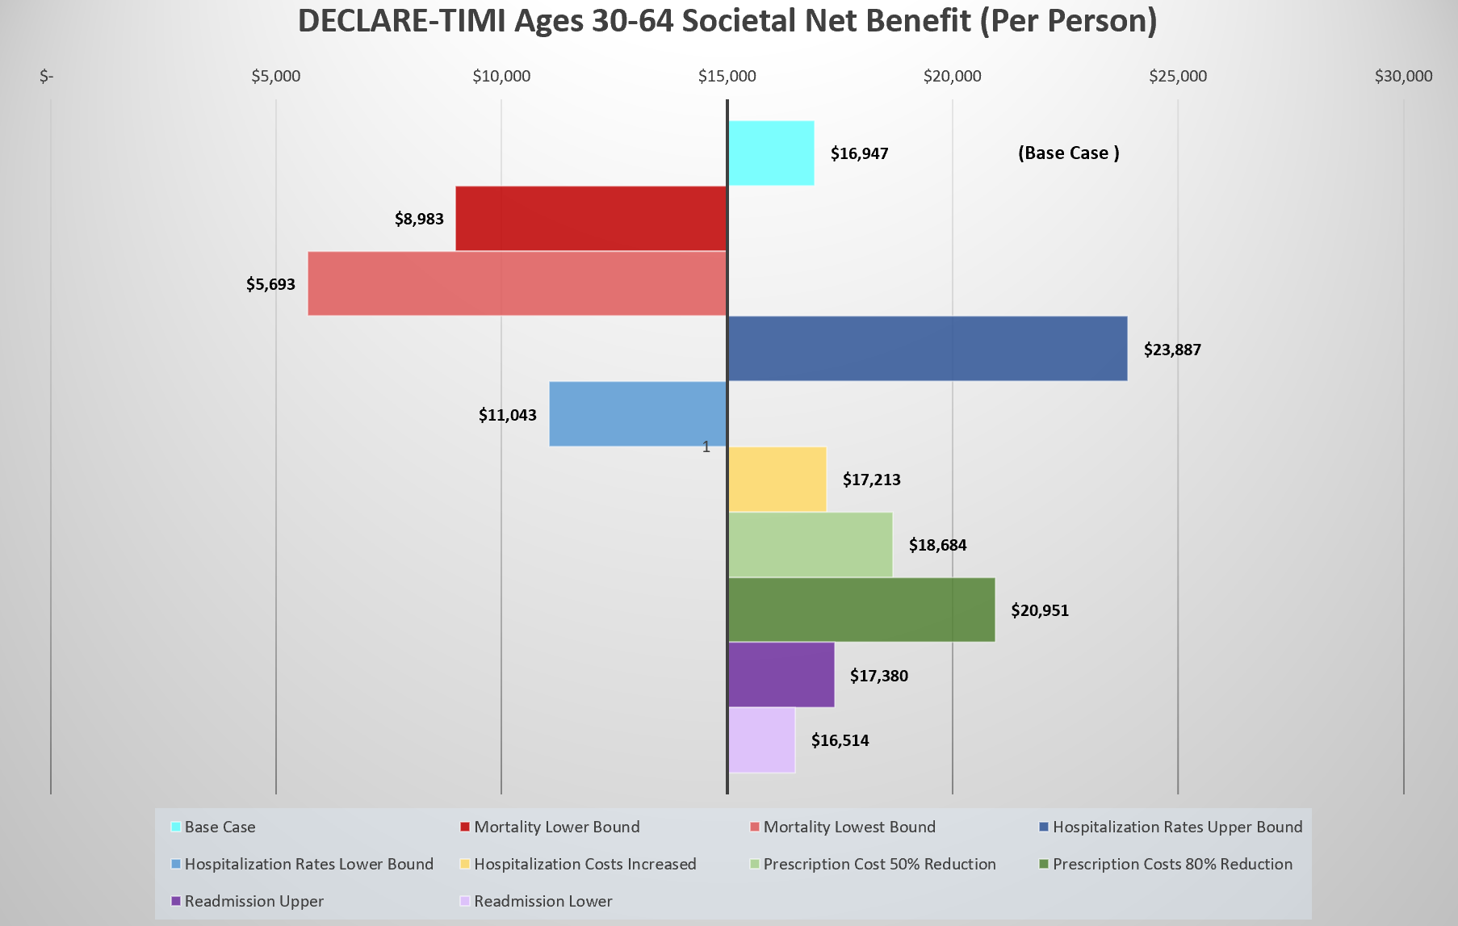
Supplementary Figure 2: DECLARE-TIMI Ages 30-64 Societal Net-benefit (per person). Results of sensitivity analysis for DECLARE-TIMI trial model.

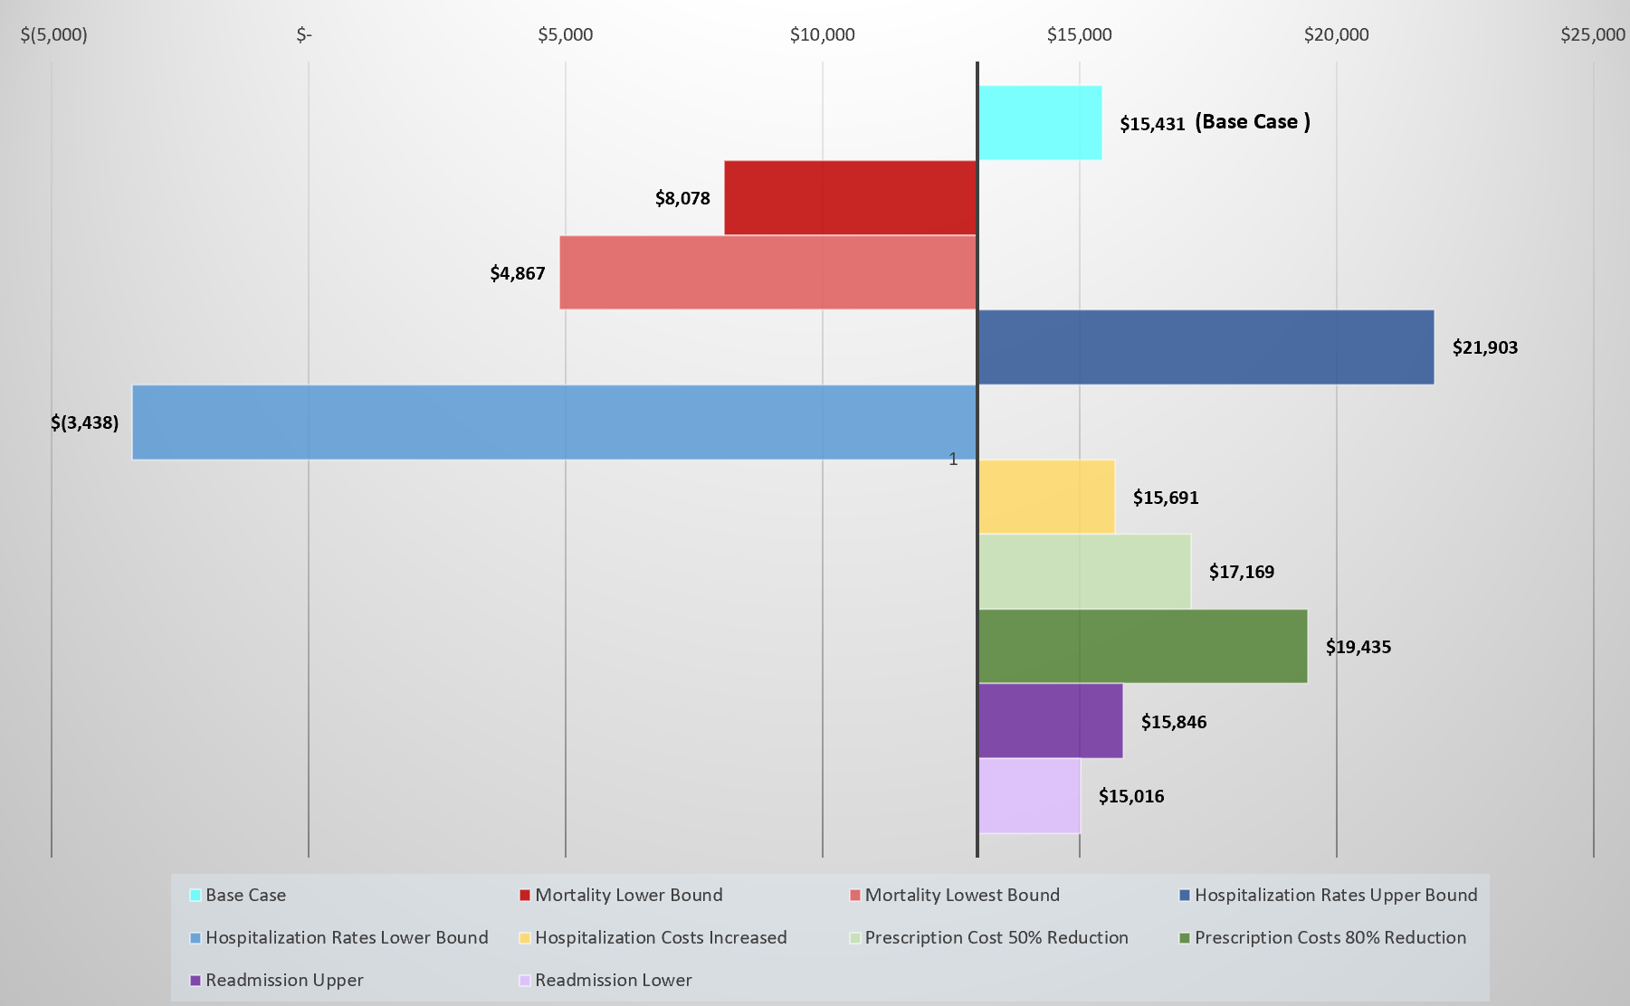
Supplementary Figure 3: EMPA-REG ages 30-64 Societal Net-benefit (per person). Results of the sensitivity analysis for EMPA-REG trial model.

Supplementary Table 5: Benefit-to-Cost ratio results of sensitivity analysis on SGLT-2i prescription costs from a payer perspective across real-world & trial models
Model | 30-44 | 45-54 | 55-64 | SUM 30-64
MarketScan:
Direct Medical Net Benefit (benefit- cost) 50% | $ (75,860.38) | $ (209,150.96) | $ (710,430.58) | $ (995,441.91)
Direct Medical Benefit: Cost Ratio 50% | 0.33 | 0.63 | 0.23 | 0.38
Direct Medical Net Benefit (benefit- cost) 80% | $ (8,071.46) | $ 126,581.82 | $ (161,366.19) | $ (42,855.83)
Direct Medical Benefit: Cost Ratio 80% | 0.82 | 1.56 | 0.57 | 0.93
CANVAS
Direct Medical Net Benefit (benefit- cost) 50% | $ (75,860.38) | $ (209,150.96) | $ (710,430.58) | $ (995,441.91)
Direct Medical Benefit: Cost Ratio 50% | 0.67 | 0.63 | 0.52 | 0.57
Direct Medical Net Benefit (benefit- cost) 80% | $ 30,222.71 | $ 125,746.50 | $ 103,215.98 | $ 259,185.19
Direct Medical Benefit: Cost Ratio 80% | 1.66 | 1.55 | 1.28 | 1.40
DECLARE-TIMI
Direct Medical Net Benefit (benefit- cost) 50% | $ (55,176.90) | $ (291,666.13) | $(563,351.66) | $ (910,194.69)
Direct Medical Benefit: Cost Ratio 50% | 0.51 | 0.48 | 0.39 | 0.43
Direct Medical Net Benefit (benefit- cost) 80% | $ 12,612.02 | $ 44,066.64 | $ (14,287.28) | $ 42,391.38
Direct Medical Benefit: Cost Ratio 80% | 1.27 | 1.19 | 0.96 | 1.07
EMPA-REG
Direct Medical Net Benefit (benefit- cost) 50% | $ (56,531.57) | $ (297,949.20) | $ (572,390.38) | $ (926,871.14)
Direct Medical Benefit: Cost Ratio 50% | 0.50 | 0.47 | 0.38 | 0.42
Direct Medical Net Benefit (benefit- cost) 80% | $ 11,257.35 | $ 37,783.58 | $ (23,325.99) | $ 25,714.93
Direct Medical Benefit: Cost Ratio 80% | 1.25 | 1.17 | 0.94 | 1.04

