The interaction effect between previous stroke and hip fracture on post-operative mortality. A nationwide cohort study

By
Thomas J. Hjelholt, Søren P. Johnsen, Peter K. Brynningsen, Alma B. Pedersen

Supplementary Material

Contents:
Supplementary Table 1 ICD-10 and ATC codes and weights for Charlson Comorbidity Index and other baseline variables
Supplementary Figure 1 Study population flowchart.
Supplementary Table 2 Baseline characteristics, individual Charlson comorbidities
Supplementary Table 3 31-365 day mortality in the four cohorts: risks, rates and interaction contrast (IC). Overall and stratified on comorbidity and age
Supplementary Table 4 1-5 year mortality in the four cohorts: risks, rates and interaction contrast (IC). Overall and stratified on comorbidity and age
Supplementary Figure 2 31-365 day mortality in the four cohorts: Hazard ratios and attributable proportion (AP). Overall and stratified on comorbidity and age.
Supplementary Figure 3 1-5 year mortality in the four cohorts: Hazard ratios and attributable proportion (AP). Overall and stratified on comorbidity and age.
Supplementary Figure 4 Directed acyclic graph illustrating the association between stroke, hip fracture and death
Supplementary Table 1. ICD-10 and ATC codes and weights for Charlson Comorbidity Index and other baseline variables
Charlsons comorbidity index | ICD-10 codes | Points
Myocardial infarction | I21, I22, I23 | 1
Congestive heart failure | I50, I110, I130, I132 | 1
Peripheral vascular disease | I70, I71, I72, I73, I74, I77 | 1
Cerebrovascular disease | I6*, G45, G46 | 1
Dementia | F00, F01, F02, F03, F051, G30 | 1
Chronic pulmonary disease | J40, J41, J42, J43, J44, J45, J46, J47, J60, J61, J62, J63, J64, J65, J66, J67, J684, J701, J703, J841, J920, J961, J982, J983 | 1
Connective tissue disease | M05, M06, M08, M09, M30, M31, M32, M33, M34, M35, M36, D86 | 1
Ulcer disease | K221, K25, K26, K27, K28 | 1
Mild liver disease | B18, K700, K701, K702, K703, K709, K71, K73, K74, K760 | 1
Diabetes without end-organ damage | E100, E101, E109, E110, E111, E119 | 1
Hemiplegia | G81, G82 | 2
Moderate to severe renal disease | I12, I13, N00, N01, N02, N03, N04, N05, N07, N11, N14, N17, N18, N19, Q61 | 2
Diabetes with end organ damage | E102, E103, E104, E105, E106, E107, E108, E112, E113, E114, E115, E116, E117, E118 | 2
Non-metastatic solid tumour | C0, C1, C2, C3, C4, C5, C6, C70, C71, C72, C73, C74, C75 | 2
Leukaemia | C91, C92, C93, C94, C95 | 2
Lymphoma | C81, C82, C83, C84, C85, C88, C90, C96 | 2
Moderate to severe liver disease | B150, B160, B162, B190, K704, K72, K766, I85 | 3
Metastatic solid tumour | C76, C77, C78, C79, C80 | 6
AIDS | B21, B22, B23, B24 | 6
Other baseline variables | ICD-10 codes
Stroke (for matching) | I60 – I64
Baseline medication use | ATC-codes
Antihypertensives | C02CA, C02A, C02B, C02CC, C02D, C02K, C02L, C03A, C03B, C03D, C03EA, C03X, C04, C07, C08, C09
Lipid lowering | C10AA, C10B, C10AB, C10AC, C10AD, C10AX
Platelet inhibitors | B01AC
Oral anticoagulants | B01AA, B01AE07, B01AF
Non-insulin antidiabetics | A10B
Insulin | A10A
Antidepressants | N06A
Antipsychotics | N05A
Osteoporosis medication | M05BA, M05BB, M05BX03, M05BX04, G03XC01, H05AA
Lookback period: 1994-index date

Supplementary Figure 1. Study population flowchart.

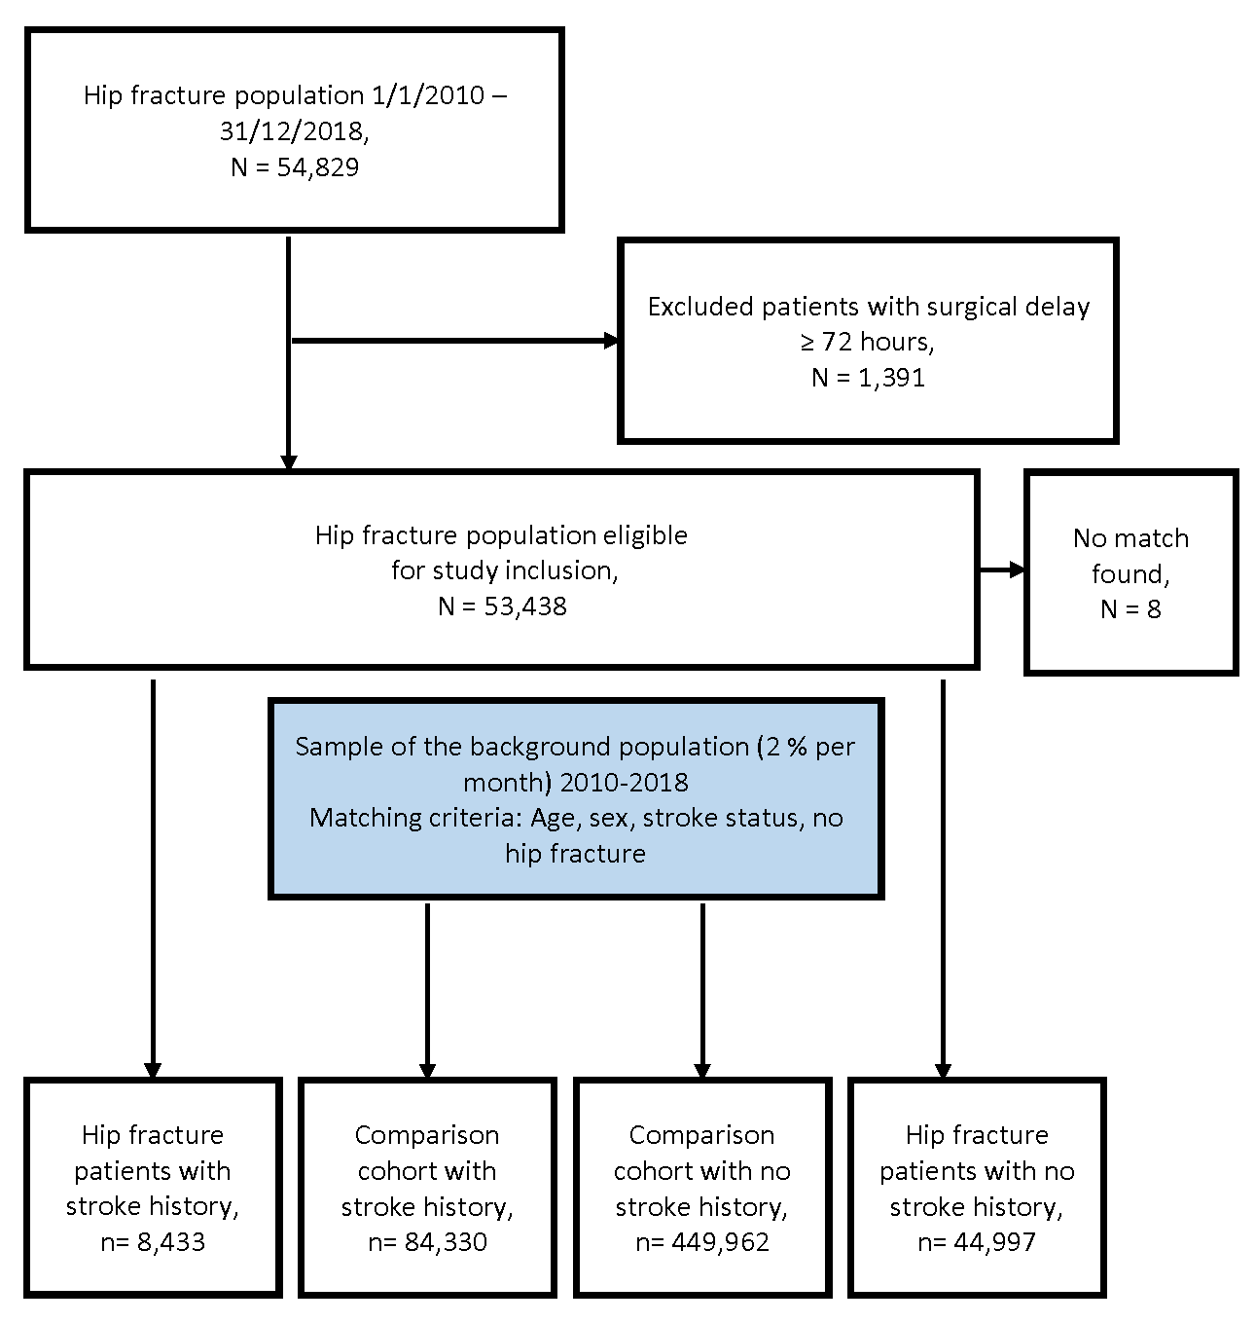

Supplementary Table 2. Patient characteristics at index date, individual Charlson comorbidities
 | Stroke patients |  |  | Non-stroke patients
 | Hip fracture  (N= 8,433) | Non-hip fracture  (N= 84,330) |  | Hip fracture  (N=44,997) | Non-hip fracture  (N=449,962)
Individual Charlson Comorbidity Index categories
Myocardial infarction | 575 (6.82) | 5,429 (6.44) |  | 2,186 (4.86) | 19,150 (4.26)
Congestive heart failure | 976 (11.57) | 8,465 (10.04) |  | 3,571 (7.94) | 27,432 (6.10)
Peripheral vascular disease | 1,058 (12.55) | 8,584 (10.18) |  | 3,496 (7.77) | 23,481 (5.22)
Cerebrovascular disease* | 8,433 (100.00) | 84,330 (100.00) |  | 2,696 (5.99) | 19,341 (4.30)
non-stroke cerebrovascular disease** | 1,999 (23.70) | 21,574 (25.58) |  | 2,696 (5.99) | 19,341 (4.30)
Dementia | 1,085 (12.87) | 6,165 (7.31) |  | 4,288 (9.53) | 17,870 (3.97)
Chronic pulmonary disease | 1,290 (15.30) | 9,735 (11.54) |  | 5,735 (12.75) | 36,974 (8.22)
Connective tissue disease | 1,290 (15.30) | 9,735 (11.54) |  | 5,735 (12.75) | 36,974 (8.22)
Ulcer disease | 561 (6.65) | 4,320 (5.12) |  | 2,101 (4.67) | 13,855 (3.08)
Mild liver disease | 121 (1.43) | 568 (0.67) |  | 583 (1.30) | 1,854 (0.41)
Diabetes (uncomplicated) | 1,128 (13.38) | 10,534 (12.49) |  | 3,872 (8.61) | 28,874 (6.42)
Hemiplegia | 49 (0.58) | 500 (0.59) |  | 85 (0.19) | 429 (0.10)
Renal disease | 617 (7.32) | 4,466 (5.30) |  | 1,955 (4.34) | 12,717 (2.83)
Diabetes w end-organ damage | 732 (8.68) | 6,088 (7.22) |  | 1,964 (4.36) | 12,621 (2.80)
Any Tumor | 1,356 (16.08) | 12,369 (14.67) |  | 7,137 (15.86) | 62,306 (13.85)
Leukemia | 39 (0.46) | 383 (0.45) |  | 250 (0.56) | 1,928 (0.43)
Lymphoma | 88 (1.04) | 615 (0.73) |  | 466 (1.04) | 3,277 (0.73)
Moderate-severe liver disease | 48 (0.57) | 193 (0.23) |  | 225 (0.50) | 541 (0.12)
* This category is not included in the computation of the charlson comorbidity index score because cohorts are selected based on diagnoses included in the category
** This is not a Charlson Comorbidity Index category, but included for transparency regarding stroke and non-stroke diagnoses in the Cerebrovascular disease category

Supplementary Table 3. 31-365 day mortality in the four cohorts: risks, rates and interaction contrast (IC). Overall and stratified on comorbidity and age
 | Events,  N | Person  years | Cumulative  incidence,  % (95%CI) | Standardized  MR/100  person years  (95%CI) | IC (95%CI)
Comparison cohort without stroke | 32,168 | 413,736.8 | 8.2 (8.1-8.2) | 7.8 (7.7-7.9) | NA
Comparison cohort with stroke | 9,473 | 75,195.7 | 13.1 (12.8-13.3) | 11.6 (11.3-11.8) | NA
Hip fracture cohort without stroke | 7,420 | 34,421.4 | 27.1 (26.7-27.5) | 21.1 (20.6-21.6) | NA
Hip fracture cohort with stroke | 1,646 | 6,109 | 32.7 (31.7-33.7) | 25.4 (24-26.8) | 0.5 (-1-2)
Stratified on CCI groups
CCI 0
Comparison cohort without stroke | 12,002 | 248,787.9 | 5.1 (5-5.2) | 4.8 (4.7-4.9) | NA
Comparison cohort with stroke | 2,843 | 34,324.1 | 8.7 (8.5-9) | 8.2 (7.9-8.6) | NA
Hip fracture cohort without stroke | 2,505 | 17,390.4 | 19.1 (18.6-19.7) | 14.5 (14-15.1) | NA
Hip fracture cohort with stroke | 476 | 2,365.4 | 25.7 (24.1-27.3) | 19.7 (18-21.6) | 1.8 (-0.1-3.7)
CCI 1-2
Comparison cohort without stroke | 1,271 | 11,387 | 10.8 (10.6-11) | 11.2 (10.6-11.8) | NA
Comparison cohort with stroke | 447 | 2,616.6 | 14 (13.6-14.4) | 18.1 (16.4-19.9) | NA
Hip fracture cohort without stroke | 1,866 | 1,269.3 | 30.3 (29.6-31) | 159.1 (152-166.5) | NA
Hip fracture cohort with stroke | 428 | 263.2 | 33.8 (32.2-35.4) | 176.4 (160.2-194.4) | 10.5 (-8.2-29.1)
CCI 3+
Comparison cohort without stroke | 7,034 | 38,808.6 | 18.4 (18-18.7) | 18.1 (17.7-18.6) | NA
Comparison cohort with stroke | 2,779 | 12,383.7 | 22.1 (21.4-22.8) | 23.6 (22.7-24.5) | NA
Hip fracture cohort without stroke | 1,862 | 4,741 | 42.9 (41.8-44.1) | 43 (40.9-45.1) | NA
Hip fracture cohort with stroke | 452 | 1,251.8 | 41.9 (39.7-44.1) | 40 (36.1-44.5) | -8.4 (-13.2--3.6)
Stratified on age groups
Age 65-75
Comparison cohort without stroke | 1,373 | 89,863.2 | 1.7 (1.6-1.7) | 1.5 (1.4-1.6) | NA
Comparison cohort with stroke | 596 | 16,060.5 | 4.1 (3.8-4.4) | 2.6 (2.4-2.9) | NA
Hip fracture cohort without stroke | 920 | 8,187.6 | 14 (13.3-14.7) | 8.3 (7.7-8.9) | NA
Hip fracture cohort with stroke | 217 | 1,448.7 | 17.8 (16-19.7) | 11.1 (9.4-13.2) | 1.8 (-0.3-3.8)
Age 75-85
Comparison cohort without stroke | 6,807 | 152,902.5 | 4.7 (4.6-4.8) | 4.5 (4.3-4.6) | NA
Comparison cohort with stroke | 2,688 | 29,712.8 | 9.5 (9.2-9.8) | 7.6 (7.3-7.9) | NA
Hip fracture cohort without stroke | 2,334 | 13,187.7 | 22 (21.3-22.6) | 15.9 (15.2-16.6) | NA
Hip fracture cohort with stroke | 589 | 2,492.2 | 28.4 (26.9-30) | 19.8 (18-21.7) | 0.8 (-1.2-2.8)
Age 85-95
Comparison cohort without stroke | 18,492 | 151,783.2 | 12.5 (12.3-12.7) | 12.2 (12-12.4) | NA
Comparison cohort with stroke | 5,180 | 26,669.1 | 19.4 (19-19.9) | 17.9 (17.4-18.4) | NA
Hip fracture cohort without stroke | 3,494 | 11,767.4 | 35.8 (35-36.5) | 29.6 (28.6-30.6) | NA
Hip fracture cohort with stroke | 728 | 1,996.6 | 42.4 (40.6-44.1) | 34.2 (31.7-36.9) | -1.1 (-4-1.7)
Age 95+
Comparison cohort without stroke | 5,496 | 19,188 | 27.1 (26.5-27.7) | 28.6 (27.9-29.4) | NA
Comparison cohort with stroke | 1,009 | 2,753.3 | 34 (32.4-35.6) | 35.1 (33-37.4) | NA
Hip fracture cohort without stroke | 672 | 1,278.7 | 54.1 (52-56.1) | 54.3 (50.3-58.6) | NA
Hip fracture cohort with stroke | 112 | 171.5 | 60.1 (54.7-65.1) | 66.1 (54.4-80.2) | 5.3 (-8.4-19)

Supplementary Table 4. 1-5 year mortality in the four cohorts: risks, rates and interaction contrast (IC). Overall and stratified on comorbidity and age
 | Events,  N | Person  years | Cumulative  incidence,  % (95%CI) | Standardized  MR/100  person years  (95%CI) | IC (95%CI)
Comparison cohort without stroke | 92,099 | 1,343,866.8 | 37.6 (37.4-37.8) | 6.9 (6.8-6.9) | NA
Comparison cohort with stroke | 22,458 | 221,822.1 | 51.7 (51.2-52.1) | 9.6 (9.5-9.7) | NA
Hip fracture cohort without stroke | 10,655 | 99,663.4 | 61.1 (60.6-61.7) | 10.6 (10.4-10.8) | NA
Hip fracture cohort with stroke | 2,185 | 16,176.1 | 70.4 (69.2-71.6) | 12.7 (12.1-13.3) | -0.7 (-1.3-0.0)
Stratified on CCI groups
CCI 0
Comparison cohort without stroke | 43,682 | 854,225.7 | 28.9 (28.7-29.1) | 5.1 (5.1-5.2) | NA
Comparison cohort with stroke | 8,326 | 10,8713 | 41.3 (40.6-41.9) | 7.7 (7.5-7.8) | NA
Hip fracture cohort without stroke | 4,574 | 54,354.9 | 50.6 (49.8-51.4) | 8.5 (8.2-8.7) | NA
Hip fracture cohort with stroke | 746 | 6,863.1 | 61.8 (59.6-63.9) | 10.7 (9.9-11.5) | -0.4 (-1.2-0.5)
CCI 1-2
Comparison cohort without stroke | 34,742 | 386,804.4 | 46.7 (46.4-47) | 9 (8.9-9.1) | NA
Comparison cohort with stroke | 9,400 | 82,253.5 | 55.9 (55.3-56.6) | 12.1 (11.9-12.4) | NA
Hip fracture cohort without stroke | 4,243 | 34,083 | 66.8 (65.9-67.6) | 13.4 (12.9-13.8) | NA
Hip fracture cohort with stroke | 907 | 6,446.8 | 71.6 (69.7-73.4) | 15 (14-16.1) | -1.5 (-2.6--0.3)
CCI 3+
Comparison cohort without stroke | 13,675 | 102,836.7 | 62.8 (62.2-63.3) | 13.3 (13.1-13.5) | NA
Comparison cohort with stroke | 4,732 | 30,855.6 | 69.5 (68.5-70.4) | 16.1 (15.6-16.6) | NA
Hip fracture cohort without stroke | 1,838 | 11,225.5 | 79.5 (78.3-80.6) | 17.9 (17-18.8) | NA
Hip fracture cohort with stroke | 532 | 2,866.2 | 82.2 (79.8-84.2) | 20.7 (18.9-22.7) | 0 (-2.1-2.2)
Stratified on age groups
Age 65-75
Comparison cohort without stroke | 4,911 | 322,744 | 9.6 (9.4-9.8) | 1.5 (1.5-1.6) | NA
Comparison cohort with stroke | 1,969 | 54,967.3 | 21.5 (20.7-22.3) | 2.8 (2.7-2.9) | NA
Hip fracture cohort without stroke | 1,459 | 26,209.5 | 37.3 (36.1-38.5) | 4.8 (4.5-5) | NA
Hip fracture cohort with stroke | 345 | 4,362.6 | 48 (45-50.8) | 6.4 (5.6-7.4) | 0.4 (-0.5-1.3)
Age 75-85
Comparison cohort without stroke | 24,223 | 528,961.8 | 26.5 (26.3-26.8) | 4.6 (4.5-4.6) | NA
Comparison cohort with stroke | 7,581 | 92,037.8 | 44.1 (43.4-44.7) | 7.2 (7.1-7.4) | NA
Hip fracture cohort without stroke | 3,707 | 39,767.6 | 54.5 (53.6-55.4) | 8.8 (8.5-9.1) | NA
Hip fracture cohort with stroke | 849 | 6,685.7 | 66.8 (64.8-68.8) | 11 (10.2-11.9) | -0.4 (-1.3-0.5)
Age 85-95
Comparison cohort without stroke | 53,199 | 451,026.8 | 56.7 (56.4-57) | 11.8 (11.7-11.9) | NA
Comparison cohort with stroke | 11,495 | 69,549.2 | 71.3 (70.6-71.9) | 15.7 (15.4-16) | NA
Hip fracture cohort without stroke | 4,879 | 31,080.1 | 76.1 (75.3-76.9) | 15.7 (15.3-16.2) | NA
Hip fracture cohort with stroke | 915 | 4,793.5 | 83.6 (81.9-85.1) | 18.3 (17.1-19.5) | -1.4 (-2.7-0)
Age 95+
Comparison cohort without stroke | 9,766 | 41,134.2 | 85.4 (84.8-86) | 23.7 (23.3-24.2) | NA
Comparison cohort with stroke | 1,413 | 5,267.8 | 90.6 (89.2-91.8) | 26.6 (25.2-28) | NA
Hip fracture cohort without stroke | 610 | 2,606.3 | 92.2 (90.7-93.6) | 23.7 (21.8-25.7) | NA
Hip fracture cohort with stroke | 76 | 334.3 | 92.7 (87.7-95.8) | 22.2 (17.4-28.2) | -4.4 (-10.2-1.5)

Supplementary Figure 2. 31-365 day mortality in the four cohorts: Hazard ratios and attributable proportion (AP). Overall and stratified on comorbidity and age.
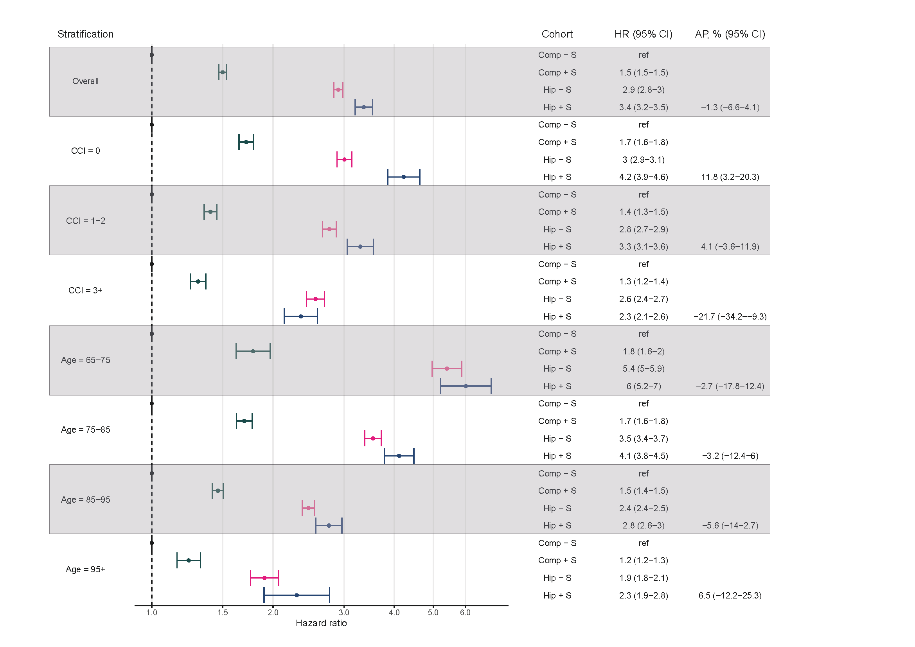
Supplementary Figure 3. 1-5 year mortality in the four cohorts: Hazard ratios and attributable proportion (AP). Overall and stratified on comorbidity and age.
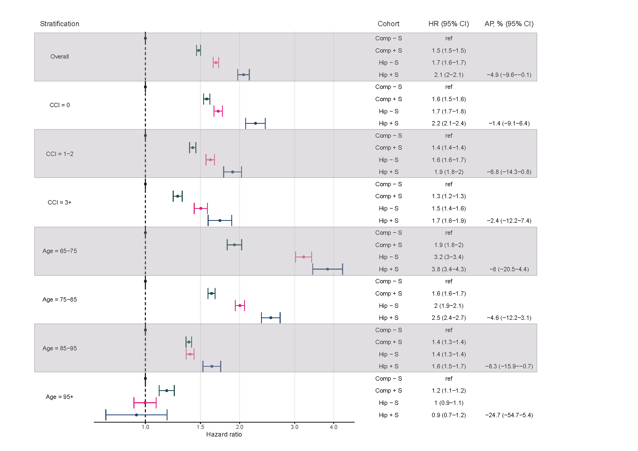
Supplementary Figure 4. Directed acyclic graph illustrating the association between stroke, hip fracture and death.
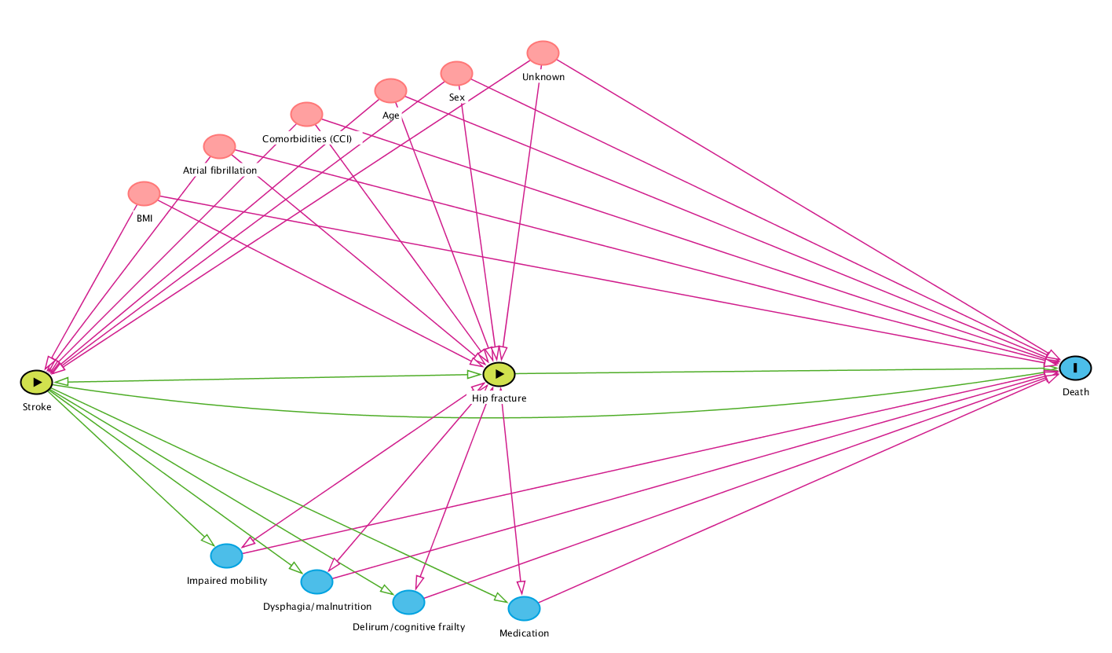
Directed Acyclic Graph (DAG) of the association investigated in this study. The factors with red color above the green horizontal line connecting stroke- hip fracture and death are considered as confounders of the association, whereas the blue colored factors below the green horizontal line are considered mediators. Illustrated using DAGitty v 3.0 at http://www.dagitty.net

