Figure Legends:
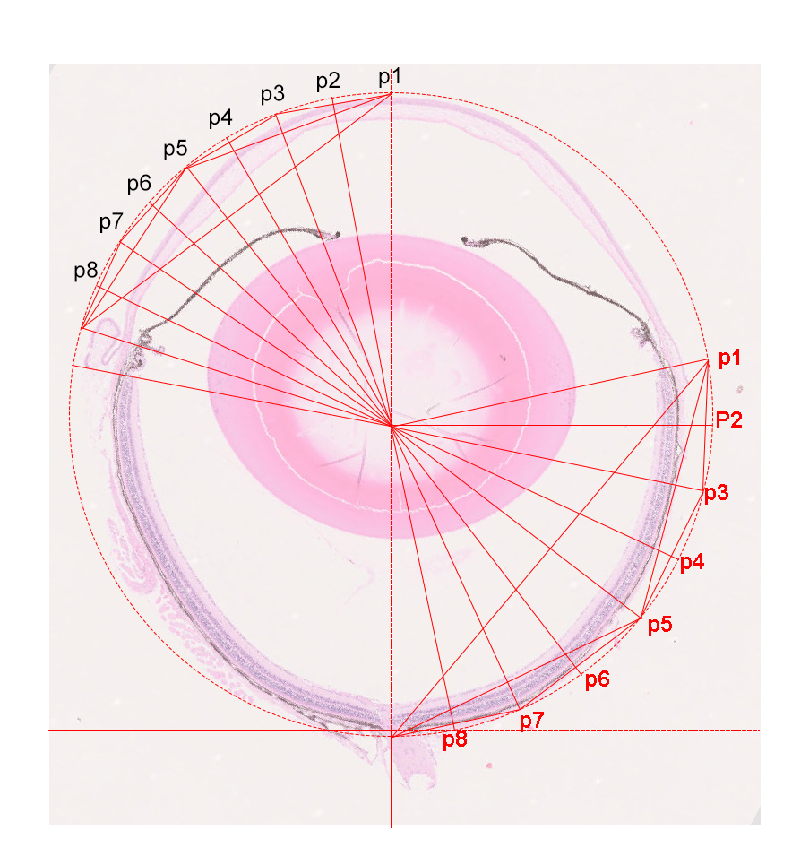
Figure 1 The diagrammatic drawing of mean thickness measuring sites. Mean thickness of cornea=1/8 (∑Thickness _{p1+p2+p3+p4+p5+p6+p7+p8}); thickness of retina =1/7 (∑Thickness _{p2+p3+p4+p5+p6+p7+p8}); Mean thickness of choroid=1/7 (∑Thickness _{p2+p3+p4+p5+p6+p7+p8}).
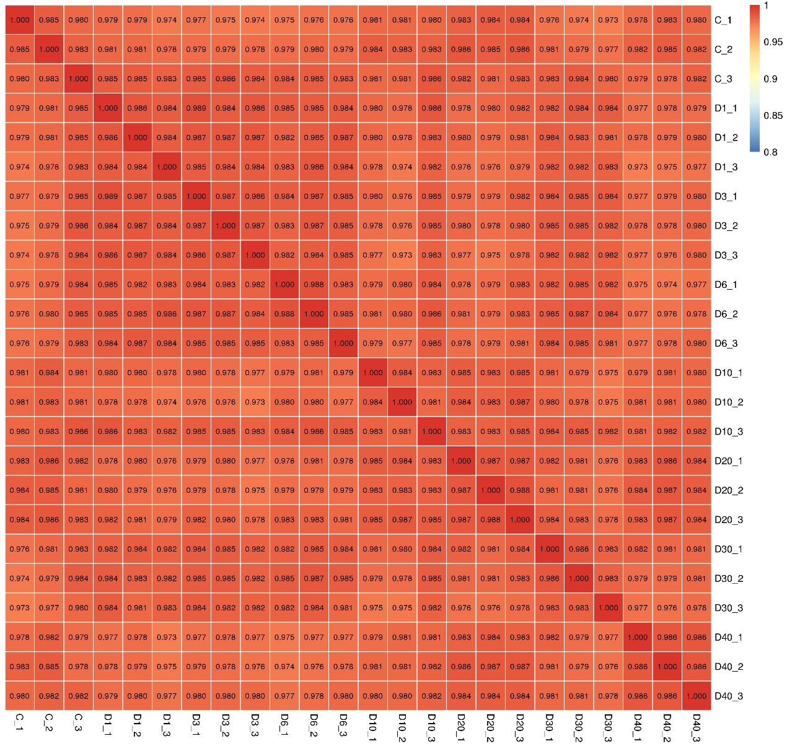
Figure 2 Heat maps of Pearson correlation coefficients between all samples. Pearson correlation coefficient is negative correlation when it is close to -1, positive correlation when it is close to 1, and no correlation when it is close to 0.

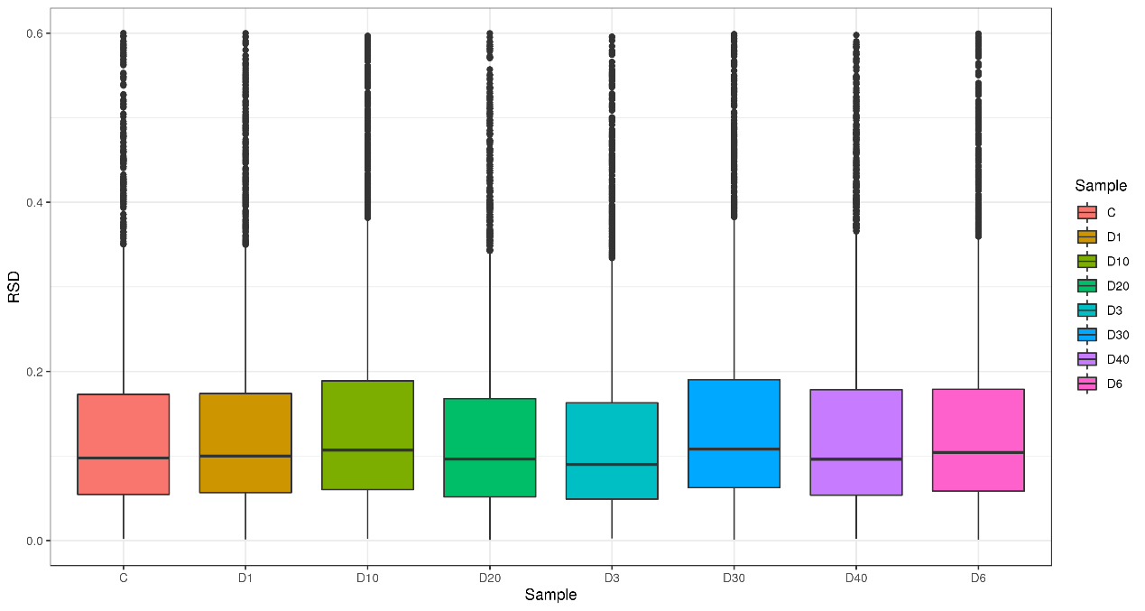
Figure 3 The boxplot of relative standard deviation (RSD) of quantitative protein values between repeated samples. The smaller the overall RSD value was, the better the quantitative repeatability was.

Table 1 The list of differentially expressed protein between D3 and D40.
Protein accession | Gene name | D40/D3 Ratio | D40/D3 P value | Regulated Type
Q9WTM5 | Ruvbl2 | 1.5011 | 0.000603 | Up
Q9ERD7 | Tubb3 | 1.5484 | 0.012486 | Up
E9PZQ0 | Ryr1 | 1.7499 | 0.014099 | Up
Q9D6F9 | Tubb4a | 1.5122 | 0.041573 | Up
Q8R0X7 | Sgpl1 | 1.7386 | 0.016432 | Up
Q7TQ48 | Srl | 1.5355 | 0.00967 | Up
Q9CXW2 | Mrps22 | 2.14 | 0.021276 | Up
Q8BIJ7 | Rufy1 | 1.7097 | 0.025988 | Up
Q9WTX2 | Prkra | 1.5385 | 0.007259 | Up
Q8BWF0 | Aldh5a1 | 1.6601 | 0.002236 | Up
P97443 | Smyd1 | 1.6725 | 0.004187 | Up
Q91WQ3 | Yars1 | 1.9765 | 0.042384 | Up
Q8BYH7 | Tbc1d17 | 1.632 | 0.009079 | Up
Q921E2 | Rab31 | 1.5036 | 0.005008 | Up
Q8VCI5 | Pex19 | 1.521 | 0.000753 | Up
Q91VS7 | Mgst1 | 1.5074 | 0.037067 | Up
Q9QYR6 | Map1a | 1.6394 | 0.047135 | Up
Q9JJW5 | Myoz2 | 2.5433 | 0.033898 | Up
P70245 | Ebp | 3.0881 | 2.16E-06 | Up
P04247 | Mb | 2.665 | 0.001956 | Up
P58774 | Tpm2 | 1.5285 | 0.021431 | Up
Q8VDQ8 | Sirt2 | 3.0786 | 0.00355 | Up
P13542 | Myh8 | 1.7057 | 0.009016 | Up
P08551 | Nefl | 8.3056 | 0.001167 | Up
P32848 | Pvalb | 1.8874 | 0.010178 | Up
O35593 | Psmd14 | 1.8107 | 0.023083 | Up
P11404 | Fabp3 | 1.5188 | 0.004722 | Up
Q62082 | Myl10 | 2.8475 | 0.005889 | Up
Q8K183 | Pdxk | 2.3459 | 0.01158 | Up
Q91VF2 | Hnmt | 1.8679 | 0.02697 | Up
Q8R366 | Igsf8 | 1.5216 | 0.002466 | Up
Q9JHK4 | Rabggta | 1.6289 | 0.024567 | Up
Q9WVB6 | Lenep | 1.7766 | 0.001258 | Up
Q5FW53 | Mybphl | 1.7688 | 0.011778 | Up
P60202 | Plp1 | 34.5765 | 0.000326 | Up
Q62234 | Myom1 | 1.6102 | 0.008387 | Up
P06330 | -- | 1.5425 | 0.024865 | Up
Q9D2P8 | Mobp | 4.0202 | 0.013533 | Up
P03995 | Gfap | 8.4643 | 0.002603 | Up
P20917 | Mag | 20.729 | 0.001348 | Up
Q8CI43 | Myl6b | 1.5196 | 0.000811 | Up
Q9D023 | Mpc2 | 1.6923 | 0.02302 | Up
Q6PIE5 | Atp1a2 | 1.7026 | 0.006102 | Up
Q91ZP9 | Necab2 | 4.2398 | 0.000116 | Up
Q9DC51 | Gnai3 | 1.6515 | 0.038473 | Up
P70232 | Chl1 | 1.5092 | 0.048262 | Up
P13541 | Myh3 | 1.9336 | 0.00149 | Up
O70622 | Rtn2 | 1.8357 | 0.003731 | Up
Q9DB60 | Prxl2b | 1.5364 | 0.006003 | Up
Q5XKE0 | Mybpc2 | 1.8185 | 0.001952 | Up
Q08642 | Padi2 | 1.6685 | 0.004516 | Up
P11438 | Lamp1 | 1.5211 | 0.010252 | Up
Q61885 | Mog | 6.5762 | 0.003294 | Up
P19246 | Nefh | 2.5191 | 0.014166 | Up
P08553 | Nefm | 4.2107 | 0.002009 | Up
P27573 | Mpz | 1.582 | 0.031113 | Up
A2ABU4 | Myom3 | 1.5354 | 0.030231 | Up
P28650 | Adss1 | 2.0534 | 0.023468 | Up
A2AAJ9 | Obscn | 1.5133 | 0.046195 | Up
Q6P3A8 | Bckdhb | 2.8034 | 0.000178 | Up
Q9CR61 | Ndufb7 | 2.1051 | 0.044916 | Up
P04370 | Mbp | 165.9737 | 0.000221 | Up
Q8K296 | Mtmr3 | 1.6992 | 0.017035 | Up
Q6P8J7 | Ckmt2 | 1.7252 | 0.00164 | Up
Q9CZX0 | Elp3 | 1.6322 | 0.001455 | Up
Q8R429 | Atp2a1 | 1.5367 | 0.005019 | Up
Q99KN9 | Clint1 | 2.7851 | 0.003208 | Up
Q9JLB0 | Mpp6 | 6.0653 | 0.002908 | Up
Q8CG85 | Mamdc2 | 1.742 | 0.022615 | Up
P17156 | Hspa2 | 3.2816 | 0.003761 | Up
Q8CIX8 | Lgsn | 1.6253 | 0.000951 | Up
Q9JI91 | Actn2 | 1.5178 | 0.000784 | Up
Q8K1F9 | Lctl | 1.5239 | 8.03E-05 | Up
O09172 | Gclm | 1.5197 | 0.038395 | Up
Q9CRY7 | Gdpd1 | 1.5153 | 0.024792 | Up
P35846 | Folr1 | 1.5121 | 0.002064 | Up
Q3UV17 | Krt76 | 1.9897 | 0.010125 | Up
P70295 | Aup1 | 1.5572 | 0.008549 | Up
Q8BYW9 | Eogt | 1.932 | 0.009312 | Up
Q61133 | Gstt2 | 1.6508 | 0.00804 | Up
Q640R3 | Hepacam | 5.3054 | 0.027483 | Up
Q8BZJ7 | Dcun1d2 | 3.6923 | 0.000613 | Up
Q9QXC1 | Fetub | 3.2293 | 0.036487 | Up
P35505 | Fah | 1.5006 | 0.012433 | Up
P21550 | Eno3 | 1.5069 | 0.003857 | Up
Q9CQB5 | Cisd2 | 1.7593 | 0.000222 | Up
P61963 | Dcaf7 | 2.012 | 0.000159 | Up
P46660 | Ina | 2.871 | 0.01577 | Up
P04186 | Cfb | 1.7503 | 0.026678 | Up
Q924X2 | Cpt1b | 1.5178 | 0.003605 | Up
Q8JZQ2 | Afg3l2 | 4.3612 | 0.004282 | Up
O09161 | Casq2 | 1.922 | 0.003907 | Up
P16330 | Cnp | 41.8837 | 0.000214 | Up
Q6X893 | Slc44a1 | 5.5171 | 0.017815 | Up
Q9JHS9 | Cwc15 | 1.7174 | 0.019571 | Up
P50114 | S100b | 1.9018 | 0.003077 | Up
Q9CYN9 | Atp6ap2 | 0.5963 | 0.001164 | Down
Q9QYA2 | Tomm40 | 0.523 | 0.009661 | Down
Q91XB0 | Trex1 | 0.6535 | 0.039531 | Down
P62996 | Tra2b | 0.6004 | 0.028691 | Down
Q9WV80 | Snx1 | 0.4889 | 0.000419 | Down
Q80U72 | Scrib | 0.5771 | 0.043119 | Down
P35441 | Thbs1 | 0.5367 | 0.005347 | Down
Q8K480 | Mfrp | 0.65 | 0.039129 | Down
P97434 | Mprip | 0.543 | 0.006698 | Down
P39654 | Alox15 | 0.486 | 0.044477 | Down
Q6PFR5 | Tra2a | 0.6539 | 0.046354 | Down
P83882 | Rpl36a | 0.636 | 0.001245 | Down
Q04750 | Top1 | 0.5657 | 0.003485 | Down
Q91YN5 | Uap1 | 0.5693 | 0.040738 | Down
Q4VA53 | Pds5b | 0.662 | 0.020251 | Down
O55125 | Nipsnap1 | 0.6359 | 0.000893 | Down
Q9CQ02 | Commd4 | 0.6524 | 0.047797 | Down
P14901 | Hmox1 | 0.5841 | 0.035645 | Down
P51880 | Fabp7 | 0.4177 | 0.011881 | Down
Q9D1H9 | Mfap4 | 0.5977 | 0.006352 | Down
Q9Z331 | Krt6b | 0.6475 | 0.002798 | Down
Q60675 | Lama2 | 0.6362 | 0.003842 | Down
Q8JZM8 | Muc4 | 0.6261 | 0.029837 | Down
Q61749 | Eif2b4 | 0.5535 | 0.026759 | Down
Q3UVK0 | Ermp1 | 0.5962 | 0.027251 | Down
Q61830 | Mrc1 | 0.4898 | 0.002416 | Down
P70414 | Slc8a1 | 0.491 | 0.01386 | Down
O54974 | Lgals7 | 0.4378 | 0.003763 | Down
P63158 | Hmgb1 | 0.6433 | 0.01302 | Down
Q9Z110 | Aldh18a1 | 0.3222 | 0.013793 | Down
Q9CRC8 | Lrrc40 | 0.5081 | 0.004078 | Down
Q62087 | Pon3 | 0.6573 | 0.044342 | Down
Q8K4Z5 | Sf3a1 | 0.6535 | 0.011602 | Down
Q99J08 | Sec14l2 | 0.4679 | 0.047185 | Down
Q8R5J9 | Arl6ip5 | 0.6367 | 0.016628 | Down
P19253 | Rpl13a | 0.6304 | 0.041912 | Down
P52430 | Pon1 | 0.5768 | 0.001091 | Down
Q9EPU0 | Upf1 | 0.6641 | 0.018464 | Down
Q924M7 | Mpi | 0.0134 | 3.33E-06 | Down
Q9JJI8 | Rpl38 | 0.558 | 0.039928 | Down
Q9DAX2 | Plpp2 | 0.449 | 0.020322 | Down
O70572 | Smpd2 | 0.5016 | 0.040123 | Down
P99027 | Rplp2 | 0.6195 | 0.00373 | Down
Q05186 | Rcn1 | 0.6061 | 0.000887 | Down
Q8R0G9 | Nup133 | 0.6276 | 0.039935 | Down
O54990 | Prom1 | 0.5731 | 0.022617 | Down
Q1RNF8 | Samd11 | 0.4955 | 0.000326 | Down
P08074 | Cbr2 | 0.3187 | 0.003456 | Down
Q9CZD3 | Gars1 | 0.1181 | 9.32E-07 | Down
O35345 | Kpna6 | 0.6461 | 0.017401 | Down
P70444 | Bid | 0.5608 | 0.007785 | Down
Q9Z277 | Baz1b | 0.3966 | 0.038239 | Down
P43276 | H1-5 | 0.5474 | 0.014274 | Down
Q9QXA5 | Lsm4 | 0.5156 | 0.047993 | Down
Q61781 | Krt14 | 0.6386 | 0.005815 | Down
P43274 | H1-4 | 0.5418 | 0.003281 | Down
Q6ZPY7 | Kdm3b | 0.6539 | 0.04013 | Down
Q61739 | Itga6 | 0.6351 | 0.018292 | Down
Q8BGF6 | Elmod2 | 0.6572 | 0.007329 | Down
P43275 | H1-1 | 0.4776 | 0.00132 | Down
Q6ZQ88 | Kdm1a | 0.5851 | 0.045696 | Down
Q64378 | Fkbp5 | 0.6582 | 0.005657 | Down
Q99LJ6 | Gpx7 | 0.6513 | 0.012682 | Down
P10922 | H1-0 | 0.6388 | 0.000638 | Down
P23198 | Cbx3 | 0.5739 | 0.043106 | Down
Q8C6K9 | Col6a6 | 0.4552 | 0.030494 | Down
Q9ESU6 | Brd4 | 0.6525 | 0.041855 | Down
P63037 | Dnaja1 | 0.6297 | 0.015467 | Down
Q80X19 | Col14a1 | 0.6225 | 0.000743 | Down
Q09PK2 | Asprv1 | 0.5482 | 0.017088 | Down
Q9EPU4 | Cpsf1 | 0.5799 | 0.002369 | Down
P59017 | Bcl2l13 | 0.4514 | 0.029444 | Down
Q3UQ28 | Pxdn | 0.4645 | 0.024188 | Down
Q8BH04 | Pck2 | 0.6382 | 0.003683 | Down

