Supplementary Table 1. Patient characteristics according to metastatic burden

Variables | Extensive metastasis  (≥5 lesions) (n=51) |  |  | Oligometastasis  (<5 lesions) (n=7) |  | p value
Variables | Number of patients (%) |  |  |  |  | p value
Age (years) | Median 60  (range, 29-84) |  |  | Median 49  (range, 42-68) |  | 0.351
Sex |  |  |  |  |  | 0.411
Male | 48 (94.4) |  |  | 6 (85.7)
Female | 3 (5.9) |  |  | 1 (14.3)
HCC etiology |  |  |  |  |  | 0.805
B-viral | 48 (94.1) |  |  | 7 (100)
C-viral | 2 (3.9) |  |  | 0 (0)
Others | 1 (2.0) |  |  | 0 (0)
Liver cirrhosis |  |  |  |  |  | 0.123
Yes | 42 (82.4) |  |  | 4 (57.1)
No | 9 (17.6) |  |  | 3 (42.9)
Child-Pugh grade |  |  |  |  |  | 0.814
A | 30 (58.8) |  |  | 5 (71.4)
B | 11 (21.6) |  |  | 1 (14.3)
C | 10 (19.6) |  |  | 1 (14.3)
Time interval between initial HCC diagnosis and SBM (months) | Median 15.5  (range, 0-140) |  |  | Median 24  (range, 2-45) |  | 0.428
Tumor size  (cm, in longest diameter) | Median 3.3  (range, 1.1-7.9) |  |  | Median 2.6  (range, 1.5-3.5) |  | 0.447
AFP (ng/ml) | Median 521.2  (range, 2.58-149,211) |  |  | Median 359.35  (range, 4.3-100,000) |  | 0.493
PIVKA-II (mAU/ml) | Median 2000  (range, 17-75,000) |  |  | Median 3156  (range, 131-59,021) |  | 0.101
Status of primary liver tumor |  |  |  |  |  | 0.347
PD | 34 (66.7) |  |  | 3 (42.9)
SD | 12 (23.5) |  |  | 2 (28.6)
PR | 1 (2.0) |  |  | 0 (0)
CR | 4 (7.8) |  |  | 2 (28.6)
8th AJCC stage of primary tumor |  |  |  |  |  | 0.85
T0N0 | 4 (7.8) |  |  | 2 (28.6)
T1N0 | 4 (7.8) |  |  | 1 (14.3)
T2N0 | 4 (7.8) |  |  | 1 (14.3)
T3aN0 | 1 (2.0) |  |  | 0 (0)
T3bN0 | 13 (25.5) |  |  | 2 (28.6)
T4N0 | 0 (0) |  |  | 0 (0)
N1 | 25 (49.0) |  |  | 1 (14.3)
*Abbreviations: HCC, hepatocellular carcinoma; AFP, alpha-feto protein; PIVKA-II, prothrombin-induced by vitamin K absence or antagonist-II; PD, progressive disease; SD, stable disease; PR, partial response; CR, complete response, AJCC; American Joint Committee on Cacner

Supplementary Table 2. Patient characteristics according to the BED
Variables | BED ≥ 50Gy (n=21) | BED < 50Gy  (n=18) | No RT (n=19) |  | p value
Variables | No of patients (%)
Age (years) | Median 61  (range, 32-84) | Median 56  (range, 29-73) |  | Median 60, (range, 45-72) | 0.726†
Sex |  |  |  |  | 0.148
Male | 20 (95.2) | 18 (100) |  | 16 (84.2)
Female | 1 (4.8) | 0 (0) |  | 3 (15.8)
HCC etiology |  |  |  |  | 0.575
B-viral | 20 (95.2) | 17 (94.5) |  | 18 (94.7)
C-viral | 0 (0) | 1 (5.5) |  | 1 (5.3)
Others | 1 (4.8) | 0 (0) |  | 0 (0)
Liver cirrhosis |  |  |  |  | 0.97
Yes | 17 (81.0) | 14 (77.8) |  | 15 (78.9)
No | 4 (19.0) | 4 (22.2) |  | 4 (21.1)
Child-Pugh grade |  |  |  |  | 0.107
A | 17 (76.2) | 9 (50.0) |  | 9 (47.4)
B | 2 (14.3) | 6 (33.3) |  | 4 (21.1)
C | 2 (9.5) | 3 (16.7) |  | 6 (31.6)
Metastatic burden |  |  |  |  | 0.118
Oligometastasis  (<5 lesions) | 5 (23.8) | 1 (5.5) |  | 1 (5.3)
Extensive metastasis  (≥5 lesions) | 16 (76.2) | 17 (94.5) |  | 18 (94.7)
Time interval between initial HCC diagnosis and SBM (months) | Median 21  (range, 0-92) | Median 10  (range, 0-104) |  | Median 38  (range, 0-140) | 0.111†
Tumor size (cm, in longest diameter) | Median 3.4 (range, 1.5-5.5) | Median 3.3  (range, 1.9-5.0) |  | Median 2.8 (range, 1.1-7.9) | 0.557†
AFP (ng/ml) | Median 271.96 (range, 3.49-100,000) | Median 1524.76 (range, 2.58-120,000) |  | Median 573.3 (range, 2.94-149,211.42) | 0.958†
PIVKA-II (mAU/ml) | Median 2000 (range, 94-75,000) | Median 2000 (range, 21-75,000) |  | Median 2000 (range, 17-75,000) | 0.759†
Status of primary liver tumor |  |  |  |  | 0.796
PD | 13 (61.9) | 13 (72.2) |  | 11 (57.9)
SD | 5 (23.8) | 4 (22.2) |  | 5 (26.3)
PR | 1 (4.8) | 0 (0) |  | 0 (0)
CR | 2 (9.5) | 1 (5.5) |  | 3 (15.8)
8th AJCC stage of primary tumor |  |  |  |  | 0.284
T0N0 | 2 (9.5) | 1 (5.5) |  | 3 (15.8)
T1N0 | 0 (0) | 2 (11.1) |  | 3 (15.8)
T2N0 | 2 (9.5) | 0 (0) |  | 3 (15.8)
T3aN0 | 0 (0) | 1 (5.5) |  | 0 (0)
T3bN0 | 6 (28.6) | 4 (22.2) |  | 5 (26.3)
T4N0 | 0 (0) | 0 (0) |  | 0 (0)
N1 | 11 (52.4) | 10 (55.6) |  | 5 (26.3)
*Abbreviations: BED, biologically effective dose; HCC, hepatocellular carcinoma; SBM, skull base metastasis; AFP, alpha-feto protein; PIVKA-II, prothrombin-induced by vitamin K absence or antagonist-II; PD, progressive disease; SD, stable disease; PR, partial response; CR, complete response, AJCC; American Joint Committee on Cacner
†For numerical variables, one-way analysis of variance (ANOVA) method was used to compare means across 3 groups. P value for each variables was calculated after Levene’s test for equality of variances.

Supplementary Table 3. Treatment characteristics and response rates according to metastatic burden

Variables | Extensive metastasis  (≥5 lesions) |  |  | Oligometastasis  (< 5 lesions) |  | p value
Variables | No. of patients (%) |  |  |  |  | p value
Treatments for SBM |  |  |  |  |  | 0.403
RT alone | 24 (47.1) |  |  | 4 (57.1)
RT + Systemic agents | 6 (11.8) |  |  | 2 (28.6)
Surgery + RT | 3 (5.9) |  |  | 0 (0)
Systemic agent alone | 4 (7.8) |  |  | 1 (14.3)
None | 14 (27.5) |  |  | 0 (0)
RT modality |  |  |  |  |  | 0.631
Conventional RT  (fx size <5 Gy) | 18 (54.5) |  |  | 2 (33.3)
Hypofractionated RT or stereotactic radiosurgery  (fx size ≥5 Gy) | 11 (33.3) |  |  | 3 (50.0)
Gamma knife surgery | 4 (12.1) |  |  | 1 (16.7)
RT dose (Gy) | Median 30  (range, 9-60) |  |  | Median 52  (range, 27-60) |  | 0.476
RT dose in BED (Gy) | Median 45.6  (range, 28-150.0) |  |  | Median 78  (range, 39-99.9) |  | 0.213
Fraction number | Median 10  (range, 1-15) |  |  | Median 10  (range, 1-20) |  | 0.651
Local response  (1 month after RT) |  |  |  |  |  | 0.709
CR/PR/SD | 15 (62.5) |  |  | 4 (66.7)
PD | 9 (37.5) |  |  | 2 (33.3)
Local treatment for viable primary liver tumor |  |  |  |  |  | 0.123
None | 42 (82.4) |  |  | 4 (66.7)
TACE | 5 (9.8) |  |  | 2 (33.3)
RT | 4 (7.8) |  |  | 1 (16.7)
*Abbreviations: SBM, skull base metastasis; RT, radiation therapy; fx, fraction; SRS, stereotactic radiosurgery; BED, biologically effective dose; CR, complete response; PR, partial response; SD, stable disease; PD, progressive disease

Supplementary figure 1. Survival analysis according to BED among patients who received radiation therapy; (a) in the full metastasis group and (b) in the oligometastasis group.
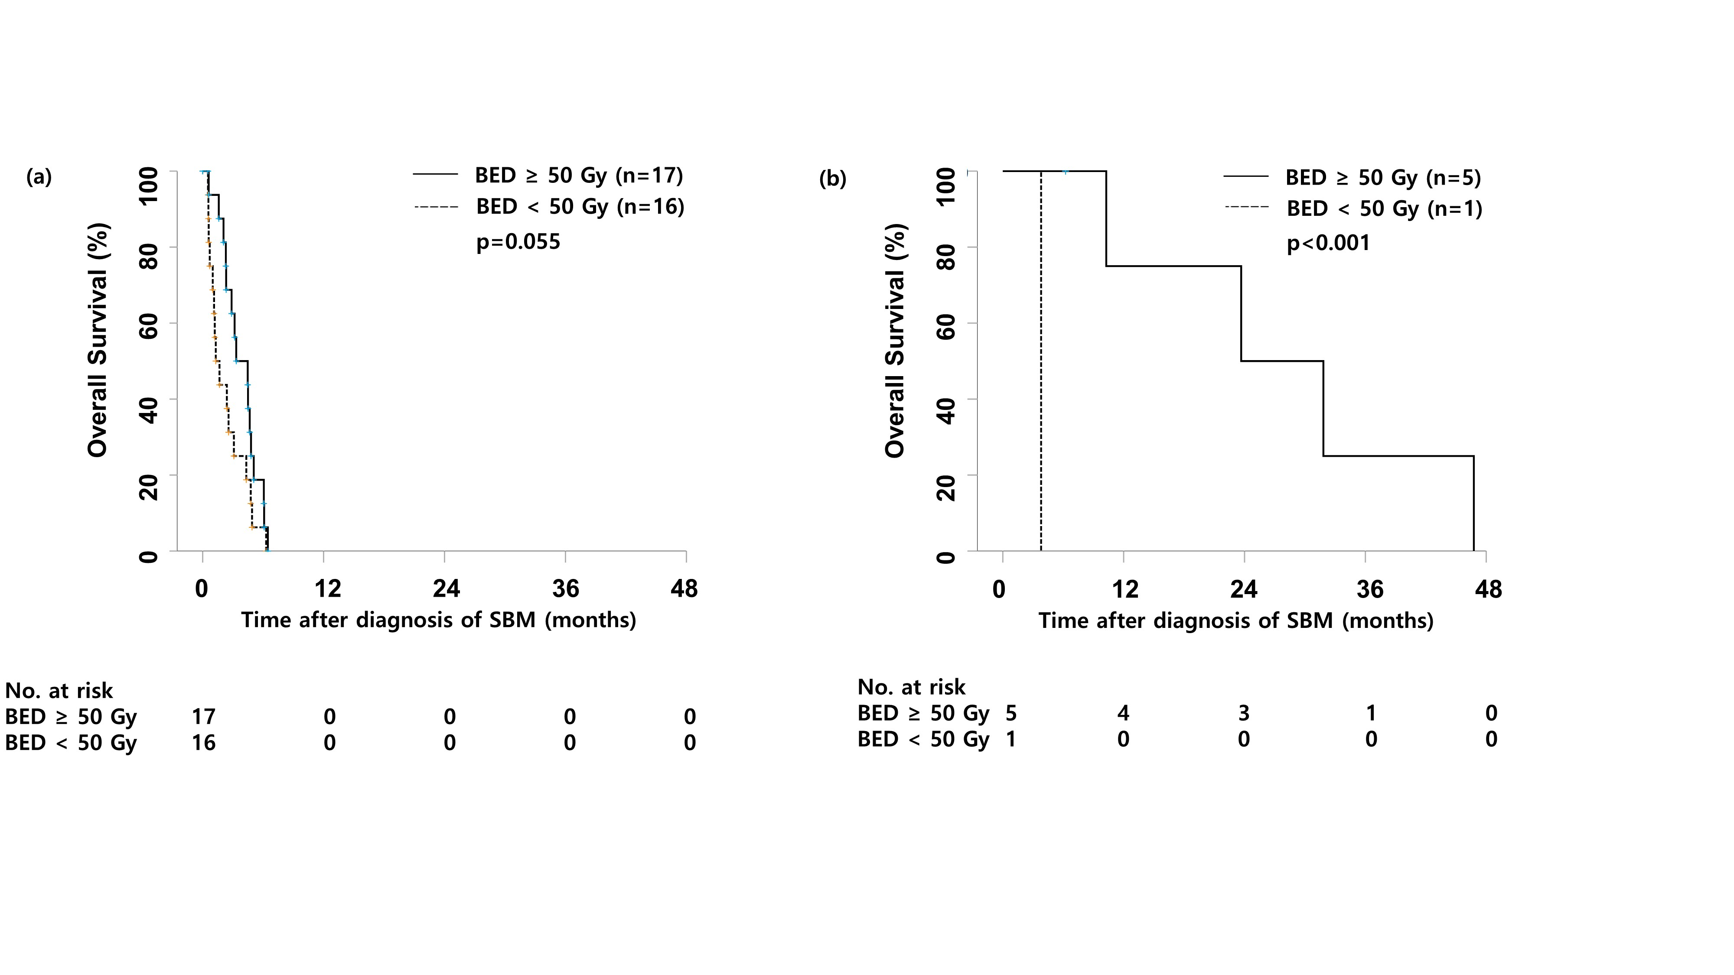
*Abbreviation: BED, biologically effective dose; SBM, skull base metastasis

