SUPPLEMENTARY MATERIALS
Contents
Appendix A: Search strategy for the collection of published data 2
Appendix B: Phase 1 interviews discussion guide 3
Appendix C: Phase 2 interview discussion guide 9
Appendix D: Thematic analysis – predetermined coding framework 13
Appendix E: Country and profession of interviewed health care professionals (HCPs) 15
Appendix F: Examples of the collected quantitative data from published sources found in the evidenced care pathways 16
REFERENCES 18
Appendix G: Overview of the Evidenced Care Pathway for COPD in Japan 21
References for Japan 22
Appendix H: Overview of the Evidenced Care Pathway for COPD in Canada 23
References for Canada 24
Appendix I: Overview of the Evidenced Care Pathway for COPD in England 25
References for England 26
Appendix J: Overview of the evidenced care pathway for COPD in Germany 28
References for Germany 29
Appendix K: Additional qualitative evidence to support results of thematic analysis 31

Appendix A: Search strategy for the collection of published data
PubMed and grey literature (conference abstracts, HTA reports, publicly available national databases reporting on COPD outcomes) were searched, and reference lists of relevant papers were reviewed.
Search terms:
- COPD OR chronic obstructive pulmonary disease AND [country]
- “COPD patient pathway” AND [country]
- COPD OR chronic obstructive pulmonary disease AND “clinical care” AND [country]
- COPD OR chronic obstructive pulmonary disease AND management AND [country]
- COPD OR chronic obstructive pulmonary disease AND economic AND [country]

Appendix B: Phase 1 interviews discussion guide
The aim of the phase 1 interviews was to validate and fill knowledge gaps in the detailed visual representation of the COPD care pathway that had been developed based on the GOLD recommendations ¹, national guidelines ^{2–5} and information collected from the literature review. Interviews were conducted in English using the videoconferencing software Microsoft Teams. An interpreter was used when required. Participants were shown the COPD care pathway using Whimsical, a web-based visualization application with an infinite canvas (www.whimsical.com), or Microsoft PowerPoint and asked to critically appraise both the pathway steps and supporting quantitative data.
Semi-structured interviews were conducted following the interview topic guide shown in Table 1. The interviewing followed an iterative process; amending questions in the discussion guide to capture new themes and refine the pathway. The questions listed in the topic guide are non-exhaustive i.e., other follow up questions were asked depending on participants answers. Not every question was asked in every country. To note: due to time constraints, on average, 2 out of the 3 pathway sections (pre-diagnosis, diagnosis, and treatment and management) were covered per interview.

Table 1 Phase 1 Interview topic guide
Topic | Questions | Prompt
1. Introductions/background | Brief introductions (including the interpreter); get verbal consent to record the interview; remind interviewee about the aims of the study and their role in the interview; check the length of the interview
2. Context setting | Can you describe your relevant background in respiratory medicine? And in COPD particularly? | Roles  Patient groups treated  Research  Length of time
What are the main issues in the status or provision of treatment of COPD in [country]?
What impact do you think COVID-19 will have on the future pathway and management of COPD in [country]?
3. Pathway overview [start presenting pathway on-screen] | What do you see as the main issues or blocks in terms of diagnosing/treating COPD? Discuss some of the underlying causes of this
 | What data is there to support this?
4. Detailed pathways [questions to ask in each pathway section] | Who is giving care?  Is the patient flow correct?  What are the timelines between each step?  Have we missed any steps?  Where do you think COVID-19 will have the most impact? | Spirometry
 | Are there any points in the pathway where the delivery of care varies hugely from the recommendations? | GOLD  National
5. Pre-diagnosis | Do many patients present with an exacerbation-like event before they have a diagnosis?  Before the diagnosis of COPD, are there missed opportunities for diagnosis?  What triggers a patient to seek/receive a diagnosis?  Is it common for exacerbations to be the first symptom of COPD in a patient? (e.g., before diagnosis)
6. Diagnosis | How long does it take for a patient to receive a diagnosis once they have presented to healthcare?  Where are most people diagnosed? At GP or specialist?  Do you use spirometry to confirm a COPD diagnosis?  If spirometry is not used, what do you use to assess for a COPD diagnosis?  Is spirometry included in the regular check-ups?  How often are patients referred to a specialist during diagnosis?  How long does it take for a referral by the GP for the patient to see the specialist?  Do specialists re-take all diagnosis procedures once a patient is referred?  Do you use the GOLD A-D groups to assess severity?  Do you use the IPAG, mMRC or CAT to assess symptoms burden?
7. Treatment and management | How often do you review and follow up with patients?  Do you change the treatment plan at a follow-up?  What tests do you do at a follow-up? Are these the same as used for diagnosis?  What member of staff conducts routine follow-ups?  How long is a follow-up appointment?  Do your patients follow their management plans?  Do most patients see GP or specialist for their management plan?  How long is a new patient appointment?  What treatments do you commonly prescribe?  Do you use non-pharmacological treatments? If yes, what services do you generally use in treatment? E.g., smoking cessation, pedometer, pulmonary rehab  How often do you do inhaler checks?
8. Exacerbations | What is the rate of readmissions for exacerbations?  Would a patient's treatment plan be adapted in the hospital or are they referred back to their GP/specialist?  Do patients receive support when they are discharged home?  Where do patients present for an exacerbation? E.g., ED/outpatient/hospital  What care do they receive during an exacerbation? E.g., antibiotics or steroids  What tests are used to assess patients in the ED/outpatient/hospital?  How long do patients stay at the ED before being admitted or discharged?  How long do patients stay at the hospital when admitted?  Do many patients manage their exacerbations at home?
9. Ending [summarize the issues/barriers they have identified] | Do you have anything else to add, any comments or any questions?
Abbreviations: GOLD, Global Initiative for Chronic Obstructive Lung Disease; ED, emergency department; GP, general practitioner; IPAG, International Primary Care Airways Guidelines; mMRC, Modified Medical Research Council Dyspnea Scale; CAT, COPD Assessment Test

Appendix C: Phase 2 interview discussion guide
The aims of the phase two interviews were to 1) validate the pathways developed in phase one, and 2) validate the identified barriers to optimal COPD care from phase one, as well as highlight additional ones. Interviews were conducted in English using the videoconferencing software Microsoft Teams. An interpreter was used when required. Participants were shown the COPD care pathway using Microsoft PowerPoint and asked to critically appraise both the pathway steps and identified barriers in phase one.
Semi-structured interviews were conducted following the interview topic guide shown in Table 2, refined from the phase one topic guide. The interviewing followed an iterative process; amending questions in the discussion guide to capture new themes and refine the pathway. The questions listed in the topic guide are non-exhaustive i.e., other follow up questions were asked depending on participants answers. Not every question was asked in every country. To note: due to time constraints, on average, 2 out of the 3 pathway sections (pre-diagnosis, diagnosis, and treatment and management) were covered per interview.

Table 2 Phase 2 Interview topic guide
Topic | Questions | Prompt
1. Introductions/background | Brief introductions (including the interpreter); get verbal consent to record the interview; remind interviewee about the aims of the study and their role in the interview; check the length of the interview | Highlight that the PowerPoint pathway is formatted and looks ‘designed’ but they should not assume that they are complete or correct
2. Context setting | Can you describe your relevant background in respiratory medicine? And in COPD particularly? | Roles  Patient groups treated  Research  Length of time
What are the main issues in the status or provision of treatment of COPD in [country]? What are the underlying causes? What possible solutions are there?
What impact do you think COVID-19 will have on the future pathway and management of COPD in [country]?
3. Detailed pathways [questions to ask in each pathway section] | Does the pathway look correct to you? Have we missed any steps? | Who  Where
 | Where do you think COVID-19 will have the most impact? | Spirometry
 | Are there any points in the pathway where the delivery of care varies hugely from the recommendations? | GOLD  National
4. Pre-diagnosis | See Table 1 – any questions not covered in phase 1; further probes into questions with contradictory responses in phase 1
5. Diagnosis | See Table 1 – any questions not covered in phase 1; further probes into questions with contradictory responses in phase 1
6. Treatment and management | See Table 1 – any questions not covered in phase 1; further probes into questions with contradictory responses in phase 1
7. Exacerbations | See Table 1 – any questions not covered in phase 1; further probes into questions with contradictory responses in phase 1
8. Reaction to our identified barriers and opportunities | How do you feel about them?  Is there anything surprising?  Is there anything obvious missing?
9. Ending [summarize the issues/barriers they have identified] | Do you have anything else to add, any comments or any questions?
Abbreviation: GOLD, Global Initiative for Chronic Obstructive Lung Disease

Appendix D: Thematic analysis – predetermined coding framework
Topic | Question
Pre-diagnosis | Missed opportunities for diagnosis  Symptoms & risk factors driving patients to present  Smoking  Breathlessness  First presentation to healthcare (primary care)  First presentation to emergency care  Length of time to diagnosis  Number of presentations patients typically have before diagnosis is made
Diagnosis | Diagnostic tests  Overdiagnosis/underdiagnosis/misdiagnosis
Treatment and management | Initial treatment plan  Pharmacological  Non-pharmacological  Smoking cessation  Vaccinations  Education (breathing exercises, diet, inhaler technique/adherence checks)  Oxygen therapy  Pulmonary rehab  Palliative care  Treatment review and adjustment  Different types of healthcare professionals involved
Exacerbations | COPD action plan  Reporting of exacerbations  Presentation to healthcare (primary care)  Presentation to emergency care  Hospitalization  Discharge  Follow up after exacerbation
Awareness | HCPs awareness of COPD in general  Patients lack awareness of COPD as a disease  Language  Terms used to describe COPD are difficult to understand  English terminology does not translate well across languages
COVID-19
Abbreviations: COPD, chronic obstructive pulmonary disease; HCPs, health care professionals.

Appendix E: Country and profession of interviewed health care professionals (HCPs)
Characteristics | England |  | Canada |  | Germany |  | Japan |  | Total
Characteristics | Phase 1 | Phase 2 | Phase 1 | Phase 2 | Phase 1 | Phase 2 | Phase 1 | Phase 2 | Total
GP | 1 | 1 | 1 |  |  |  |  |  | 3
Respiratory specialist | 1 | 2 | 3 | 1 | 1 | 5 | 2 | 3 | 18
Non-respiratory specialist |  |  |  |  |  |  |  | 1 | 1
Respiratory nurse consultant |  | 1 |  |  |  |  |  |  | 1
Respiratory therapist |  |  |  | 1 |  |  |  |  | 1
Total | 2 | 4 | 4 | 2 | 1 | 5 | 2 | 4 | 24
Abbreviation: GP, general practitioners.
Note: Due to low numbers of participants in phase one from Germany, two additional phase one interviews were conducted in phase two.

Appendix F: Examples of the collected quantitative data from published sources found in the evidenced care pathways
 | Japan | Canada | England | Germany
Undiagnosed patients | - | Almost 80% of patients are undiagnosed ⁶ | 10-34% (13,000-16,250) COPD admissions a year are in people who have not been previously diagnosed.^{7,8} | 50 - 81% of COPD patients are undiagnosed.^{9–11}
Spirometry | 42% of GPs possessed a spirometer but only 32% considered pulmonary function tests to be important.¹² | 56% of physician diagnosed COPD is confirmed with spirometry in primary care.¹³ | 81% of diagnoses are confirmed with spirometry.¹⁴ | 40% of primary care physicians conduct adequate spirometry for COPD.¹⁵
Pulmonary rehabilitation programs | 4-11% of patients attended PR programmes.¹⁶ | 0.4% of COPD patients in Canada have access to pulmonary rehab.¹⁷ | Exercise plans are used by around 50% of patients.¹⁸ | 17-34% of patients participate in pulmonary rehab.¹⁹
Percentage of patients mainly treated by general practitioner | 50% ⁷ | 90% ⁸ | - | -
Length of hospital stays (day) | 12-18 days ¹⁶ | 5-13.2 days ^{20–23} | 3-7 days ^{14,24,25} | 2-12 days ^{26–28}
Mean annual direct health care costs per patient | ¥351,681 to ¥522,420  (3,226 to 4,792 USD$) ^{7,16,29} | $4,147  (3,249 USD$)  ²⁰ | £2,211 (excluding exacerbations)  (2,822 USD$)³⁰ | €7,934  (9,247 USD$)³¹
COPD expenditure on inpatient care per patient | ¥43,914  (403 USD$)²⁹ | $9,074  (6,839 USD$)³² | £2,639  (3,369 USD$)³⁰ | €3,918  (4,567 USD$)³¹
Abbreviations: COPD, chronic obstructive pulmonary disease; GP, general practitioner.
Notes: All costs were inflated to 2019; for comparison across countries costs were also converted to 2019 USD$

REFERENCES
1. Global Initiative for Chronic Obstructive Lung Disease. Global Strategy for the Diagnosis, Management, and Prevention of Chronic Obstructive Pulmonary Disease: 2020 Report.
2. O’Donnell DE, Aaron S, Bourbeau J, et al. Canadian Thoracic Society recommendations for management of chronic obstructive pulmonary disease – 2007 update. 2007;14:28.
3. O’Donnell DE, Aaron S, Bourbeau J, et al. 26. Canadian Thoracic Society recommendations for management of chronic obstructive pulmonary disease – 2007 update. Can Respir J. 2007;14(Suppl B):5B-32B.
4. National Institute for Health and Care Excellence. Chronic Obstructive Pulmonary Disease in over 16s: Diagnosis and Management.; 2018. https://www.nice.org.uk/guidance/ng115
5. Japanese Respiratory Society. Guidelines for the Diagnosis and Treatment of COPD (Chronic Obstructive Pulmonary Disease) 3rd Edition: Pocket Guide.; 2010. https://www.jrs.or.jp/modules/english/index.php?content_id=15
6. Gershon AS, Thiruchelvam D, Chapman KR, et al. Health Services Burden of Undiagnosed and Overdiagnosed COPD. CHEST. 2018;153(6):1336-1346. doi:10.1016/j.chest.2018.01.038
7. Foo J, Landis SH, Maskell J, et al. Continuing to Confront COPD International Patient Survey: Economic Impact of COPD in 12 Countries. PLoS ONE. 2016;11(4):e0152618. doi:10.1371/journal.pone.0152618
8. Cho EE, Mecredy GC, Wong HH, Stanbrook MB, Gershon AS. Which Physicians Are Taking Care of People With COPD? CHEST. 2019;155(4):771-777. doi:10.1016/j.chest.2018.12.018
9. Lamprecht B, Soriano JB, Studnicka M, et al. Determinants of Underdiagnosis of COPD in National and International Surveys. Chest. 2015;148(4):971-985. doi:10.1378/chest.14-2535
10. Gingter C, Wilm S, Abholz HH. Is COPD a rare disease? Prevalence and identification rates in smokers aged 40 years and over within general practice in Germany. Family Practice. 2008;26(1):3-9. doi:10.1093/fampra/cmn084
11. Berghaus TM, Karschnia P, Haberl S, Schwaiblmair M. Disproportionate decline in admissions for exacerbated COPD during the COVID-19 pandemic. Respiratory Medicine. Published online August 2020:106120. doi:10.1016/j.rmed.2020.106120
12. Fukuchi Y, Nishimura M, Ichinose M, et al. COPD in Japan: the Nippon COPD Epidemiology study. Respirology. 2004;9(4):458-465. doi:10.1111/j.1440-1843.2004.00637.x
13. Bourbeau J, Sebaldt RJ, Day A, et al. Practice patterns in the management of chronic obstructive pulmonary disease in primary practice: The CAGE study. Can Respir J. 2008;15(1):13-19.
14. Public Health England. Inhale - INteractive Health Atlas of Lung conditions in England. Published 2019. Accessed September 30, 2021. https://fingertips.phe.org.uk/profile/inhale/data#page/0/gid/8000003/pat/46/par/E39000026/ati/165/are/E38000056/cid/4/page-options/ovw-do-0
15. Glaab T, Banik N, Singer C, Wencker M. Leitlinienkonforme ambulante COPD-Behandlung in Deutschland. Dtsch med Wochenschr. 2006;131(21):1203-1208. doi:10.1055/s-2006-941752
16. Igarashi A, Fukuchi Y, Hirata K, et al. COPD uncovered: a cross-sectional study to assess the socioeconomic burden of COPD in Japan. Int J Chron Obstruct Pulmon Dis. 2018;13:2629-2641. doi:10.2147/COPD.S167476
17. Camp PG, Hernandez P, Bourbeau J, et al. Pulmonary Rehabilitation in Canada: A Report from the Canadian Thoracic Society COPD Clinical Assembly. Canadian Respiratory Journal. 1900;22:369851. doi:10.1155/2015/369851
18. Khan A, Dickens AP, Adab P, Jordan RE. Self-management behaviour and support among primary care COPD patients: cross-sectional analysis of data from the Birmingham Chronic Obstructive Pulmonary Disease Cohort. npj Prim Care Resp Med. 2017;27(1):46. doi:10.1038/s41533-017-0046-6
19. Lutter JI, Lukas M, Schwarzkopf L, et al. Utilization and determinants of use of non-pharmacological interventions in COPD: Results of the COSYCONET cohort. Respiratory Medicine. 2020;171:106087. doi:10.1016/j.rmed.2020.106087
20. Maleki-Yazdi MR, Kelly SM, Lam SY, Marin M, Barbeau M, Walker V. The burden of illness in patients with moderate to severe chronic obstructive pulmonary disease in Canada. Can Respir J. 2012;19(5):319-324. doi:10.1155/2012/328460
21. FitzGerald JM, Haddon JM, Bradley-Kennedy C, Kuramoto L, Ford GT. Resource Use Study In COPD (RUSIC): A prospective study to quantify the effects of COPD exacerbations on health care resource use among COPD patients. Can Respir J. 2007;14(3):145-152.
22. Rowe BH, Villa‐Roel C, Guttman A, et al. Predictors of Hospital Admission for Chronic Obstructive Pulmonary Disease Exacerbations in Canadian Emergency Departments. Academic Emergency Medicine. 2009;16(4):316-324. doi:10.1111/j.1553-2712.2009.00366.x
23. Canadian Institute for Health Information. Hospital stays in Canada. Accessed July 29, 2020. https://www.cihi.ca/en/hospital-stays-in-canada
24. Harries TH, Thornton HV, Crichton S, Schofield P, Gilkes A, White PT. Length of stay of COPD hospital admissions between 2006 and 2010: a retrospective longitudinal study. Int J Chron Obstruct Pulmon Dis. 2015;10:603-611. doi:10.2147/COPD.S77092
25. Hurst J, McMillan V, Mortier K, et al. National Asthma and Chronic Obstructive Pulmonary Disease Audit Programme (NACAP). COPD Clinical Audit 2017/18 (People with COPD Exacerbations Discharged from Acute Hospitals in England and Wales between September 2017 and 2018. Data Analysis and Methodology Report. RCP; 2019. https://www.nacap.org.uk/nacap/welcome.nsf/vwFiles/NACAP-COPD-SC-202007/$File/NACAP_COPD_SC_Clinical_National_Report_2018_19_060720.pdf?openelement
26. Kirsch F, Schramm A, Schwarzkopf L, et al. Direct and indirect costs of COPD progression and its comorbidities in a structured disease management program: results from the LQ-DMP study. Respir Res. 2019;20. doi:10.1186/s12931-019-1179-7
27. Achelrod D, Schreyögg J, Stargardt T. Health-economic evaluation of home telemonitoring for COPD in Germany: evidence from a large population-based cohort. Eur J Health Econ. 2017;18(7):869-882. doi:10.1007/s10198-016-0834-x
28. Nowak D, Dietrich E, Oberender P, et al. Krankheitskosten von COPD in Deutschland. Pneumologie. 2004;58(12):837-844. doi:10.1055/s-2004-830143
29. Nishimura S, Zaher C. Cost impact of COPD in Japan: Opportunities and challenges? Respirology. 2004;9(4):466-473. doi:10.1111/j.1440-1843.2004.00617.x
30. Punekar YS, Shukla A, Müllerova H. COPD management costs according to the frequency of COPD exacerbations in UK primary care. Int J Chron Obstruct Pulmon Dis. 2014;9:65-73. doi:10.2147/COPD.S54417
31. Rehman A ur, Hassali MAA, Muhammad SA, Harun SN, Shah S, Abbas S. The economic burden of chronic obstructive pulmonary disease (COPD) in Europe: results from a systematic review of the literature. Eur J Health Econ. 2020;21(2):181-194. doi:10.1007/s10198-019-01119-1
32. Mittmann N, Kuramoto L, Seung SJ, Haddon JM, Bradley-Kennedy C, FitzGerald JM. The cost of moderate and severe COPD exacerbations to the Canadian healthcare system. Respiratory Medicine. 2008;102(3):413-421. doi:10.1016/j.rmed.2007.10.010

Appendix G: Overview of the Evidenced Care Pathway for COPD in Japan
Total cost: ¥815.5 billion per year.
The average annual total cost per patient for moderate/severe COPD is estimated to be ¥439,124. [6]
COPD is the 10th highest cause of death in Japan. [12]
18,577 died of COPD in 2018 (15.0 per 100,000). [21]
Treatment review and adjustment
Mortality
Return to
landing page
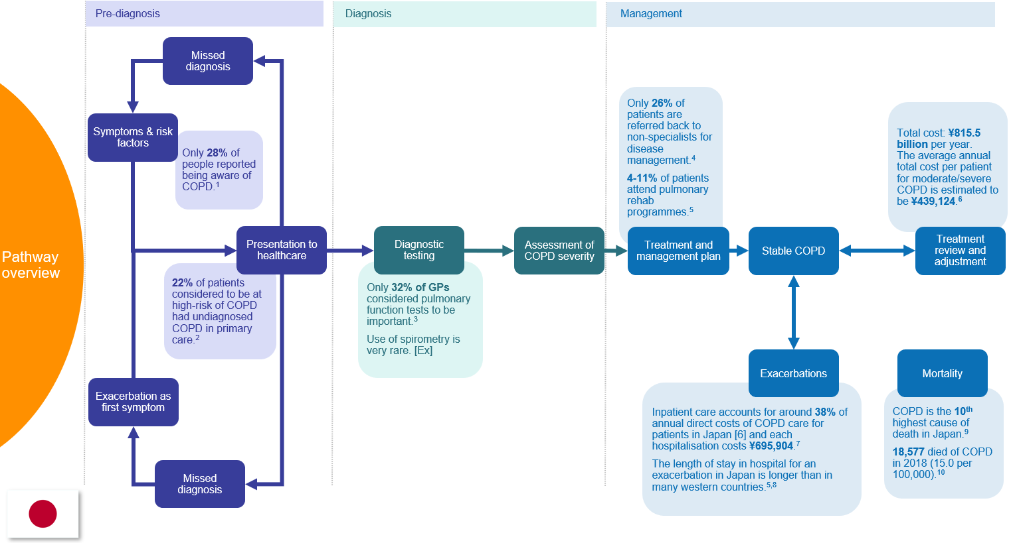
[Ex]: Sourced from an interview with a clinical expert for this project. Note: quotes might have been edited for length and clarity.
To access to full evidenced care pathway for Japan click here. All costs are adjusted to 2019 Japanese yen ¥.
Abbreviations: COPD, chronic obstructive pulmonary disease; GP, general practitioner.

References for Japan
1. GOLD Japan Committee. [COPD awareness survey]. Accessed August 24, 2021. http://www.gold-jac.jp/copd_facts_in_japan/copd_degree_of_recognition.html
2. Takahashi T, Ichinose M, Inoue H, Shirato K, Hattori T, Takishima T. Underdiagnosis and undertreatment of COPD in primary care settings. Respirology. 2003;8(4):504-508. doi:10.1046/j.1440-1843.2003.00501.x
3. Ryujin Y, Ogawa E, Nagao T, et al. Behavioral Changes in General Practitioners towards Chronic Obstructive Pulmonary Disease Over Five Years: An Observational Study. Internal Medicine. 2015;54(14):1705-1710. doi:10.2169/internalmedicine.54.4170
4. Motegi T, Yamada K, Ishii T, Gemma A, Kida K. Long-term management of chronic obstructive pulmonary disease: A survey of collaboration among physicians involved in pulmonary rehabilitation in Japan. Respiratory Investigation. 2012;50(3):98-103. doi:10.1016/j.resinv.2012.06.004
5. Igarashi A, Fukuchi Y, Hirata K, et al. COPD uncovered: a cross-sectional study to assess the socioeconomic burden of COPD in Japan. Int J Chron Obstruct Pulmon Dis. 2018;13:2629-2641. doi:10.2147/COPD.S167476
6. Nishimura S, Zaher C. Cost impact of COPD in Japan: Opportunities and challenges? Respirology. 2004;9(4):466-473. doi:10.1111/j.1440-1843.2004.00617.x
7. Motegi T, Yamada K, Kida K. [Cost analysis for inpatient therapy for patients with acute exacerbations of chronic obstructive pulmonary disease]. Nihon Kokyuki Gakkai Zasshi. 2006;44(11):787-794.
8. Nishimura K, Nakamura S, Kusunose M, et al. Comparison of patient-reported outcomes during acute exacerbations of chronic obstructive pulmonary disease. BMJ Open Respir Res. 2018;5(1). doi:10.1136/bmjresp-2018-000305
9. Nomura S, Sakamoto H, Glenn S, et al. Population health and regional variations of disease burden in Japan, 1990-2015: a systematic subnational analysis for the Global Burden of Disease Study 2015. Lancet. 2017;390(10101):1521-1538. doi:10.1016/S0140-6736(17)31544-1
10. Director-General For Statistics, Information Policy And Policy Evaluation, Ministry Of Health, Labour And Welfare. Vital Statistics of Japan.; 2018. https://www.mhlw.go.jp/english/database/db-hw/dl/81-1a2en.pdf

Appendix H: Overview of the Evidenced Care Pathway for COPD in Canada
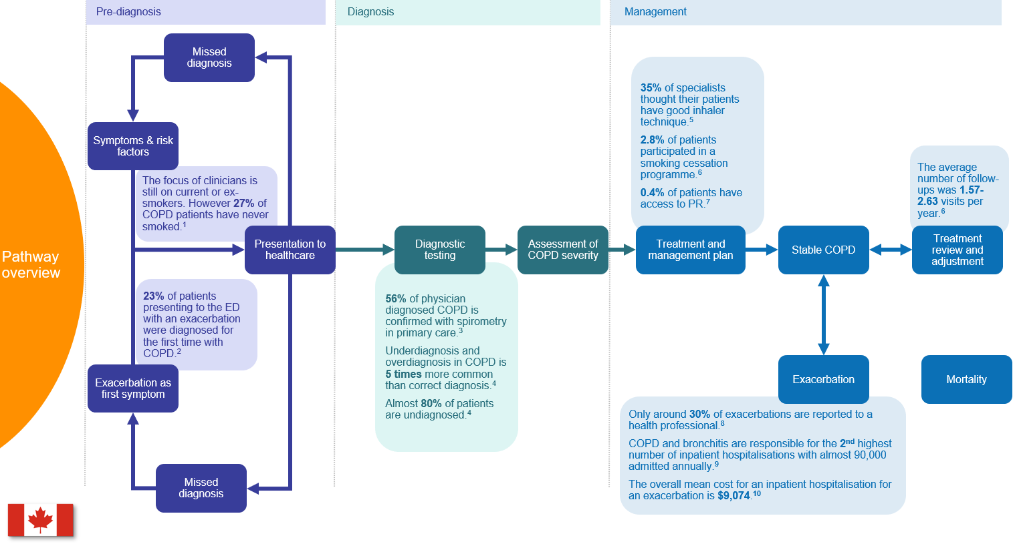
To access to full evidenced care pathway for Canada click here. All costs are adjusted to 2019 Canadian dollars $.
Abbreviations: COPD, chronic obstructive pulmonary disease; ED, emergency department; PR, pulmonary rehabilitation.

References for Canada
1. Tan WC, Sin DD, Bourbeau J, et al. Characteristics of COPD in never-smokers and ever-smokers in the general population: results from the CanCOLD study. Thorax. 2015;70(9):822-829. doi:10.1136/thoraxjnl-2015-206938
2. Rowe BH, Villa‐Roel C, Guttman A, et al. Predictors of Hospital Admission for Chronic Obstructive Pulmonary Disease Exacerbations in Canadian Emergency Departments. Academic Emergency Medicine. 2009;16(4):316-324. doi:10.1111/j.1553-2712.2009.00366.x
3. Bourbeau J, Sebaldt RJ, Day A, et al. Practice patterns in the management of chronic obstructive pulmonary disease in primary practice: The CAGE study. Can Respir J. 2008;15(1):13-19.
4. Gershon AS, Thiruchelvam D, Chapman KR, et al. Health Services Burden of Undiagnosed and Overdiagnosed COPD. CHEST. 2018;153(6):1336-1346. doi:10.1016/j.chest.2018.01.038
5. Hernandez P, Balter MS, Bourbeau J, Chan CK, Marciniuk DD, Walker SL. Canadian practice assessment in chronic obstructive pulmonary disease: Respiratory specialist physician perception versus patient reality. Can Respir J. 2013;20(2):97-105.
6. Maleki-Yazdi MR, Kelly SM, Lam SY, Marin M, Barbeau M, Walker V. The burden of illness in patients with moderate to severe chronic obstructive pulmonary disease in Canada. Can Respir J. 2012;19(5):319-324. doi:10.1155/2012/328460
7. Camp PG, Hernandez P, Bourbeau J, et al. Pulmonary Rehabilitation in Canada: A Report from the Canadian Thoracic Society COPD Clinical Assembly. Canadian Respiratory Journal. 1900;22:369851. doi:10.1155/2015/369851
8. Langsetmo L, Platt RW, Ernst P, Bourbeau J. Underreporting exacerbation of chronic obstructive pulmonary disease in a longitudinal cohort. Am J Respir Crit Care Med. 2008;177(4):396-401. doi:10.1164/rccm.200708-1290OC
9. Canadian Institute for Health Information. Hospital stays in Canada. Accessed July 29, 2020. https://www.cihi.ca/en/hospital-stays-in-canada
10. Mittmann N, Kuramoto L, Seung SJ, Haddon JM, Bradley-Kennedy C, Fitzgerald JM. The cost of moderate and severe COPD exacerbations to the Canadian healthcare system. Respir Med. 2008;102(3):413-421. doi:10.1016/j.rmed.2007.10.010

Appendix I: Overview of the Evidenced Care Pathway for COPD in England
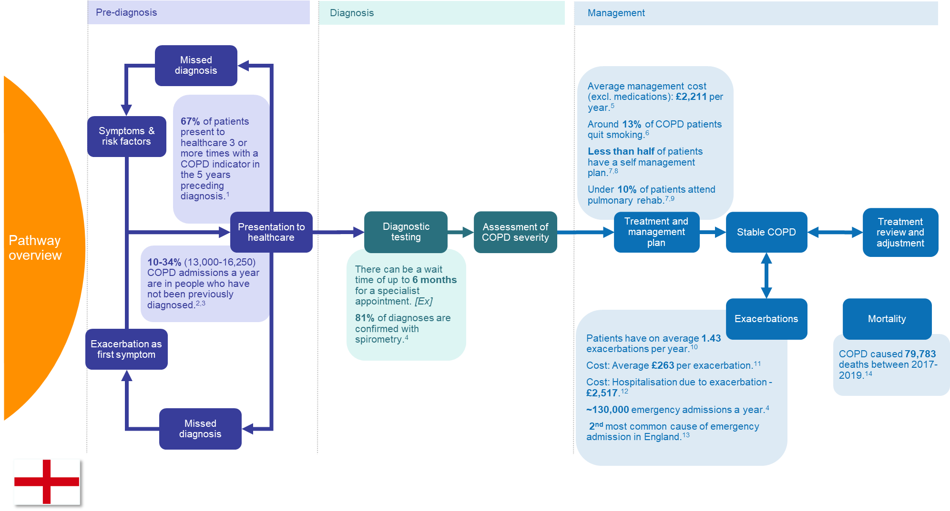
[Ex]: Sourced from an interview with a clinical expert for this project. Note: quotes might have been edited for length and clarity.
To access to full evidenced care pathway for England click here. All costs are adjusted to 2019 GBP £.
Abbreviations: COPD, chronic obstructive pulmonary disease.

References for England
1. Kostikas K, Price D, Gutzwiller FS, et al. Clinical Impact and Healthcare Resource Utilization Associated with Early versus Late COPD Diagnosis in Patients from UK CPRD Database. Int J Chron Obstruct Pulmon Dis. 2020;15:1729-1738. doi:10.2147/COPD.S255414
2. NHS Medical Directorate. COPD Commissioning Toolkit. A Resource for Commissioners. Published online August 2, 2012. https://www.gov.uk/government/publications/commissioning-toolkit-for-respiratory-services
3. Bastin A, Starling L, Ahmed R, et al. High prevalence of undiagnosed and severe chronic obstructive pulmonary disease at first hospital admission with acute exacerbation. Chron Respir Dis. 2010;7(2):91-97. doi:10.1177/1479972310364587
4. Public Health England. Inhale - INteractive Health Atlas of Lung conditions in England. Published 2019. Accessed September 30, 2021. https://fingertips.phe.org.uk/profile/inhale/data#page/0/gid/8000003/pat/46/par/E39000026/ati/165/are/E38000056/cid/4/page-options/ovw-do-0
5. Punekar YS, Shukla A, Müllerova H. COPD management costs according to the frequency of COPD exacerbations in UK primary care. Int J Chron Obstruct Pulmon Dis. 2014;9:65-73. doi:10.2147/COPD.S54417
6. Bartlett YK, Sheeran P, Hawley MS. Effective behaviour change techniques in smoking cessation interventions for people with chronic obstructive pulmonary disease: A meta-analysis. British Journal of Health Psychology. 2014;19(1):181-203. doi:10.1111/bjhp.12071
7. Khan A, Dickens AP, Adab P, Jordan RE. Self-management behaviour and support among primary care COPD patients: cross-sectional analysis of data from the Birmingham Chronic Obstructive Pulmonary Disease Cohort. npj Prim Care Resp Med. 2017;27(1):46. doi:10.1038/s41533-017-0046-6
8. Ogunbayo OJ, Russell S, Newham JJ, et al. Understanding the factors affecting self-management of COPD from the perspectives of healthcare practitioners: a qualitative study. npj Primary Care Respiratory Medicine. 2017;27(1):1-9. doi:10.1038/s41533-017-0054-6
9. Moore E, Newson R, Joshi M, et al. Effects of Pulmonary Rehabilitation on Exacerbation Number and Severity in People With COPD: An Historical Cohort Study Using Electronic Health Records. Chest. 2017;152(6):1188-1202. doi:10.1016/j.chest.2017.05.006
10. Merinopoulou E, Raluy-Callado M, Ramagopalan S, MacLachlan S, Khalid JM. COPD exacerbations by disease severity in England. Int J Chron Obstruct Pulmon Dis. 2016;11:697-709. doi:10.2147/COPD.S100250
11. Jones RCM, Price D, Ryan D, et al. Opportunities to diagnose chronic obstructive pulmonary disease in routine care in the UK: a retrospective study of a clinical cohort. The Lancet Respiratory Medicine. 2014;2(4):267-276. doi:10.1016/S2213-2600(14)70008-6
12. Curtis L, Burns A. Unit Costs of Health and Social Care 2019. PSSRU, University of Kent; 2019. https://doi.org/10.22024/UniKent%2F01.02.79286
13. National Institute for Health and Care Excellence (NICE). Resource impact report: Chronic obstructive pulmonary disease in over 16s: diagnosis and management (update) (NG115). Published online 2018. https://www.nice.org.uk/guidance/ng115/resources/resource-impact-report-pdf-6602803741
14. Public Health England. Mortality Profile. Accessed September 2, 2020. https://fingertips.phe.org.uk/profile/mortality-profile/data#page/11/gid/1938133058/pat/6/par/E12000004/ati/102/are/E06000015/iid/1204/age/1/sex/4/cid/4/page-options/ovw-do-0_car-do-0_eng-vo-0_eng-do-0

Appendix J: Overview of the evidenced care pathway for COPD in Germany
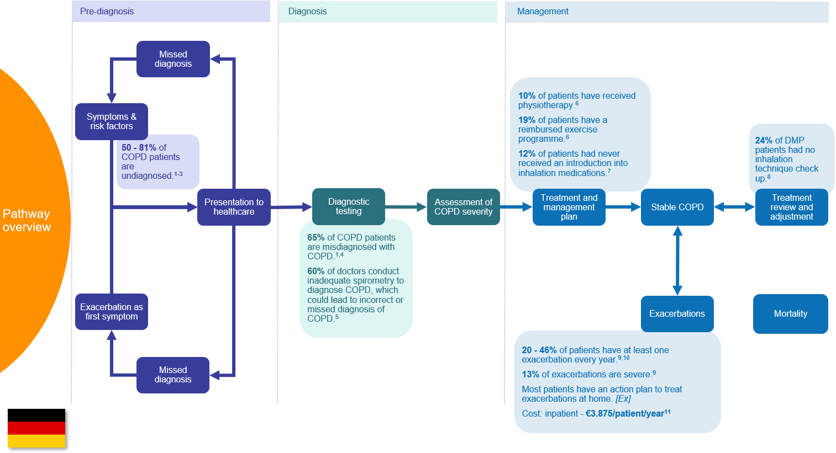
[Ex]: Sourced from an interview with a clinical expert for this project. Note: quotes might have been edited for length and clarity.
To access to full evidenced care pathway for Germany click here. All costs are adjusted to 2019 Euros €.
Abbreviations: COPD, chronic obstructive pulmonary disease; DMP, disease management program.

References for Germany
1. Lamprecht B, Soriano JB, Studnicka M, et al. Determinants of Underdiagnosis of COPD in National and International Surveys. Chest. 2015;148(4):971-985. doi:10.1378/chest.14-2535
2. Gingter C, Wilm S, Abholz HH. Is COPD a rare disease? Prevalence and identification rates in smokers aged 40 years and over within general practice in Germany. Family Practice. 2008;26(1):3-9. doi:10.1093/fampra/cmn084
3. Berghaus TM, Karschnia P, Haberl S, Schwaiblmair M. Disproportionate decline in admissions for exacerbated COPD during the COVID-19 pandemic. Respiratory Medicine. Published online August 2020:106120. doi:10.1016/j.rmed.2020.106120
4. Sator L, Horner A, Studnicka M, et al. Overdiagnosis of COPD in Subjects With Unobstructed Spirometry: A BOLD Analysis. Chest. 2019;156(2):277-288. doi:10.1016/j.chest.2019.01.015
5. Glaab T, Banik N, Singer C, Wencker M. Leitlinienkonforme ambulante COPD-Behandlung in Deutschland. Dtsch med Wochenschr. 2006;131(21):1203-1208. doi:10.1055/s-2006-941752
6. Lutter JI, Lukas M, Schwarzkopf L, et al. Utilization and determinants of use of non-pharmacological interventions in COPD: Results of the COSYCONET cohort. Respiratory Medicine. 2020;171:106087. doi:10.1016/j.rmed.2020.106087
7. Hämmerlein A, Müller U, Schulz M. Pharmacist-led intervention study to improve inhalation technique in asthma and COPD patients: Improvement of inhalation technique. Journal of Evaluation in Clinical Practice. 2011;17(1):61-70. doi:10.1111/j.1365-2753.2010.01369.x
8. infas Institut für angewandte Sozialwissenschaft GmbH. Evaluation of Disease Management Programs [Bericht der strukturierten Behandlungsprogramme der gesetzlichen Krankenkassen zum 30.06.2019 - Indikation COPD]. Published online June 30, 2019.
9. Byng D, Lutter JI, Wacker ME, et al. Determinants of healthcare utilization and costs in COPD patients: first longitudinal results from the German COPD cohort COSYCONET. COPD. 2019;Volume 14:1423-1439. doi:10.2147/COPD.S201899
10. Kardos P, Vogelmeier C, Worth H, et al. A two-year evaluation of the ‘real life’ impact of COPD on patients in Germany: The DACCORD observational study. Respiratory Medicine. 2017;124:57-64. doi:10.1016/j.rmed.2017.02.007
11. Rehman A ur, Hassali MAA, Muhammad SA, Harun SN, Shah S, Abbas S. The economic burden of chronic obstructive pulmonary disease (COPD) in Europe: results from a systematic review of the literature. Eur J Health Econ. 2020;21(2):181-194. doi:10.1007/s10198-019-01119-1

Appendix K: Additional qualitative evidence to support results of thematic analysis
Table 1 Qualitative evidence to support common structural differences
Structural differences | Supporting quotes
Insurance is a barrier to the provision of quality COPD care in Japan, Germany, and Canada | “There are some very special prices with different pharmaceutical companies for their medications and therefore the pharmacists are told to use different inhalers and different medications from different companies for different people, for patients from different insurance companies. That is a big problem.” (ID 22, Respiratory specialist, Germany)
Rural settings affected patients’ ability to be properly diagnosed, urgently treated for acute exacerbations, and have regular monitoring by HCPs | “Patients that live miles from anywhere are just as impoverished as people that live in back to backs in [city], because they can’t access any services. GPs won’t visit, so you know, they suffer just as much as people that are living in overcrowded homes really.” (ID 5, Nurse, England)  “People who live in rural areas, use cars more often, they don’t use trains as much. So, they don’t walk a lot and they don’t feel the symptoms and so their diagnosis might be delayed because they feel the onset of symptoms later. Whereas in an urban setting, people are walking more, they’re using subway and trains and they’re walking more often, so they would seek treatment for any ailments that they felt earlier.” (ID 14, Respiratory specialist, Japan)
Notes: Some clinicians were not speaking their native language and/or only English interpretations were transcribed.
Abbreviation: GP, general practitioner.
Table 2 Qualitative evidence for the subthemes within the theme: Journey to diagnosis
Subtheme: Low consideration of COPD by patients (HCP reported)
Quotes | “Unfortunately, COPD, which is often linked to smoking there’s a huge psychological component and there’s guilt in that. […] I know I smoke; this is a disease I deserve […] So, there’s guilt and then there’s avoiding the system. So, unfortunately, COPD is also probably underdiagnosed because there’s a psychological component that we need to recognize […] the guilt related to smoking meaning that they don’t seek help as much as they should be because they feel they […] deserve it sometimes.” (ID 9, GP, Canada)  “What that means is that people aren’t aware enough that exacerbations can be a presenting […] And it is a frighteningly common route into the diagnosis, i.e., much, much more common than it should be.” (ID 6, Respiratory specialist, England)
Any national nuances? | Yes, there is no term for ‘COPD’ in Japanese  “I think COPD we should use some Japanese name. Japanese Respiratory Society tried to use COPD it is a good name. I also agree it’s a good name to express the disease, but COPD in a patient with COPD is a high age patient usually over 60, 70 they are not so familiar with English words.” (ID 17, Non-respiratory specialist, Japan)
Subtheme: Low consideration of COPD by HCPs
Quotes | “We have […] many general practitioners in Japan, but they are very keen to diabetes mellitus, and hypertension and heart disease, but not for COPD.” (ID 14, Respiratory specialist, Japan)
Misdiagnosis due to poor quality diagnosis
Quotes | “The problem is when it comes to exacerbation if pulmonology says it is an exacerbation, very many times the GP says it’s just acute bronchitis. So, he gets his antibiotic, not even cortisone, and then goes home. But this was the first exacerbation, so here the COPD remains undiagnosed” (ID 23, Respiratory specialist, Germany)  “The biggest problem is asthma and also heart disease. There are many cases where it’s difficult to tell the difference between the symptoms.” (ID 15, Respiratory specialist, Japan)
Poor utilization of spirometry
Quotes | “Quite a number of these spirometries are not to evaluate, or the quality is very poor because people are not trained. So, the patients are not trained to make a spirometry. The nurses are not trained to perform a spirometry and the physicians are not trained to interpret the spirometry. So, it’s a very difficult thing.” (ID 22, Respiratory specialist, Germany)  “Yes, spirometry is very important item, but even chest physician, or specialist don’t do, so very rare, yes, it’s a problem.” (ID 14, Respiratory specialist, Japan)
Any national nuances? | Yes, in Japan and Germany ‘loud voices’ were stated as one reason why spirometry is not performed.  “They [doctors] have to talk to their nurses to persuade the nurses to do a spirometry because they don’t like it because it has to be loud and they have to shout to the patients, which they are not willing to do. I’m pretty sure no-one likes to perform spirometries, but it’s part of the job. And the patients don’t like it as well.” (ID 22, Respiratory specialist, Germany)
Notes: Some clinicians were not speaking their native language and/or only English interpretations were transcribed.
Abbreviations: COPD, chronic obstructive pulmonary disease; GP, general practitioner.
Table 3 Qualitative evidence for the subthemes within the theme: Treatment and Management
Subtheme: Poor utilization of non-pharmacological treatments
Quotes | “So, the rehabilitation program […] that needs to be improved. I think it’s very important. So compared to heart disease rehabilitation, the program is much more delayed. We are far more advanced for rehabilitation of heart disease then we are for respiratory diseases.” (ID 15, Respiratory specialist, Japan)
Any national nuances? | No, but countries do report variations in the available alternatives to pulmonary rehabilitation.  As pulmonary rehabilitation is a limited resource in all four countries patients were instead encouraged to attend community exercise programs in England, Canada, and Germany. In Japan, HCPs prescribed a certain number of steps per week measured by a pedometer.  “After they’re diagnosed, for example, the doctor will tell the patient, increase your number of steps by 20%. Next week I want to see a 20% increase in your steps, and they’ll use the smartphone after their diagnosis to do that.” (ID 14, Respiratory specialist, Japan)
Subtheme: Pharmacological treatment is often inadequate or inappropriate
Quotes | “I’ll give you an example, somebody who is in the Spiriva handy-haler, the dry powder, gets switched to Spiriva Respimat and the dry powder is one puff once a day and the Respimat is two puffs once a day, and some of them will not have realized that they’re supposed to be taking two puffs and they’re still taking one puff of the Respimat, so they’re having half their dose. So, you only figure that out when you ask them how many times a day are you taking this inhaler?” (ID 10, Respiratory specialist, Canada)  “So, get inhaler technique right. Again, I think a lot of clinicians aren’t good at assessing inhaler technique which means a lot of patients are using their medication ineffectively.” (ID 1, GP, England)  “You get really bizarre practices because you’ll find that, you know, someone has met the [inhaler] rep and that’s all they know because that’s all they’ve been shown how to use, and they won’t know that we don’t favor that device for lots of reasons.” (ID 3, Respiratory specialist, England)
Subtheme: Poor treatment and recognition of exacerbations
Quotes | “I think the other thing with that is, it’s putting an awful lot of responsibility on patients to recognize their own symptoms and know when to start them [rescue packs], and for carers as well.” (ID 5, Nurse, England)  “So, I only provide an action plan for those patients who understand and will adhere to it, and I can trust they will do that. So, for example, if they take too much medicine, I can’t give them the action plan. Or if they have dementia and are incapable of taking care of themselves or recognizing symptoms then I won’t give them the action plan.” (ID 16, Respiratory specialist, Japan)
Notes: Some clinicians were not speaking their native language and/or only English interpretations were transcribed.
Abbreviations: GP, general practitioner; HCP, healthcare professional.

