Supplementary data

Methods for model development
The patients in the entire cohort were randomly divided into the training and validation cohorts with a ratio of 7:3. Given the numerous candidate predictors (33 variables) and the limited sample size (90 cases in the entire cohort), a standard logistic regression with variable selection for model development would lead to large estimated coefficients of the model, overfitting, and unstable. Thus, the variable selection method based on the penalty function was used. The least absolute shrinkage and selection operator (LASSO), proposed by Tibshirani²⁶, is a method that can also be utilized for biomarker selection in high dimensional data. This method minimizes the residual sum of squares by subjecting um of the absolute value of the coefficients being less than a tuning parameter (λ) in the linear regression model or minimizes the negative log-likelihood in the binary logistic regression model. It can compress the estimate of unimportant predictors to zero at a certain λ to exclude those predictors and handle “multicollinearity” among the predictors Tibshirani²⁶. The optimal λ can be selected by cross-validation. We firstly assume all the continuous predictors exert a linear relationship to the outcome and put all the variables into Lasso logistic regression for variables selection and coefficients estimation in the training cohort. However, some continuous variables may exhibit a non-linear relationship to the outcome, and simply dichotomizing continuous predictors is paired with significant information loss²⁷. Therefore, we transform the continuous variables by restricted cubic splines (RCS) with 3 or 4 knots. The knots are selected based on the Akaike information criterion (AIC) ²⁸. The matrix derived from a continuous variable by RCS was assigned to one group and was subjected to group Lasso for feature selection combined with other predictors ²⁹. In group Lasso, the variables in one group either all enter the model or are all eliminated. The Lasso scores were calculated by multiplying the selected variables with corresponding coefficients and summing them and were then served as single predictive factors and input into a standard logistic regression to obtain the predicted probability and linear predictors. Next, the formula of the Lasso scores was substituted, and thereafter the predicted probability and linear predictors can be calculated from individually selected variables. The models based on Lasso (lLasso) and group Lasso (gLasso) were subsequently compared in both the training and validation cohorts.

Table S1 Comparison of the clinical/laboratory data between training and validation cohorts
Cohorts | Training | Validation | P-value
N | 63 | 27
Age at diagnosis (months) | 22.0 (13.0-37.0) | 25.0 (11.0-40.0) | 0.944
Age at recurrence (months) | 35.0 (24.5-51.5) | 34.0 (18.5-53.5) | 0.853
Interval (months) | 9.0 (4.5-17.0) | 7.0 (3.0-14.0) | 0.845
Fever duration (d) | 6.0 (5.0-7.0) | 6.0 (5.0-8.5) | 0.387
CRP (mg/L) | 60.0 (19.0-96.0) | 90.0 (25.5-154.0) | 0.075
WBC (10^9/L) | 12.5 ± 5.3 | 13.7 ± 4.3 | 0.219
HGB (g/L) | 117.5 ± 12.1 | 115.5 ± 13.5 | 0.509
Alb (g/L) | 35.8 ± 5.3 | 35.2 ± 4.0 | 0.252
PLT (10^9/L) | 322.7 ± 96.7 | 339.6 ± 140.6 | 0.888
ALT (U/L) | 21.7 (12.9-56.0) | 16.4 (11.1-38.7) | 0.214
CK-MB (U/L) | 14.0 (10.0-20.0) | 14.0 (10.5-18.0) | 0.445
AST (U/L) | 30.1 (24.5-45.4) | 30.7 (24.6-40.2) | 0.439
Neutrophils (10^9/L) | 8.4 ± 5.0 | 10.0 ± 4.5 | 0.101
N (%) | 62.4 ± 19.3 | 69.8 ± 15.1 | 0.088
Lymphocyte (10^9/L) | 3.0 ± 1.4 | 2.6 ± 1.1 | 0.223
L (%) | 24.4 (14.2-34.2) | 18.6 (14.5-23.1) | 0.078
DB (μmol/L) | 1.3 (0.7-2.0) | 1.1 (0.5-1.8) | 0.111
TB (μmol/L) | 7.1 (5.1-10.7) | 6.7 (5.4-8.8) | 0.134
Prothrombin time (s) | 12.3 (11.4-13.7) | 13.2 (11.8-13.8) | 0.495
Na (mmol/L) | 134.6 ± 3.6 | 135.2 ± 3.9 | 0.628
ESR (mm/h) | 62.9 ± 27.2 | 62.3 ± 28.2 | 0.822
INR | 1.1 ± 0.2 | 1.1 ± 0.1 | 0.091
KD type |  |  | 1.000
Complete | 59 (93.7%) | 26 (96.3%)
Incomplete | 4 (6.3%) | 1 (3.7%)
Gender |  |  | 0.797
Boys | 46 (73.0%) | 19 (70.4%)
Girls | 17 (27.0%) | 8 (29.6%)
Coronary artery complications |  |  | 0.029
No | 39 (61.9%) | 23 (85.2%)
Yes | 24 (38.1%) | 4 (14.8%)
Rash |  |  | 0.441
No | 16 (25.4%) | 9 (33.3%)
Yes | 47 (74.6%) | 18 (66.7%)
Conjunctival injection |  |  | 0.007
No | 5 (7.9%) | 8 (29.6%)
Yes | 58 (92.1%) | 19 (70.4%)
Oral mucosal change |  |  | 0.424
No | 4 (6.3%) | 3 (11.1%)
Yes | 59 (93.7%) | 24 (88.9%)
Cervical lymphadenopathy |  |  | 0.787
No | 8 (12.7%) | 4 (14.8%)
Yes | 55 (87.3%) | 23 (85.2%)
Edema of the hands and feet |  |  | 0.238
No | 27 (42.9%) | 8 (29.6%)
Yes | 36 (57.1%) | 19 (70.4%)
Perianal change |  |  | 0.580
No | 48 (76.2%) | 22 (81.5%)
Yes | 15 (23.8%) | 5 (18.5%)
Electrocardiogram change |  |  | 0.597
No | 11 (17.5%) | 6 (22.2%)
Yes | 52 (82.5%) | 21 (77.8%)
IVIG resistance at the first episode |  |  | 1.000
No | 56 (88.9%) | 24 (88.9%)
Yes | 7 (11.1%) | 3 (11.1%)
IVIG resistance at recurrence |  |  | 0.904
No | 52 (82.5%) | 22 (81.5%)
Yes | 11 (17.5%) | 5 (18.5%)
Note, IVIG, intravenous immunoglobulin; WBC, white blood cell count; N%, neutrophils percentage; L%, lymphocyte percentage; Na, serum sodium; TB, total bilirubin; DB, direct bilirubin; CRP, C-reactive protein; PLT, platelet; Hb, hemoglobin; ESR, erythrocyte sedimentation rate; ALB, serum albumin; ALT, serum alanine aminotransferase; AST, serum aspartate transaminase; CK-MB, creatine kinase MB; INR, international normalized ratio.

Figure S1 Formulas of lLasso and gLasso models
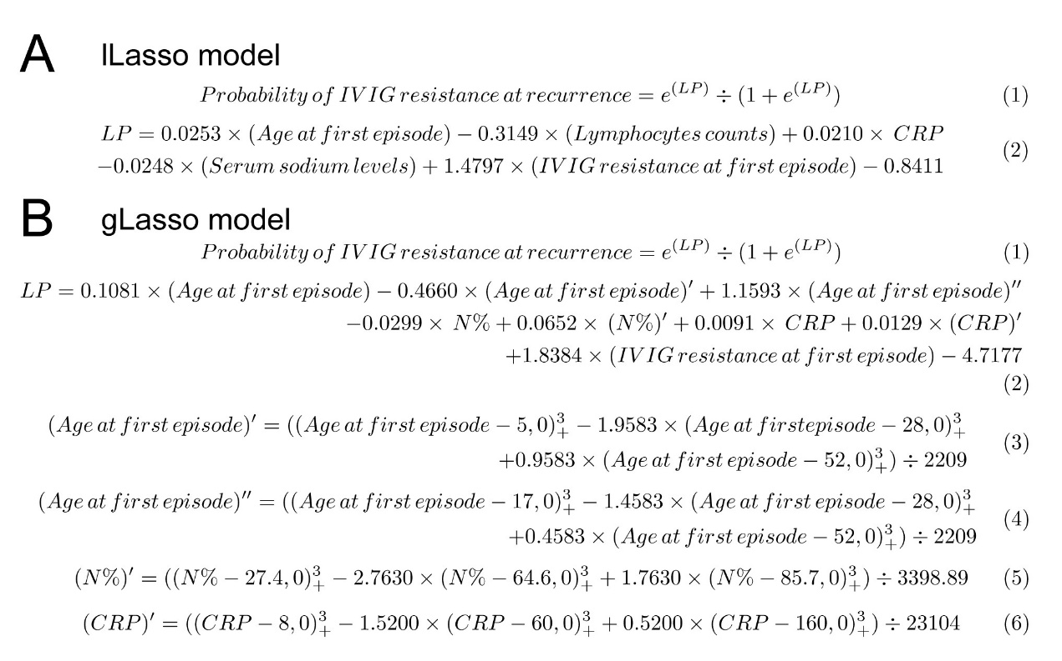
Figure S1. Formulas of lLasso model and gLasso model to predict IVIG resistance at recurrence in KD patients. (A) The probability of IVIG resistance at recurrence can be calculated from the linear predictor (LP) by formula 1. And LP of lLasso model can be calculated by summing the products of multiplying the selected variables and their coefficients (formula 2). B. The probability of IVIG resistance at recurrence can be calculated from the linear predictor (LP) by formula 1. And LP of gLasso model can be calculated by summing the products of multiplying the selected variables and their coefficients (formula 2). Notably, in gLasso model, the continuous variables are assumed to have non-linear relationships to the outcomes and expanded by restricted cubic splines (RCS). The continuous variables, age at the first episode, N%, and CRP, were modeled using RCS with 4, 3, and 3 knots, respectively, resulting in two (formula 3 and 4), one (formula 5), and one (formula 6) extra parameters, respectively.

