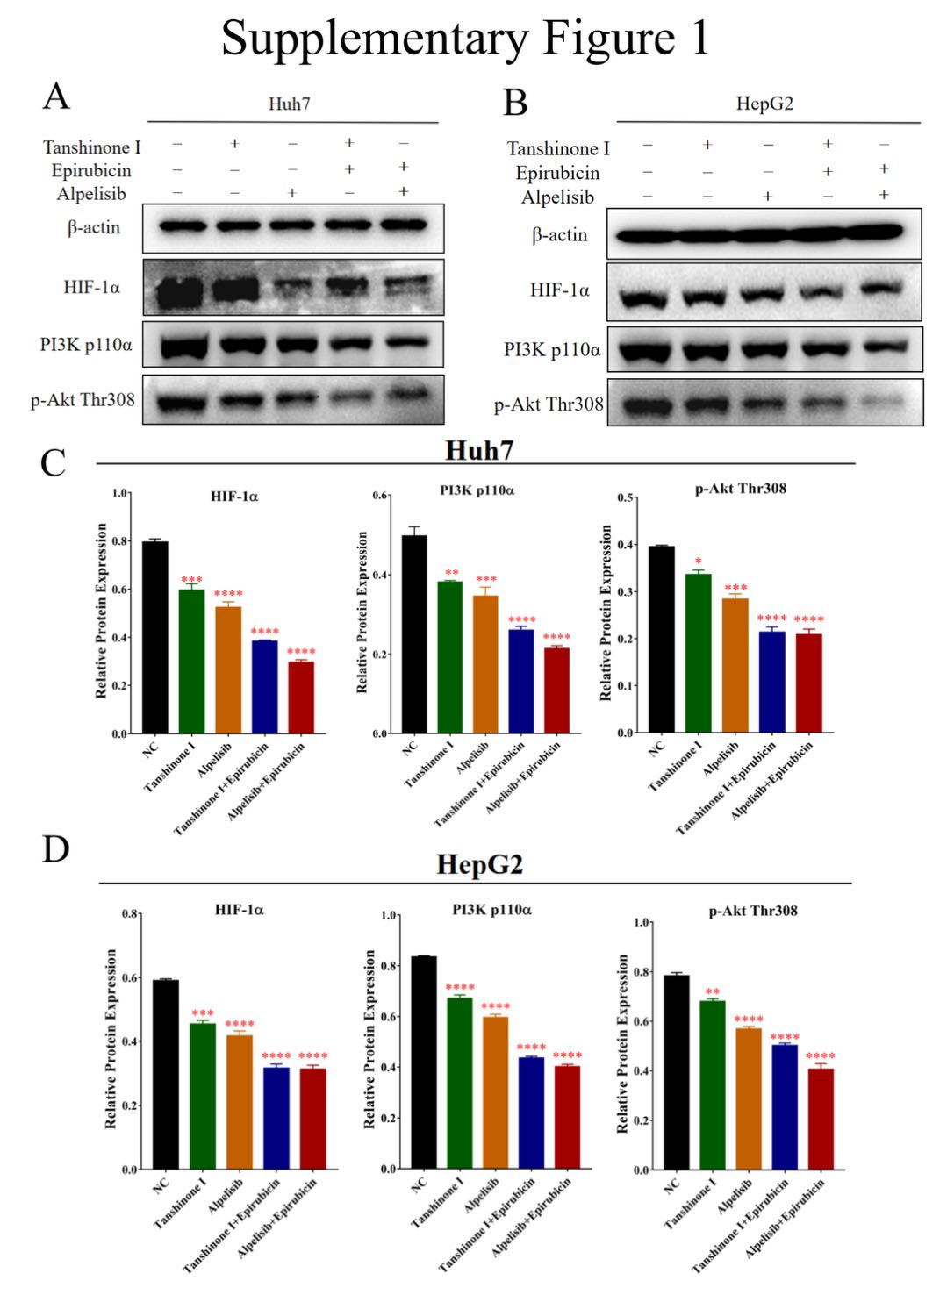

Supplementary Figure 1 Legend
Supplementary Figure 1: Both of Tan I and the PI3K inhibitor (alpelisib) could inhibit the expression levels of PI3K-p110α, p-Akt-Thr308, and HIF-1α. The combined treatment of Tan I and EADM or the combined treatment of alpelisib and EADM could enhance the inhibition of PI3K/AKT/HIF-1α signaling. (A, B) Western blotting was performed to detect the expression levels of PI3K p110α, p-Akt Thr308 and HIF-1α in Huh7 and HepG2 treated with Tan I, EADM, alpelisib, and the combination treatment, compared with the group without treatment. (C, D) The relative expressions of PI3K p110α, p-Akt Thr308, and HIF-1α in Huh7 and HepG2 were quantified via normalization to β-actin. The data presented mean +/- SEM. *p < 0.01; **p < 0.001; ***p < 0.0001; ****p < 0.00001; n.s, no statistical significance. All data were repeated three times.

