Supplementary Table 1. Acupoint and description of acupoint location
acupoint | Description of acupoint location
Xiyan (EX-LE5) | In the medial depression of the patella and the patellar ligament.
Dubi (ST35) | In the lateral depression of the patella and the patellar ligament.
Liangqiu (ST34) | On the line between the anterior superior iliac spine and the iliac base, about 1.3mm above the lateral iliac base.
Xuehai (SP10) | On the eminence of the head medial to the quadriceps femoris, about 1.3mm above the medial iliac base.

Supplementary Table 2. Scheme for the histopathological assessment of the three features of chronic synovitis
Enlargement of the synovial lining cell layer | 0 points | The lining cells form one layer
Enlargement of the synovial lining cell layer | 1 point | The lining cells form 2–3 layers
Enlargement of the synovial lining cell layer | 2 points | The lining cells form 4–5 layers, few multinucleated cells might occur
Enlargement of the synovial lining cell layer | 3 points | The lining cells form more than 5 layers, the lining might be ulcerated and multinucleated cells might occur
The density of the resident cells | 0 points | The synovial stroma shows normal cellularity
The density of the resident cells | 1 point | The cellularity is slightly increased
The density of the resident cells | 2 points | The cellularity is moderately increased, multinucleated cells might occur
The density of the resident cells | 3 points | The cellularity is greatly increased, multinucleated giant cells, pannus formation and rheumatoid granulomas might occur
Inflammatory infiltrate | 0 points | No inflammatory infiltrate
Inflammatory infiltrate | 1 point | Few mostly perivascular situated lymphocytes or plasma cells
Inflammatory infiltrate | 2 points | Numerous lymphocytes or plasma cells, sometimes forming follicle-like aggregates
Inflammatory infiltrate | 3 points | Dense band-like inflammatory infiltrate or numerous large follicle-like aggregates
Sum 0 or 1 | No synovitis
Sum 2–4 | Low-grade synovitis
Sum 5–9 | High-grade synovitis

Supplementary Table 3. The OARSI template to estimate the histopathological grade of KOA
Grade (key feature) | Associated criteria (tissue reaction)
Grade 0: surface intact, cartilage morphology intact | Matrix: normal architecture  Cells: intact, appropriate orientation
Grade 1: surface intact | Matrix: superficial zone intact, edema and/or superficial fibrillation (abrasion), focal superficial matrix condensation  Cells: death, proliferation (clusters), hypertrophy, superficial zone  The reaction must be more than superficial fibrillation only
Grade 2: surface discontinuity | As above  ＋ Matrix discontinuity at superficial zone (deep fibrillation)  ± Cationic stain matrix depletion (Safranin O or Toluidine Blue) upper 1/3 of cartilage  ± Focal perichondronal increased stain (mid zone)  ± Disorientation of chondron columns  Cells: death, proliferation (clusters), hypertrophy
Grade 3: vertical  fissures (clefts) | As above  Matrix vertical fissures into mid zone, branched fissures  ±Cationic stain depletion (Safranin O or Toluidine Blue) into lower 2/3 of cartilage (deep zone)  ±New collagen formation (polarized light microscopy, Picro Sirius Red stain)  Cells: death, regeneration (clusters), hypertrophy, cartilage domains adjacent to fissures
Grade 4: erosion | Cartilage matrix loss: delamination of superficial layer, mid-layer cyst formation  Excavation: matrix loss superficial layer and mid zone
Grade 5: denudation | Surface: sclerotic bone or reparative tissue, including fibrocartilage within the denuded surface. Microfracture with  repair limited to the bone surface
Grade 6: deformation | Bone remodeling (more than osteophyte formation only). Includes: microfracture with fibrocartilaginous and osseous  repair extending above the previous surface

Grade = depth progression into cartilage.

Supplementary Figure 1. Annotation of acupoints in supine mice

Supplementary Figure 2. The electronic intelligent fire needling acupuncture

Supplementary Figure 3. The procedure of needling in mice
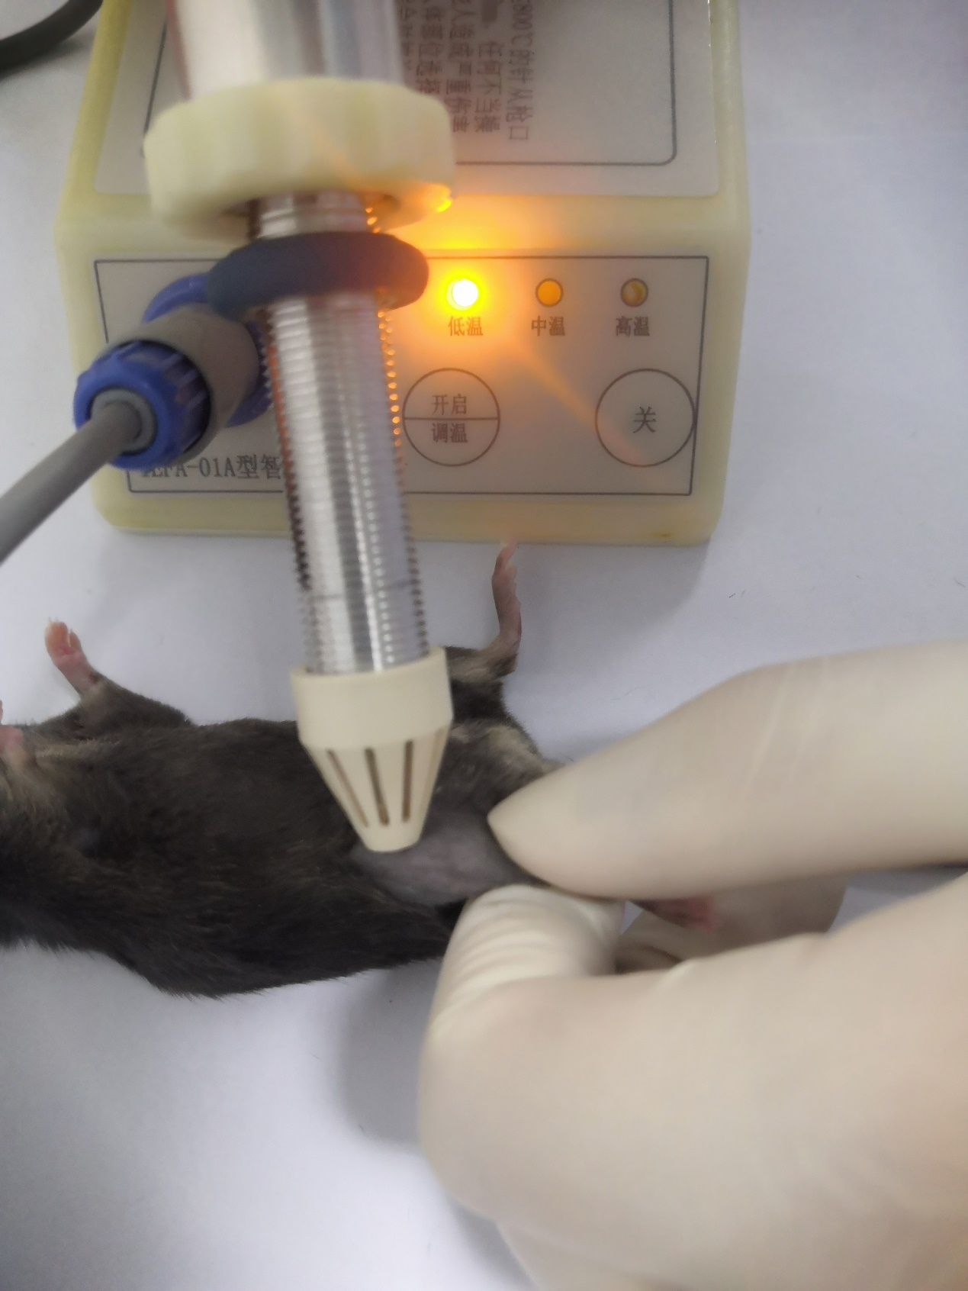

Supplementary Figure 4. Hematoxylin and eosin (HE) staining of the whole joint
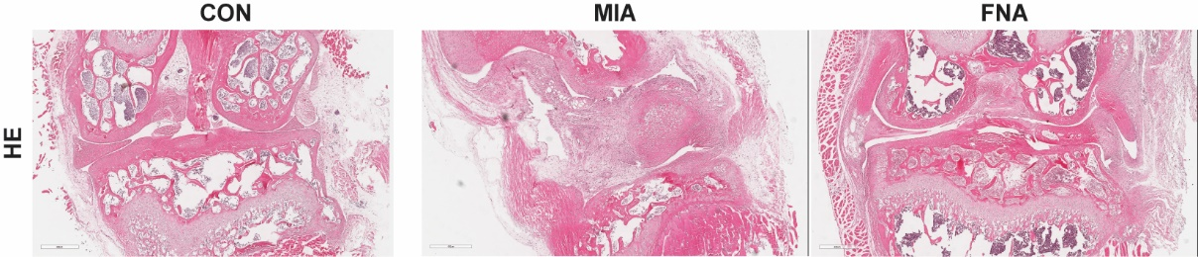

Supplementary Figure 5. Comparison of serum inflammatory cytokine concentrations

