Supplementary materials

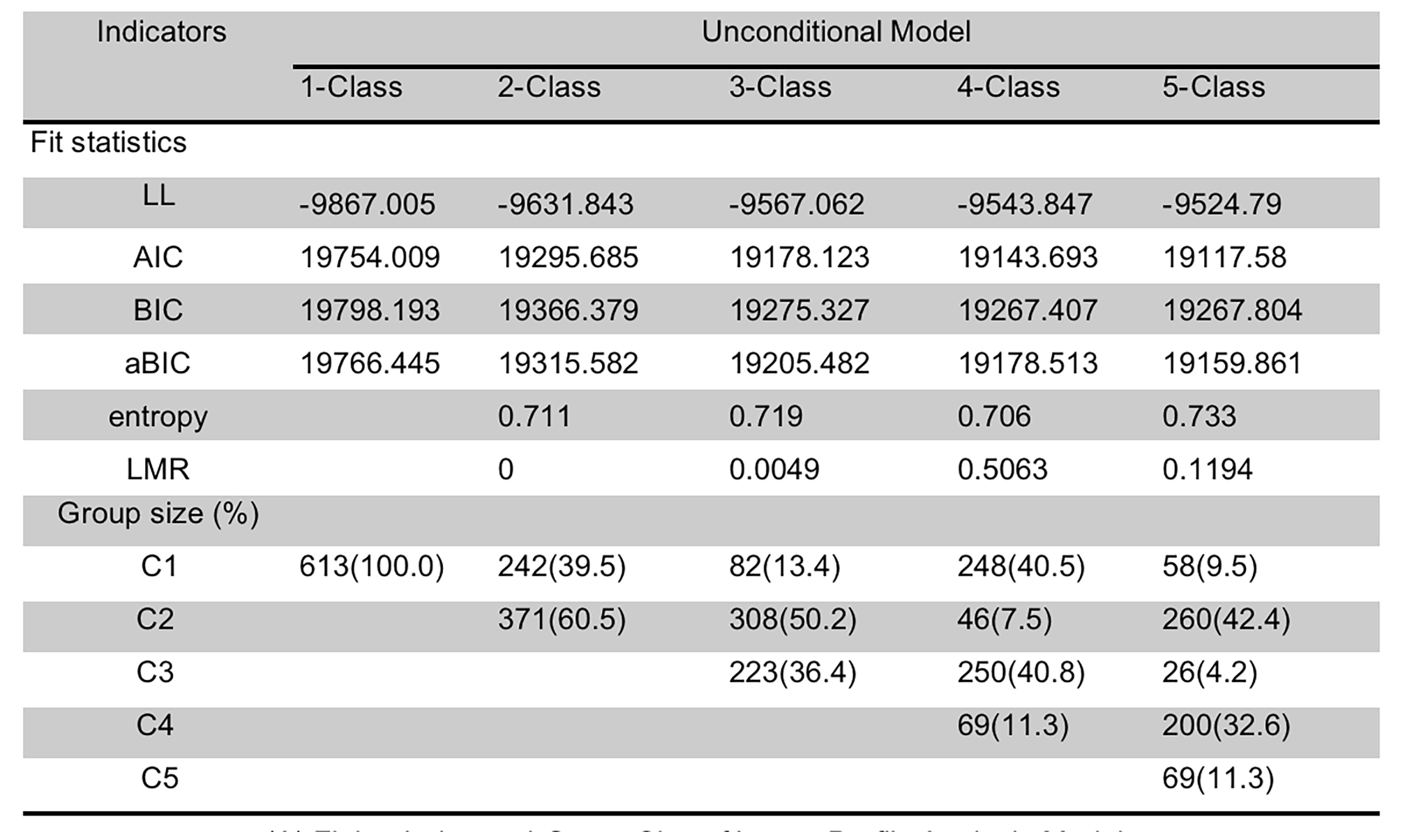
Supplementary Table S1: Fitting index and Groups Size of Latent Profile Analysis Models

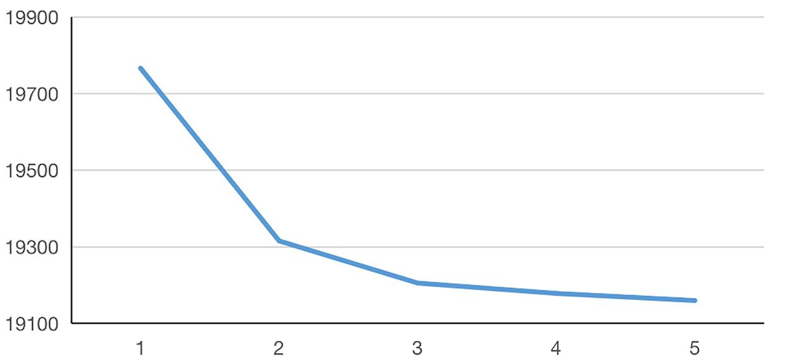
Supplementary Figure S1: The steep slopes of aBIC

