Table S1. Primer names and sequences
The name of the primer | sequence (5’-3’)
bla_{KPC}-F | CAGCTCATTCAAGGGCTTTCTT
bla_{KPC}-R | GCAGACTCCTAGCCTAAATGTG
bla_{IMP}-F | GTAGTTTATTGGTCTACATGAC
bla_{IMP}-R | AGTTTCAAGAGTGATGCGTCT
bla_{NDM}-F | GCTACAGTGAACCAAATTAAG
bla_{NDM}-R | AATGGCTCATCACGATCATG
bla_{VIM}-F | GTAGTTTATTGGTCTACATGAC
bla_{VIM}-R | TTGTGTGCTTTGACAACGTT
bla_{OXA48}-F | ATGCGTGTATTAGCCTTATCG
bla_{OXA48}-R | TTCCTGTTTGAGCACTTCT

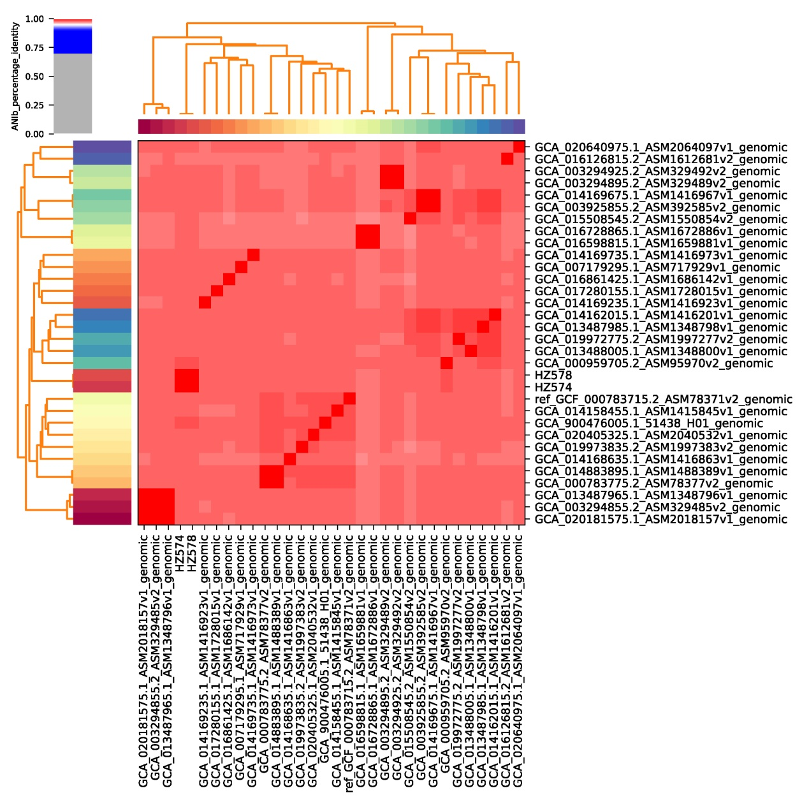
Fig S1. High throughput ANI analysis is used to compare the whole genome sequencing results to reveal distinct species of Aeromonadaceae.

Table S2. 30 complete genome bases of A. caviae downloaded from the National Center for Biotechnology Information (NCBI)
Assembly | collection date | geographic location | latitude and longitude | isolation source
GCA_014169735.1 | 2018/8/6 | Japan:Tokyo | 35.6316 N 139.7460 E | wastewater
GCA_900476005.1 | 2017/3/24
GCA_016126815.2 | 2013/7/11 | Brazil: Parana | 25.44365755 S 49.27629185 W | combined sewer
GCA_015508545.2 | 2018 | Japan:Kanagawa
GCA_013488005.1 | 2016 | China: Beijing | 39 N 116 E | Shunt fluid
GCA_014158455.1 | 2018/8/6 | Japan:Tokyo | 35.6684 N 139.4278 E | wastewater
GCA_014168635.1 | 2018/2/13 | Japan:Tokyo | 35.6640 N 139.4378 E | wastewater
GCA_014169235.1 | 2018/2/13 | Japan:Tokyo | 35.6538 N 139.5126 E | wastewater
GCA_003294855.2 | 2016/11/1 | China: Beijing |  | sludge from bioreactor treating oxytetracycline bearing wastewater
GCA_019972775.2 | 2018 | Japan:Kanagawa
GCA_007179295.1 | 2018/4/20 | China:Guangdong | 23.12 N 114.42 E | Sewage
GCA_020181575.1 | 2020 | China: Zhejiang | 28 N 121 E | sputum
GCA_019973835.2 | 2018 | Japan:Kanagawa
GCA_016861425.1 | 2019 | Japan:Kanagawa
GCA_003925855.2 | Aug-18 | Japan:Tokyo | 35.631549 N 139.745949 E | wastewater
GCA_014169675.1 | 2018/8/6 | Japan:Tokyo | 35.6316 N 139.7460 E | wastewater
GCA_020640975.1 | 2020/12/9 | China:Ningbo | 30 N 120 E | bile
GCA_013487985.1 | 2015 | China: Beijing | 39 N 116 E | bile
GCA_013487965.1 | 2016 | China: Beijing | 39 N 116 E | Shunt fluid
GCA_000783775.2 | 2013/9/16 |  |  | stool
GCA_020405325.1 | 2020/10/3 | China:Ningbo | 30 N 120 E | bile
GCA_016598815.1 | 2013/7/11 | Brazil: Parana | 25.42396678 S 49.26189415 W | combined sewer effluent
GCA_016728865.1 | 2013/7/11 | Brazil: Parana | 25.44365755 S 49.27629185 W | combined sewer effluent
GCA_014162015.1 | 2017/8/23 | Japan:Tokyo | 35.6316 N 139.7460 E | wastewater
GCA_017280155.1 | 2016 | China: wenzhou
GCA_003294925.2 | 2016/11/1 | China: Beijing |  | sludge from bioreactor treating oxytetracycline bearing wastewater
GCA_003294895.2 | 2016/11/1 | China: Beijing |  | sludge from bioreactor treating oxytetracycline bearing wastewater
GCA_000959705.2 | 2010/12/17 | Brazil: Curitiba | 25.445547 S 49.239273 W | stool
GCA_014883895.1 | 2013/9/16 |  |  | stool
Reference | 2018/8/6 | Japan:Tokyo | 35.6316 N 139.7460 E | wastewater

