Supplemental Figure 1: Horsens Fertility Cohort (2012-2018) nested in CROSS-TRACKS. Data sources listed are the register data used for Horsens Fertility Cohort
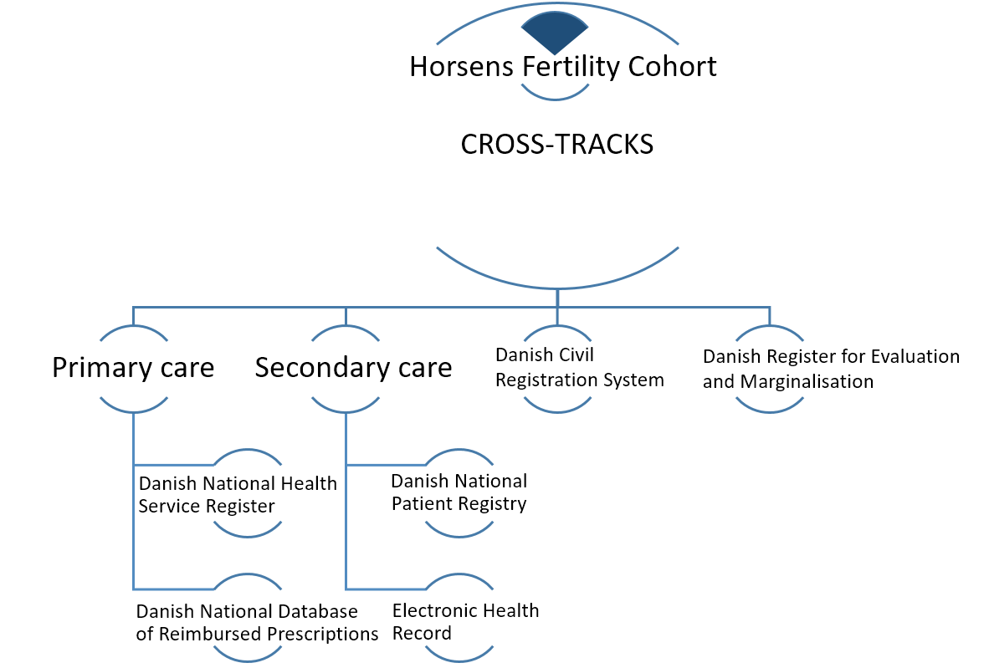

Supplemental Table 1 Use of primary and secondary healthcare for cases and controls in the 5 years prior to the index date
 |  |  | Overall 5 years prior index date
 |  |  | Cases (n(%)) | Controls (n(%)) | OR  (95% CI) | aOR  (95% CI)
Face to face GP consultations |  |  | Mean yearly no of contacts n = 15,605^{b}
Never |  |  | <5 (0.7) | 108 (3.0) | Ref | Ref
Any |  |  | >705 (99.3) | 3,447 (97.0) | 22.07 (3.08, 158.27) | 20.65 (2.82, 150.94)
T1: 0 - 1ª |  |  | 135 (19.0) | 947 (26.6) | Ref | Ref
T2: 2 - 3ª |  |  | 257 (36.2) | 1,344 (37.8) | 1.34 (1.07, 1.68) | 1.27 (1.01, 1.61)
T3: ≥ 4ª |  |  | 319 (44.9) | 1,264 (35.6) | 1.77 (1.42, 2.19) | 1.62 (1.28, 2.04)
All GP contacts^{c} |  |  | Mean yearly no of contacts n = 42,059^{b}
Never |  |  | <5 (0.7) | 92 (2.6) | Ref | Ref
Any |  |  | >705 (99.3) | 3,463 (97.4) | 18.86 (2.62, 135.6) | 17.29 (2.36, 126.69)
T1: 0 – 4^{d} |  |  | 128 (18.0) | 908 (25.5) | Ref | Ref
T2: 5 -11^{d} |  |  | 321 (45.2) | 1,588 (44.7) | 1.44 (1.15, 1.79) | 1.36 (1.07, 1.72)
T3: ≥ 12^{d} |  |  | 262 (36.9) | 1,059 (29.8) | 1.75 (1.39, 2.20) | 1.60 (1.24, 2.05)
Prescribed drugs^{e} |  |  | Mean yearly no of drugs n = 11,939^{f}
Never |  |  | 98 (13.8) | 734 (20.7) | Ref | Ref
Any |  |  | 613 (86.2) | 2,821 (79.4) | 1.63 (1.29, 2.04) | 1.53 (1.21, 1.93)
0 |  |  | 98 (13.8) | 734 (20.7) | Ref | Ref
1-3 |  |  | 457 (64.3) | 2,170 (61.0) | 1.58 (1.25, 1.99) | 1.51 (1.19, 1.91)
≥4 |  |  | 156 (21.9) | 651 (18.3) | 1.80 (1.37, 2.37) | 1.61 (1.21, 2.15)
Hospitalization |  |  | Mean yearly no of contacts n =2,159^{b}
Never |  |  | 220 (30.9) | 1,295 (36.4) | Ref | Ref
Any |  |  | 491 (69.1) | 2,260 (63.6) | 1.29 (1.08, 1.53) | 1.21 (1.01, 1.45)
0 |  |  | 220 (30.9) | 1,295 (36.4) | Ref | Ref
1-3 |  |  | 482 (67.8) | 2,229 (62.7) | 1.28 (1.07, 1.53) | 1.21 (1.01, 1.44)
≥4 |  |  | 9 (1.3) | 31 (0.9) | 1.71 (0.80, 3.65) | 1.42 (0.65, 3.09)
Hospitalization type
Inpatient
Never |  |  | 549 (77.2) | 2,957 (83.2) | Ref | Ref
Any |  |  | 162 (22.8) | 598 (16.8) | 1.46 (1.20, 1.78) | 1.40 (1.15, 1.71)
Outpatient
Never |  |  | 249 (35.0) | 1,470 (41.4) | Ref | Ref
Any |  |  | 462 (65.0) | 2,085 (58.7) | 1.31 (1.11, 1.56) | 1.24 (1.04, 1.47)
Emergency
Never |  |  | 574 (80.7) | 2,939 (82.7) | Ref | Ref
Any |  |  | 137 (19.3) | 616 (17.3) | 1.15 (0.93, 1.42) | 1.09 (0.89, 1.35)

Note: OR, odds ratio; aOR, adjusted odds ratio; CI, confidence interval; Ref, reference. Adjusted for income and citizenship.
ªTertiles calculated on the basis of total number of contacts for controls in the year prior to the index date.
^{b}Mean yearly no of contacts for cases and controls for the period 5 years prior to the index date
^{c}All GP contacts: face-to-face daytime, mail, phone, on-call doctor.
^{d}Tertiles calculated on the basis of total number of contacts for controls in the year prior to the index date.
^{e} Number of drugs was calculated as every redeemed drug per year and allowed for redemptions of the same drug multiple times, regardless of pack size.
^{f}Mean yearly no of redeemed prescriptions for cases and controls for the period 5 years prior to the index date.

