Supplementary Information

Multifunctional theranostic nanoparticles for enhanced tumor targeted imaging and synergistic FUS/Chemotherapy on murine 4T1 breast cancer cell
Zhengyue Kang^{1,2*} Min Yang^{1,2*}Xiaoling Feng^{1,2}Hongjian Liao^{1,2} Zhifei Zhang^{1,2} Yonghong Du^{1,2}

¹State Key Laboratory of Ultrasound in Medicine and Engineering, College of Biomedical Engineering, Chongqing Medical University, Chongqing, 400016, People's Republic of China;
²Chongqing Key Laboratory of Biomedical Engineering, Chongqing Medical University, Chongqing, 400016, People's Republic of China.

Correspondence: Yonghong Du
¹State Key Laboratory of Ultrasound in Medicine and Engineering, College of Biomedical Engineering, Chongqing Medical University, Chongqing, 400016, People's Republic of China;
²Chongqing Key Laboratory of Biomedical Engineering, Chongqing Medical University, Chongqing, 400016, People's Republic of China.
Tel: +86-23-68485021
Fax: +86-23-68485021
Email: duyonghong@cqmu.edu.cn

Methods and Results:
Determination of the DOX absorbance curve
The drug DOX standard absorbance curve was calculated through the absorbance intensities among varying concentrations of DOX (1,5,10,20,40,50,60,70,100,125 μg/mL) by UV-vis spectrophotometer (UV-2600 SHIMADZU,Japan) at 480 nm. The results showed that the standard concentration-absorbance intensity curve was calculated as: Y= 0.0178*X + 0.05081 (R²= 0.9972 )

Figure S1: The absorbance curve of DOX was detected by UV-vis spectrophotometer. The concentration-absorbance intensity relationship was calculated as: Y= 0.0178*X + 0.05081 (R²= 0.9972 )

The encapsulation of DOX into A-DPPs
3.0 mg A-DPPs was dissolved in 2.0ml DMSO (MW 78.13, Sigma-Aldrich, USA) and stirred to release the drug entirely. Absorbance value of 1.0 ml solution was measured at 480 nm by UV-vis spectrophotometer. The results displayed that the characteristic absorbance value peak of A-DPPs solution was the same as the free DOX, suggesting the successful loading of drug DOX into nanoparticles.

Figure S2: The absorbtion value of A-DPPs, PFH and free DOX at 480 nm. The successful package of DOX within the core of A-DPPs was confirmed.

Calculation of the encapsulation and loading content of PFH into A-DPPs
PFH is a hydrophobic material with a low boiling point (56℃). We quantified the encapsulation efficiency (%EE) of PFH within nanoparticles according to the following calculation laws. It has been reported by Mousnier’s study that the shell thickness-to-radius ration (T/R) of microbubbles after vaporization of nanoparticles influences the PFH volume fraction in the A-DPPs, which roughly demonstrates the PFH encapsulation efficiency.^{1,2} Hence, combined with the Mousnier’s method and our results, the PFH volume fraction may able to be calculated by the following formula:

$φ_{PFH exp}=\frac{V_{core}}{V_{core}+V_{shell}}=\frac{4/3 π(R+T)³}{4/3 πR³}=(1−\frac{T}{R})³$ （1）

where $V_{core}$ and $V_{shell}$ are the volume of the core and shell of microbubbles from the vaporized A-DPPs , respectively.
This experimental value need to be directly compared with the theoretical value of the PFH volume fraction:

$φ_{PFH theo}=\frac{V_{PFH}}{V_{PFH}+m_{PLGA}/ρ_{PLGA}}$ （2）

where $V_{PFH}$ is the initial volume of PFH in the A-DPPs formulations, $m_{PLGA}$ is the initial mass of PLGA and $ρ_{PLGA}$ is the PLGA density (1.3 g/cm³).
Thus, the $m_{PLGA}$ is 0.04 g and the $V_{PFH}$ is 0.2 mL in the initial conditions in the formulations according to formula (2), the${ φ}_{PFH theo}$ was calculated to be 0.87. The shell thickness-to-radius ration (T/R) of the vaporized A-DPPs was determined to be 0.43 ± 0.02 by measuring their shell thickness (T) and the radius (R) directly on the optical images (Figure 5Af). Based on the formula (1), the experimental PFH volume fraction in A-DPPs was calculated to be 0.19 ± 0.02. After comparison with the ${ φ}_{PFH theo}$, the %EE of PFH was counted to be 21.46 ± 1.85%. (Table S1)
The loading content (%LC) of PFH was determined by evaporation method.³ First, 200.0 μL PFH was weighted before heating and weighted every 10 min after heating at 75℃ for 60 min. The weight loss was compared and mass-time curve was draw. Then, after A-DPPs suspensions were lyophilized, the dry nanoparticles were heated at 75℃ on the heating panel for 60 min to evaporate PFH entirely and the %LC of PFH were calculated according to the following formula:
%LC=(weight of NPs_{heated before} - weight of NPs_{heated after})/weight of NPs_{heated before}
Consequently, PFH can be heated to vaporize completely after 60 min at 75℃. The %LC of PFH was calculated to be 9.15±0.67 %. (Figure S3) Results showed that PFH was encapsulated into naoparticles successfully.

Table S1 Calculation of the encapsulation efficiency of PFH according to Mousnier’s method.
Thickness (μm) | Radius (μm) | T/R | $$φ_{PFH exp}$$ | ${EE}_{PFH}$ (%)
15.25 | 34.16 | 0.45 | 0.17 | 19.57
14.58 | 34.04 | 0.43 | 0.19 | 21.55
14.26 | 34.49 | 0.41 | 0.20 | 23.27
Mean ± SD |  |  |  | 21.46 ± 1.85

Figure S3: The loading content of PFH inside A-DPPs. 200.0 μL PFH and dry nanoparticles were placed inside the glass bottle and were heated for 60 min, respectively. The weight loss was recorded and the mass ratio was calculated. The loading content of PFH was 9.15 ± 0.67 %.

Tumor growth in vivo
When the tumor size reached 100-150 mm³, 4T1 tumor-bearing Balb/c mice were randomly divided into 6 groups with the following treatments (n=5): (1) Saline; (2) Free DOX; (3) DPPs; (4) A-DPPs; (5) FUS; (6) A-DPPs+FUS. All agents were mixed in 200 µL Saline. For the Free DOX group, the DOX dose in each injection was 1.5 mg/kg. For (3), (4), (6) groups, each mouse was injected with agents at concentration of 4.0 mg/ mL via tail vein respectively. For groups with FUS, the FUS exposure was conducted by the therapeutic FUS transducer at an energy of 80 W/cm² for 5 s under a real-time guidance of diagnostic US imaging. These mice were sacrificed 15 days after treatment and tumors were displayed.

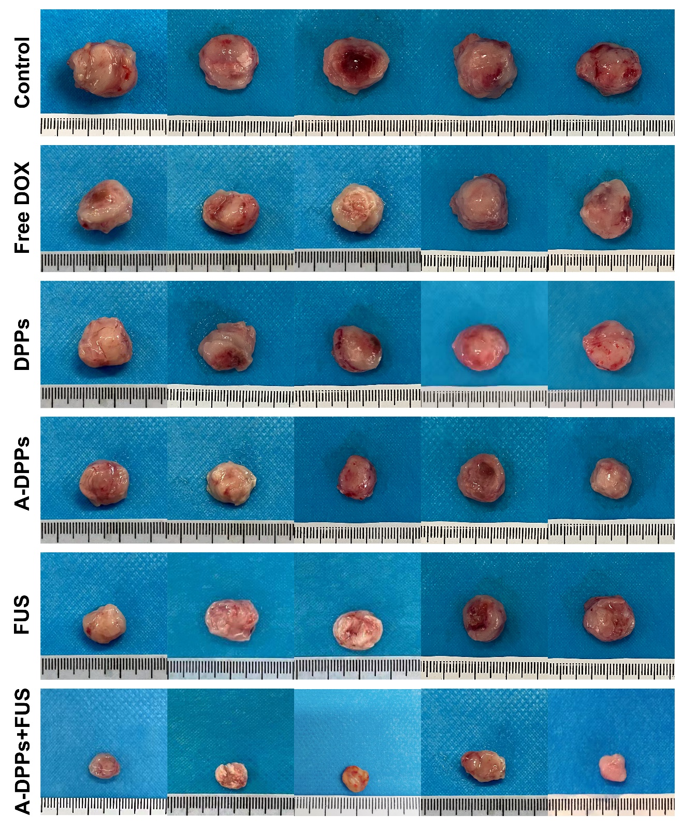
Figure S4: Tumor sizes in different treatments at Day 15. Digital photos of all tumors in each groups were shown.

References
- Mousnier, L.; Huang, N.; Morvan, E.; Fattal, E.; Tsapis, N. Influence of Polymer End- Chemistry on the Morphology of Perfluorohexane Polymeric Microcapsules Intended as Ultrasound Contrast Agents. Int. J. Pharm. 2014, 471, 10-17.
- Tang H, Guo Y, Peng L, et al. In Vivo Targeted, Responsive, and Synergistic Cancer Nanotheranostics by Magnetic Resonance Imaging-Guided Synergistic High-Intensity Focused Ultrasound Ablation and Chemotherapy. ACS Appl Mater Interfaces. 2018;10(18):15428-15441.
- Su YL, Fang JH, Liao CY, Lin CT, Li YT, Hu SH. Targeted Mesoporous Iron Oxide Nanoparticles-Encapsulated Perfluorohexane and a Hydrophobic Drug for Deep Tumor Penetration and Therapy. Theranostics. 2015;5(11):1233-1248. Published 2015 Aug 9.

