Supplemental material
Figure S1. Pre-episode versus baseline only in episodes arising from N3 stage.
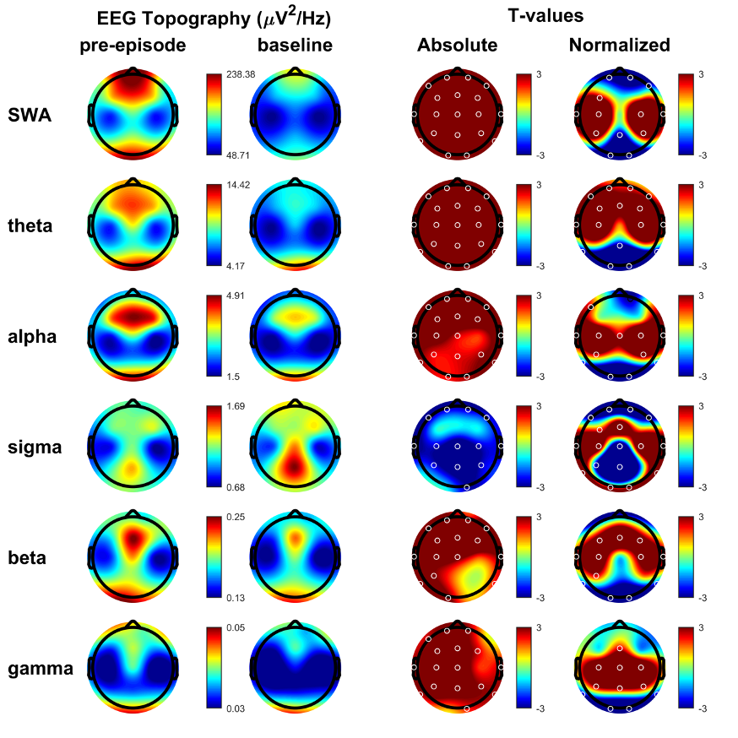

Spectral bands of DoA episodes arising from N3 stage, for each band frequency: slow wave activity or delta (0.5–4 Hz), theta (4–8 Hz), alpha (8–12 Hz), sigma (12–16 Hz), beta (15–25 Hz), and low gamma (25–45 Hz). First column: average NREM sleep EEG topographies across frequency bands during pre-episode. Second column: topographic averages during stable NREM sleep, two to three minutes before the episode. Third column: Map showing the individual electrode t-value (two-tailed, paired) maps for the comparison between pre-episode and baseline sleep in terms of absolute power. Red values represent an increase in absolute EEG power and blue values represent a decrease. Fourth column: Same as third column except that each subject was spatially normalized using the z-score across electrodes before creating the t-value comparison. White dots belong to significant clusters (P < 0.05) using statistical non-parametric mapping for multi-comparison correction.
Abbreviations: µV, microvolts; Hz, Hertz.

