Figure S1. The high-resolution of C 1s (A), N 1s (B) and Se 3d (C) peaks of the XPS spectra of Se/CDs, respectively.
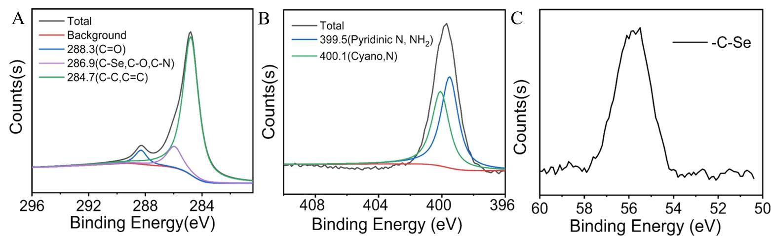

Figure S2. The effect of Se/CDs supplementation on the proliferation activity of cumulus cells and oocyte fragmentation rate
A: Proliferation activity assay of cumulus cells
Note: NC represents the negative control group. LD, MD and HD represent the Se/CDs groups supplemented with 50, 100 and 200 μg/mL of Se/CDs, respectively. The different lowercase letters in each column indicates significant differences between different groups (p<0.05).
B: Oocyte fragmentation rate
Note: NC represents the negative control group. LD, MD and HD represent the Se/CDs groups supplemented with 50, 100 and 200 μg/mL of Se/CDs, respectively. The different lowercase letters in each column indicates significant differences between different groups (p<0.05).

