Supplementary results
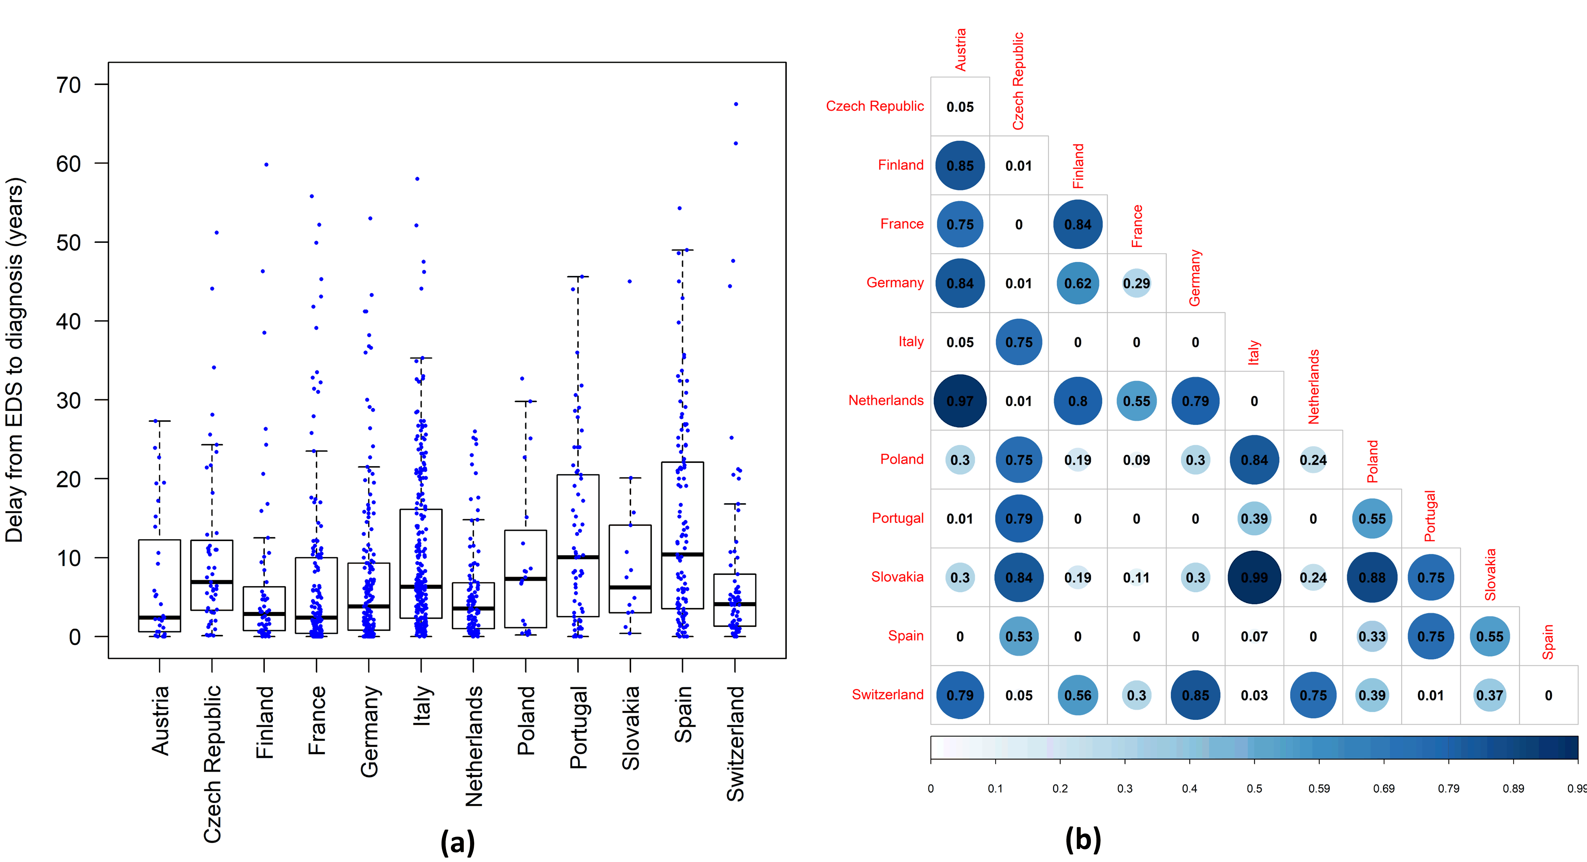Fig. S1. The diagnostic delays in each country (a) and the heat map of the pairwise comparison of the delays between the countries (b) in the whole database of 1051 patients. The 1051 patients include the non-validated patient who had missing value in any of the mandatory field but without missing data in the dates of EDS onset and diagnosis. The data are shown as boxplots and the data point of each patient is marked in blue. The diagnostic delay is significantly different among EUNN countries (Kruskal-Wallis rank sum test: P-value<0.0001).The numbers in the heat maps are the P-values of the pairwise comparisons. The value 0 in (b) means P-value<0.0001.

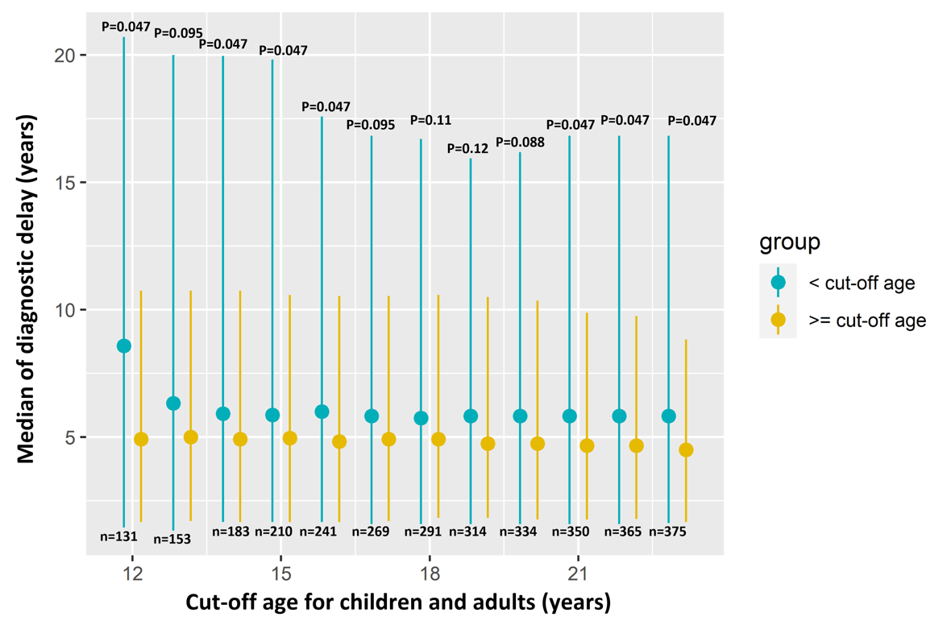
Fig. S2. The diagnostic delays in the younger subgroup (˂cut-off age) and older subgroup (≥cut-off age) defined by moving cut-off age between 12 and 23 years old. The points are the medians of the delays and the bars indicate the interquartile ranges. P-values of Wilcoxon rank sum tests between the two subgroups are added in the figure. P-values are adjusted by the false discovery rate method. The numbers of children cases (˂cut-off age) are also added, and the numbers of adults cases equal to 580-n.

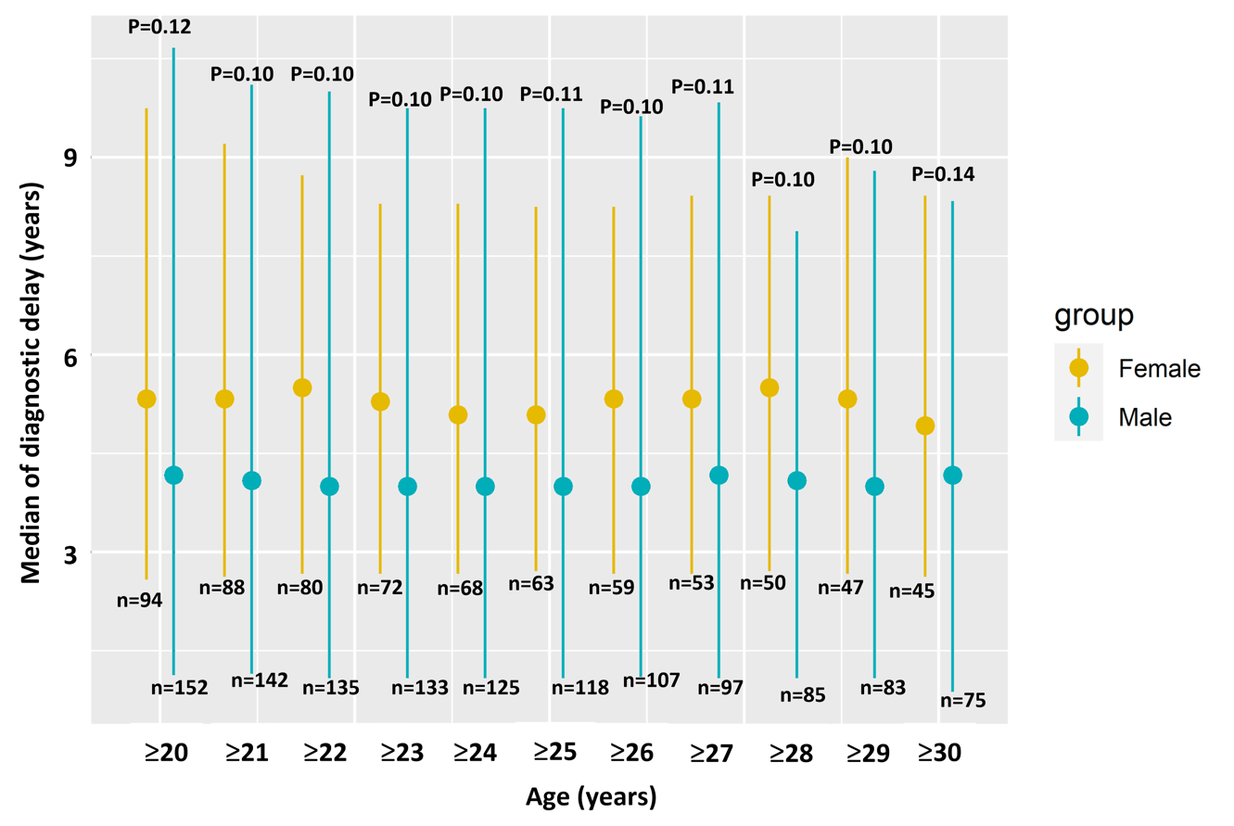
Fig. S3. The diagnostic delays between males and females in adult subgroup defined by moving cut-off age between 20 and 30 years old. The points are the medians of the delays and the bars indicate the interquartile ranges. P-values of Wilcoxon rank sum tests between males and females are added in the figure. P-values are adjusted by the false discovery rate method. The numbers of male and female patient ≥cut-off age are also displayed.
Table S1. The number of patient in each country in the additional analysis
Country | Number of patient originally used in the study | Number of patient for additional analysis *
Austria | 11 | 31
Czech Republic | 22 | 47
Finland | 42 | 56
France | 116 | 149
Germany | 70 | 167
Italy | 113 | 238 #
Netherlands | 56 | 98
Poland | 16 | 20
Portugal | 4 | 62
Slovakia | 8 | 14
Spain | 86 | 113
Swizerland | 36 | 66
TOTAL | 580 | 1051
* These patients include validated (i.e., no missing value in the mandatory fields of EUNN database), and non-validated patients (i.e., with missing value in any of the mandatory field of EUNN database) but without missing data in the dates of EDS onset and diagnosis. The EUNN decided to move the database to Redcap platform in the spring of 2018, and the new platform started to work in 2019. The original analyses were initiated in 2019 using the database before moving to Redcap, i.e., it only included patients entered by the spring of 2018. In the additional analysis we included all the entries in the database until May 2021.
# The number of patient is doubled in Italy because the whole local Bologna database was uploaded to Redcap EUNN database in 2020. The data entry from the other EUNN centers is volunteering based rather than systematically uploading their whole local databases. Therefore, selective bias (e.g., all patients from Bologna vs. selective patients from other centers) may still exist in the pooling analysis using the whole EUNN database, but it is very unlikely to influence the results of within-country comparisons shown in Table S2 below.
We include Austria and Portugal in the additional analyses in Table S2. Wilcoxon rank sum test suggests no significant difference in the diagnostic delays between patients diagnosed in 2000s and 2010s in each country except for in Finland. The diagnostic delay is significantly different among EUNN countries (Kruskal-Wallis rank sum test: P-value<0.0001).
Table S2. Wilcoxon rank sum test between patients diagnosed in 2010s and 2000s in each country
Country | Median (IQR) delay  2000-2009 (years), No. |  | Median (IQR) delay  2010-2020 (years), No. | P-value
France | 2.6 (0.8-10.3), n=49 | 1.6 (0.3-5.7), n=75 |  | 0.14
Italy | 6.2 (3.9-14.0), n=15 | 6.3 (2.3-16.2), n=219 |  | 0.88
Spain | 13.1 (5.5-21.8), n=36 | 10.0 (2.1-22.1), n=65 |  | 0.43
Germany | 3.1 (0.0-8.9), n=41 | 4.5 (1.7-9.3), n=112 |  | 0.15
Netherlands | 4.4 (2.8-5.0), n=15 | 3.5 (0.9-7.0), n=82 |  | 0.56
Finland | 7.7 (4.7-16.1), n=16 | 1.6 (0.6-3.2),n=35 |  | <0.0001
Switzerland | 4.9 (2.7-15.0), n=30 | 2.1 (1.1-5.3), n=35 |  | 0.07
Czech Republic | 9.9 (3.9-16.5), n=14 | 6.2 (3.3-11.6), n=32 |  | 0.47
Austria | 1.3 (0.2-5.7), n=10 | 4.1 (2.2-13.9), n=17 |  | 0.17
Portugal | 12.1 (4.0-20.6), n=28 | 7.0 (1.8-19.8), n=32 |  | 0.21
P-value is the Wilcoxon rank sum test between the diagnostic delays in 2000-2009 and 2010-2020.

