Supplementary materials

Figure S1: Complete flowchart for study inclusion
Abbreviations: LUTSqol, International Consultation on Incontinence Questionnaire Lower Urinary Tract Symptoms Quality of Life; UI-SF, International Consultation on Incontinence Questionnaire Urinary Incontinence Short Form.
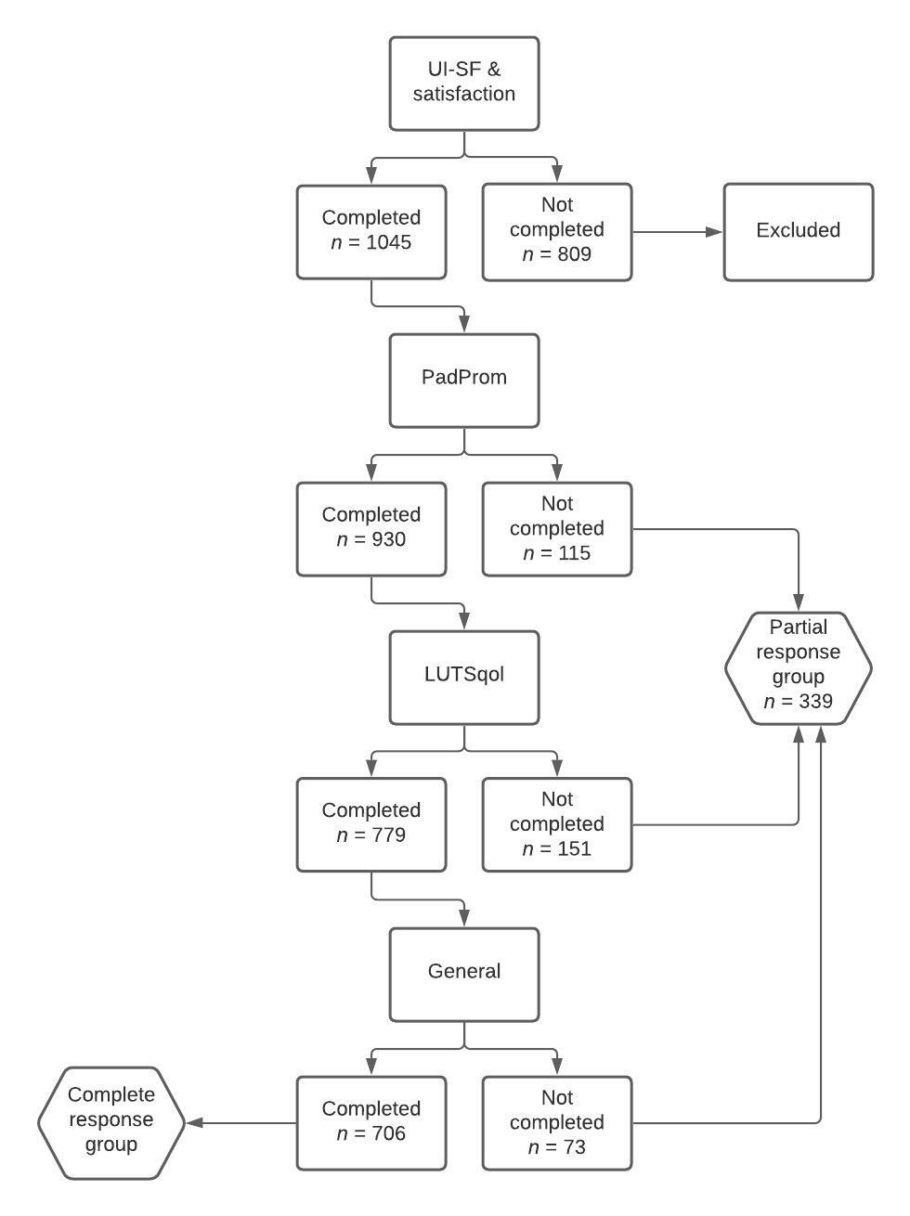

 | Partial responders  n = 339 | Complete responders  n = 706 | p-value
Age (years) | 63.2 ± 12.0 | 60.4 ± 12.0 | 0.001*
Gender |  |  | 0.007
Male | 15 (5.4) | 78 (11.0)
Female | 261 (94.6) | 628 (89.0)
Material supply |  |  | 0.294
Pharmacy | 101 (29.8) | 185 (26.2)
Online supplier | 82 (24.2) | 199 (28.2)
Shop | 156 (46.0) | 322 (45.6)
ICIQ-UI-SF
Satisfaction | 12.9 ± 3.6 | 12.8 ± 3.5 | 0.678
Material | 8.4 ± 2.8 | 8.7 ± 2.7 | 0.043
Care | 7.5 ± 2.9 | 7.2 ± 3.0 | 0.304
ICIQ-PadPROM | n = 224 | n = 706
Physical | 10.8 ± 4.1 | 10.4 ± 4.2 | 0.253
Psychological | 5.9 ± 4.0 | 5.9 ± 3.9 | 0.861
Social | 5.1 ± 3.5 | 4.3 ± 3.3 | 0.001*
Burden | 4.9 ± 2.3 | 4.8 ± 2.5 | 0.670
ICIQ-LUTSqol | n = 73 | n = 706
Score | 41.3 ± 15.3 | 40.5 ± 14.1 | 0.648
Table S1: Comparison of characteristics and outcomes between partial and complete survey responders

Notes: Data presented as mean ± standard deviation or n (% valid). Statistical analysis by t-test for continuous data and by χ² test for categorical variables. * p < 0.001, considered significant.
Abbreviations: ICIQ, International Consultation on Incontinence Questionnaire; ICIQ-LUTSqol, ICIQ Lower Urinary Tract Symptoms Quality of Life; ICIQ-PadPROM, ICIQ for Absorbent Pads; ICIQ-UI-SF, ICIQ Urinary Incontinence Short Form.

Table S2: Differences in survey questionnaire outcomes in patients with urinary incontinence who receive continence products either by pharmacy, national supplier, or shop, stratified for severity of symptoms.
 | Pharmacy | National supplier | Shop | p-value
Slight symptoms | N=7 | N=3 | N=14
Satisfaction Products | 10.6 ± 1.8 | 11.3 ± 1.2 | 8.2 ± 2.5 | 0.029
Satisfaction Care | 7.7 ± 3.2 | 9.0 ± 3.0 | 8.5 ± 2.3 | 0.739
Moderate symptoms | N=108 | N=95 | N=246
Satisfaction Products | 9.4 ± 2.6 | 9.3 ± 2.6 | 8.2 ± 2.6 | <0.001*
Satisfaction Care | 8.4 ± 2.9 | 8.4 ± 2.8 | 6.9 ± 2.6 | <0.001*
Severe symptoms | N=153 | N=159 | N=210
Satisfaction Products | 9.1 ± 2.6 | 9.2 ± 2.6 | 7.6 ± 2.7 | <0.001*
Satisfaction Care | 7.8 ± 3.0 | 7.9 ± 3.0 | 5.9 ± 2.7 | <0.001*
Very severe symptoms | N=18 | N=24 | N=8
Satisfaction Products | 7.5 ± 3.9 | 9.4 ± 2.6 | 6.4 ± 3.0 | 0.040
Satisfaction Care | 6.9 ± 4.0 | 8.1 ± 3.3 | 4.8 ± 3.2 | 0.082

Notes: Data presented as mean ± standard deviation or n (% valid). Statistical analysis by stratification based on categorization of ICIQ-UI-SF into: slight, moderate, sever and very severe symptoms. * p < 0.001, considered significant.
Abbreviations: ICIQ, International Consultation on Incontinence Questionnaire; ICIQ-UI-SF, ICIQ Urinary Incontinence Short Form.

