Supplementary Tables:

Table S1. Gen2 Confusion (Degree of Agreement) Matrices
 | Gen2 wake | Gen2 Light | Gen2 Deep | Gen2 REM
wake-N1 | 0.70(0.21) | 0.18(0.16) | 0.05(0.05) | 0.06(0.09)
wake-N2 | 0.71(0.17) | 0.17(0.14) | 0.05(0.05) | 0.07(0.09)
wake-N3 | 0.75(0.18) | 0.16(0.14) | 0.05(0.05) | 0.04(0.07)
Light-N1 | 0.09(0.05) | 0.61(0.12) | 0.22(0.11) | 0.09(0.07)
Light-N2 | 0.1(0.06) | 0.60(0.12) | 0.20(0.14) | 0.10(0.08)
Light-N3 | 0.1(0.06) | 0.60(0.13) | 0.22(0.12) | 0.09(0.07)
Deep-N1 | 0.01(0.05) | 0.23(0.22) | 0.72(0.25) | 0.03(0.08)
Deep-N2 | 0.01(0.02) | 0.20(0.22) | 0.78(0.24) | 0.01(0.03)
Deep-N3 | 0.01(0.04) | 0.19(0.24) | 0.77(0.25) | 0.02(0.06)
REM-N1 | 0.08(0.12) | 0.28(0.18) | 0.07(0.11) | 0.56(0.24)
REM-N2 | 0.08(0.07) | 0.30(0.17) | 0.10(0.12) | 0.53(0.21)
REM-N3 | 0.08(0.1) | 0.32(0.17) | 0.09(0.11) | 0.51(0.24)
Mean (standard deviation) of proportions, referenced to PSG, for each sleep stage classification. Classification accuracies for each sleep stage are highlighted in bold.
Abbreviations: N1, Night1; N2, Night2; N3, Night3; REM, rapid eye movement

Table S2. Gen3 Confusion (Degree of Agreement) Matrices
 | Gen3 wake | Gen3 Light | Gen3 Deep | Gen3 REM
wake-N1 | 0.77(0.18) | 0.17(0.14) | 0(0) | 0.07(0.09)
wake-N2 | 0.78(0.15) | 0.15(0.12) | 0(0.01) | 0.07(0.09)
wake-N3 | 0.80(0.14) | 0.15(0.12) | 0(0) | 0.05(0.07)
Light-N1 | 0.05(0.04) | 0.79(0.08) | 0.05(0.04) | 0.10(0.07)
Light-N2 | 0.06(0.05) | 0.81(0.08) | 0.05(0.04) | 0.09(0.06)
Light-N3 | 0.05(0.03) | 0.81(0.06) | 0.06(0.05) | 0.08(0.05)
Deep-N1 | 0.01(0.01) | 0.38(0.22) | 0.61(0.23) | 0(0.02)
Deep-N2 | 0.01(0.02) | 0.33(0.26) | 0.65(0.26) | 0.01(0.05)
Deep-N3 | 0.01(0.02) | 0.34(0.24) | 0.64(0.25) | 0(0.01)
REM-N1 | 0.04(0.05) | 0.13(0.11) | 0(0) | 0.83(0.14)
REM-N2 | 0.07(0.08) | 0.18(0.13) | 0(0.01) | 0.75(0.15)
REM-N3 | 0.05(0.07) | 0.16(0.13) | 0(0.01) | 0.79(0.16)
Mean (standard deviation) of proportions, referenced to PSG, for each sleep stage classification. Classification accuracies for each sleep stage are highlighted in bold.
Abbreviations: N1, Night1; N2, Night2; N3, Night3; REM, rapid eye movement.

Supplementary Figures:

In Supplementary Figure S1, epoch by epoch sensitivity of sleep stages is illustrated. Epoch by epoch specificity for 4-stage classification is shown in Supplementary Figure S2 across the 3 nights.

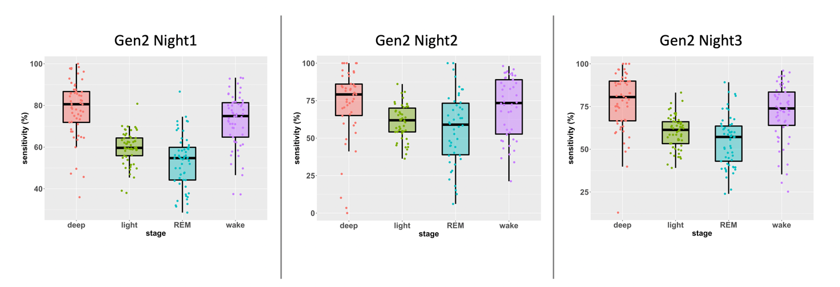
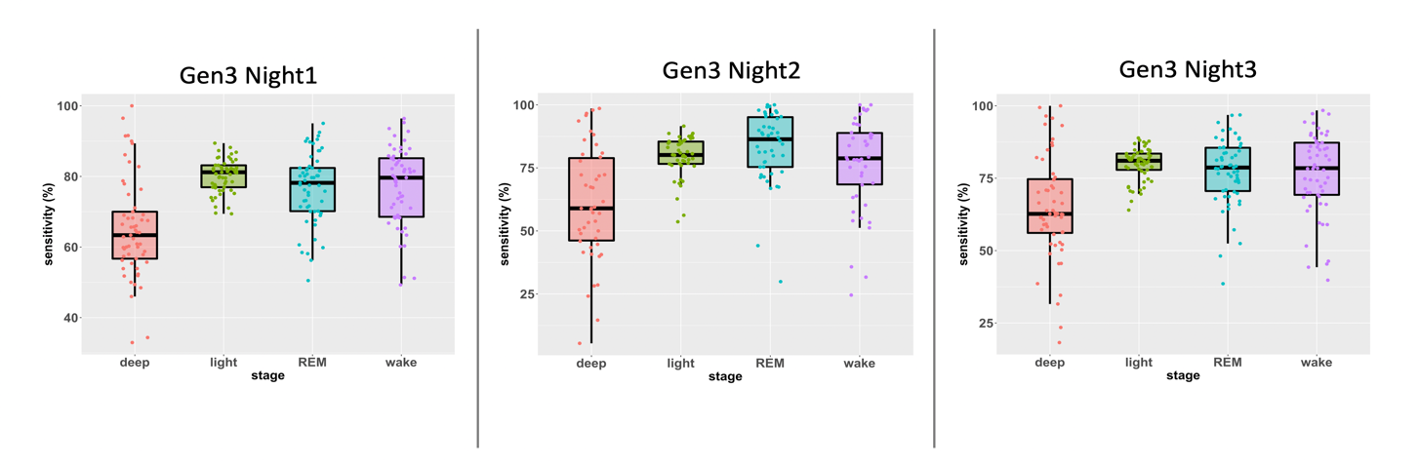 Supplementary Figure S1. Epoch by epoch sensitivity for 4-stage classification. Whiskers are computed as 1.5 times the interquartile range.

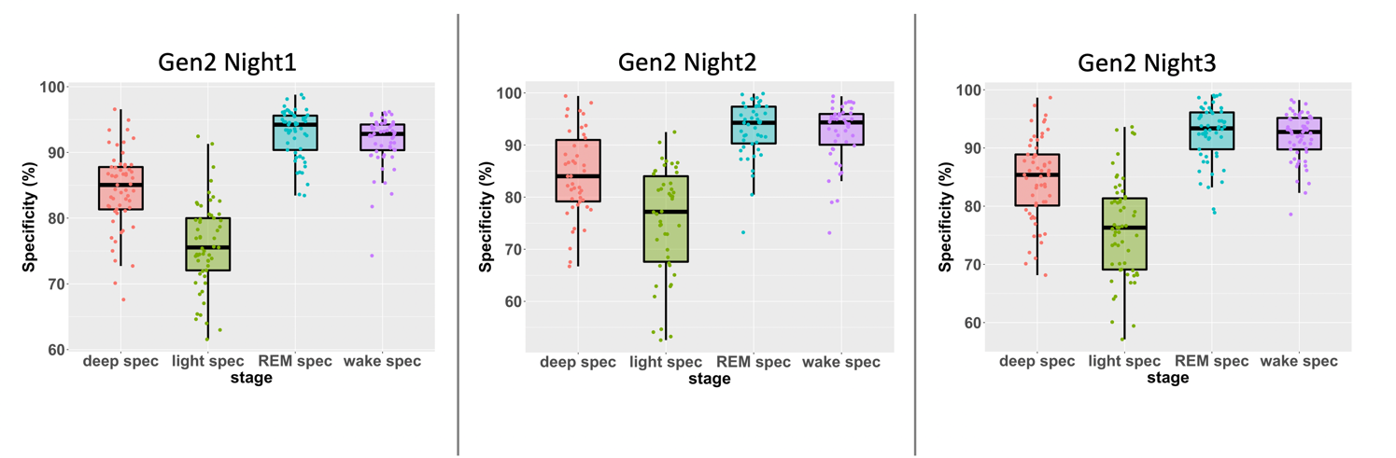

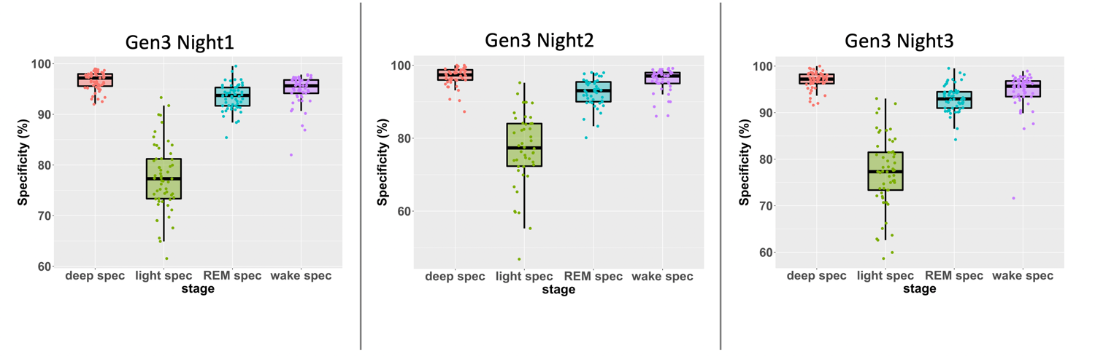
Supplementary Figure S2. Epoch by Epoch specificity for 4-stage classification. Whiskers are computed as 1.5 times the interquartile range.

