Supplementary Material
Figure S1: Selection of the study population

1. Patients treated for a non-AD indication or missing AD data

Figure S2: Cumulative number of AD patients who initiated crisaborole in MHS through Sep 2020 (N=441)
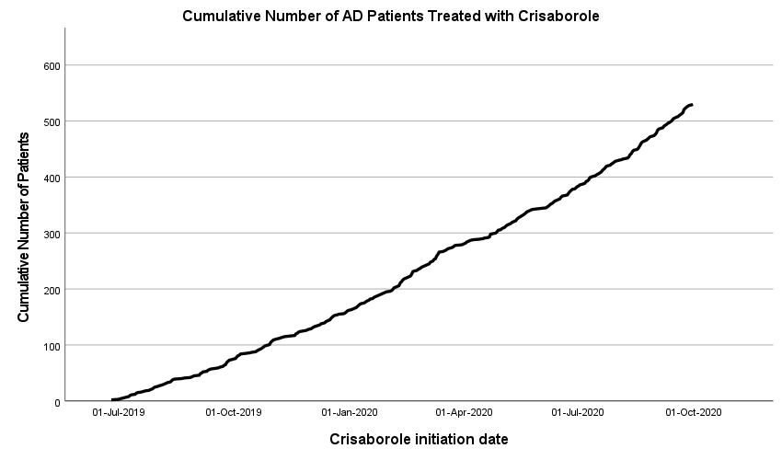

Table S1: TCS use up to 12 months prior to crisaborole initiation, by potency and age group
Quantity of TCS dispensed up to 12 months before crisaborole initiation |  | Age group, years
 |  | <12  (N=129) | 12 – 17  (N=70) | 18+  (N=242) | Total  (N=441)
Low-potency TCS | 1 pack | 26 (20.2%) | 9 (12.9%) | 45 (18.6%) | 80 (18.1%)
Low-potency TCS | 2-4 packs | 19 (14.7%) | 5 (7.1%) | 21 (8.7%) | 45 (10.2%)
Low-potency TCS | 5+ packs | 3 (2.3%) | 0 (0.0%) | 8 (3.3%) | 11 (2.5%)
Mid-potency TCS | 1 pack | 25 (19.4%) | 16 (22.9%) | 47 (19.4%) | 88 (20.0%)
Mid-potency TCS | 2-4 packs | 8 (6.2%) | 4 (5.7%) | 27 (11.2%) | 39 (8.8%)
Mid-potency TCS | 5+ packs | 3 (2.3%) | 1 (1.4%) | 6 (2.5%) | 10 (2.3%)
High-potency TCS | 1 pack | 34 (26.4%) | 15 (21.4%) | 60 (24.8%) | 109 (24.7%)
High-potency TCS | 2-4 packs | 25 (19.4%) | 22 (31.4%) | 61 (25.2%) | 108 (24.5%)
High-potency TCS | 5+ packs | 10 (7.8%) | 1 (1.4%) | 18 (7.4%) | 29 (6.6%)
TCS, topical corticosteroid

Table S2: Baseline comorbidities by age group and by AD severity (estimated from treatments dispensed up to 5 years prior to crisaborole treatment)
AD severityª | Comorbidity^{b} | Baseline period | Age group, years
AD severityª | Comorbidity^{b} | Baseline period | <12 | 12-17 | 18+ | Total
Mild | Asthma | Ever | 7 (7.4%) | 10 (20.8%) | 27 (21.1%) | 44 (16.2%)
Mild | Asthma | 5 years | 5 (5.3%) | 5 (10.4%) | 8 (6.3%) | 18 (6.6%)
Mild | Allergic rhinitis | Ever | 12 (12.6%) | 21 (43.8%) | 54 (42.2%) | 87 (32.1%)
Mild | Allergic rhinitis | 5 years | 9 (9.5%) | 19 (39.6%) | 14 (10.9%) | 42 (15.5%)
Moderate-to-severe | Asthma | Ever | 11 (32.4%) | 12 (54.5%) | 31 (27.2%) | 54 (31.8%)
Moderate-to-severe | Asthma | 5 years | 9 (26.5%) | 9 (40.9%) | 20 (17.5%) | 38 (22.4%)
Moderate-to-severe | Allergic rhinitis | Ever | 13 (38.2%) | 12 (54.5%) | 52 (45.6%) | 77 (45.3%)
Moderate-to-severe | Allergic rhinitis | 5 years | 12 (35.3%) | 11 (50.0%) | 33 (28.9%) | 56 (32.9%)
^{a.} Estimated from treatments: Moderate-to-severe AD defined as ≥1 SI or biologic or phototherapy treatment dispensed up to 5 years prior to crisaborole treatment (for medication, restricted to purchases on/after the earliest AD diagnosis).
^{b.} ≥1 diagnosis code in the given baseline period which was given by a relevant specialist or hospital or MHS Medication Approval Center, or ≥1 diagnoses from pediatrician/family physician

