Comparison of Real-world Dose and Consumption for two Extended Half-life Recombinant Factor VIII Products for the Treatment of Hemophilia A in the United States
Yanyu Wu¹; Shawn X. Sun¹; Tao Fan²
Author affiliations
¹Global Evidence & Outcomes, Data Sciences Institute, Research and Development, Takeda Development Center Americas, Inc., Cambridge, MA, USA
²US Health Economics and Outcomes Research, Takeda Pharmaceuticals USA, Inc., Lexington, MA, USA

Correspondence:
Yanyu Wu, Global Evidence & Outcomes, Data Sciences Institute, Research and Development, Takeda Development Center Americas, Inc., 40 Landsdowne Street, Cambridge, MA, USA
Tel +1 617-955-6408
Email yanyu.wu@takeda.com

Supplementary material

Supplementary Table 1 Weekly Consumption (IU/kg) for Patients Receiving Efmoroctocog Alfa or Rurioctocog Alfa Pegol Using Only 2017 Data
Statistic | Efmoroctocog Alfa |  |  |  | Rurioctocog Alfa Pegol
Statistic | Age Missing | Age <12 Years | Age ≥12 Years | Allª | Age <12 Years | Age ≥12 Years | All
Dispensing records, n | 115 | 278 | 689 | 1082 | 38 | 413 | 451
Estimated weekly prophylactic dose (IU/kg)
Mean | 99.6 | 111.2 | 102.6 | 104.5 | 88.3 | 91.6 | 91.3
95% CI | 93.0–106.2 | 99.4–123.0 | 98.6–106.6 | 100.5–108.5 | 77.7–99.0 | 87.7–95.4 | 87.6–94.9
SD | 35.6 | 99.6 | 54.0 | 67.5 | 32.4 | 40.0 | 39.4
Median | 95.5 | 87.5 | 92.8 | 92.2 | 89.2 | 86.3 | 86.4
IQR | 79.7–113.9 | 65.6–126.6 | 71.2–113.8 | 71.1–115.7 | 56.1–106.6 | 67.1–108.5 | 66.6–108.5
Note: Subgroup analyses were performed on data from one complete year (2017) after both compounds had been approved for use in the US for ≥1 year.
ªIncludes the 115 records with age missing.
Abbreviation: IQR, interquartile range.

Supplementary Figure 1 Infusion Frequency for (A) Efmoroctocog Alfaª and (B) Rurioctocog Alfa Pegol^{b}
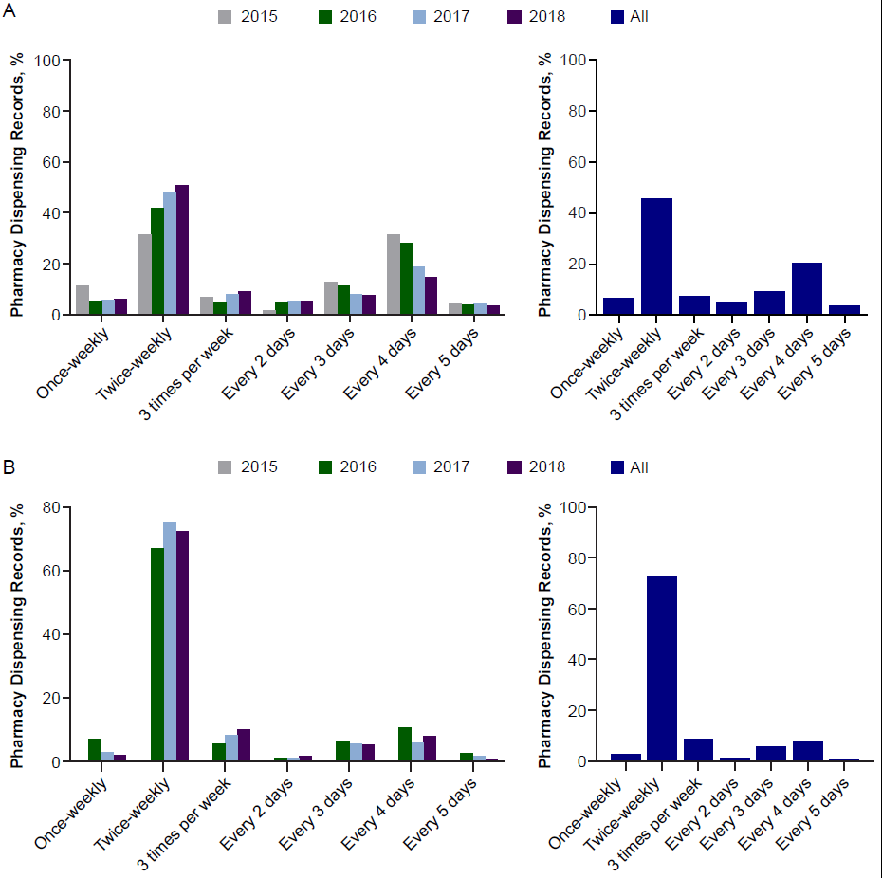
Note: Percentages may not total 100%, as some records included alternative regimens.
ªFollowing US approval in June 2014, data for efmoroctocog alfa were available from 2015 to 2018.
^{b}Following US approval in November 2015, data for rurioctocog alfa pegol were available from 2016 to 2018.

