Supplemental Figures
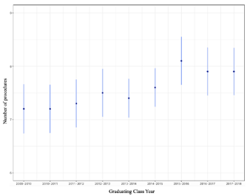
Supplemental Figure 1. Average number of Cornea/Corneoscleral Laceration/Globe Rupture procedures performed as primary surgeon per resident based on graduating class from 2009-2018 with 95% confidence interval

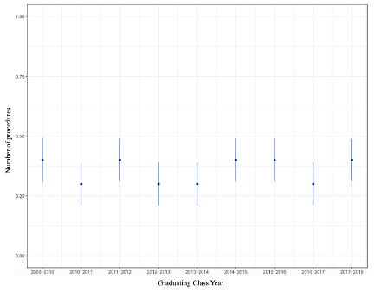

Supplemental Figure 2. Average number of intraocular foreign body procedures performed as primary surgeon per resident based on graduating class from 2009-2018 with 95% confidence interval.

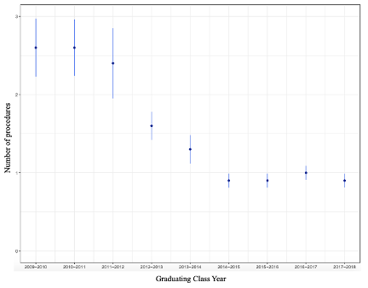
Supplemental Figure 3. Average number of “other” procedures performed as primary surgeon per resident based on graduating class from 2009-2018 with 95% confidence interval.

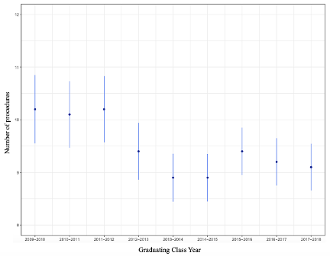
Supplemental Figure 4. Average number of total procedures performed as primary surgeon per resident based on graduating class from 2009-2018 with 95% confidence interval.

