Combined Prussian blue nanozyme carriers improve photodynamic therapy and effective interruption of tumor metastasis

Wenhao Shen^{1,#}, Gaohua Han^{1,#}, Lei Yu¹, Song Yang¹, Xiangyi Li², Wei Zhang^{3,}*, Pei Pei^{4,}*

¹Department of Oncology, Hospital Affiliated 5 to Nantong University (Taizhou People's Hospital), Taizhou, Jiangsu, China;
²Department of endocrinology, Hospital Affiliated 5 to Nantong University (Taizhou People's Hospital), Taizhou, Jiangsu, China;
³Department of Infectious Disease, Hospital Affiliated 5 to Nantong University (Taizhou People's Hospital), Taizhou, Jiangsu, China;
⁴ School of Basic Medical Sciences, Anhui Medical University, Hefei 230032, P. R. China.
#These authors contributed equally to this manuscript.
*Corresponding authors: Wei Zhang: zw562652291@126.com; Pei Pei: ppei1204@outlook.com.
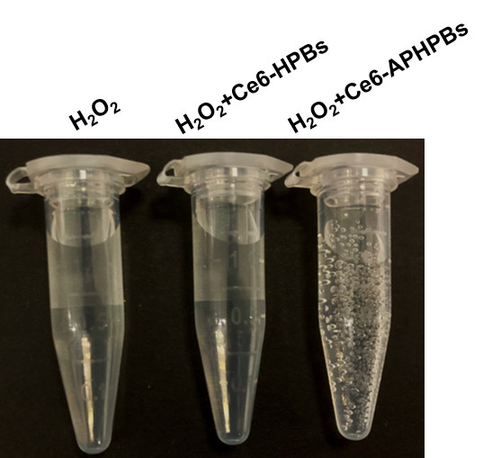
Figure S1 Photos of Ce6-APHBPs catalyzing H₂O₂ decomposition to produce O₂.
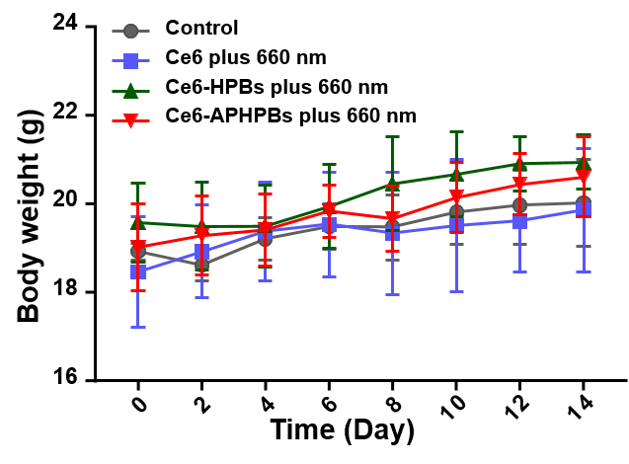
Figure S2 Body weight of 4T1 tumor bearing mice at different time points after treatments.

