Supplementary 1 The mRNA expression of Mfn1 and Mfn2 of cisplatin-induced mouse AKI models.
The data was presented as the mean ± SEM, ns = no significance, ***P <0.001, n=4-6.

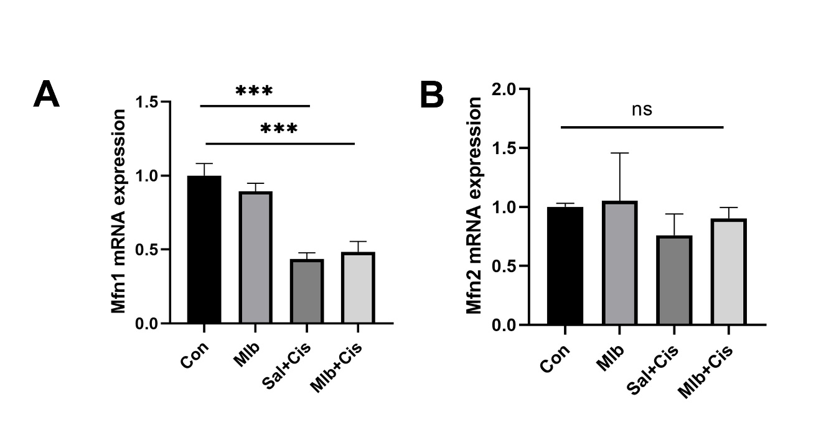
Supplementary 2 Original data of western blot.
(A) Western blot figures for Figure 2. (B) Western blot figures for Figure 3. (C)Western blot figures for Figure 5. (D) Western blot figures for Figure 6.

