Supplementary Information 1 Enrollment Criteria for Prediction score projects
Enrollment Inclusion Criteria
Subject must have met at least one clinical criteria to be eligible for treatment in the study:
- Adult patients ≥65 years of age (n=1350)
- Female gender (n=881)
- Documented PAD or CAD/PAD revascularization (n=654)
- Diabetes mellitus (n=1347)
- Chronic kidney disease (n=328)
- Troponin positive (n=1860)
- The subject (n=4130) had consented to participate and had authorized the collection and release of his medical information by signing the “Patient Informed Consent Form”.
Subject must have met at least one angiographic criteria to be eligible for treatment in the study:
- Multi-vessel coronary artery disease (n=2976)
- Target lesion requiring total stent length>30 mm (n=1085)
- Thrombotic target lesion (n=1574)
- Bifurcation lesions (n=1356)
- Left main (≥50%) or proximal LAD (≥70%) lesion (n=1774)
- Calcified target lesion (n=1369)
Candidate Variables for Model Building
Variables were considered for model building if they demonstrated a priori associations with major adverse cardiovascular and cerebrovascular events (MACCE) in previously published literature and were thought to have a clinically plausible relationship with both ischemia and bleeding outcomes.
Endpoint Definitions
All-cause death, re-myocardial infarction, revascularization, heart failure, ischemic stroke, hemorrhagic stroke

Supplementary table 1: LASSO regression
Variables | Variables
Age≦40 | Risk factors
40<Age≦50 | Hypertension
50<Age≦60 | Diabetes
60<Age≦70 | Atrial fibrillation
70<Age≦80 | CKD
Age>80 | Previous CABG
Male | Previous PCI
Optimal BP | Inflammatory factors
Normal BP | D-dimer≧0.5
Hi Normal BP | hs-CRP≦3.5
hypertension | 3.5<hs-CRP≦10
Killip I | hs-CRP>10
Killip II | Renal function
Killip III | Crea<44
Killip IV | 44≦Crea≦133
IABP using | Crea>133
EF at admission>55 | eGFR≧90
45<EF at admission≦55 | 60≦eGFR<90
EF at admission≦45 | eGFR<60
DTB time | lipid levels
Results of coronary angiography | LDL-C≧3.0mmol/L
LM lesion | HDL-C<1.0 mmol/L
No-reflow phenomenon | TG≧1.70 mmol/L
Triple-vessel lesions | Lpa>300
Complete revascularization | The lesion type
Culprit vessel | Denove lesion
LCX | In-stent restenosis
RCA | Stent thrombosis
LAD | Ticagrelor[%(n)]
LM | P2Y12 inhibitors
SVG and others
Degree of vascular stenosis
coronary artery≦70%LM≦50%
70%<coronary artery≦80%,
50%<LM≦50%
80%<coronary artery≦90%,
60%<LM≦80%
90%<coronary artery
80%<LM
BP, blood pressure; IABP, Intra-aortic balloon pump; EF, ejection fraction; DTB time, door to balloon time; CKD, chronic kidney disease; Crea, creatinine; eGFR, estimated glomerular filtration rate; PCI, percutaneous coronary intervention; CABG, coronary artery bypass grafting; HDL-C, high-density lipoprotein cholesterol; LDL-C, low-density lipoprotein cholesterol; TG, triglyceride; LPA, lipse activator; hs-CRP, high sensitive C-reactive protein; LM, Left main lesion; LCX, left circumflex coronary artery; RCA, right coronary artery; LAD, left anterior descending branch; SVG, saphenous vein graft;
Supplementary Model 1: Full model from observed data
0.02308*(AGE.GROUP=2)-0.50803*(AGE.GROUP=3)-1.38581*(AGE.GROUP=4)-2.55753*(AGE.GROUP=5) -3.70453*(AGE.GROUP=6) +0.12930*(KILLIP=2) +0.54131*(KILLIP=3) +1.14814*(KILLIP=4) -0.18817*(EF=1)+0.75118*(HISTORY.OF.CAGB.1=1)+0.40747*(TYPES.OF.LESIONS=2)+0.34999*(TYPES.OF.LESIONS=3)-0.16277*(COMPLETE.REVASCULARIZATION=1)+0.67543*(MULTI.VESSEL.DISEASE=1); Log likelihood -3402.7877
Supplementary table 2 multivariate cox regression by full model from observed data
Variables | Coefficiency | Wald | HR | Low 95%CI | High 95%CI | P value
40<Age≦50 | 0.0231 | 0.2963 | 1.0233 | 0.5726 | 1.8291 | 0.9379
50<Age≦60 | -0.5080 | 0.2990 | 0.6017 | 0.3348 | 1.0812 | 0.0893
60<Age≦70 | -1.3858 | 0.3057 | 0.2501 | 0.1374 | 0.4553 | <0.0001
70<Age≦80 | -2.5575 | 0.3237 | 0.0775 | 0.0411 | 0.1462 | <0.0001
Age>80 | -3.7045 | 0.3964 | 0.0246 | 0.0113 | 0.0535 | <0.0001
Killip II | 0.1293 | 0.1339 | 1.1380 | 0.8754 | 1.4794 | 0.3341
Killip III | 0.5413 | 0.2957 | 1.7183 | 0.9625 | 3.0674 | 0.0671
Killip IV | 1.1481 | 0.1954 | 3.1523 | 2.1493 | 4.6234 | <0.0001
EF at admission>50% | -0.1882 | 0.0971 | 0.8285 | 0.6849 | 1.0022 | 0.0527
Previous CABG | 0.7512 | 0.3082 | 2.1195 | 1.1585 | 3.8776 | 0.0148
In-stent restenosis | 0.4075 | 0.2867 | 1.5030 | 0.8569 | 2.6363 | 0.1552
Stent thrombosis | 0.3500 | 0.2029 | 1.4190 | 0.9535 | 2.1119 | 0.0845
Complete revascularization | -0.1628 | 0.1093 | 0.8498 | 0.6860 | 1.0527 | 0.1363
Muti-vessel lesions | 0.6754 | 0.1280 | 1.9649 | 1.5289 | 2.5252 | <0.0001

concordant | discordant | tied.risk | tied.time | std(c-d) | C | se(C)
373297 | 157347 | 23282 | 10 | 16449.6674 | 0.6949 | 0.0148

Supplementary Model 2: Stepwise (stepAIC) selected model from observed data
0.02308*(AGE.GROUP=2) -0.50803*(AGE.GROUP=3) -1.38581*(AGE.GROUP=4) -2.55753*(AGE.GROUP=5) -3.70453*(AGE.GROUP=6) +0.12930*(KILLIP=2) +0.54131*(KILLIP=3) +1.14814*(KILLIP=4) -0.18817*(EF=1) +0.75118*(HISTORY.OF.CAGB.1=1) +0.40747*(TYPES.OF.LESIONS=2) +0.34999*(TYPES.OF.LESIONS=3) -0.16277*(COMPLETE.REVASCULARIZATION=1) +0.67543*(MULTI.VESSEL.DISEASE=1)
Log likelihood -3402.7877
Supplementary table 3 multivariate cox regression by stepwise selected model from observed data
Variables | Coefficiency | Wald | HR | Low 95%CI | High 95%CI | P value
40<Age≦50 | 0.0231 | 0.2963 | 1.0233 | 0.5726 | 1.8291 | 0.9379
50<Age≦60 | -0.5080 | 0.2990 | 0.6017 | 0.3348 | 1.0812 | 0.0893
60<Age≦70 | -1.3858 | 0.3057 | 0.2501 | 0.1374 | 0.4553 | <0.0001
70<Age≦80 | -2.5575 | 0.3237 | 0.0775 | 0.0411 | 0.1462 | <0.0001
Age>80 | -3.7045 | 0.3964 | 0.0246 | 0.0113 | 0.0535 | <0.0001
Killip II | 0.1293 | 0.1339 | 1.1380 | 0.8754 | 1.4794 | 0.3341
Killip III | 0.5413 | 0.2957 | 1.7183 | 0.9625 | 3.0674 | 0.0671
Killip IV | 1.1481 | 0.1954 | 3.1523 | 2.1493 | 4.6234 | <0.0001
EF at admission>50% | -0.1882 | 0.0971 | 0.8285 | 0.6849 | 1.0022 | 0.0527
Previous CABG | 0.7512 | 0.3082 | 2.1195 | 1.1585 | 3.8776 | 0.0148
In-stent restenosis | 0.4075 | 0.2867 | 1.5030 | 0.8569 | 2.6363 | 0.1552
Stent thrombosis | 0.3500 | 0.2029 | 1.4190 | 0.9535 | 2.1119 | 0.0845
Complete revascularization | -0.1628 | 0.1093 | 0.8498 | 0.6860 | 1.0527 | 0.1363
Muti-vessel lesions | 0.6754 | 0.1280 | 1.9649 | 1.5289 | 2.5252 | <0.0001

Supplementary table 4 ROC curve analysis and optimal threshold analysis of prediction model
Model | Time | Best.cut.X | Best.cut.sens | Best.cut.spec | Cases | N.survivor | N.censored | Cum.incidence | Surv.prob | AUC
Full | 422.939027 | 0.995612 | 0.681 | 0.575 | 103 | 1757 | 431 | 0.048 | 0.9522 | 0.633
Full | 577.121597 | 0.703542 | 0.697 | 0.776 | 159 | 1391 | 741 | 0.081 | 0.9187 | 0.771
Full | 875.536805 | 0.851291 | 0.715 | 0.9 | 214 | 1039 | 1038 | 0.122 | 0.8781 | 0.845
Full | 1410.673611 | 0.995612 | 0.618 | 0.949 | 265 | 884 | 1142 | 0.168 | 0.8317 | 0.81
Full | 1824.966666 | 1.048901 | 0.567 | 0.917 | 319 | 749 | 1223 | 0.222 | 0.7784 | 0.806
Full | 2100.564784 | 1.216299 | 0.75 | 0.783 | 373 | 594 | 1324 | 0.282 | 0.7183 | 0.823
Full | 2332.835343 | 1.429327 | 0.795 | 0.918 | 427 | 438 | 1426 | 0.354 | 0.6461 | 0.886
Stepwise | 422.939027 | 0.995612 | 0.681 | 0.575 | 103 | 1757 | 431 | 0.048 | 0.9522 | 0.633
Stepwise | 577.121597 | 0.703542 | 0.697 | 0.776 | 159 | 1391 | 741 | 0.081 | 0.9187 | 0.771
Stepwise | 875.536805 | 0.851291 | 0.715 | 0.9 | 214 | 1039 | 1038 | 0.122 | 0.8781 | 0.845
Stepwise | 1410.673611 | 0.995612 | 0.618 | 0.949 | 265 | 884 | 1142 | 0.168 | 0.8317 | 0.81
Stepwise | 1824.966666 | 1.048901 | 0.567 | 0.917 | 319 | 749 | 1223 | 0.222 | 0.7784 | 0.806
Stepwise | 2100.564784 | 1.216299 | 0.75 | 0.783 | 373 | 594 | 1324 | 0.282 | 0.7183 | 0.823
Stepwise | 2332.835343 | 1.429327 | 0.795 | 0.918 | 427 | 438 | 1426 | 0.354 | 0.6461 | 0.886

A | B
C | D
Supplementary figure 1, the decision curve analysis of 3-year and 5-year in the derivation and validation cohort

Supplementary figure 2 ROC curves of the Grace risk score model by the derivation cohort (N = 2384). The AUC of the Grace risk score model is 0.672
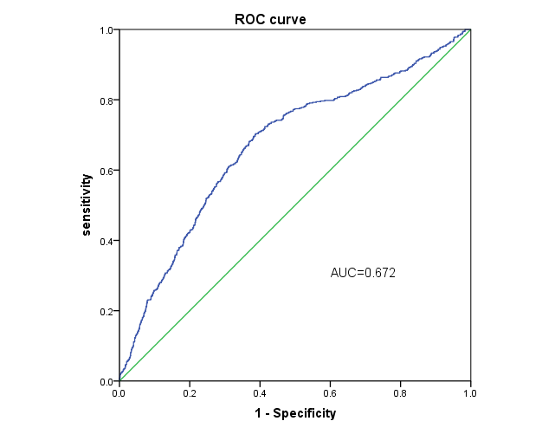

Supplementary figure 3 Subgroup of predicting all caused death (figure 4A-D), recurrence MI (figure 4E-H) and stroke (figure4 I-L) between the high risk group and relative low risk group in both development and validation group in 3-year and 5-year development and validation cohort.
A
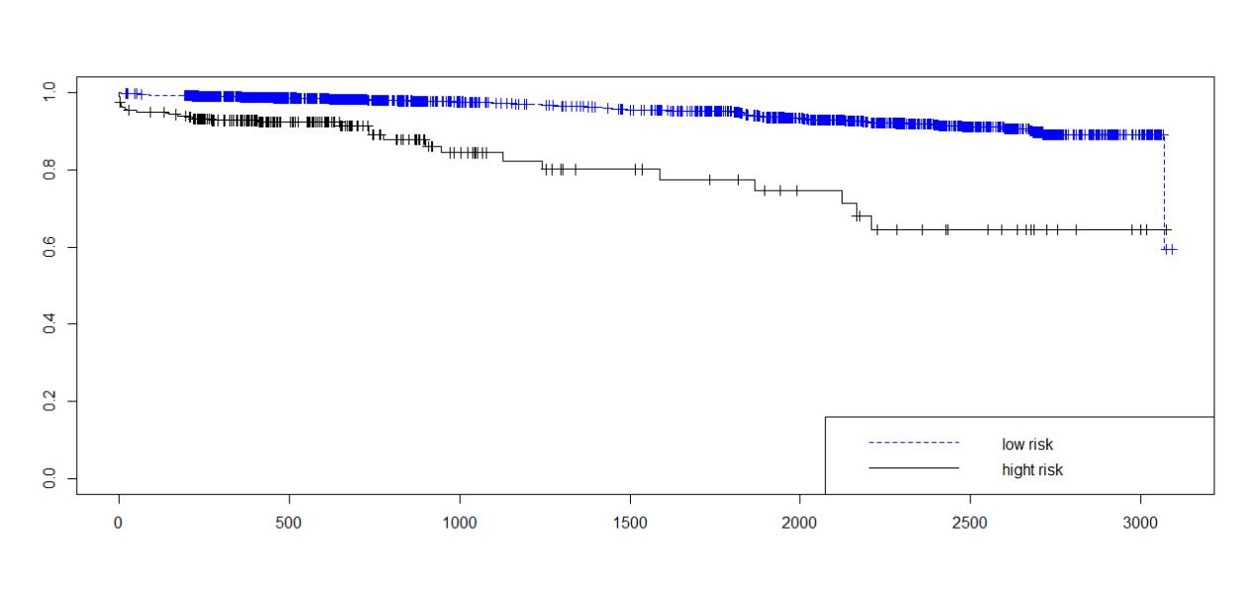
B
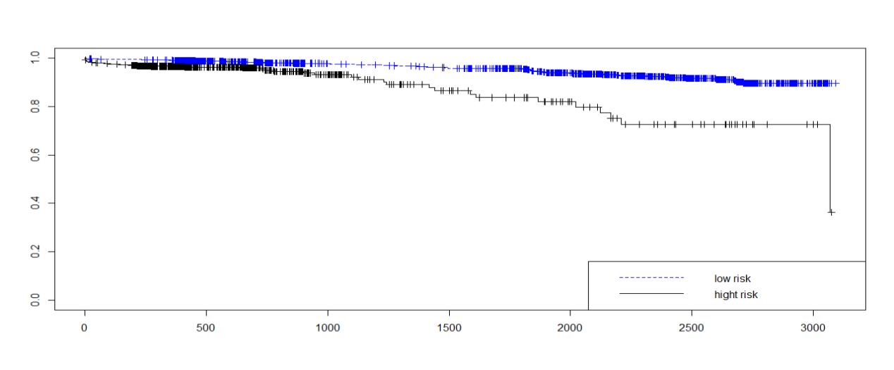
C
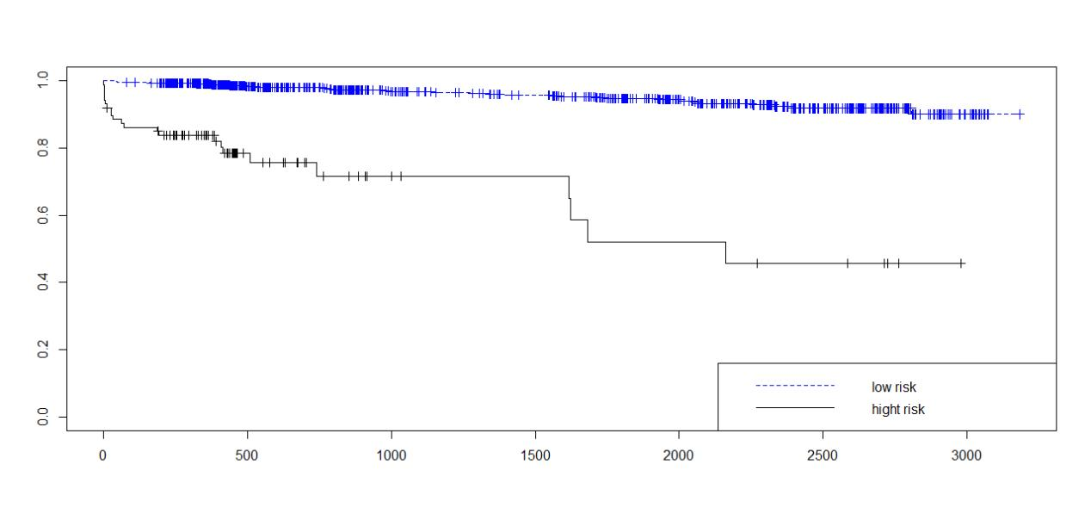
D
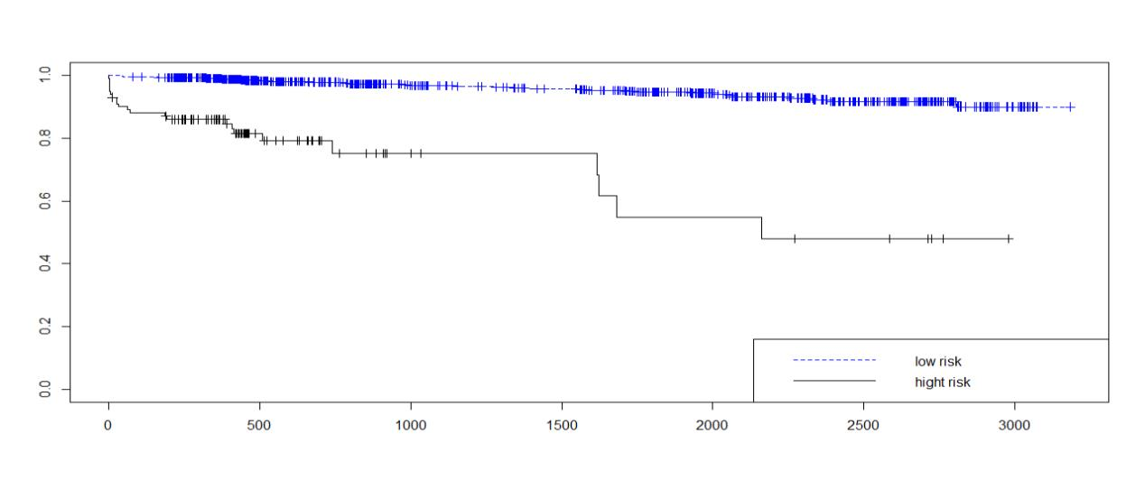
E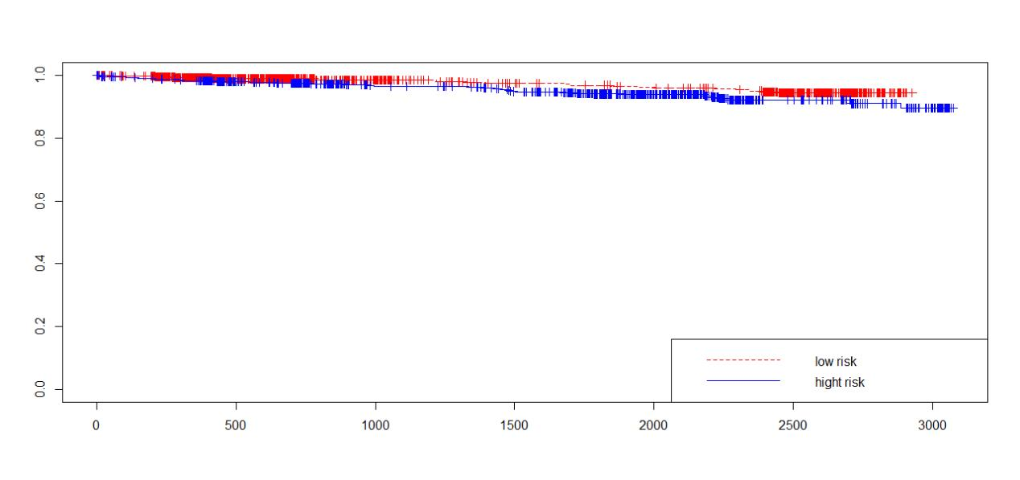
F
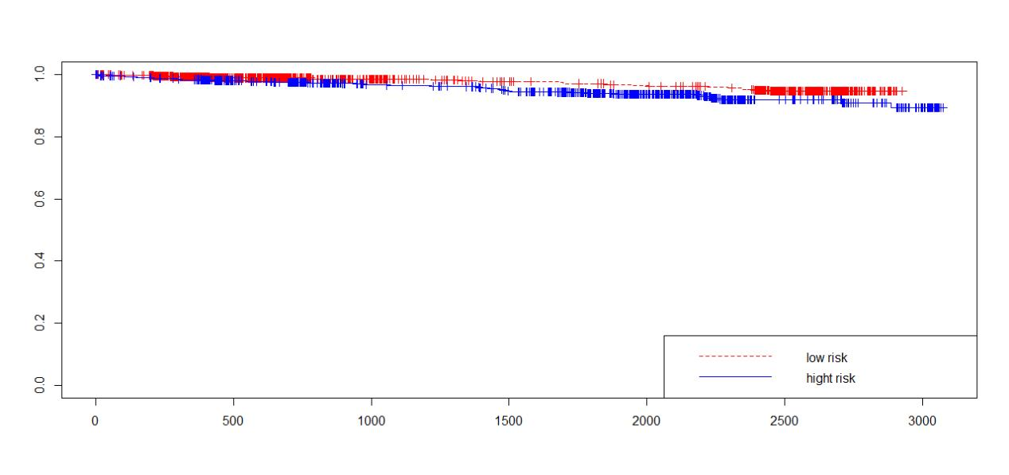
G
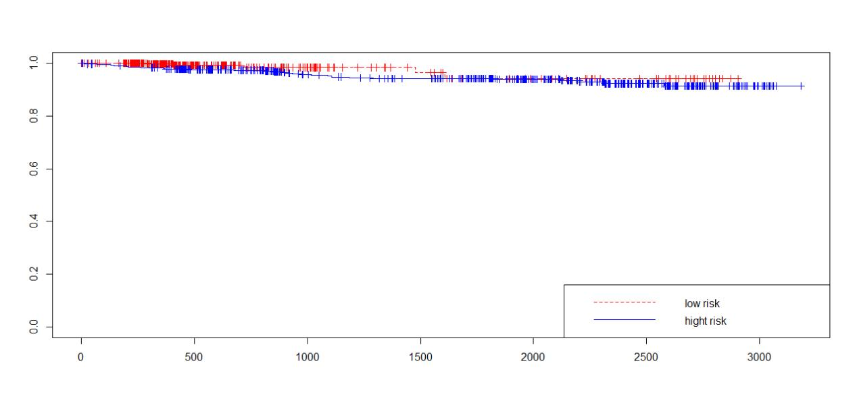
H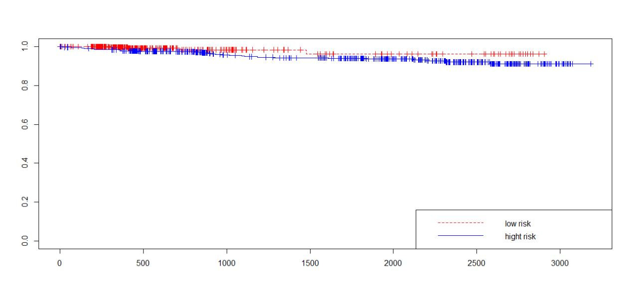

I
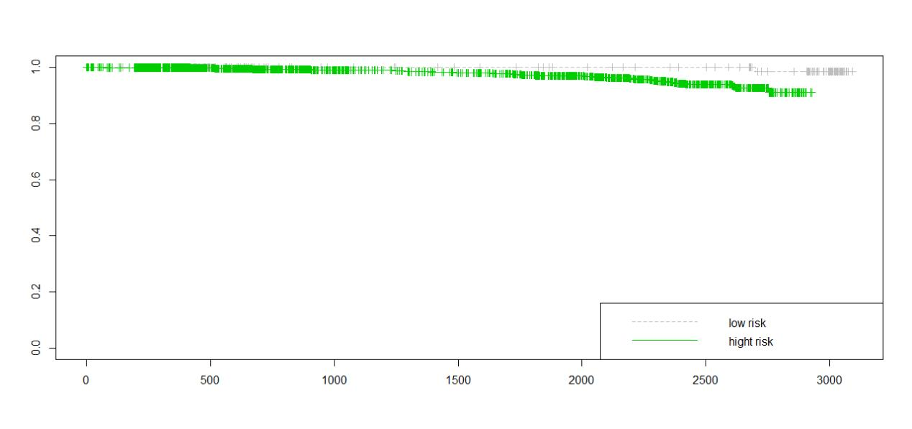
J
K
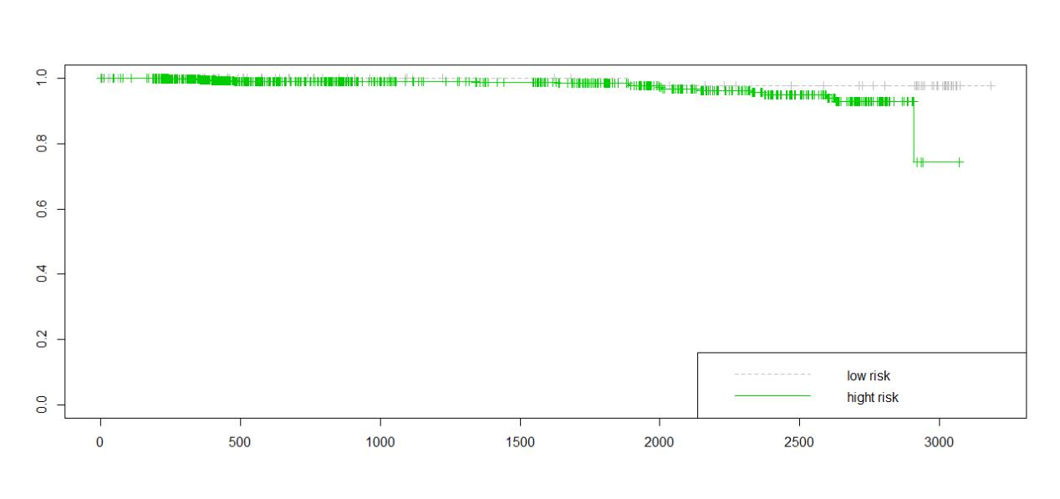
L
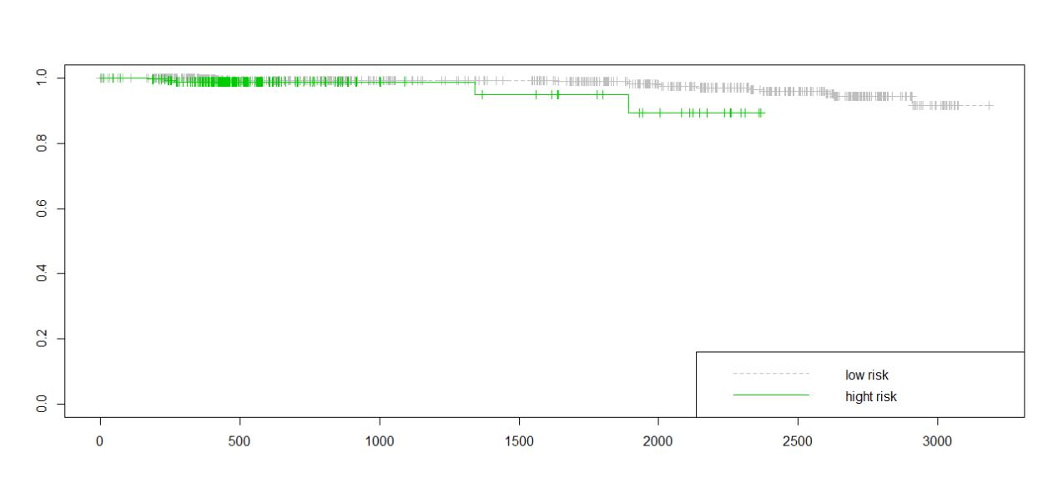

Supplementary figure 4 one-fold cross validation
Divided the data into ten parts, and then we took the first data set as the training set. Finally, the fitting model is obtained. The ROC curve was as follows. The area under curve (AUC) was 0.744 and the confidence interval was 0.645-0.789.
