Supplementary Materials

Figure Legends

Figure S1 The GO enrichment analysis of trans_targets of ElncRNAs. (A) Enrichment of BP of trans_targets. (B) Enrichment of CC of trans_targets. (C) Enrichment of MF of trans_targets.

Figure S2 The KEGG analysis of trans_targets of ElncRNAs. (A) The enrichment of pathways of trans_targets. (B) The whole analyses of trans_targets. The whole outlook of enriched pathways, including cellular process, environmental processing, genetic information processing, human diseases and original systems, of trans_targets.

Figure S1
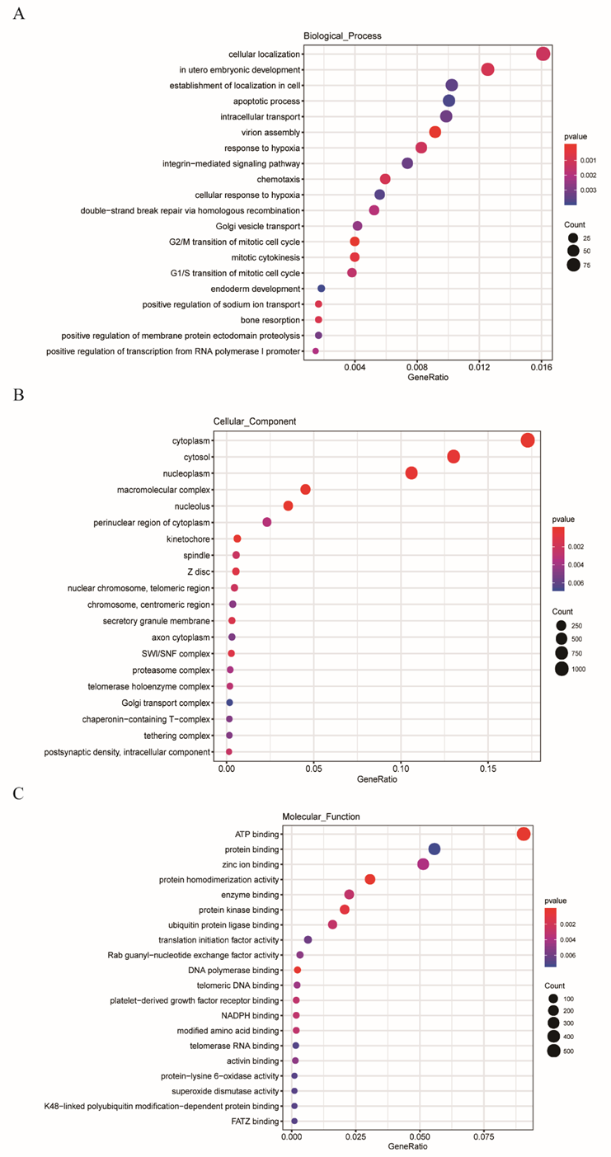

Figure S2

