Hydrophilic realgar nanocrystals prolong the survival of refractory acute myeloid leukemia mice through inducing multi-lineage differentiation and apoptosis
Tao Wang#, Xue Zhang#, Mengfan Jia, Aiyun Yang, Jian Liu, Tao Wen, Jie Meng*, Haiyan Xu*
Department of Biomedical Engineering, Institute of Basic Medical Sciences, Chinese Academy of Medical Sciences & Peking Union Medical College, Beijing 100005, China
# These authors contributed equally to this work.

*Correspondence:
Haiyan Xu
Address: 5 Dong Dan San Tiao, Beijing 100005, China;
E-mail: xuhy@pumc.edu.cn
Tel: (+86)10 69156437

Jie Meng
Address: 5 Dong Dan San Tiao, Beijing 100005, China;
E-mail: mengjie@ibms.pumc.edu.cn
Tel: (+86)10 65135502

Figure S1. Mean fluorescence intensity (MFI) of the cells stained with CD11b(A), CD235a (B), and CD41a (C).

Figure S2. Morphological changes in Kasumi-1 cells with or without the treatment of ee-As₄S₄. A. Image of Wright-Gamesa staining. (I-IV) presented the overall cellular size (I) and the typical megakaryocyte -like (II), granulocyte-like (III), and erythroid-like (IV) phenotypes after being treated with ee-As4S4. Scale bar=20 μm. B. Forward scatter (FSC) of Kasumi-1 cells. **P<0.01

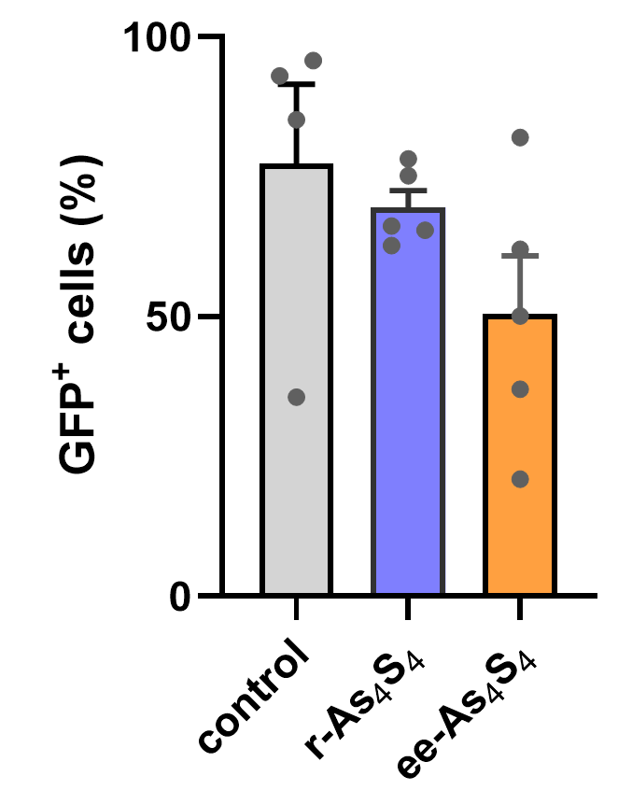
Figure S3. The percentage of GFP⁺ leukemia cells in the bone marrow determined by flow cytometry.
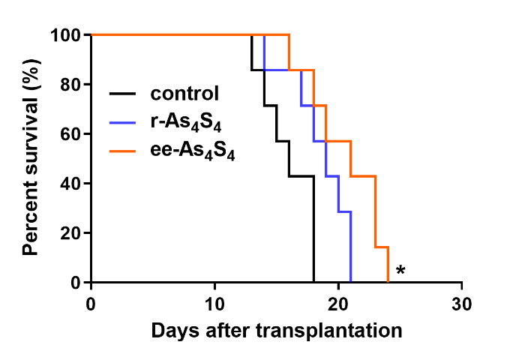
Figure S4. Survival curves of AML mice orally administrated with ddH₂O, ee-As₄S₄, and r-As₄S₄.

Figure S5. The composition of WBC in AML mice (A) and healthy mice (B).

