A Machine Learning Model Based on Health Records for Predicting Recurrence after Microwave Ablation of Hepatocellular Carcinoma

Supplementary Materials
- Supplementary Methods
1.1 Ultrasound-guided percutaneous microwave ablation (US-PMWA) procedure
1.2 Post-ablation assessment and follow-up protocol
1.3 Introduction of other three models building
- Supplementary Tables
Table S1. The details of all 36 variables in this study
Table S2. The parameters of the ML models
Table S3. Subgroup analysis of 9 variables in XGBoost model
- Supplementary Figures
Fig S1. Schematic diagram of sigmod function
Fig S2. Schematic diagram of the random forest algorithm model construction process
Fig S3. SVM algorithm model construction process diagram
Fig. S4.Screening process of RFECV. When 9 variables were retained, the XGBoost model exhibited the best discrimination
Fig. S5. The calibration curves of the internal validation set (A) and the external validation set (B) .
Fig. S6. The AI system for recurrence prediction after MWA accessed online.
Fig. S7. The influence of 9 variables on the outcome in the XGBoost model.
Fig. S8. The feature importing ranking of the XGBoost model.

- Supplementary Methods
1.1 US-PMWA procedure
All microwave ablation (MWA) procedures were performed by two interventional radiologists (P. L. and J. Y.) with more than ten years of abdominal ultrasound experience. Color Doppler and grayscale ultrasound were performed to choose the safest access for the antenna. The antenna was connected to the MW generator and inserted into the target area of the tumor. When there were 2 antennas, they were usually deployed in parallel 1–2.5 cm apart. In addition, the antennas were usually deployed parallel to vessels to decrease the damage to large vessels. In general, the microwave energy application was set to 50–60W for 5–10 min per session. The region of ablation was monitored with real-time ultrasound. MWA emission was stopped when the hyperechoic zone covered the entire tumor, including a safety margin. If necessary, owing to tumor size, multiple overlapping ablations were usually needed to envelope the entire tumor with at least a 5 mm safety margin.

1.2 Post-ablation assessment and follow-up protocol
Contrast-enhanced (CE) imaging (CE-magnetic resonance imaging, CE-computed tomography, or CE ultrasound) was performed within 3 days after the ablation to assess whether complete ablation was achieved. If a residual tumor was recognized, additional ablation was performed to achieve complete coagulation. Patients were followed up at 1 month, every 3 months in the first year after ablation, and then every 6 months in the following years. Patients were also monitored prospectively for recurrence with a standard protocol that included serum AFP and CE imaging. A MR scan of the abdomen was performed every 6 months.
The observed outcome of this study is defined as intrahepatic recurrence (IR) which was divided into 2 types as following: local tumor recurrence (LTR) and intrahepatic distant recurrence (IDR). LTR was defined as the appearance of new tumor foci at the ablative margin after the local eradication of all tumor cells with ablation. IDR was defined as the detection of the tumor distally from the site of ablation within the liver. Ultrasound-guided fine-needle biopsy was required to confirm the diagnosis when imaging findings were atypical during the follow-up period.

1.3 Introduction of Other Three Models building
1.3.1 Introduction of logistic regression model construction
Logistic regression is a kind of generalized linear regression. It is assumed that there is a hypothesis function $h_{θ}(x)=θ^{T}x$ to fit the decision boundary (not limited to linear, but also polynomial), and then establish the relationship between this boundary and the classification probability through the sigmod function ($g\left(z\right)= \frac{1}{1+ e^{-z}}$) (Fig S1), and get the probability in the case of two classifications.The gradient descent algorithm is used to find the minimum value of the cost function and find the best parameter θ to complete the construction of the prediction model.
$$J\left(θ\right)= \frac{1}{m} \sum_{i=1}^{m}{Cost(h_{θ}\left(x_{i}\right),y_{i})}$$
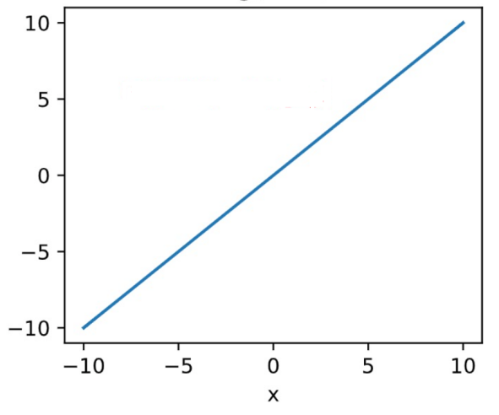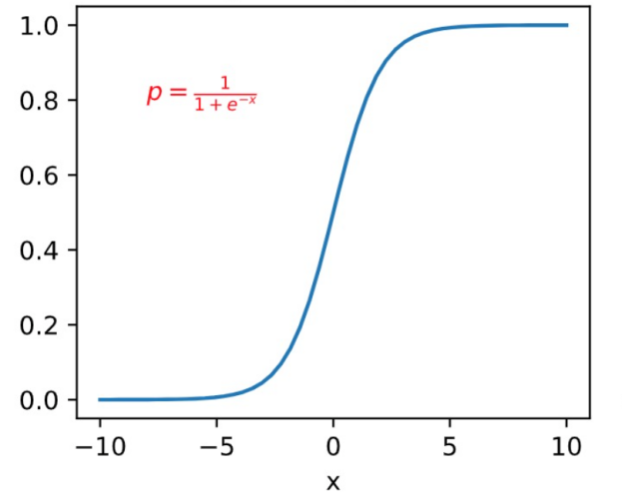
Fig S1. Schematic diagram of sigmod function

1.3.2. Introduction of random forest model construction
The random forest approach divides the initial cohort into two groups – “in-bag” and “out-of-bag” samples. The in-bag sample is created by random sampling.The out-of-bag sample is composed of the unsampled data from the initial cohort，and typically includes about one-third of the initial cohort. This process is repeated multiple times to create multiple pairings of in-bag and out-of-bag samples. For each pairing, a decision tree is constructed on the in-bag sample, using a random set of potential candidate variables for each split, and then using out-of-bag samples for verification. The predictions from each tree are used as “votes”, and the outcome with the most votes is considered the dichotomous outcome prediction for that sample (Fig S2). Using this method, multiple decision trees are constructed to create the final classification prediction model and determine overall variable importance. Accuracies and error rates are computed for each observation using the out-of-bag predictions, and then averaged over all observations. Finally, the most important variables are determined according to the contribution of features to the model's prediction accuracy.
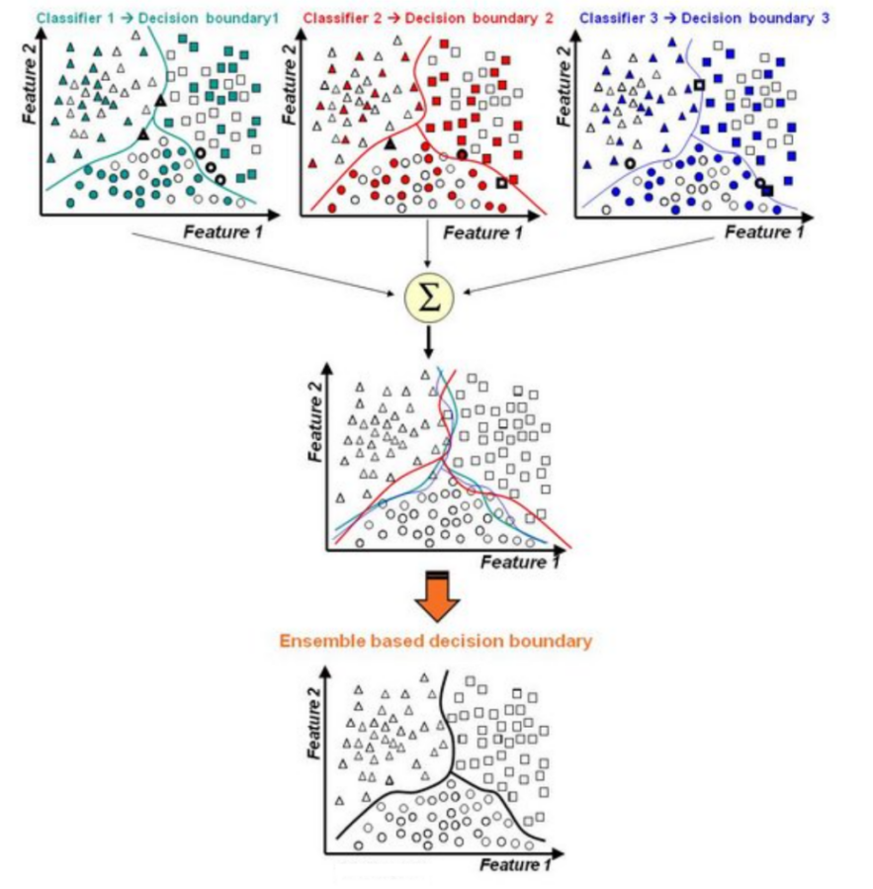
Fig S2. Schematic diagram of the random forest algorithm model construction process

1.3.3 Introduction of SVM model construction
The prototype of SVM is the maximum interval classifier. The core of the model is to find a linear "hyperplane" between two types of data, so that different types of data can fall on both sides of the hyperplane, and the hyperplane is separated from the two types of data as much as possible At the farthest point, SVM introduces a kernel function on this basis to map the original low-dimensional feature space to a higher-dimensional feature space (Fig S3), effectively solving nonlinear problems, and making the data set linearly separable. In addition, a slack variable ξ (representing the distance between the misclassified point and the correct boundary) is added to the model, combined with the corresponding penalty coefficient C as a constraint, to make the misclassification of the model as reasonable as possible, thereby improving the generalization ability of the model. Its Lagrangian function formula is as follows:
$$L\left(w,b,α,ε,μ\right)= \frac{1}{2}{||w||}^{2}+C\sum_{i=1}^{m}{ε_{i}}+\sum_{i=1}^{m}{α_{i}\left(1-ε_{i }-y_{i}\left(w^{T}x_{i}+b\right)\right)- \sum_{i=1}^{m}{μ_{i}}}ε_{i }$$
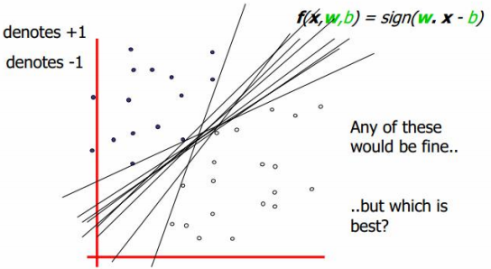
Fig S3. SVM algorithm model construction process diagram

- Supplementary Tables
Table S1. The details of all 36 variables in this study.
Variable |  | Variable name |  | Abbreviation
Demographic and history
 |  | Age
 |  | Gender
 |  | Etiology
 |  | Comorbidity score |  | CS
 |  | Cirrhosis
 |  | Child-Pugh grade |  | CTP grade
 |  | Diagnosis basis |  | DB
 |  | Ascites
Tumor data
 |  | Number of tumors |  | No. of tumors
 |  | Maximum diameter of tumor |  | MD of tumor
 |  | Abutting organs |  | AO
 |  | Tumor location |  | TL
Treatment parameter
 |  | Ablation number |  | AN
 |  | Ablation sessions |  | AS
 |  | Ablation time |  | AT
 |  | Ablation power |  | AP
Laboratory findings
 |  | Alanine aminotransferase |  | ALT
 |  | Aspartate aminotransferase |  | AST
 |  | α-fetoprotein |  | AFP
 |  | Gamma glutamyl transferase |  | γ-GT
 |  | Alkaline phosphatase |  | AKP
 |  | Albumin |  | ALB
 |  | Total bilirubin |  | TBIL
 |  | Bilirubin |  | BIL
 |  | Creatinine |  | Cre
 |  | Glucose |  | Glu
 |  | Cholinesterase |  | CHE
 |  | Hemoglobin |  | HB
 |  | Red blood cell |  | RBC
 |  | White blood cell |  | WBC
 |  | Platelet |  | PLT
 |  | Lymphocyte |  | LYM
 |  | Neutrophils |  | NEU
 |  | Prothrombin time |  | PT
 |  | Prothrombin activity |  | PTA
 |  | International Normalized Ratio |  | INR
Table S2. The parameters of the ML models
Parameters | Type |  | Explanation |  | Values
booster | string |  | Specify which booster to use: gbtree, gblinear or dart |  | ‘gbtree’
learning_rate | float |  | Boosting learning rate |  | 0.01
n_estimators | int |  | Number of boosted trees to fit |  | 901
max_depth | int |  | Maximum tree depth for base learners |  | 2
min_child_weight | float |  | The sum of the smallest sample weights |  | 7
subsample | float |  | Subsample ratio of the training instance |  | 0.5
reg_alpha | float |  | L1 regularization term on weights |  | 0.053
reg_lambda | float |  | L2 regularization term on weights |  | 12
scale_pos_weight | float |  | Balancing of positive and negative weights |  | 1.02

Table S3. Subgroup analysis of 9 variables in XGBoost model.
Variables | Subgroup | AUC (95% CI)
Variables | Subgroup | Training set | Internal Validation set | External Validation set
No. of tumors | Single | 0.78 (0.74-0.81) | 0.65 (0.56-0.73) | 0.60 (0.51-0.69)
No. of tumors | Multiple | 0.80 (0.75-0.84) | 0.61 (0.52-0.73) | 0.74 (0.61-0.86)
Etiology | HBV | 0.71 (0.63-0.79) | 0.73 (0.69-0.88) | 0.68 (0.51-0.86)
Etiology | Non HBV | 0.76 (0.72-0.79) | 0.75 (0.68-0.81) | 0.78 (0.71-0.84)
Comorbidity score | Absence | 0.80 (0.76-0.84) | 0.66 (0.56-0.76) | 0.70 (0.60-0.80)
Comorbidity score | Presence | 0.78 (0.74-0.81) | 0.73 (0.65-0.81) | 0.79 (0.72-0.87)
AFP | Low(<25.9ug/ml) | 0.77 (0.74-0.81) | 0.74 (0.66-0.81) | 0.69 (0.61-0.77)
AFP | High(≥25.9ug/ml) | 0.81 (0.77-0.86) | 0.61 (0.51-0.72) | 0.80 (0.70-0.90)
NEU | Low(<0.614) | 0.77 (0.73-0.81) | 0.72 (0.63-0.80) | 0.81 (0.74-0.89)
NEU | High(≥0.614) | 0.79 (0.75-0.83) | 0.66 (0.56-0.77) | 0.70 (0.60-0.80)
PLT | Low(<128.0×10⁹) | 0.74 (0.66-0.82) | 0.75 (0.58-0.91) | 0.75 (0.60-0.90)
PLT | High(≥128.0×10⁹) | 0.76 (0.73-0.79) | 0.72 (0.66-0.79) | 0.77 (0.70-0.83)
WBC | Low(<4.40×10⁹) | 0.76 (0.73-0.79) | 0.71 (0.65-0.78) | 0.78 (0.71-0.84)
WBC | High(≥4.40×10⁹) | 0.77 (0.69-0.85) | 0.66 (0.55-0.86) | 0.72 (0.56-0.78)
CHE | Low(<5846.8u/L) | 0.79 (0.75-0.83) | 0.63 (0.52-0.75) | 0.72 (0.60-0.84)
CHE | High(≥5846.8u/L) | 0.77 (0.73-0.80) | 0.71 (0.63-0.79) | 0.79 (0.71-0.86)
PT | Low(<13.2s) | 0.81 (0.77-0.86) | 0.63 (0.52-0.77) | 0.70 (0.55-0.85)
PT | High(≥13.2s) | 0.77 (0.73-0.80) | 0.71 (0.64-0.78) | 0.74 (0.66-0.81)
Abbreviation: AFP : α-fetoprotein; NEU: Neutrophils; PLT : Platelet; WBC : White blood cell; CHE: Cholinesterase; PT: Prothrombin time.
- Supplementary Figures
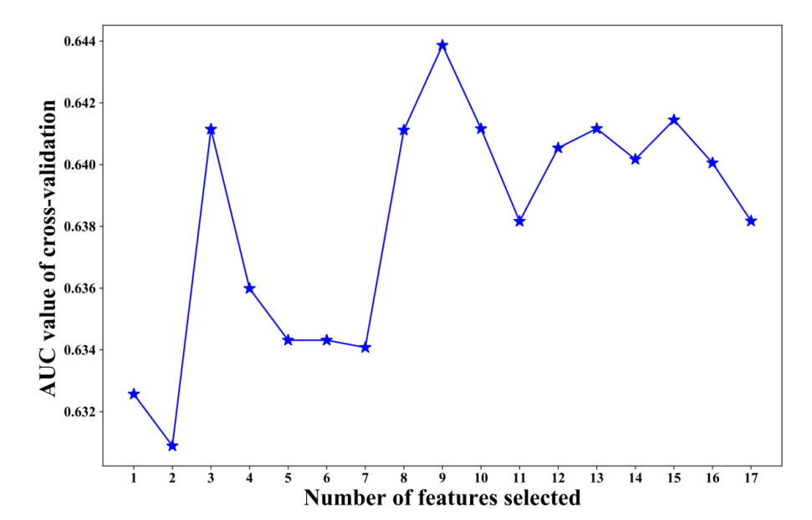
Fig. S4. Screening process of RFECV. When 9 variables were retained, the XGBoost model exhibited the best discrimination.

Fig. S5. The calibration curves of the internal validation set (A) and the external validation set (B) .

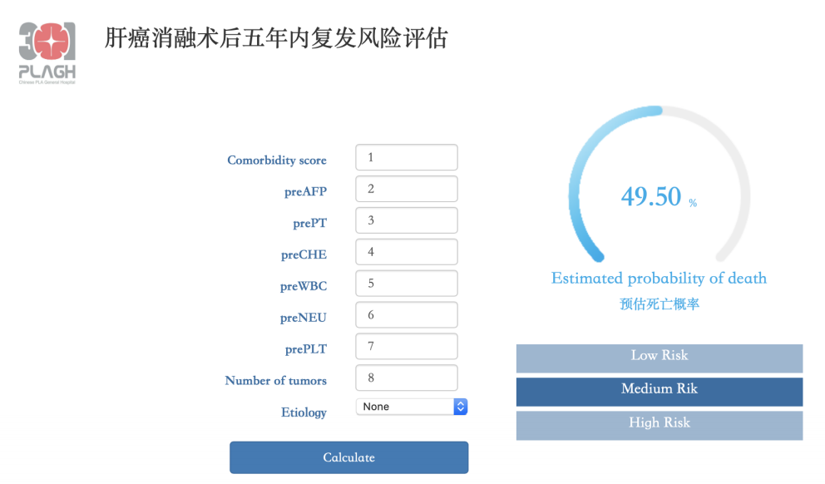
Fig. S6. The AI system for recurrence prediction after MWA accessed online.

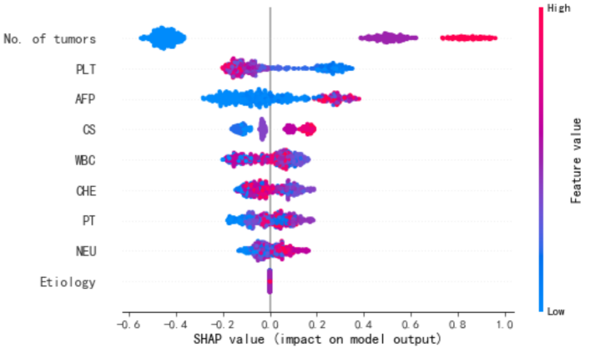

Fig.S7. The influence of 9 variables on the outcome in the XGBoost model.

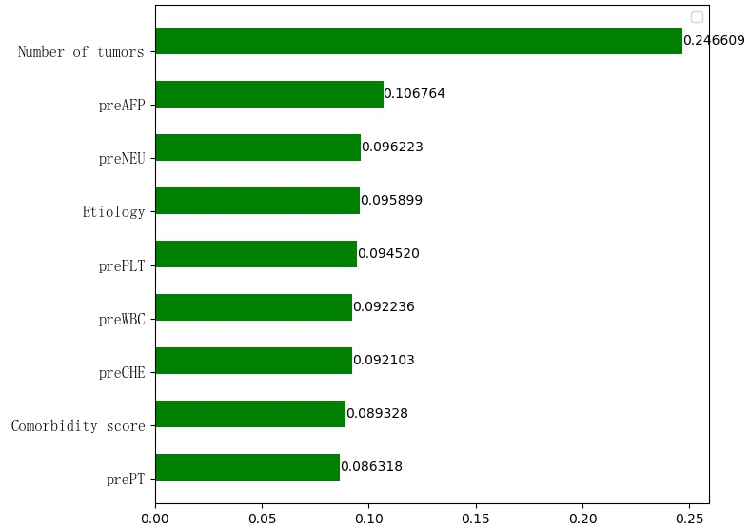
Fig. S8. The feature importance ranking of the XGBoost model.

