Supporting Information

GOx-functionalized Platelet Membranes-Camouflaging Nanoreactors for Enhanced Multimodal Tumor Treatment
Ying Du^{a,c}, Shujun Wang^{b}, Jianfeng Luan^{b}, Meilin Zhang^{a,c}, Baoan Chen*^{a,c}, Yanfei Shen*^{c}
ªDepartment of Hematology and Oncology, Zhongda Hospital, School of Medicine, Southeast University, Nanjing, Jiangsu, China
^{b}Department of Blood Transfusion, Jinling Hospital, Nanjing University School of Medicine, Nanjing, Jiangsu, China
^{c} School of Medicine, Southeast University, Nanjing, Jiangsu, China
*These authors contributed equally to this work
Keywords
Glucose oxidase, PLT membrane, nanoparticles, tumor microenvironment, tumor treatment
Address all correspondence to:
Baoan Chen, Department of Hematology and Oncology, Zhongda Hospital, School of Medicine, Southeast University, Nanjing, Jiangsu 210009, China; Email cba8888@hotmail.com
Yanfei Shen, School of Medicine, Southeast University, Nanjing, Jaingsu 210009, China; Email Yanfei.Shen@seu.edu.cn

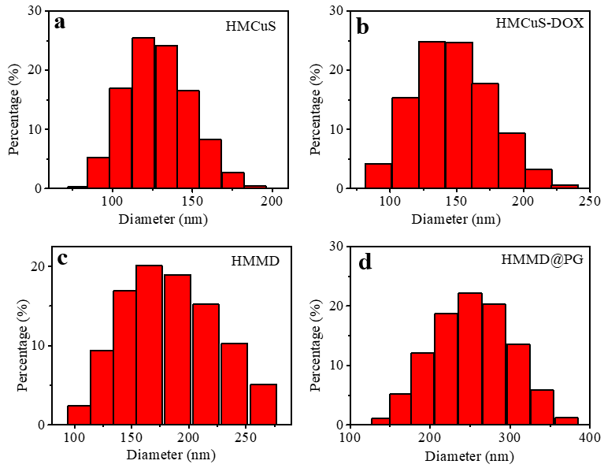
Figure S1. (a) The DLS (Dynamic Light Scattering) of HMCuS, (b) HMCuS-DOX, (c) HMMD, and (d) HMMD@PG.

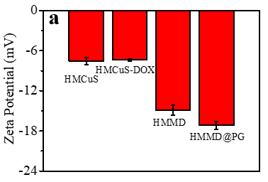
Figure S2. (a) The Zeta potential of HMCuS, HMCuS-DOX, HMMD, and HMMD@PG.

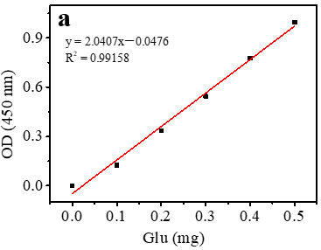
Figure S3. (a) The standard calibration curve equation of glucose.

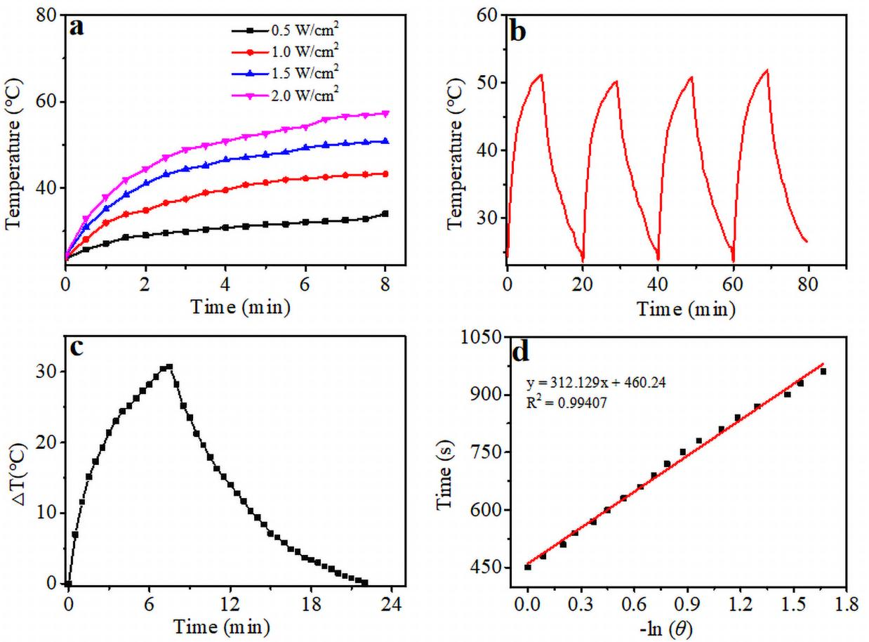
Figure S4. (a) Photothermal conversion curves of a suspension of the HMMD@PG (100 µg/mL) under NIR laser irradiation (808 nm) with various power for 8 min. (b) Four on-off cycles photothermal conversion curves of HMMD@PG (100 µg/mL) under NIR laser irradiation (808 nm, 1.5 W/cm²). (c) Temperature increase and decrease curves of HMMD@PG (100 µg/mL) in water by 1.5 W/cm² 808 nm laser for 8 min. (d) Linear time data versus -lnθ obtained from the cooling period.

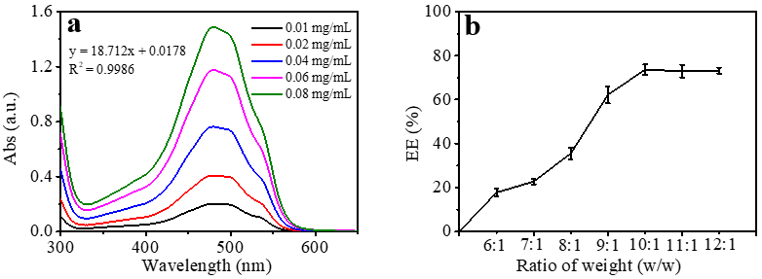
Figure S5. (a)The standard UV–vis adsorption curve of different concentrations of DOX in deionized water and the standard calibration curve equation of DOX. (b) The encapsulation efficiency of DOX in HMMD.

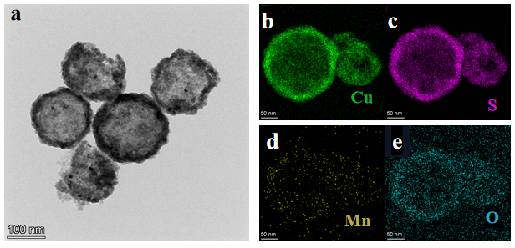

Figure S6. (a) The TEM imaging of HMMD mixed with GSH solution (2mM). (b-e) EDS elemental mapping of HMMD mixed with GSH solution (2mM).

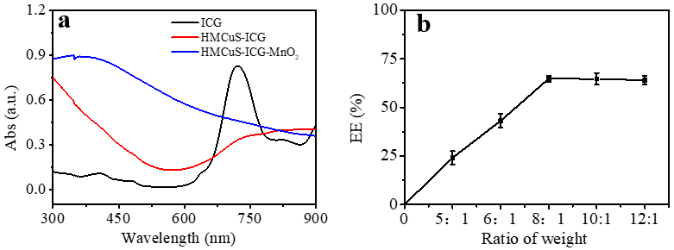
Figure S7. (a)The UV–vis adsorption curve of ICG, HMCuS-ICG, and HMCuS-ICG-MnO₂. (b) The EE of ICG in HMCuS-ICG-MnO₂.

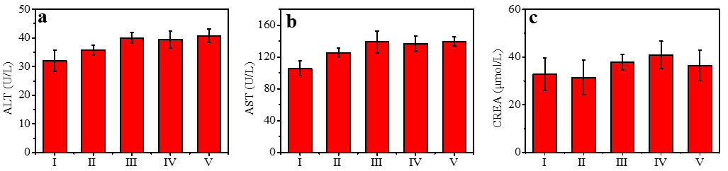
Figure S8. (a)The ALT, (b) AST and (c) CREA results of 4T1 tumor bearing mice in different treatment groups over 14 days treatment.
Table S1. Quantitative analysis of Mn and Cu obtained from the EDS of the HMMD.
Element | Atomic Fraction (%) | Atomic Error (%) | Mass Fraction (%) | Mass Error (%) | Fit error (%)
Mn | 6.36 | 1.26 | 8.55 | 1.39 | 0.69
Cu | 44.04 | 8.69 | 68.49 | 11.13 | 0.20

