Supplementary material

Evaluation of the therapeutic pattern and pharmaco-utilization in hypercholesterolemic patients treated with statins: a retrospective study on Italian real-world data
Valentina Perrone, Elisa Giacomini, Diego Sangiorgi, Margherita Andretta, Fausto Bartolini, Alessandro Lupi, Fulvio Ferrante, Stefano Palcic, Davide Re, Luca Degli Esposti

Supplementary Table 1. List of approved protocols by Ethics Committees
Ethics Committee | Approved Protocol number
Comitato Etico per la sperimentazione clinica delle province di Verona e Rovigo | Prot n 64198 of 3/10/2018
Comitato Etico Unico Regionale FVG | Prot. n 2578 of 5/2/2019
Comitato Etico Interaziendale AOU “Maggiore della Carità” – ASL BI-ASL NO-ASL VCO | Prot n 364/CE of 12/4/2019
Ceas UMBRIA | Prot n 14657/18/ON of 25/10/2018
Comitato Etico Lazio 2 | Prot. N 0199138/2018 of 5/12/2018
Comitato Etico Regione Abruzzo – ASL Avezzano- Sulmona-L’Aquila | Prot. n 8 of 16/5/2019

Supplementary Table 2. Definition criteria for Familial hypercholesterolemia (Dutch Lipid Clinic Network, DLCN)
Criteria | Score assignment
Family history | First-degree relatives with premature coronary and vascular disease (men: <55 years; women: <60 years) (ICD-9-CM codes V173, V174) (1 point)
Clinical history | Premature coronary artery disease (men: <55 years; women: <60 years) (2 points), premature cerebrovascular disease (men: <55 years; women: <60 years) (1 point)
Physical examination | Tendon xanthoma (ICD-9-CM code 272.7) (6 points), corneal arch before age 45 (ICD-9-CM 371.41) (4 points)
LDL-C levels | >325 mg/dL (8 points), 251-325 mg/dL (5 points), 191-250 mg/dL (3 points), 155-190 mg/dL (1 point); the real LDL value was recalculated taking into account the possible type of lipid-lowering therapy administered continuously, in relation to the percentage reduction capacity of the LDL values ​​of the single molecule/dosage (see Supplementary Table 3)
Molecular genetic testing (DNA analysis) | Outpatient specialist service codes 91.29.3, 91.30.3, 91.29.4, 91.29.5) (8 points), excluding patients with tumors (ICD-9-CM codes 140-239, ATC L), delivery ( ICD-9-CM codes 630-679), cystic fibrosis (ICD-9-CM code 277.0), consumption of drugs for the central nervous system (code ATC N)
Supplementary Table 3. FH-derived cohorts’ criteria definitions
FH cohort | Criteria definition
CVD | CORONAROPATHY: at least one hospitalization diagnosed with acute myocardial infarction (ICD-9-CM code: 410), acute cardiac ischaemia (ICD-9-CM code: 411), angina pectoris (ICD-9-CM code -9: 413), chronic cardiac ischaemia (ICD-9-CM code: 414 ); CEREBROVASCULAR DISEASE: at least one hospitalization diagnosed with subarachnoid haemorrhage (ICD-9-CM code: 430), intracerebral haemorrhage (ICD-9-CM code: 431-432), ischemic stroke (ICD-9-CM code: 434; 436), transient ischemic attack (ICD-9-CM code: 435), other cerebrovascular diseases (ICD-9-CM code: 433; 437-438); PERIPHERAL VASCULAR DISEASE: at least one hospitalization with diagnosis of atherosclerosis (ICD-9-CM code: 440), other bacterial vascular diseases (ICD-9-CM code: 443); PERCUTANEOUS CORONARY ANGIOPLASTY: at least one hospitalization with diagnosis of percutaneous transluminal coronary angioplasty (ICD-9-CM code: V4582, procedural codes 0066, 3609); CHRONIC KIDNEY INSUFFICIENCY: at least one hospitalization diagnosed with chronic renal insufficiency (ICD-9-CM code: 585).
Diabetes Mellitus | at least two prescriptions of antidiabetic drugs (ATC code A10) or hospitalization with a diagnosis of diabetes (ICD-9-CM code 250).
Mixed- Dyslipidemia | Patients with at least one hospitalization diagnosed with mixed familial hypercholesterolemia (ICD-9-CM code 272.2) or exemption code 025.272.2
Primary-Prevention | Patients on statin treatment and at least one LDL determination, not included in previous study cohorts.

Supplementary Table 4. List of treatments evaluated for nFH and FH patients

ATC | Molecule |  | mg
C10AA05 | ATORVASTATIN (HP) |  | 40
C10AA05 | ATORVASTATIN (HP) |  | 80
C10AA07 | ROSUVASTATIN (HP) |  | 20
C10AA07 | ROSUVASTATIN (HP) |  | 40
C10BA05 | ATORVASTATIN AND EZETIMIBE (HP) |  | 40
C10BA05 | ATORVASTATIN AND EZETIMIBE (HP) |  | 80
C10BA06 | ROSUVASTATIN AND EZETIMIBE (HP) |  | 20
C10BA06 | ROSUVASTATIN AND EZETIMIBE (HP) |  | 40
C10AA01 | SIMVASTATIN |  | 10
C10AA01 | SIMVASTATIN |  | 20
C10AA01 | SIMVASTATIN |  | 40
C10AA01 | SIMVASTATIN |  | 80
C10AA02 | LOVASTATIN |  | 20
C10AA02 | LOVASTATIN |  | 40
C10AA03 | PRAVASTATIN |  | 10
C10AA03 | PRAVASTATIN |  | 20
C10AA03 | PRAVASTATIN |  | 40
C10AA04 | FLUVASTATIN |  | 20
C10AA04 | FLUVASTATIN |  | 40
C10AA04 | FLUVASTATIN |  | 80
C10AA05 | ATORVASTATIN |  | 10
C10AA05 | ATORVASTATIN |  | 20
C10AA07 | ROSUVASTATIN |  | 5
C10AA07 | ROSUVASTATIN |  | 10
C10BA02 | SIMVASTATIN AND EZETIMIBE |  | 10
C10BA02 | SIMVASTATIN AND EZETIMIBE |  | 20
C10BA02 | SIMVASTATIN AND EZETIMIBE |  | 40
C10BA02 | SIMVASTATIN AND EZETIMIBE |  | 80
C10BA05 | ATORVASTATIN AND EZETIMIBE |  | 10
C10BA05 | ATORVASTATIN AND EZETIMIBE |  | 20
C10BA06 | ROSUVASTATIN AND EZETIMIBE |  | 10
C10AX09 | EZETIMIBE | /
HP: high-potency treatment

Supplementary Table 5. Stratification by age-ranges of FH patients and FH-derived cohorts
 | nFH | CVD | Diabetes Mellitus | Mixed-Dyslipidemia | Primary-Prevention
N | 164,161 | 46,782 | 34,803 | 1,617 | 80,959
Age 0-39 years (n, %) | 781 (0.5) | 114 (0.2) | 118 (0.3) | 8 (0.5) | 541 (0.7)
Age 40-49 years (n, %) | 4,510 (2.7) | 900 (1.9) | 821 (2.4) | 65 (4.0) | 2,724 (3.4)
Age 50-59 years (n, %) | 17,201 (10.5) | 3,670 (7.8) | 3,543 (10.2) | 177 (10.9) | 9,811 (12.1)
Age 60-69 years (n, %) | 39,205 (23.9) | 8,984 (19.2) | 8,997 (25.9) | 380 (23.5) | 20,844 (25.7)
Age 70-79 years (n, %) | 58,885 (35.9) | 16,604 (35.5) | 13,127 (37.7) | 573 (35.4) | 28,581 (35.3)
Age 80+ years (n, %) | 43,579 (26.5) | 16,510 (35.3) | 8,197 (23.6) | 414 (25.6) | 18,458 (22.8)

Age-ranges | CVD patients (N) | CVD patients affected  by diabetes N (%)
0-4 | / | /
5-9 | / | /
10-14 | / | /
15-19 | <4 | 0 (0.0)
20-24 | 4 | 0 (0.0)
25-29 | 5 | 0 (0.0)
30-34 | 19 | <4
35-39 | 85 | 10 (11.8)
40-44 | 238 | 32 (13.4)
45-49 | 662 | 112 (16.9)
50-54 | 1337 | 313 (23.4)
55-59 | 2333 | 673 (28.8)
60-64 | 3592 | 1214 (33.8)
65-69 | 5392 | 2145 (39.8)
70-74 | 7558 | 3124 (41.3)
75-79 | 9046 | 3671 (40.6)
80-84 | 8916 | 3568 (40.0)
85-89 | 5603 | 2057 (36.7)
90-94 | 1772 | 605 (34.1)
95-99 | 215 | 57 (26.5)
100+ | 4 | 4 (100.0)
Supplementary Table 6. Stratification by age-ranges of CVD patients affected by diabetes

Supplementary Table 7. Stratification by age-ranges of FH patients
 | FH
N | 1,287
Age 0-39 years (n, %) | 33 (2.6)
Age 40-49 years (n, %) | 101 (7.8)
Age 50-59 years (n, %) | 309 (24.0)
Age 60-69 years (n, %) | 355 (27.6)
Age 70-79 years (n, %) | 365 (28.4)
Age 80+ years (n, %) | 124 (9.6)

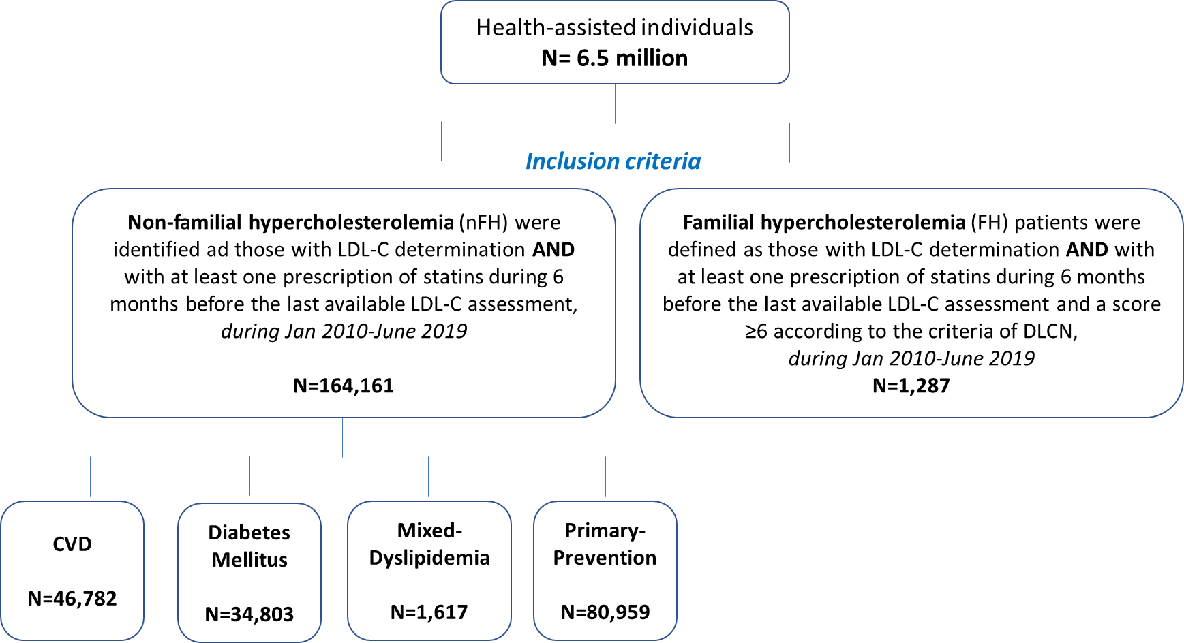

Supplementary Figure.1. Flow-chart for nFH and FH patients indentification and nFH-derived sub-cohorts definition
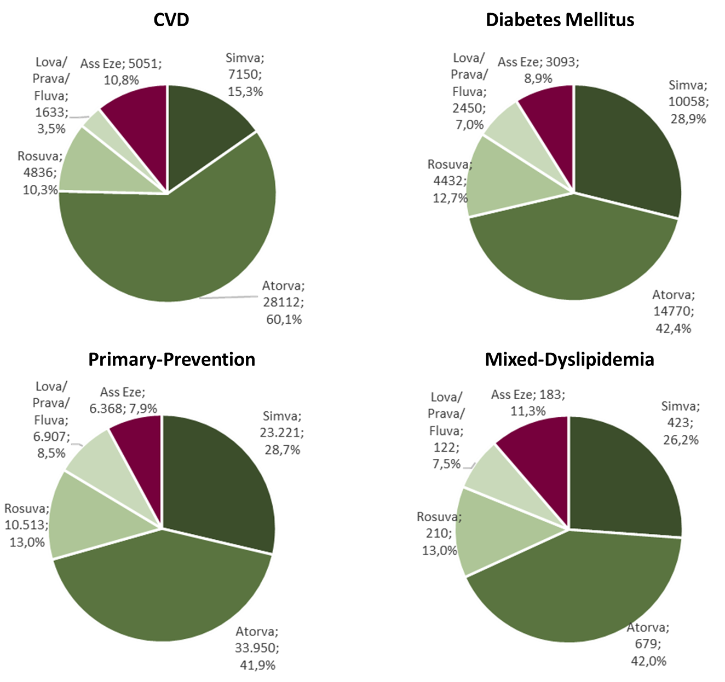
Supplementary Figure 2. Prescription frequency of different statins among nFH-derived cohorts. At the index-date the identification of therapeutic options prescribed among nFH-derived cohorts was assessed. Abbreviations: Atorva, atorvastatin; Simva, simvastatin; Rosuva, rosuvastatin; Lova, lovastatin; Prava, pravastatin; Fluva, fluvastatin; Ass Eze, statin associated with ezetimide or ezetimide alone; nFH, non-familial hypercholesterolemia; CVD, cardiovascular disease cohort; FH, familial hypercholesterolemia.

