Peanut allergy and peanut immunotherapy survey

- This survey is expected to take about 30-40 minutes to complete
- You do not have to complete it all at once, you can click on the link and continue from where you left it
- Some of the questions may seem repetitive, but each question is different so it is important you read the question each time.

This survey is divided into several sections:

Section 1: Background
- You will be asked a number of background questions such as your and your child’s age, ethnicity and gender and about your child’s peanut allergy
Section 2: Health-related quality of life
- You will be asked a number of questions about your and your child’s health-related quality of life and to complete a short questionnaire
Section 3: Peanut immunotherapy hypothetical scenarios
- You will be shown some scenarios each describing a different stage of peanut immunotherapy treatment. You will be asked to rate your and your child’s hypothetical health-related quality of life in each scenario.

Section 1: Background questions

- What is the relationship between you and the person with peanut allergy you care for?
  - I am their parent [survey will refer to ‘your child’]
  - I am their guardian [survey will refer to ‘the person you provide care for’]
  - I am their grandparent [survey will refer to ‘your grandchild’]
  - Other ____________ [survey will refer to ‘the person you provide care for’]

- What is your child’s age? _____ (if more than one child with peanut allergy please think about the child with the most severe allergy / most impacted by their allergy for the purpose of this study)

- Is your child…
  - Male
  - Female
  - Other
  - Prefer not to answer

- Is your child…
  - White (White British/ other)
  - Black (Black British/ Caribbean/ African/ other)
  - Asian (Asian British/ Indian/ Pakistani/ Bangladeshi/ Chinese/ Other)
  - Mixed race
  - Other:
  - Prefer not to answer

- How many people including yourself provide informal (unpaid) care for your child that includes consideration of their peanut allergy (e.g. their daily needs, practical and emotional support)?
  - 1
  - 2
  - 3 or more

- [if 2 or more selected] What proportion of the care do you provide?
  - Less than 50%
  - 50%
  - More than 50%

- How old was your child when they had their first allergic reaction to peanut? ______
  - Don’t know

- How old was your child when their peanut allergy was diagnosed by a medical doctor/nurse? ______
  - Don’t know

- Is your child allergic to any food other than peanut?
  - Celery
  - Cow milk and dairy products
  - Egg
  - Fish
  - Fruit
  - Meat or poultry
  - Mustard
  - Seeds (e.g. Poppy, Pumpkin, Sunflower)
  - Sesame
  - Shellfish/crustacean/molluscs
  - Soya beans / other legumes
  - Sulphites
  - Wheat/gluten
  - Other nuts (e.g. almonds, walnuts)
  - Other (please specify) _________

- Not including food allergies, does your child have any other illnesses or conditions which limit their daily activities?
  - Asthma
  - Allergic rhinitis (hay fever)
  - Atopic dermatitis (eczema)
  - Other: ___________________
  - No
  - Not sure
  - Prefer not to answer

- How would you describe the severity of your child’s peanut allergy?
  - Mild
  - Moderate
  - Severe

- What amount of peanut do you know / believe would cause your child to have a reaction if they accidentally ingested it?
  - Less than or equal to a trace
  - Less than 1 peanut
  - 1 peanut or more
  - Don’t know

- [unless answered ‘don’t know to Q14] Which of the following is your previous response based on?
  - A food challenge
  - My belief about the amount they can tolerate
  - They have accidentally eaten that amount with or without a reaction
  - Other _________

- Has your child been prescribed an adrenaline auto-injector (AAI) for their peanut allergy?
  - Yes
  - No
  - Don’t know

- Please tell us about the frequency of your child’s allergic reactions from accidental exposure to peanut in the last 12 months.
(only include each reaction once, include the most severe level of treatment per reaction, e.g. if a reaction required treatment with an AAI and hospitalisation, only include it as hospitalisation)
- Number of reactions that required no treatment or treatment with antihistamines only ____
- Number of reactions that required treatment with an adrenaline autoinjector (AAI) _____
- Number of reactions that required emergency medical attention (e.g. visit to doctor or accident and emergency (A&E)) _____
- Number of reactions that required hospitalisation (staying overnight in hospital) _____

- When did your child experience THEIR LAST allergic reaction from accidental exposure to peanut?
- Less than 3 months ago
- In the last 3 - 6 months
- In the last 6 – 12 months
- In the last 1 – 2 years
- In the last 2 – 5 years
- More than 5 years ago
- Not sure

The next few questions are about you
- What is your age? _____

- Are you…
  - Male
  - Female
  - Other
  - Prefer not to answer

- Do you have peanut allergy?
  - Yes
  - No
  - Don’t know
  - Prefer not to answer

- Do you have another food allergy (other than peanut)?
  - Yes
  - No
  - Don’t know
  - Prefer not to answer

- Not including allergies, do you have any other illnesses or conditions which limit your daily activities?
- Allergic rhinitis (hay fever)
- Asthma
- Other chronic lung/breathing disorder (e.g. Chronic Obstructive Pulmonary Disorder)
- Diabetes Type 1
- Diabetes Type 2
- Uncontrolled hypertension
- Eating disorders
- Gastrointestinal / digestive disorder (e.g. Crohn’s disease, ulcerative colitis)
- Heart disease
- Mood disorders (e.g. depression)
- Skin disorders (e.g. eczema)
- Stress
- Other (please specify) _________
- None of the above
  - Prefer not to answer

Section 2: Health-related quality of life
The following questions are a validated questionnaire designed to assess health-related quality of life. The questions are not specific to peanut allergy and may not seem relevant.
Some of the questions may seem repetitive, however it is important you answer all of the questions.
Please answer the following questions thinking about how your child feels today

- How would you rate your child’s overall health-related quality of life (social, physical and, psychological wellbeing)?
- Very good
- Good
- Fair
- Poor
- Very poor

- How would you rate your child’s anxiety related to food?
- No anxiety
- A little anxious
- Moderately anxious
- Very anxious
- Extremely anxious

- How would you rate your child’s emotional well-being?
- Very good
- Good
- Fair
- Poor
- Very poor

- How would you rate your child’s ability to engage in social activities?
- Very good
- Good
- Fair
- Poor
- Very poor

- How would you rate your child’s ability to perform daily activities?
- Very good
- Good
- Fair
- Poor
- Very poor

Now we would like you to answer the following questions about your health-related quality of life.
Please answer the following questions thinking about how you feel today.
Similar to the previous questionnaire about your child, the following questions are a validated questionnaire designed to assess health-related quality of life and are not specific to peanut allergy.
However it is important you answer all of the questions.

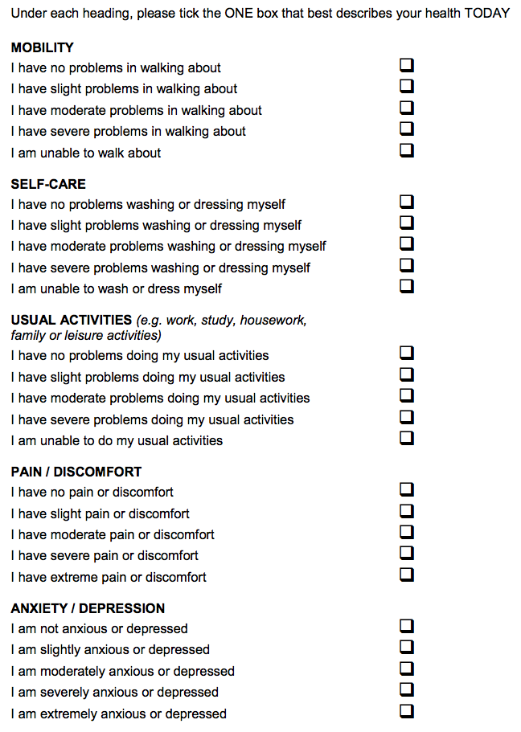

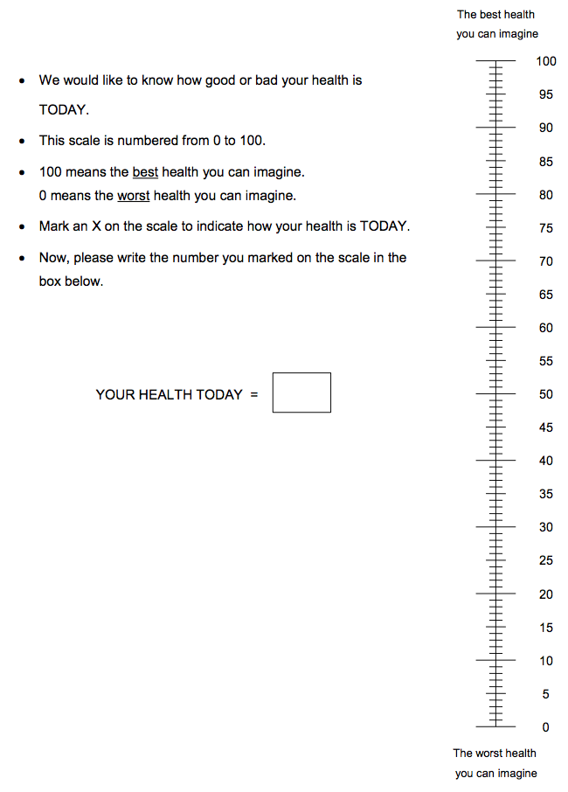

- How would you rate your overall health-related quality of life (social, physical and, psychological wellbeing)?
- Very good
- Good
- Fair
- Poor
- Very poor

- How would you rate your own emotional well-being?
- Very good
- Good
- Fair
- Poor
- Very poor

- How would you rate your ability to engage in social activities?
- Very good
- Good
- Fair
- Poor
- Very poor

- How would you rate your ability to perform daily activities?
- Very good
- Good
- Fair
- Poor
- Very poor

Section 3: Peanut immunotherapy hypothetical scenarios
In this section of the survey you are going to be shown some different descriptions, each describing a child with peanut allergy who is, or has been, taking a treatment for peanut allergy.
The treatment is an immunotherapy; this involves taking a small amount of the food you’re allergic to, with the aim of building up immunity to it.
When you start an immunotherapy, the first stage involves gradual increases in the amount of the allergen (peanut protein powder) you take. This part of the treatment lasts for about 6 months. Once you have reached the final dose, you would maintain that dose each day and if the treatment is successful the amount of peanut you can tolerate would have increased. The extent to which it has increased will vary from person to person.
The following descriptions will outline the treatment and the amount of peanut protein the child can tolerate.
Please think about your child / the person with peanut allergy you provide care for, living in the state of health described. You will then be asked to rate what you think their health-related quality of life would be in that scenario, and what your health-related quality of life would be like.

Scenario 1: Up-dosing
- Up-dosing lasts for 6 months and aims to gradually build up the amount of peanut you can tolerate to achieve a maintenance dose equivalent to about 1 peanut
- During that time, you need to visit your doctor’s clinic at the start of treatment and every 2 weeks to increase the amount of peanut protein in your dose. Each visit lasts 2-3 hours
- Between clinic visits you take a daily treatment containing a small amount of peanut protein at home, at the same time each day
- During this process you may be up to 10% more likely to experience a moderate allergic reaction, such as stomach pain (due to taking a daily dose of peanut protein) than you would be in usual day to day life when actively avoiding peanut
- While you are taking a daily dose, you do not know the exact amount of peanut you would be able to tolerate in an accidental exposure

- You need to:
  - Avoid eating peanuts or products containing peanuts apart from the treatment
  - Carry two adrenaline auto-injectors (AAI)
  - Be monitored by a caregiver for an hour after each dose
  - Avoid doing sports or strenuous physical activity or having a hot bath or shower within 3 hours of taking the treatment
- The treatment is a powder mixed into cold soft food (such as yoghurt)
- Throughout treatment you will be supported by a medical team should dose changes be required
Thinking about your child experiencing up-dosing:

Imagining your child experiencing up-dosing please answer the following questions based on how you think they would feel/function during this time.

- During up-dosing do you think your child’s health-related quality of life would be
- Very good
- Good
- Fair
- Poor
- Very poor

- During up-dosing do you think your child’s emotional well-being would be
- Very good
- Good
- Fair
- Poor
- Very poor

- During up-dosing do you think your child’s ability to engage in social activities would be
- Very good
- Good
- Fair
- Poor
- Very poor

- During up-dosing do you think your child’s ability to perform daily activities would be
- Very good
- Good
- Fair
- Poor
- Very poor

Scenario 2: Treatment maintenance
Please read the following scenario. Please think about your child / the person with peanut allergy you provide care for, living in the state of health described. You will then be asked to rate what you think their health-related quality of life would be in this scenario, and what your health-related quality of life would be like.
- You have completed the up-dosing phase and now take a daily maintenance treatment at home, at the same time each day
- Your treatment maintenance dose is equivalent to 1 peanut.
- Your risk of experiencing a reaction from accidentally eating something containing a trace amount of peanut (such as a biscuit or icecream) is reduced by at least 95%.
- You do not know the exact amount of peanut you can tolerate per accidental exposure, it may be between 1 to 8 peanuts.
- There is a low risk you might experience a reaction after taking your daily dose

- You need to:
  - Avoid eating peanuts or products containing peanuts apart from the treatment
  - Carry two adrenaline auto-injectors (AAI)
  - Be monitored by a caregiver for an hour after each dose
  - Avoid doing sports or strenuous physical activity or having a hot bath or shower within 3 hours of taking the treatment
- The treatment is a powder mixed into cold soft food (such as yoghurt)
- Throughout treatment you will be supported by a medical team should dose changes be required

Imagining your child experiencing treatment maintenance please answer the following questions based on how you think they would feel/function during this time.

GO TO EQ-5D-Y

- Do you think your child’s health-related quality of life during maintenance would be
- Very good
- Good
- Fair
- Poor
- Very poor

- During maintenance do you think your child’s emotional well-being would be
- Very good
- Good
- Fair
- Poor
- Very poor

- During maintenance do you think your child’s ability to engage in social activities would be
- Very good
- Good
- Fair
- Poor
- Very poor

- During maintenance do you think your child’s ability to perform daily activities would be
- Very good
- Good
- Fair
- Poor
- Very poor

Scenario 3: Tolerated dose of peanut protein 2000mg (6 – 8 peanuts)
Please read the following scenario. Please think about your child / the person with peanut allergy you provide care for, living in the state of health described. You will then be asked to rate what you think their health-related quality of life would be in this scenario, and what your health-related quality of life would be like.
- You take a daily treatment containing a small amount of peanut protein (equivalent to 1 peanut) at home, at the same time each day
- There is a low risk you might experience a reaction after taking a dose
- You have been told that if you were to accidentally eat a product containing peanuts, you would be able to tolerate the equivalent of 6-8 peanuts

- You need to:
  - Avoid eating peanuts or products containing peanuts apart from the treatment
  - Carry two adrenaline auto-injectors (AAI)
  - Be monitored by a caregiver for an hour after each dose
  - Avoid doing sports or strenuous physical activity or having a hot bath or shower within 3 hours of taking the treatment
- The treatment is a powder mixed into cold soft food (such as yoghurt)
- Throughout treatment you will be supported by a medical team should dose changes be required

Imagining your child in this scenario please answer the following questions based on how you think they would feel/function.

GO TO EQ-5D-Y

- In this scenario do you think your child’s health-related quality of life would be
- Very good
- Good
- Fair
- Poor
- Very poor

- In this scenario do you think your child’s emotional well-being would be
- Very good
- Good
- Fair
- Poor
- Very poor

- In this scenario do you think your child’s ability to engage in social activities would be
- Very good
- Good
- Fair
- Poor
- Very poor

- In this scenario do you think your child’s ability to perform daily activities would be
- Very good
- Good
- Fair
- Poor
- Very poor

Caregiver questions
The following questions will be asked about the caregiver after each scenario above:

Now we would like you to imagine your child experiencing up-dosing / maintenance / 2000mg tolerated dose as described, and answer the following questions based on how you think you would feel during this time

- EQ-5D-5L

- In this scenario do you think your health-related quality of life would be
- Very good
- Good
- Fair
- Poor
- Very poor

- In this scenario do you think your emotional well-being would be
- Very good
- Good
- Fair
- Poor
- Very poor

- In this scenario do you think your ability to engage in social activities would be
- Very good
- Good
- Fair
- Poor
- Very poor

- In this scenario do you think your ability to perform daily activities would be
- Very good
- Good
- Fair
- Poor
- Very poor

[If their child is aged 12-17]
We would also be interested in getting your child’s views on some of these questions. This would involve them completing a shorter version of the survey. The survey would ask them some questions about their health-related quality of life at different stages of the treatment. If your child completes the survey you will receive additional panel points (details will be provided in the e-mail about the survey).
Please enter your e-mail address if you may be interested in your child participating in the survey _______________________

You have reached the end of the survey. Thank you for taking the time to participate in our research!

