Supplementary materials

Supplementary Figure 1. Map showing the location of the participating sites for the Liverpool-Heart and bRain Project (L-HARP) which had opened recruitment or were processing local approvals prior to opening recruitment.

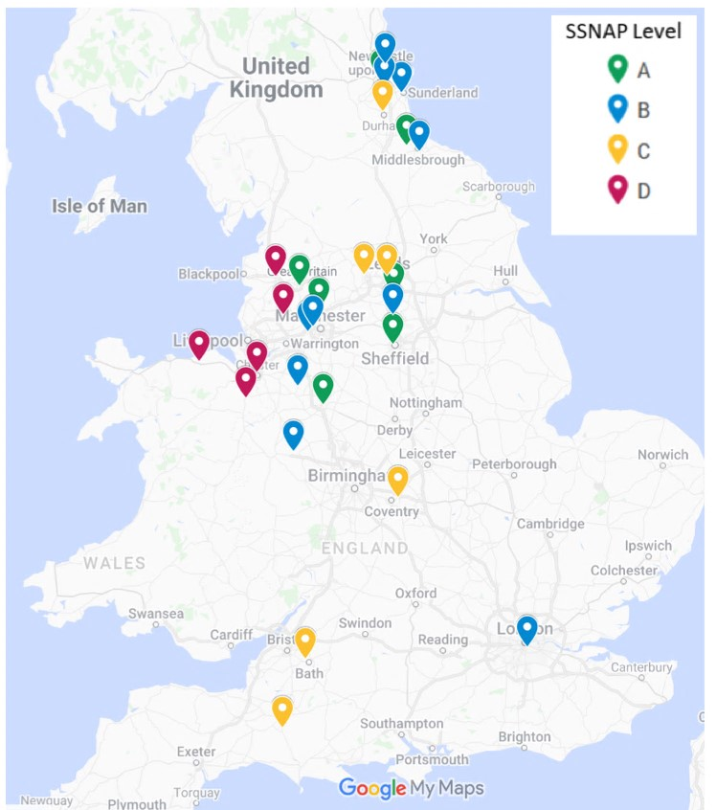
SSNAP: Sentinel Stroke National Audit Programme scores hospitals from (A-E) based on performance across 44 key indicators of care. A = First class service, B = Good or excellent in many aspects, C = Reasonable overall - some areas require improvement, D = Several areas require improvement. Based on the July-September 2021 SSNAP performance tables.
Map data © 2022 GeoBasis-DE/BKG (© 2009), Google, Instituto Geográfico Nacional. Available from: https://mymaps.google.com/. Accessed March 1, 2022.
Supplementary Table 1. Overview of data to be collected at baseline and follow-up.

Variable  (questionnaire used if applicable) | Collected at Baseline | Collected at Follow-up
Demographic statistics e.g. age, sex, height, weight | X
Blood pressure | X
Diagnosed medical conditions | X | X
Cardiovascular history | X | X
Prescribed medications | X | X
Blood sample results including cholesterol levels, triglycerides, blood glucose, haemoglobin, white cell count, serum creatinine* | X
Electrocardiogram (ECG) image and results* | X
Echocardiogram results* | X
Stroke severity  (National Institutes of Health Stroke Scale: NIHSS)¹ | X
Degree of disability after stroke  (Modified Rankin Scale)² | X
Functional independence  (Barthel Index)³ | X | X
Cognitive function  (Montreal Cognitive Assessment: MoCA)⁴ | X | X
Fatigue  (Fatigue Assessment Scale)⁵ | X | X
Depression  (Patient Health Questionnaire: PHQ-9)⁶ | X | X
Anxiety  (General Anxiety Disorder: GAD-7)⁷ | X | X
Quality of life  (EQ-5D-5L without the visual analogue scale)⁸ | X | X
*Data only collected if the procedure is completed as part of usual care.

Supplementary Table 2. Risk prediction models for atrial fibrillation which will be examined in the Liverpool-Heart And bRain Project (L-HARP).
Risk model | Variables included in the model
C₂HEST⁹ | Age (≥75 years old), coronary artery disease, chronic obstructive pulmonary disease, hypertension, systolic heart failure, hyperthyroidism.
Atherosclerosis Risk in Communities (ARIC)¹⁰ | Age, black race, height, systolic blood pressure, hypertension medication use, smoking status, precordial murmur, left atrial enlargement, left ventricular hypertrophy, diabetes mellitus, heart failure, coronary heart disease.
Cohorts for Heart and Aging Research in Genomic Epidemiology (CHARGE)-atrial fibrillation (AF)¹¹ | Age, white race, height, weight, blood pressure, current smoker, hypertension treatment, Type 2 diabetes, heart failure, myocardial infarction, left ventricular hypertrophy, PR Interval.
Framingham Heart Study¹² | Age, systolic blood pressure, hypertension treatment, body mass index, PR Interval, significant murmur, heart failure.
HAVOC score¹³ | Age (≥75 years old), hypertension, valvular heart disease, peripheral vascular disease, obesity, congestive heart failure, coronary artery disease.
HATCH score¹⁴ | Age (>75 years old), hypertension, stroke or transient ischaemic attack, chronic obstructive pulmonary disease and heart failure.

Supplementary references

1. Lyden P, Lu M, Jackson C, et al. Underlying structure of the National Institutes of Health Stroke Scale: results of a factor analysis. NINDS tPA Stroke Trial Investigators. Stroke. 1999;30(11):2347-2354.
2. van Swieten JC, Koudstaal PJ, Visser MC, Schouten HJ, van Gijn J. Interobserver agreement for the assessment of handicap in stroke patients. Stroke. 1988;19(5):604-607.
3. Collin C, Wade DT, Davies S, Horne V. The Barthel ADL Index: a reliability study. Int Disabil Stud. 1988;10(2):61-63.
4. Nasreddine ZS, Phillips NA, Bédirian V, et al. The Montreal Cognitive Assessment, MoCA: a brief screening tool for mild cognitive impairment. J Am Geriatr Soc. 2005;53(4):695-699.
5. Cumming TB, Mead G. Classifying post-stroke fatigue: Optimal cut-off on the Fatigue Assessment Scale. J Psychosom Res. 2017;103:147-149.
6. Kroenke K, Spitzer RL, Williams JB. The PHQ-9: validity of a brief depression severity measure. J Gen Intern Med. 2001;16(9):606-613.
7. Spitzer RL, Kroenke K, Williams JB, Löwe B. A brief measure for assessing generalized anxiety disorder: the GAD-7. Arch Intern Med. 2006;166(10):1092-1097.
8. Herdman M, Gudex C, Lloyd A, et al. Development and preliminary testing of the new five-level version of EQ-5D (EQ-5D-5L). Qual Life Res. 2011;20(10):1727-1736.
9. Li YG, Bisson A, Bodin A, et al. C2HEST Score and Prediction of Incident Atrial Fibrillation in Poststroke Patients: A French Nationwide Study. Journal of the American Heart Association. 2019;8(13):e012546.
10. Chamberlain AM, Agarwal SK, Folsom AR, et al. A clinical risk score for atrial fibrillation in a biracial prospective cohort (from the Atherosclerosis Risk in Communities [ARIC] study). Am J Cardiol. 2011;107(1):85-91.
11. Alonso A, Krijthe BP, Aspelund T, et al. Simple risk model predicts incidence of atrial fibrillation in a racially and geographically diverse population: the CHARGE-AF consortium. J Am Heart Assoc. 2013;2(2):e000102.
12. Schnabel RB, Sullivan LM, Levy D, et al. Development of a risk score for atrial fibrillation (Framingham Heart Study): a community-based cohort study. Lancet. 2009;373(9665):739-745.
13. Kwong C, Ling AY, Crawford MH, Zhao SX, Shah NH. A Clinical Score for Predicting Atrial Fibrillation in Patients with Cryptogenic Stroke or Transient Ischemic Attack. Cardiology. 2017;138(3):133-140.
14. Suenari K, Chao TF, Liu CJ, Kihara Y, Chen TJ, Chen SA. Usefulness of HATCH score in the prediction of new-onset atrial fibrillation for Asians. Medicine (Baltimore). 2017;96(1):e5597.

