Supplementary information:

Local and systemic delivery of BimS gene nano-complex for efficient oral squamous cell carcinoma therapy

Supplementary materials and methods
Plasmid gel retardation assay
For the plasmid gel retardation assay, 1 μg of phBimS was mixed with different molecular ratios of DMP nanoparticles and incubated for 15 minutes to evaluate the binding ability of DMP with plasmid. The DMP/phBimS complex was electrophoresed on a 1% (w/v) agarose gel for 15 min at 100 V. The gel was pre-stained with GoldView II Nuclear Staining Dye (Solarbio®) and detected with an E-gel imager (Bio-Rad®, ChemiDox XRS, USA). The loading efficiency of the DMP/phBimS system against mRNA was determined by quantitively analyzing the plasmids retarding gel. Agarose gels were collected and purified to obtain unloaded plasmid, which was then measured by reading the absorbance in a spectrophotometer at 260 nm. Loading efficiency (DL) was calculated using the following formula:
DL $=$ $\frac{loaded plasmid}{loaded plasmid+DMP}$ $×$ 100%

Cytotoxicity assay
Human embryonic kidney 293T cells were cultured in a 96-well plate at 5×10³ cells per well in 100 μL medium (DMEM containing 10% FBS). Each well was added with different concentrations of DMP or PEI25K 24 h after culturing. Twenty-four hours after treatment, 20 μL of MTT solution was added to each well to stop the reaction. The plates were then incubated at 37°C for 4 h and medium was replaced by 150 μL DMSO. The plates were incubated for a further 10 min at room temperature shaking on a shaker. The absorbance of each well (wavelength: 562 nm) was recorded and analyzed (Spectramax® Absorbance Reader, Molecular Devices, USA).

Quantitative real-time polymerase chain reaction (PCR)
To determine the level of phBimS transcription intracellularly, total RNA was harvested from SCC15 cells transfected with DMP, DMP/pVAX (1 μg plasmid per well) and DMP/phBimS (1 μg plasmid per well) using a FastPure Cell/Tissue Total RNA Isolation Kit (Vazyme®). The transfection weight ratio of DMP:plasmid was 20:1. Briefly, SCC15 cells were seeded in 6-well plates (1.3×10⁵ per well) and transfection were conducted according to the protocol above. The plate was incubated at 37°C and total RNA was extracted 24 h after transfection. The mRNA was used as template to synthesize cDNAs by SuperScript II (Sigma-Aldrich Inc®). The SYBR qPCR Master Mix (Vazyme®) was used to perform quantitative Real-Time PCR. GAPDH was used as a reference to quantitate the hBimS expression level. The PCR primers for hBimS (forward: 5′- AGA CAG AGC CAC AAG CTT CC, reverse: 5′- TCC AAT ACG CCG CAA CTC TT) and GAPDH (forward: 5′- GTC TCC TCT GAC TTC AAC AGC G, reverse; 5′- ACC CTG TTG CTG TAG CCA A) were synthesized and purified.

Clonogenic assay
We used a clonogenic assay to detect the cell proliferation capacity of DMP. Briefly, SCC15 cells were seeded in a 6-well plate (800 cells per well). The transfection of DMP, DMP/pVAX (4 μg plasmid per well), and DMP/phBimS (4 μg plasmid per well) were conducted 24 h after seeding according to the protocol mentioned above with the 20:1 weight ratio of DMP:plasmid. The plates were incubated at 37°C, and cells continued to culture and formed colonies. One week after transfection, when colonies could be clearly observed by the naked eye, the supernatant was discarded, and the colonies were carefully washed twice with phosphate buffered saline (PBS). Paraformaldehyde was used to fix colonies for 15 min and crystal violet (0.1%) was used to stain cells for a further 20 min. The 6-well plate was photographed and the number of colonies was counted.

Anti-proliferation assay
We assessed the growth inhibition ability of the DMP/phBimS complex. Briefly, SCC15 cells were seeded into a 96-well plate (5×10³ cells per well) overnight at 37°C under a humidified atmosphere containing 5% CO₂. The cells were transfected with DMP, DMP/pVAX (0.5 μg per well), and DMP/phBimS (0.5 μg per well) according to the protocols above (DMP:plasmid=20:1, w/w). After 24 h, the anti-proliferation was measured by MTT assay.

Western blot analysis
To test the change in proteins in the apoptotic pathway, SCC15 (8×10⁴ cells per well) were seeded in 6-well plates and were transfected with DMP, DMP/pVAX (2 μg plasmid per well), and DMP/phBimS (2 μg plasmid per well) in 20:1 weight ratio of DMP:plasmid. Protein samples were extracted with RIPA/IP (Beyotime®) 48 h after transfection and samples were stored at –80°C before use. The total protein concentration was determined with Coomassie brilliant blue G-250 (Beyotime®) to ensure a consistent loading volume. Samples were separated by polyacrylamide gel electrophoresis (Beyotime®) and transferred to a polyvinylidene difluoride (PVDF) membrane (Millipore®) before blocking the membrane with 5% non-fat milk (Servicebio Technology®, Wuhan). We probed the target protein with 10 ml primary antibody overnight at 4°C (Bim, 1:1000; Cell Signaling Technology®, C34C5). We incubated the PVDF membrane with goat-rabbit secondary antibody (1:10,000; Cell Signaling Technology®) after each primary antibody. The target proteins were detected using a chemiluminescence system (ChemiScope Touch, CLINX, Shanghai).

Appendix Figure S1. The DMP/phBimS complex induced limited apoptosis in 293T cells after transfection, as measured by flow cytometry.
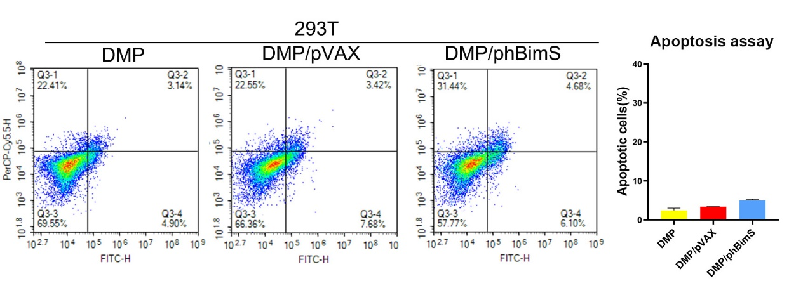

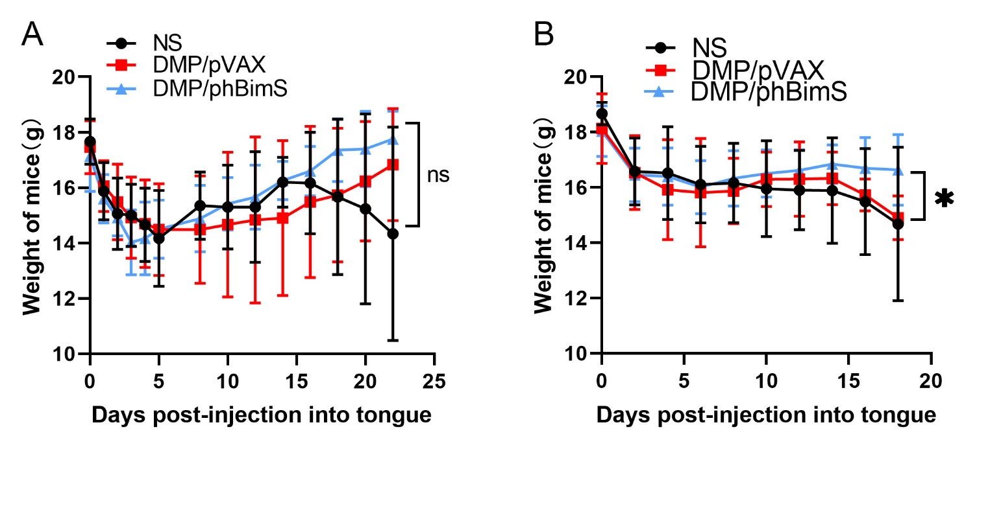
Figure S2. Mice body weight observation in mouse tongue xenograft model via different administration pathways. (A) Body weight change curve of mice from each group treated with local administration treatment. (B) Body weight change curve of mice from each group treated with systemic administration treatment (*P < 0.05).

Figure S3. Hematoxylin and eosin (H&E) analysis of the main organs of different groups. (A) H&E analysis of the main organs from each group treated with local administration (scale bar: 150 μm). (B) H&E analysis of the main organs from each group treated with systemic administration (scale bar: 150 μm).
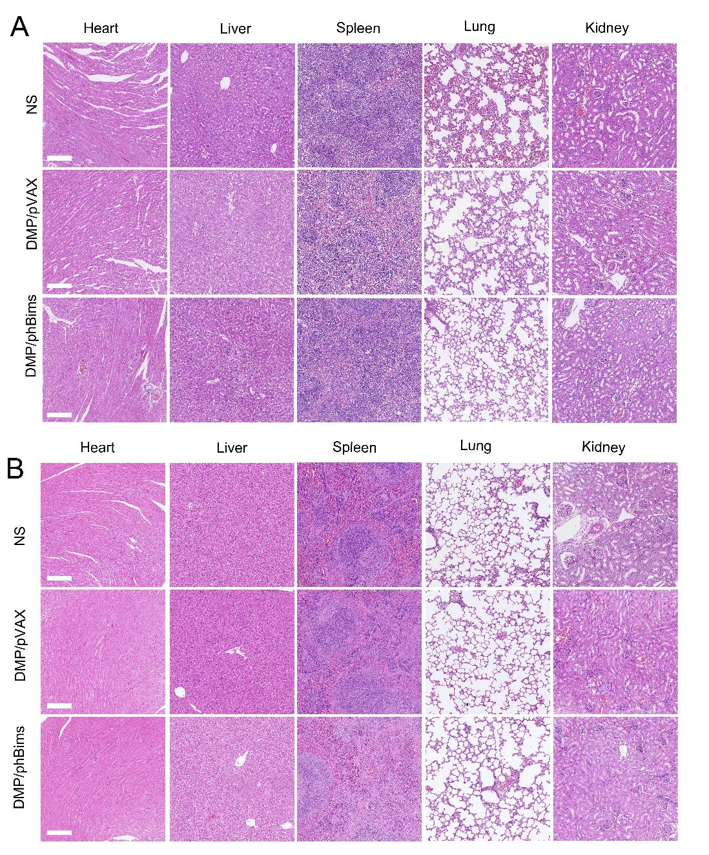

Figure S4. Blood routine analysis of DMP/phBimS complex-treated mice after intravenous administration compared with NS group mice.
