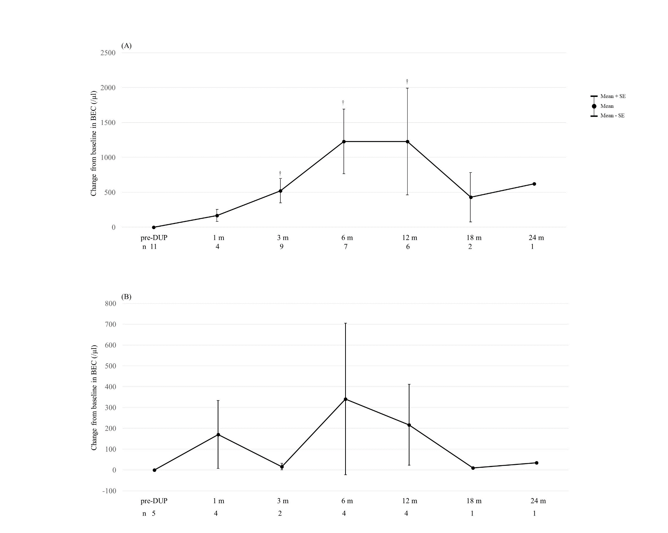
Supplementary Figure 1: The change from baseline in BEC
(A) switching from anti-IL-5/IL-5 receptor antibody
(B) switching from anti-IgE antibody
All data were analyzed using the Wilcoxon signed-rank test. The upper and lower bars represent the standard errors.
†p < 0.05 compared with baseline
Abbreviations: pre-DUP; pretreatment with dupilumab, BEC; blood eosinophil count, m; month(s), n; number of patients for whom clinical data were available.

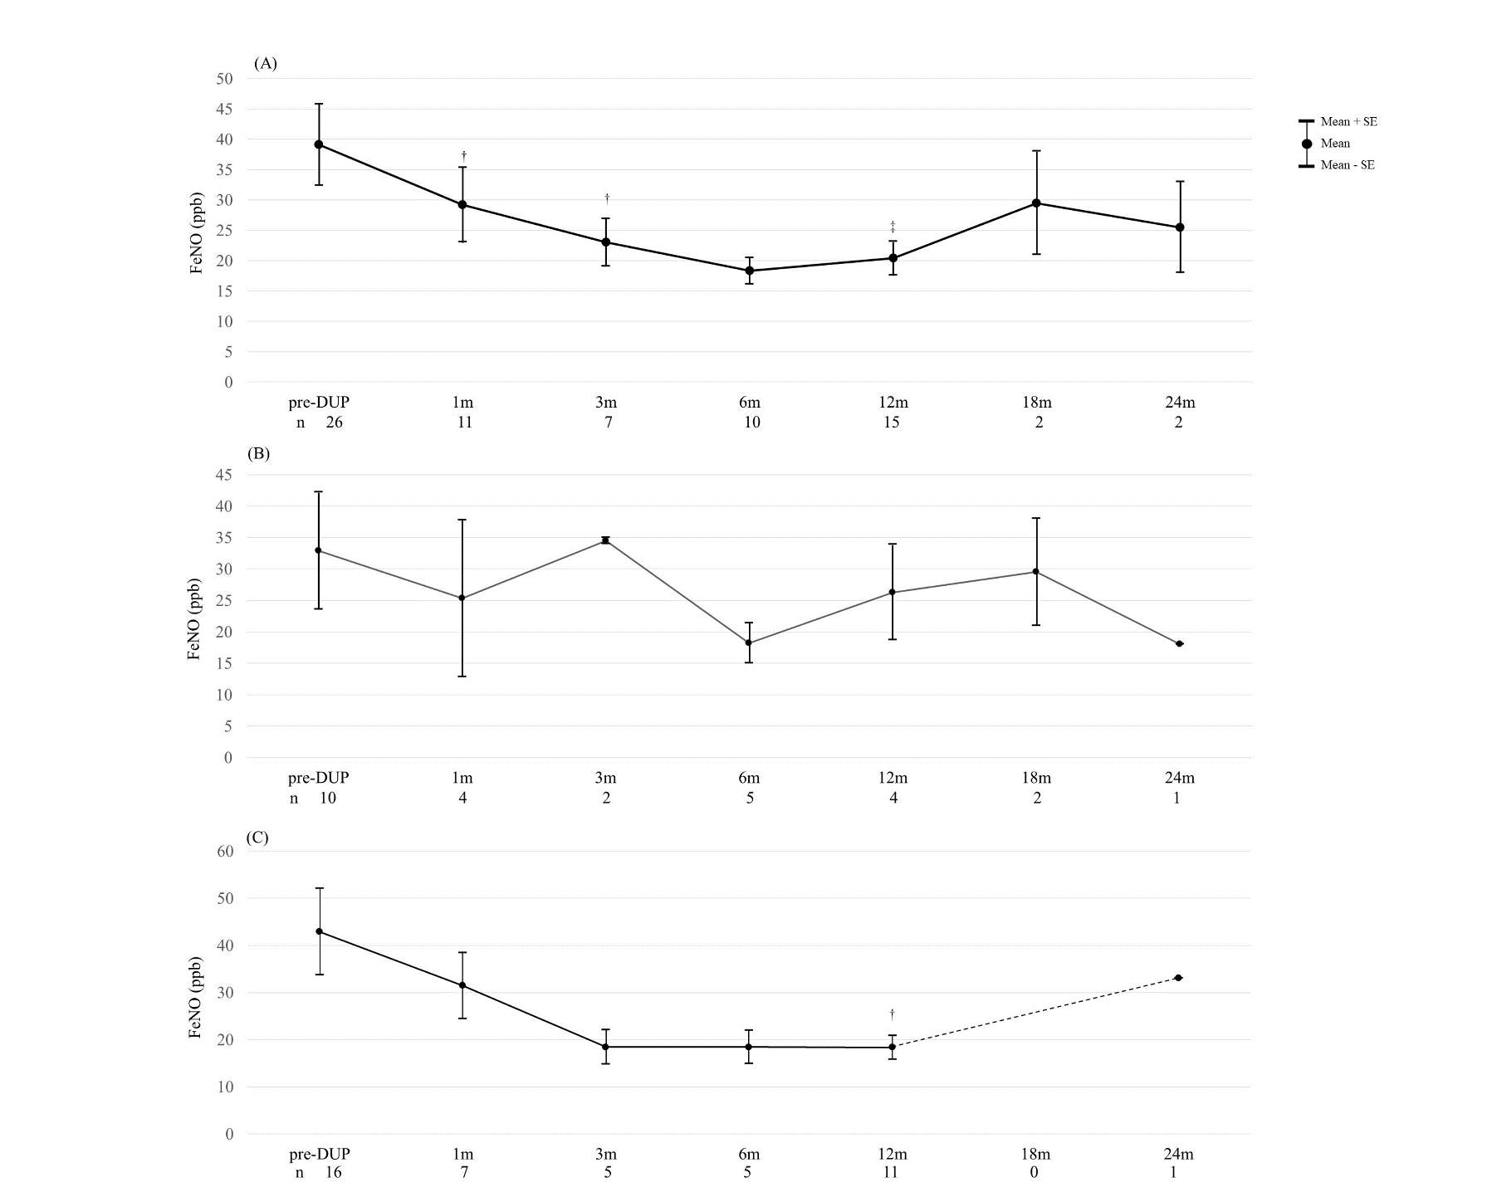
Supplementary Figure 2: The change in FeNO
(A) All patients, (B) Previous biologics (-), (C) Previous biologics (+)
All data were analyzed using the Wilcoxon signed-rank test. The upper and lower bars represent the standard errors.
In supplementary Figure 2(C), since there is no data at 18 months and only one data at 24 months, a dashed line was used to show the change.
†p < 0.05 compared with baseline
‡p < 0.01 compared with baseline
Abbreviations: pre-DUP; pretreatment with dupilumab, FeNO; fraction exhaled nitric oxide, m; month(s), n; number of patients for whom clinical data were available.

