Supplementary 1. Steps of simple prostatectomy.
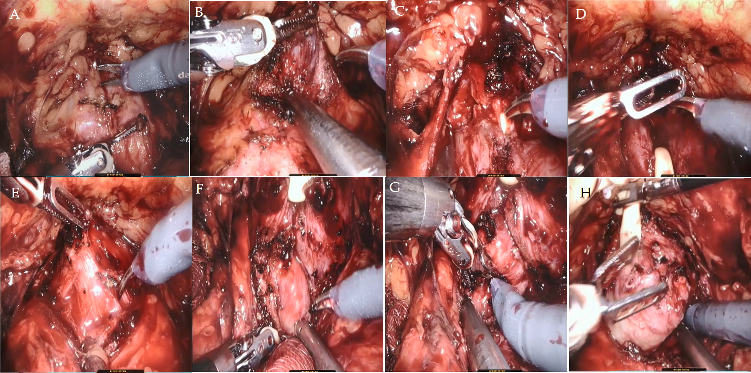
Notes: (A) Incision to the anterior capsule of the prostate. (B) Exposure of the surgical capsule. (C) Transection of the urethra. (D) Using urethral catheter for traction. (E) Dissection of the anterior bladder neck. (F) Dissection of the median lobe. (G) Dissection of the posterior bladder neck (H) Removal of the prostate and leaving the capsule intact.
Supplementary 2. Distribution of the general data.
 | iPCa (n= 57) | Non-iPCa (n= 238)
Age | Skewness: 0.03± 0.32; kurtosis: -0.20± 0.62 | Skewness: -0.17± 0.16; kurtosis: 0.51± 0.31
BMI | Skewness: 0.26± 0.36; kurtosis: -1.24± 0.62 | Skewness: -0.44± 0.16; kurtosis: -0.27± 0.31
PSA | Skewness: 3.16± 0.31; kurtosis: 8.99± 0.62 | Skewness: 0.86± 0.16; kurtosis: 0.50± 0.31
Prostate volume (ml) | Skewness: 1.10± 0.32; kurtosis: 2.45± 0.61 | Skewness: 1.30± 0.16; kurtosis: 1.42± 0.32
Note: Skewness and kurtosis, used to judge the distribution of data, were expressed along with standard error.

