Annual and post-exacerbation follow-up of asthma patients in clinical practice – a large population-based study in Sweden

Supplementary data
Supplementary Figure 1. Study Design
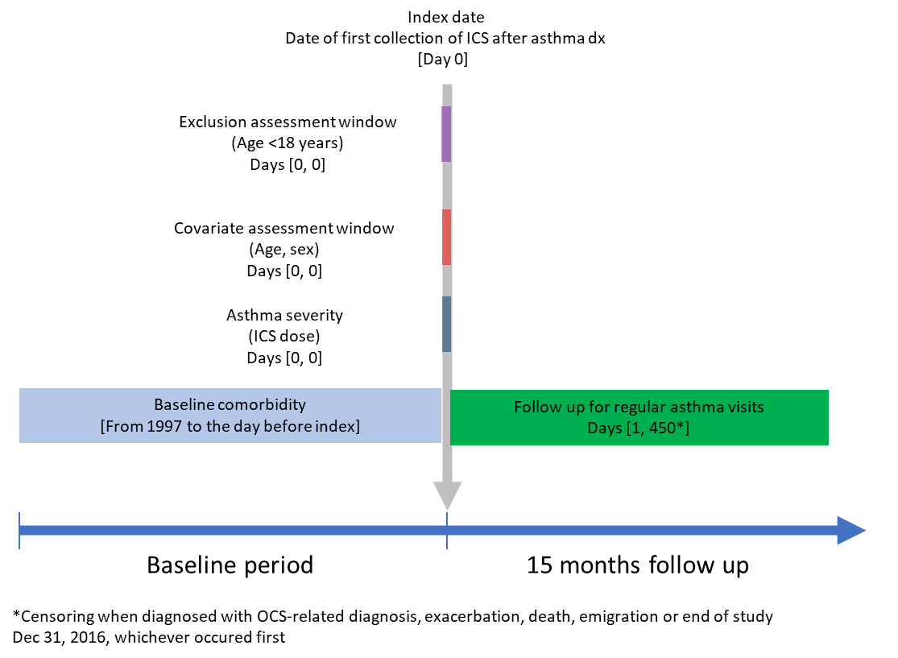

Supplemental Table 1. Medication and diagnoses codes
Medication | ATC-code
ICS | R03BA
ICS/LABA combinations | R03AK06-08, 10-11
ICS/LABA/LAMA combinations | R03AL08-09
LABA | R03AC12-13, 18-19, R03CC12
LAMA | R03AL03-07
SABA | R03AC02-03
Leukotriene modifiers | R03DC03
Methylxanthines | R03DA04-05
PD4 antagonists | R03DX07
N-acetylcysteine | R05CB01
Nasal corticosteroids | R01AD01, 05, 08-09, 11-12, 58
OCS | H02AB01-02, 04, 06-09
Diagnoses | ICD-10 code
Asthma | J45-46
Chronic rhinitis | J31
Nasal polyps | J33
Acute lower respiratory tract infections | J20-J22
Chronic bronchitis | J40-J42
COPD | J44
Pneumonia | J11-J18
Acute upper respiratory tract infections | J00-J06
Hypertension | I10-I15
Allergies | J30.1-J30.4
Dermatitis and eczema | L20-L30
Depression | F32
Malignant neoplasm | C00-C97
Diabetes, type 2 | E11
Ischaemic heart disease | I20-I25
Heart Failure | I50
Osteoporosis | M82
Chron’s disease | K50
Ulcerative colitis | K51
Rheumaroid arthritis | M05
Polymyalgia rheumatica | M35.3

Supplemental Table 2. Incidence rate ratios (IRR) of asthma follow-up visits up to 15 months after index date
 | IRR (95% CI)
Gender
Males | 1.00 (ref)
Females | 1.09 (1.05-1.13)
Calendar year (cont,) | 1.09 (1.09-1.10)
Age at index (years)
18-34 | 1.00 (ref)
35-49 | 1.09 (1.04-1.13)
50-64 | 1.11 (1.06-1.16)
65+ | 1.16 (1.10-1.21)
Negative binomial regression model

