Supplementary Materials
Supplementary Figure 1 HPLC chromatograms of Anoectochilus Roxburghii (Wall.) Lindl. Polysaccharides extract. “Man” = Mannose, “Rib” = Ribose, “Rha” = Rhamnose, “Glc-UA” = Glucuronic acid, “Gal-UA” = Galacturonic Acid, “Glc” = Glucose, “Gal” = Galactose. “Xyl” = Xylose, “Ara” = Arabinose, “Fuc” = Fucose.

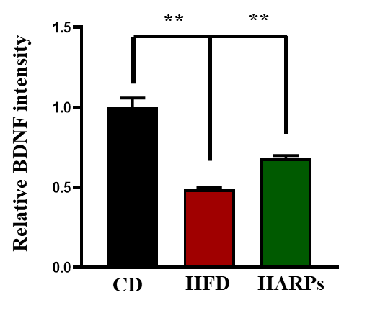
Supplementary Figure 2 The quantitative evaluation of BDNF expression in hippocampal Immunofluorescence staining. Microscopy results of BDNF expression in the different experimental groups of hippocampal tissue, with respective bar graphs (n = 6). The image data were collected from three independent experiments and were analyzed by ImageJ software. The differences have been shown in the graphs. Data were expressed as mean ± SEM, one-way ANOVA followed by post hoc analysis. p = < 0.05 were considered significant. *p < 0.05, **p < 0.01.

Supplementary Figure 3 | The assessment of data distribution with Quantile-Quantile plots.

Supplementary Table 1 | List of specific primers used for RT-PCR gene expression
Primer | Forward Primer | Reverse Primer
MCP-1 | TCTGTGCCTGCTGCTCATAG | GCTTGTCCAGGTGGTCCATG
F4/80 | ATGTCTGGCTTGCACCTAGTA | CCCCAAAGCGAGTAACAAATTCT
TNF-α | CCTCTCTCTAATCAGCCCTCTG | GAGGACCTGGGAGTAGATGAG
IL-6 | TTCCATCCAGTTGCCTTCTTG | TATCCTCTGTGAAGTCTCCTCTC
BDNF | CTCCGCCATGCAATTTCCACT | GCCTTCATGCAACCGAAGTA
Tau | AACCAGATCGGGATGGAGTTC | CAGCGACCGAGGGATGTACT
ZO-1 | TGGGAACAGCACACAGTGAC | GCTGGCCCTCCTTTTAACAC
Occludin | AGTACATGGCTGCTGATG | CCCACCATCCTCTTGATGTGT
Reg3g | CCTCAGGACATCTTGTGTCTGTGCTC | TCCACCTCTGTTGGGTTCATAGCC
MUC-2 | CACTGCGATGCCAACGACA | GCCACTAACTGCTTGTTCACCTGTA
18s | TTGACGGAAGGGCACCACCAG | GCACCACCACCCACGGAATCG

Supplementary Table 2 | The result of the major 10 Monosaccharide in the aqueous extract detected by HPLC.

The name of  Monosaccharide | Retention time | Response factor | Peak area | Content  (μg/ml） | Concentration  (μg/ml）
Mannose | 13.76 | 161.524 | 7992.320 | 49.481 | 49.481
Ribose | 17.70 | 172.029 | 34.421 | 0.200 | 0.200
Rhamnose | 18.52 | 136.982 | 423.485 | 3.092 | 3.092
Glucuronic acid | 21.55 | 104.499 | 330.352 | 3.161 | 3.161
Galacturonic Acid | 24.78 | 109.192 | 1436.649 | 13.157 | 13.157
Glucose | 27.82 | 253.295 | 17255.907 | 68.126 | 68.126
Galactose | 31.86 | 170.686 | 6788.187 | 39.770 | 39.770
Xylose | 33.23 | 179.966 | 173.581 | 0.965 | 0.965
Arabinose | 34.89 | 184.500 | 1320.564 | 7.158 | 7.158
Fucose | 39.36 | 150.834 | 103.902 | 0.689 | 0.689

