Supplementary materials

Hydroxyl Group-Targeted Conjugate and Its Self-Assembled Nanoparticle of Peptide Drug: Effect of Degree of Saturation of Fatty Acids and Modification of Physicochemical Properties

Critical Aggregation Concentration (CAC) Measurement
Pyrene was used as a hydrophobic probe in this study. At first, pyrene was dissolved in acetone at 3×10⁻⁴ M and injected to a series of vials to have the final concentration at 6×10⁻⁷ M after mixing with samples. After acetone evaporation in oven at 60 ºC, three conjugate LSC, LOC and LLC solution with different concentration (0.001 to 0.5 mg/mL) were added to pyrene. These vials were sonicated for 90 min in the sonication bath. A spectrophotometer (BioTek Synergy H1 Hybrid Multi-Mode Reader) was utilized to measure the fluorescence spectrum of all samples. The excitation wavelength was set up at 336 nm and the emission spectrum was scanned from 350 to 400 nm with the step size of 4 nm and integration time of 2 s. The intensity ratio of the first (I₁ = 374 nm) and the third (I₃ = 386 nm) energy bands in the recorded spectrum was analyzed to obtain the CAC values of LSC, LOC and LLC (Figure S1).

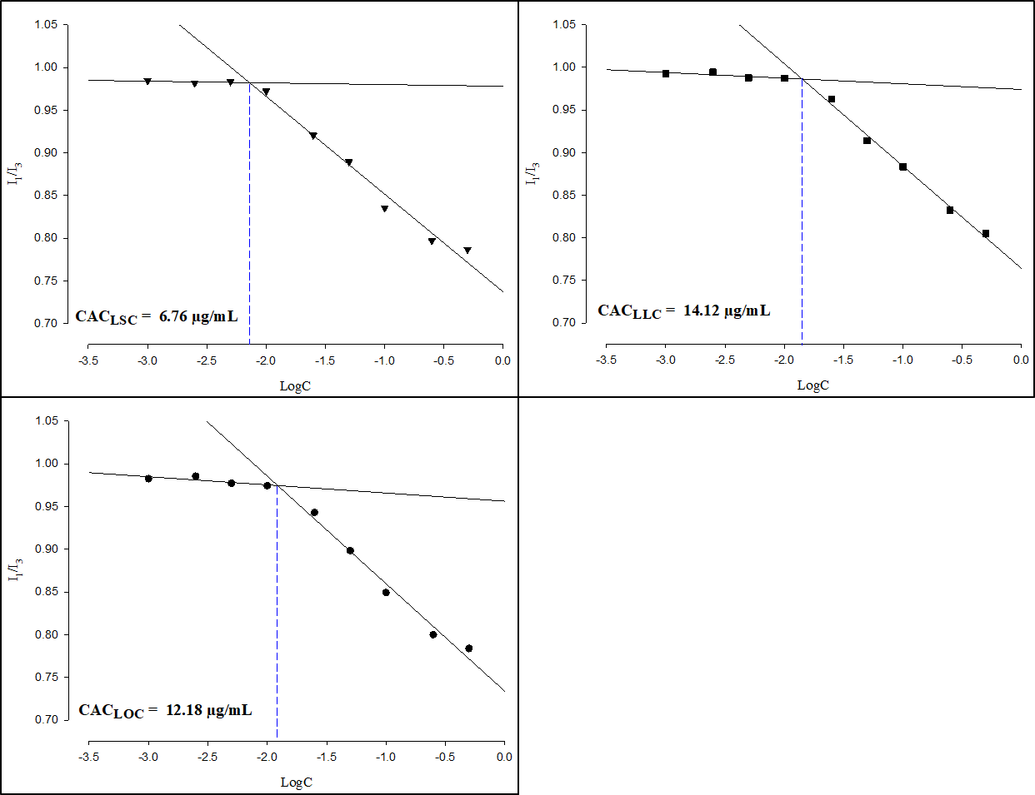

Figure S1 CAC values of LSC, LOC and LLC

