In supplement Figure 1A-1C, Compare the cfPWV between different age in quartile. The results showed older subjects had higher cfPWV and higher proportion of AS.

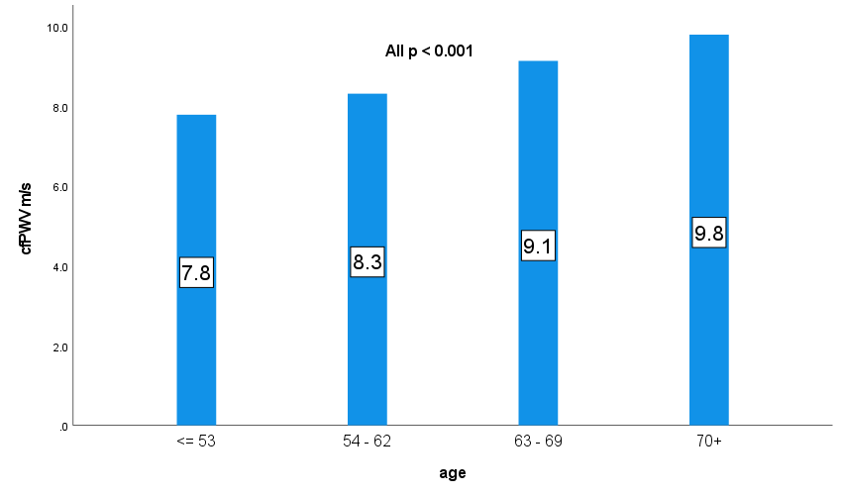
1AA
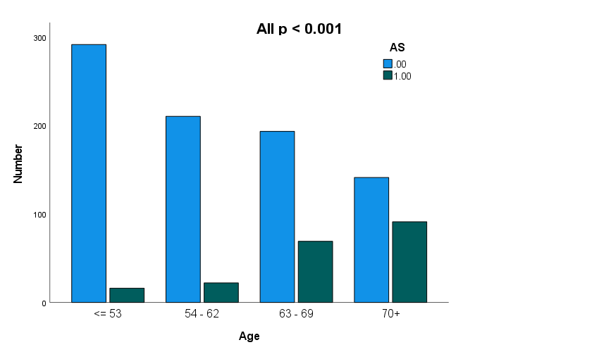
1BA
Supplement Figure 1A and 1B the cfPWV and number of AS between different age in quartile. P < 0.001 for comparison between any two groups.
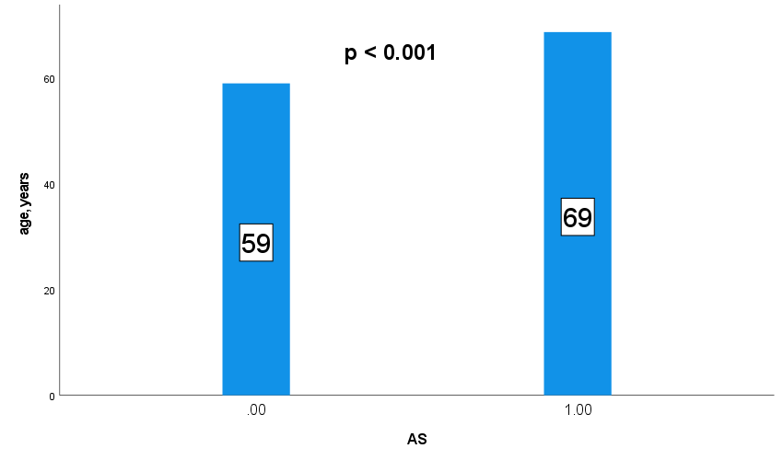
1CA
Supplement Figure 1C the subjects with AS were older than those with no AS.

