Table S1. The results of the 2 × 2 (diagnosis × gender) ANOVA of the demographic and clinical data
Characteristic | CID (n=106) |  | GSC (n=55) |  | Main effect of Diagnosis |  |  | Main effect of Sex |  |  | Interactive effect of Diagnosis and Sex
Characteristic | Male(n=40) | Female (n=66) | Male(n=21) | Female (n=34) | F/P | η2 | Power | F/P | η2 | Power | F/P | η2 | Power
Age | 35.92(10.44) | 36.11(12.06) | 34.10(8.78) | 36.79(9.82) | 0.22(0.638) | 0.001 | 0.075 | 0.88(0.349) | 0.006 | 0.154 | 0.26(0.607) | 0.002 | 0.081
Education | 13.57(3.95) | 14.69(3.41) | 14.33(5.07) | 12.79(4.95) | 0.65(0.421) | 0.004 | 0.126 | 0.08(0.769) | 0.020 | 0.432 | 3.52(0.062) | 0.022 | 0.462
SAS | 50.00(9.03) | 46.51(10.08) | 30.73(9.17) | 33.33(10.77) | 90.13(<0.001) | 0.417 | 1.000 | 0.07(0.794) | 0.006 | 0.154 | 3.24(0.074) | 0.037 | 0.687
SDS | 50.80(11.24) | 48.36(10.01) | 30.58(6.31) | 33.07(7.61) | 112.13(<0.001) | 0.370 | 1.000 | 0.86(0.354) | 0.005 | 0.152 | 2.86(0.105) | 0.020 | 0.432
Abbreviations: CID, chronic insomnia disorder; GSC, good sleep controls; PSQI, Pittsburgh Sleep Quality Index; SDS, Zung self-rating depression scale; SAS, Zung self-rating anxiety scale.

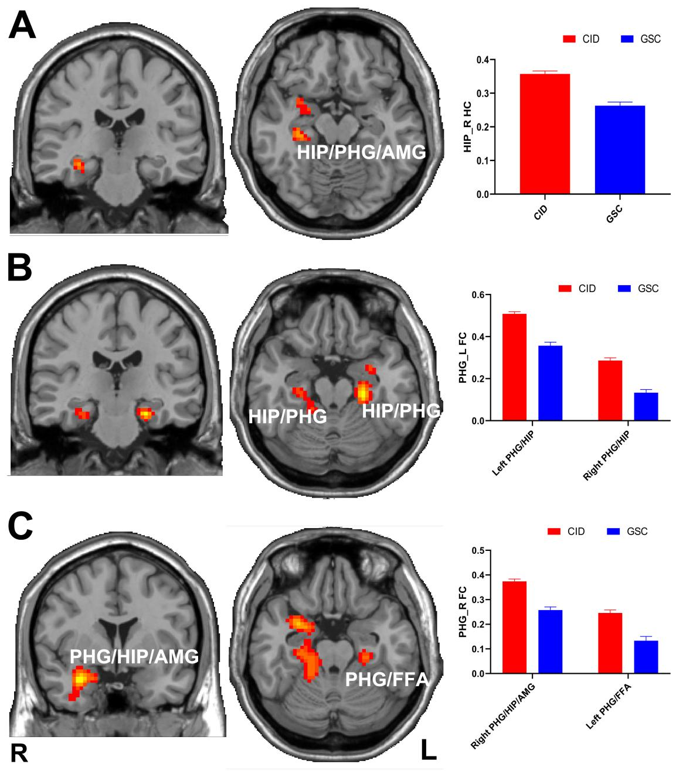
Figure S1. The main effect of diagnosis on the right HIP (A) / bilateral PHG (B,C) functional connectivity networks. Abbreviations: CID, chronic insomnia disorder; GSC, good sleep control; HIP, hippocampus; PHG, parahippocampal gyrus; FC, functional connectivity; AMG, amygdala; FFA, fusiform area.

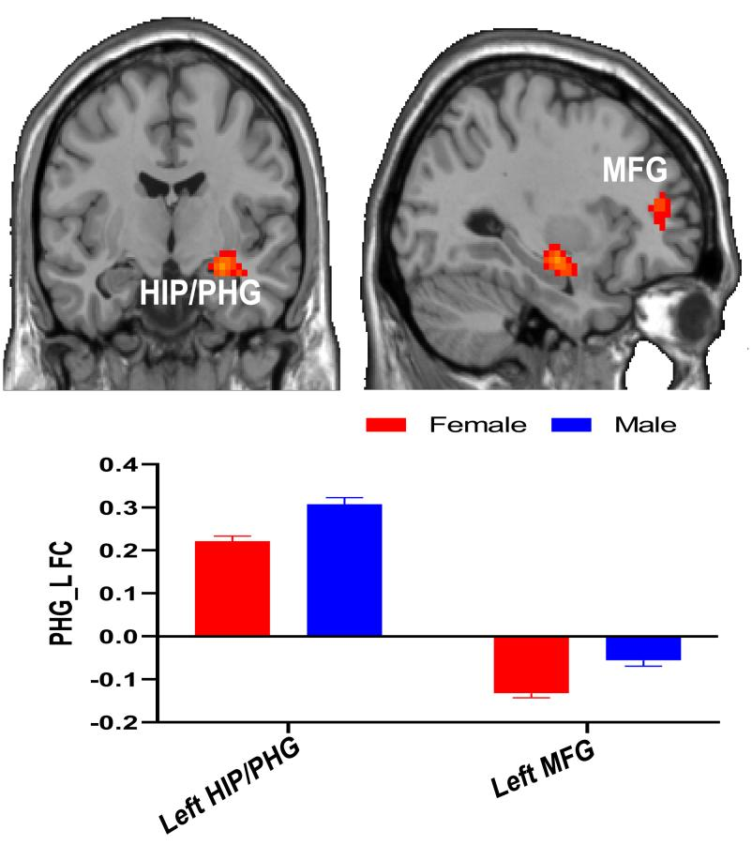
Figure S2. The main effect of sex on the left parahippocampal gyrus functional network. Abbreviations: HIP, hippocampus; PHG, parahippocampal gyrus; FC, functional connectivity; MFG, middle frontal gyrus.

