Supporting information
Chemi-excited photodynamic therapy integrated in polymeric nanoparticles capable of MRI against atherosclerosis
Dan Muª, Xin Wang^{a1}, Huiting Wangª, Xuan Sun^{b}, Qing Dai^{b}, Pin Lvª, Renyuan Liuª, Yu Qi^{b}, Jun Xie^{b}, Biao Xu^{b,c}*, Bing Zhang^{a,d}*
¹Both authors contributed equally.
ªDepartment of Radiology, Affiliated Nanjing Drum Tower Hospital of Nanjing University Medical School, Nanjing 210008, China.
^{b}Department of Cardiology, Affiliated Nanjing Drum Tower Hospital of Nanjing University Medical School, Nanjing 210008, China.
^{c}State Key Laboratory of Pharmaceutical Biotechnology, Nanjing University, Nanjing 210023, Jiangsu, People’s Republic of China.
^{d}Institute of brain Science, Nanjing University，Nanjing, Jiangsu，210008, China.
*Corresponding authors:
Biao Xu, e-mail: xubiao62@nju.edu.cn; Bing Zhang, e-mail: zhangbing_nanjing@nju.edu.cn.

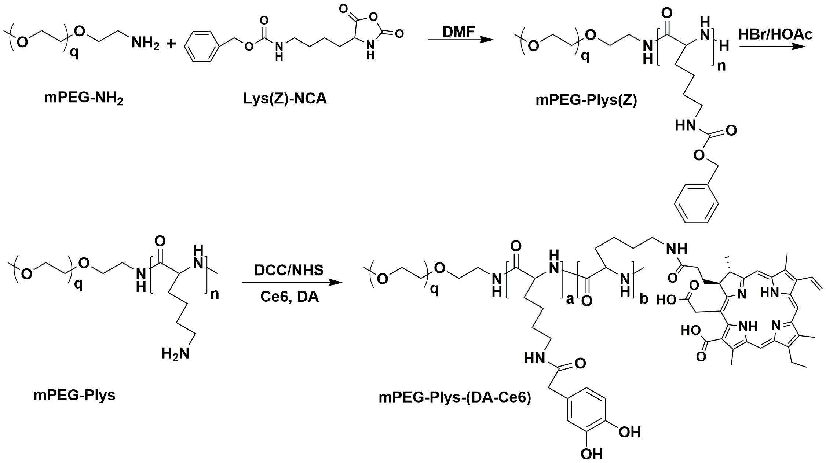
Scheme S1. The synthetic route of mPEG-Plys-(DA-Ce6).

Table S1. DLS information of nanoparticles.
NPs | Size/nm | PDI | Zeta potential/mV
BNPs | 130.5±5.6 | 0.24±0.04 | -9.8±6.4
FeNPs | 125.3±6.4 | 0.19±0.05 | -7.2±5.7
CNPs | 145.7±10.1 | 0.20±0.03 | -12.4±8.1
FeCNPs | 138.4±8.2 | 0.15±0.04 | -6.9±7.2
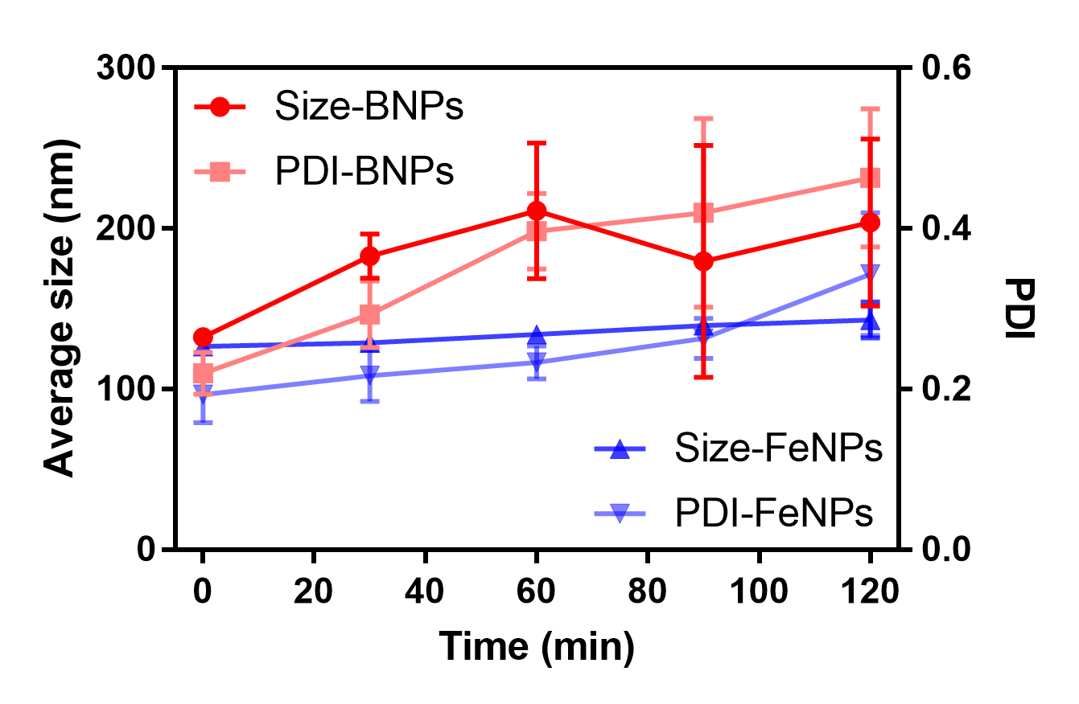
Figure S1. Stability of BNPs and FeNPs in the presence of SDS.
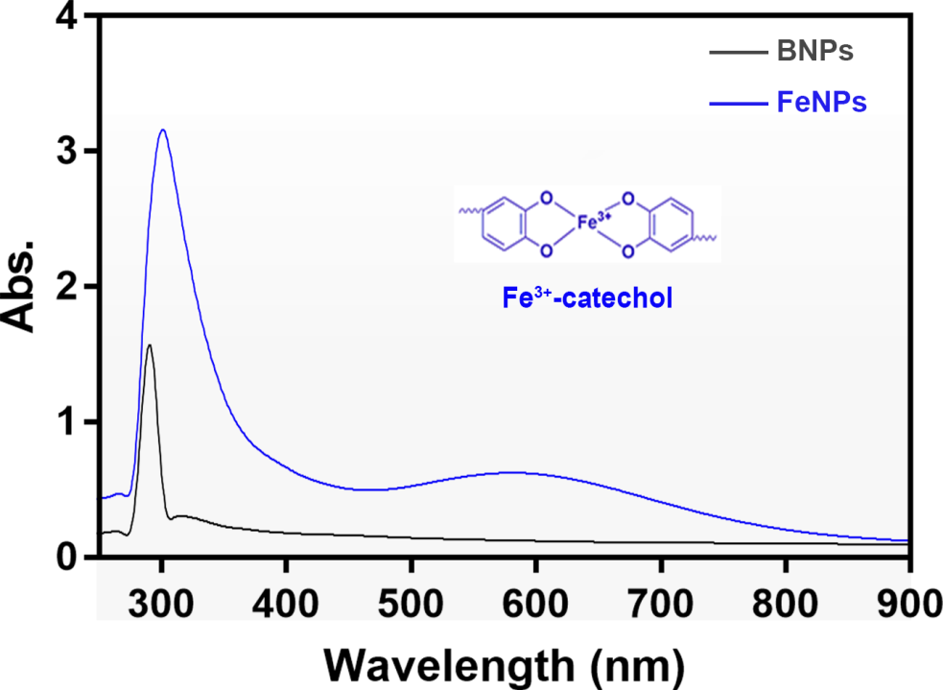
Figure S2. Absorption spectra of BNPs and FeNPs.
Figure S3. CPPO release from CNPs and FeCNPs in PBS containing 20 % methanol.
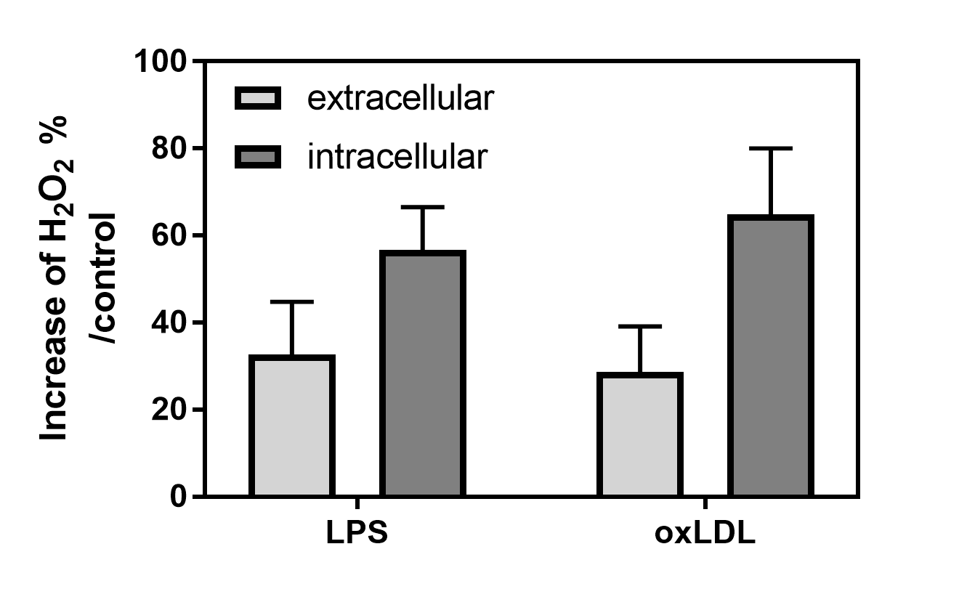
Figure S4. Hydrogen peroxide percentage of RAW264.7 cells activated by LPS and oxLDL compared with cells without activation.
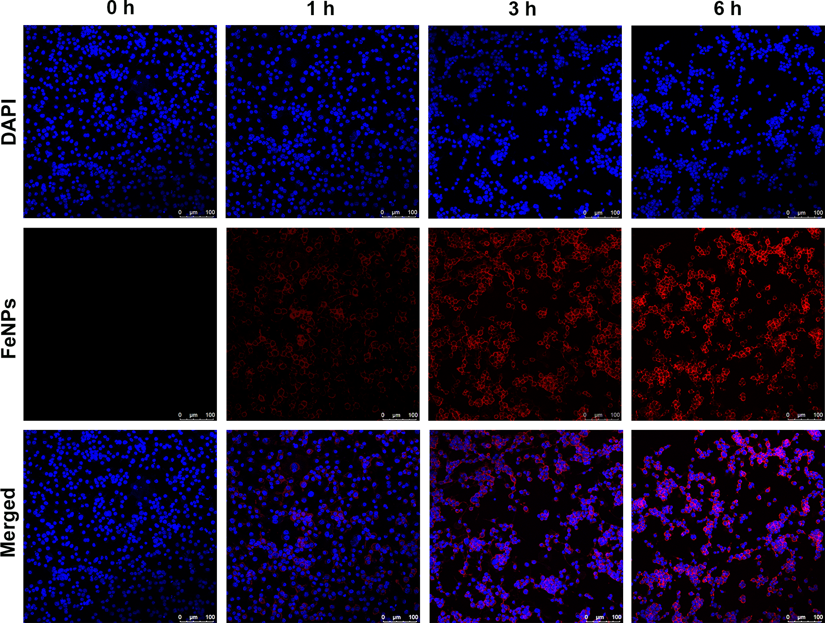
Figure S5. CLSM images of RAW264.7 without activation incubated with FeNPs for 1 h, 3 h and 6 h. Scale bar: 100 μm.
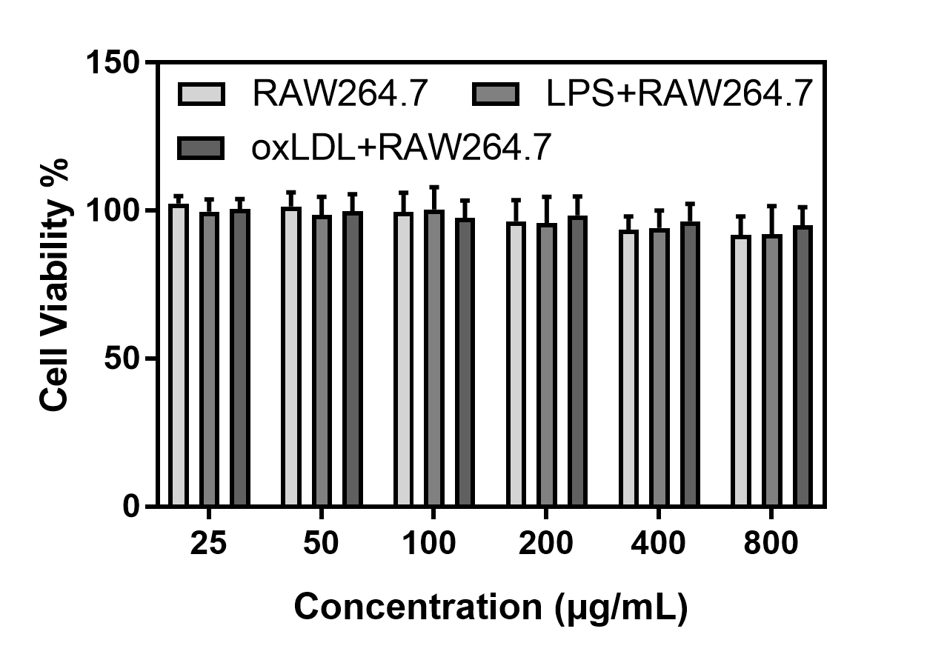
Figure S6. Cytotoxicity of FeNPs against RAW264.7 cells with or without activation of LPS and oxLDL.
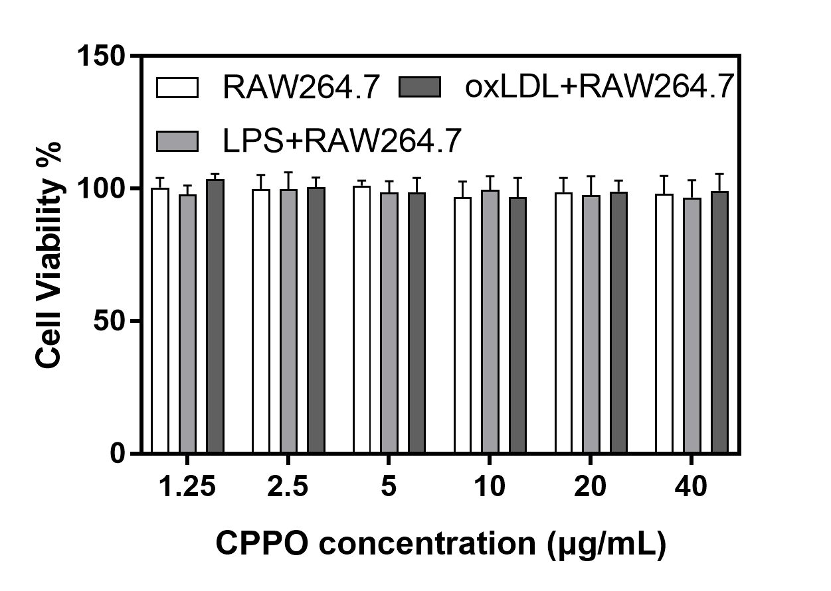
Figure S7. Cytotoxicity of CCPO against RAW264.7 cells with or without activation of LPS and oxLDL.
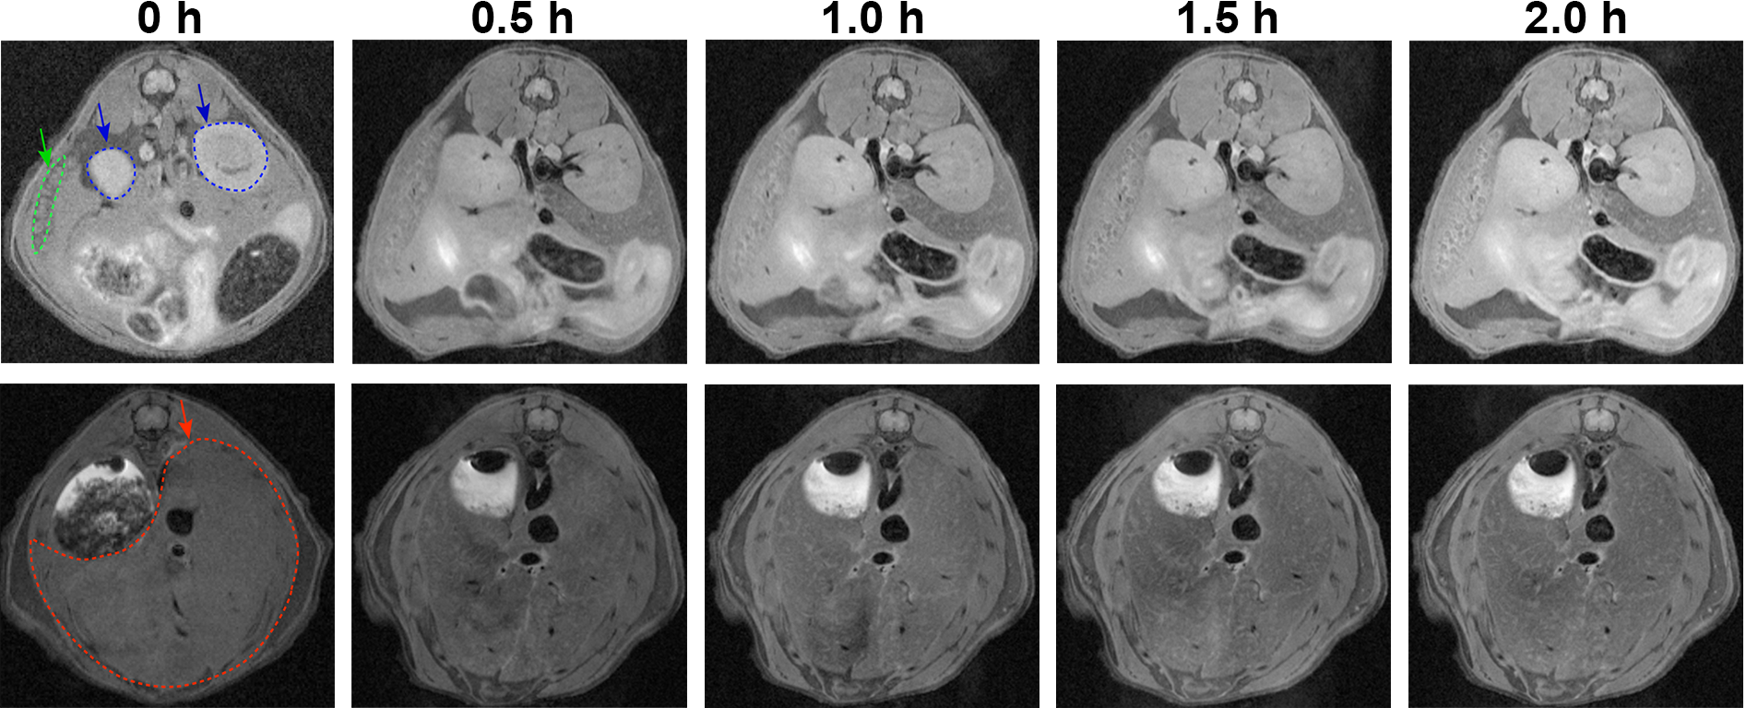
Figure S8. Representative T₁-weighted MRI images of spleen, kidney and liver in high-fat diet ApoE^{-/-} mice after injection of FeCNPs. Pre-contrast images were regarded as images at 0 h. Green line: spleen; blue line: kidney; red line: liver.
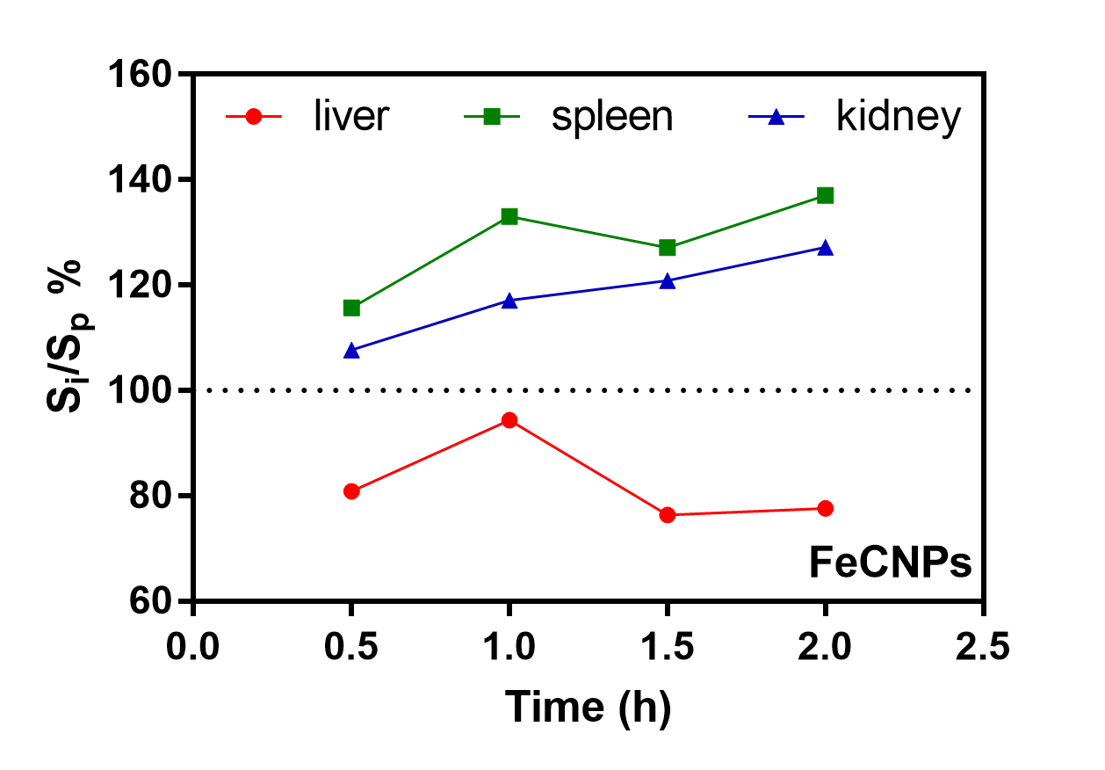
Figure S9. Time-dependent signal ratio from images of spleen, kidney and liver (S_{i}) in high-fat diet ApoE^{-/-} mice after injection of FeCNPs to pre-contrast images (S_{p}).
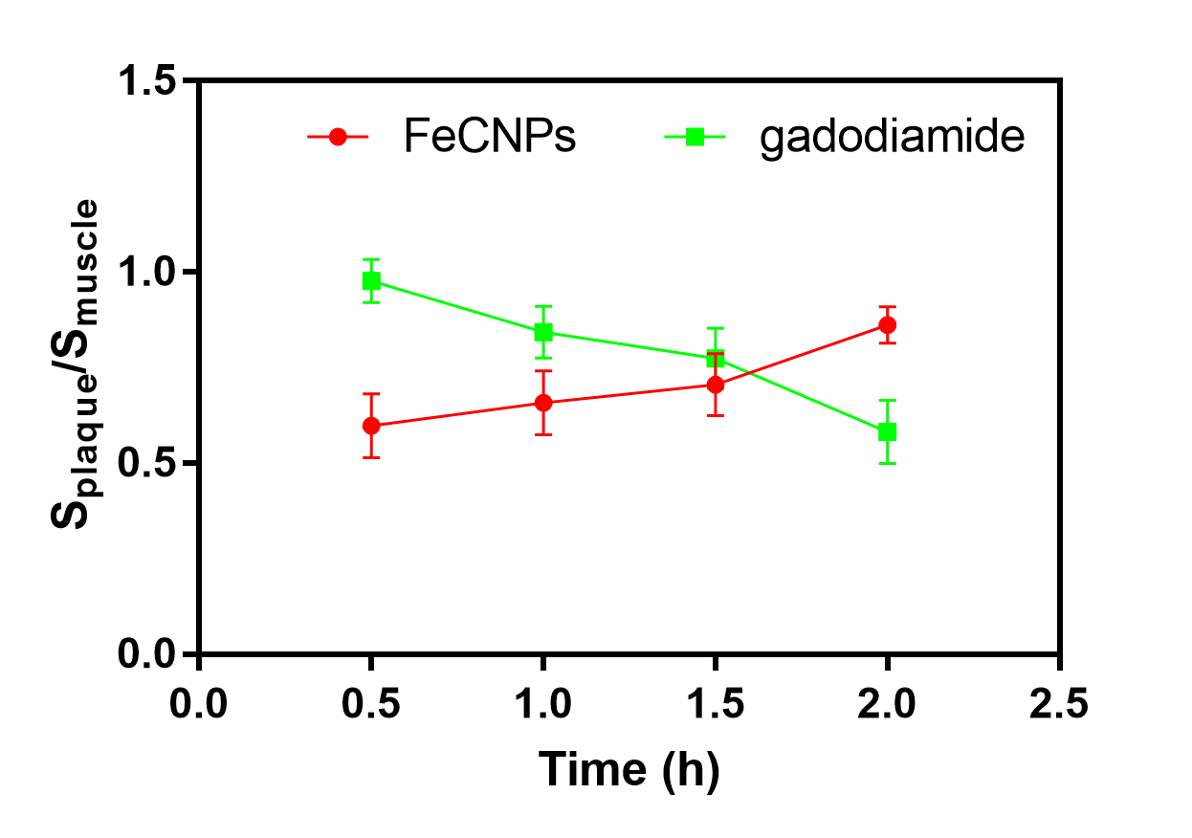
Figure S10. Time-dependent signal ratio of plaque to muscle.
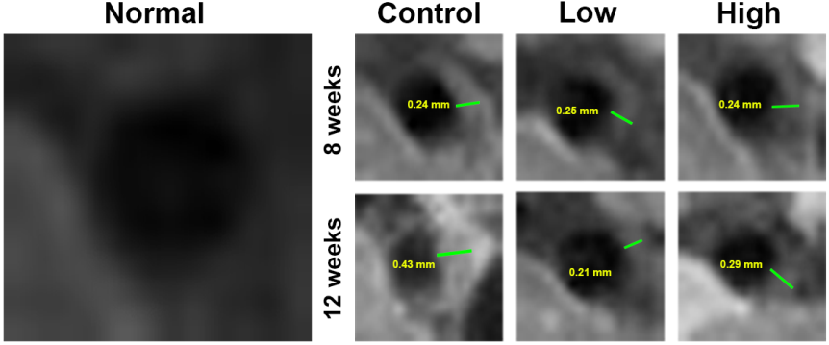
Figure S11. T₁-weighted MRI images of plaques in brachiocephalic artery before and after treatment. The thickness of plaques was labeled.

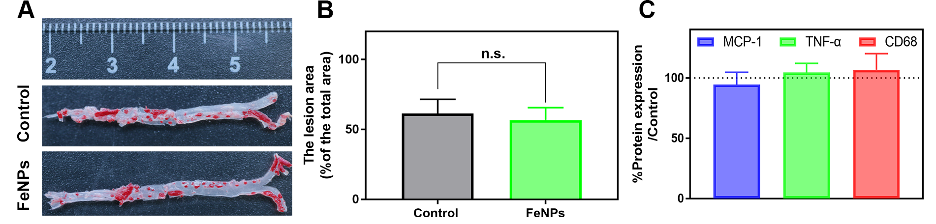Figure S12. (A) Representative images of ORO stained aortas from high-fat diet ApoE^{-/-} mice after treatment with PBS (Control) and FeNPs. (B) The lesion area ratio of ORO-stained area to whole area. n.s.: no significance. (C) Quantitative analysis of the expression of MCP-1, TNF-α and CD68.
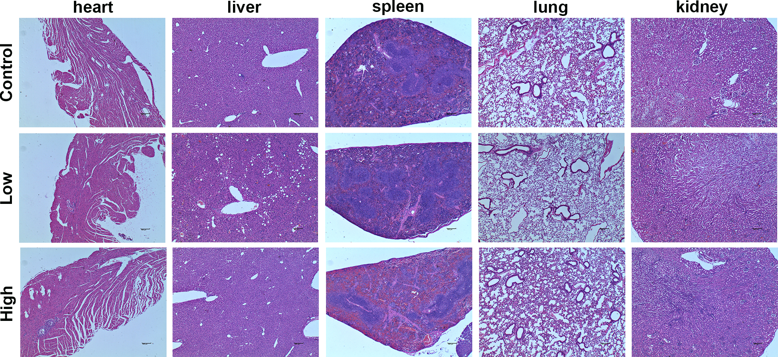
Figure S13. H&E analysis of sections of major organs from mice treated with low and high dose of FeCNPs. Scale bar: 100 µm.

