Supplementary materials

Supplementary Table S1 Comparisons of clinical characteristics between DK/DKA groups

Characteristic | Patients without DK/DKA (n = 239) | Patients with DK/DKA (n = 101) | P
Age, years | 57.0 (17.0) | 49.0 (25.0) | < 0.001*
Gender, male/female | 147/92 | 74/27 | 0.038*
BMI, kg/m² | 24.1 (5.1) | 23.7 (5.3) | 0.781
Past history of hypertension, n (%) | 90 (37.7) | 34 (33.7) | 0.485
Family history of diabetes, n (%) | 71 (29.7) | 31 (30.7) | 0.856
Smoking, n (%) | 62 (25.9) | 35 (34.7) | 0.104
HbA1c, % | 11.3 (2.6) | 13.2 (2.0) | < 0.001*
Fasting C-Peptide, μg/L | 2.22 (1.32) | 1.14 (0.92) | < 0.001*
2-h C-Peptide, μg/L | 3.69 (3.35) | 1.89 (1.84) | < 0.001*
HOMA-β | 180.85 (188.52) | 110.25 (128.67) | < 0.001*
HOMA-IR | 29.70 (23.14) | 18.67 (16.13) | < 0.001*
Diabetic nephropathy, n (%) | 45 (20.1) | 36 (35.6) | 0.001*
Diabetic peripheral neuropathy, n (%) | 19 (7.9) | 3 (3.0) | 0.088
Carotid atherosclerosis, n (%) | 55 (45.5) | 22 (52.4) | 0.439
Systolic BP, mm Hg | 133 (26) | 129 (23) | 0.383
Diastolic BP, mm Hg | 86 (12) | 85 (11) | 0.603
HDL-C, mmol/L | 1.05 (0.30) | 0.90 (0.30) | < 0.001*
LDL-C, mmol/L | 3.35 (1.24) | 3.26 (1.78) | 0.897
Triglyceride, mmol/L | 1.68 (1.29) | 1.55 (1.50) | 0.508
Total cholesterol, mmol/L | 5.01 (1.49) | 5.11 (1.80) | 0.680
Uric acid, μmol/L | 312 (140) | 323 (174) | 0.191
eGFR, mL/min/1.73 m² | 88.43 (27.54) | 94.38 (38.63) | 0.001*
FT3, pmol/L | 3.73 (0.81) | 3.08 (1.05) | < 0.001*
FT4, pmol/L | 14.38 (3.19) | 14.06 (4.38) | 0.394
FT3/FT4 ratio | 0.26 (0.05) | 0.22 (0.05) | < 0.001*
TSH, μIU/ml | 1.27 (1.13) | 1.34 (1.36) | 0.774
Positive thyroid antibody, n (%) | 16 (6.9) | 12 (12.2) | 0.114
Note: *P-value < 0.05.
Abbreviations: DK, diabetic ketosis; DKA, diabetic ketoacidosis; BMI, body mass index; HbA1c, glycated hemoglobin; HOMA-β, homeostasis model assessment of β cell function; HOMA-IR, homeostasis model assessment of insulin resistance; BP, blood pressure; HDL-C, high-density lipoprotein cholesterol; LDL-C, low-density lipoprotein cholesterol; eGFR, estimated glomerular filtration rate; FT3, free triiodothyronine; FT4, free thyroxine; TSH, thyroid stimulating hormone.

Supplementary Table S2 Comparisons of clinical characteristics between DN groups

Characteristic | Patients without DN (n = 258) | Patients with DN (n = 82) | P
Age, years | 55.5 (16.0) | 55.5 (24.0) | 0.609
Gender, male/female | 170/88 | 51/31 | 0.541
BMI, kg/m² | 23.9 (5.2) | 25.5 (4.5) | 0.002*
Past history of hypertension, n (%) | 85 (32.9) | 39 (47.6) | 0.017*
Family history of diabetes, n (%) | 75 (29.1) | 27 (32.9) | 0.507
Smoking, n (%) | 71 (27.5) | 26 (31.7) | 0.464
FPG, mmol/L | 13.34 (7.22) | 12.69 (6.93) | 0.264
2-h PG, mmol/L | 19.91 (10.24) | 19.24 (10.02) | 0.488
HbA1c, % | 11.9 (2.6) | 11.7 (2.4) | 0.575
Fasting C-Peptide, μg/L | 1.71 (1.39) | 1.98 (1.65) | 0.204
2-h C-Peptide, μg/L | 3.08 (2.75) | 2.78 (3.43) | 0.195
HOMA-β | 156.05 (176.55) | 185.29 (242.69) | 0.090
HOMA-IR | 24.46 (21.50) | 25.74 (28.32) | 0.362
Albumin excretion rate, mg/24h | 8.14 (12.38) | 55.82 (54.73) | < 0.001*
Urinary total protein, mg/24h | 108.78 (77.55) | 291.35 (370.08) | < 0.001*
Urinary albumin-to-creatinine ratio, mg/L | 11.50 (14.50) | 61.00 (72.50) | < 0.001*
Diabetic ketosis or ketoacidosis, n (%) | 65 (25.2) | 36 (43.9) | 0.001*
Diabetic peripheral neuropathy, n (%) | 18 (7.0) | 4 (4.9) | 0.501
Carotid atherosclerosis, n (%) | 54 (43.5) | 23 (59.0) | 0.092
Systolic BP, mm Hg | 131 (25) | 136 (30) | 0.076
Diastolic BP, mm Hg | 85 (16) | 84 (18) | 0.666
HDL-C, mmol/L | 1.03 (0.31) | 0.91 (0.44) | 0.002*
LDL-C, mmol/L | 3.35 (1.19) | 3.03 (1.55) | 0.011*
Triglyceride, mmol/L | 1.63 (1.19) | 1.97 (2.12) | 0.023*
Total cholesterol, mmol/L | 5.05 (1.52) | 4.91 (1.93) | 0.382
Uric acid, μmol/L | 312 (137) | 323 (185) | 0.676
eGFR, mL/min/1.73 m² | 91.15 (30.20) | 85.49 (34.68) | 0.225
FT3, pmol/L | 3.64 (0.81) | 2.99 (1.42) | < 0.001*
FT4, pmol/L | 14.43 (3.31) | 14.02 (4.12) | 0.058
FT3/FT4 ratio | 0.26 (0.05) | 0.22 (0.06) | < 0.001*
TSH, μIU/ml | 1.34 (1.14) | 1.20 (1.32) | 0.277
Positive thyroid antibody, n (%) | 20 (8.0) | 8 (10.0) | 0.583
Note: *P-value < 0.05.
Abbreviations: DN, diabetic nephropathy; BMI, body mass index; FPG, free plasma glucose; PG, plasma glucose; HbA1c, glycated hemoglobin; HOMA-β, homeostasis model assessment of β cell function; HOMA-IR, homeostasis model assessment of insulin resistance; BP, blood pressure; HDL-C, high-density lipoprotein cholesterol; LDL-C, low-density lipoprotein cholesterol; eGFR, estimated glomerular filtration rate; FT3, free triiodothyronine; FT4, free thyroxine; TSH, thyroid stimulating hormone.
.

Supplementary Table S3 Multivariate analysis of associated factors of diabetic nephropathy in patients with newly diagnosed T2DM (excluding patients with DK/DKA)

Variable | OR | β | Wald χ² | P
Age | 0.988 | -0.013 | 0.381 | 0.537
Hypertension | 1.178 | 0.164 | 0.116 | 0.734
BMI | 1.140 | 0.131 | 5.026 | 0.025*
HOMA-IR | 1.019 | 0.019 | 4.088 | 0.043*
HOMA-β | 1.001 | 0.001 | 0.949 | 0.330
eGFR | 0.999 | -0.001 | 0.014 | 0.907
FT3 | 0.228 | -1.478 | 14.890 | < 0.001*
FT4 | 1.174 | 0.161 | 3.435 | 0.064
Note: *P-value < 0.05.
Abbreviations: T2DM, type 2 diabetes mellitus; DK, diabetic ketosis; DKA, diabetic ketoacidosis; BMI, body mass index; HOMA-IR, homeostasis model assessment of insulin resistance; HOMA-β, homeostasis model assessment of β cell function; eGFR, estimated glomerular filtration rate; FT3, free triiodothyronine; FT4, free thyroxine.

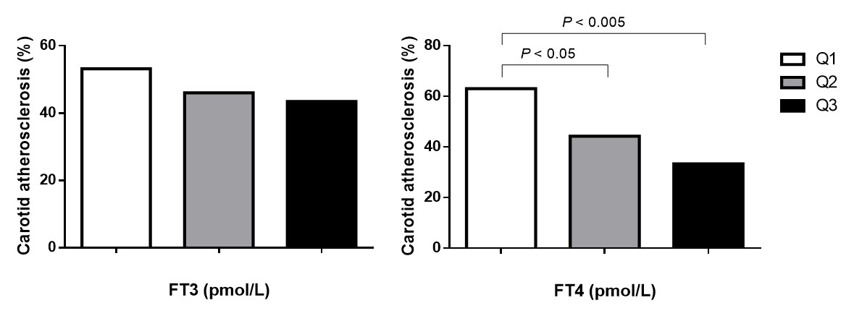
Supplementary Figure S1 Prevalence of carotid atherosclerosis in different FT3 and FT4 quartiles.
For FT3: Quartile 1 (Q1, n = 109), 1.54 to < 3.26 pmol/L; Quartile 2 (Q2, n = 119), 3.26 to < 3.88 pmol/L; Quartile 3 (Q3, n = 112), 3.88 to ≤ 7.18 pmol/L.
For FT4: Quartile 1 (Q1, n = 113), 6.66 to < 13.18 pmol/L; Quartile 2 (Q2, n = 113), 13.18 to < 15.25 pmol/L; Quartile 3 (Q3, n = 114), 15.25 to ≤ 23.92 pmol/L.
Abbreviations: FT3, free triiodothyronine; FT4, free thyroxine.

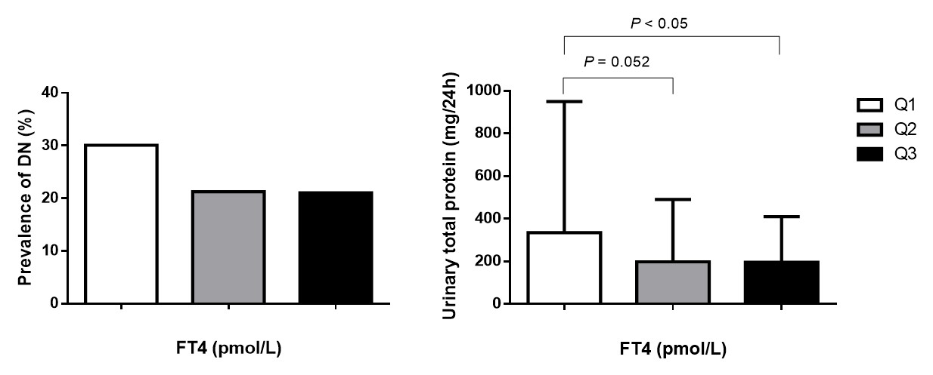
Supplementary Figure S2 Prevalence of DN and levels of urinary total protein in different FT4 quartiles.
Quartile 1 (Q1, n = 113), 6.66 to < 13.18 pmol/L; Quartile 2 (Q2, n = 113), 13.18 to < 15.25 pmol/L; Quartile 3 (Q3, n = 114), 15.25 to ≤ 23.92 pmol/L.
Abbreviations: DN, diabetic nephropathy; FT4, free thyroxine.

