Supplementary material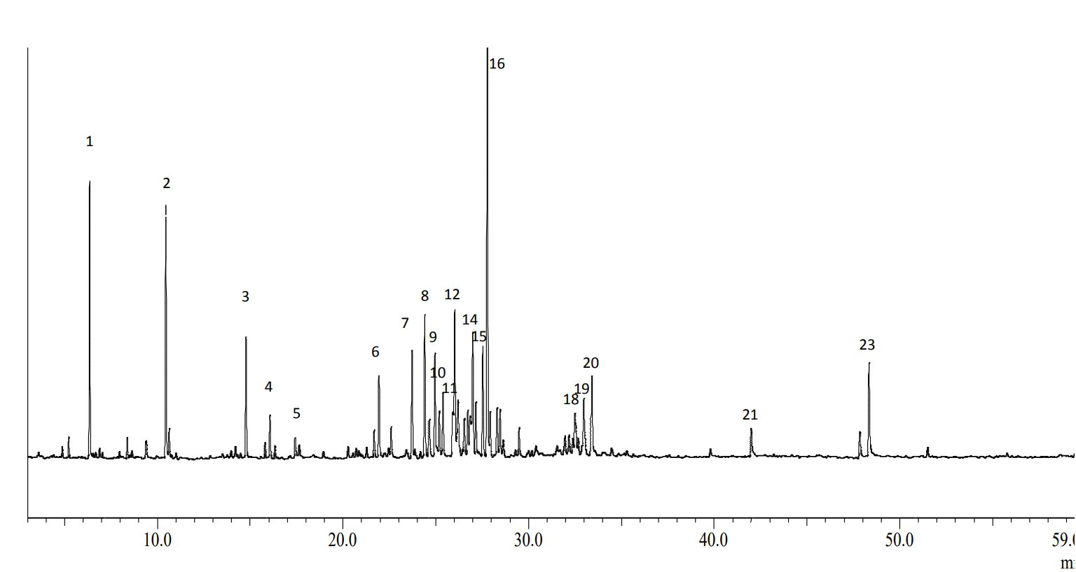
[A]
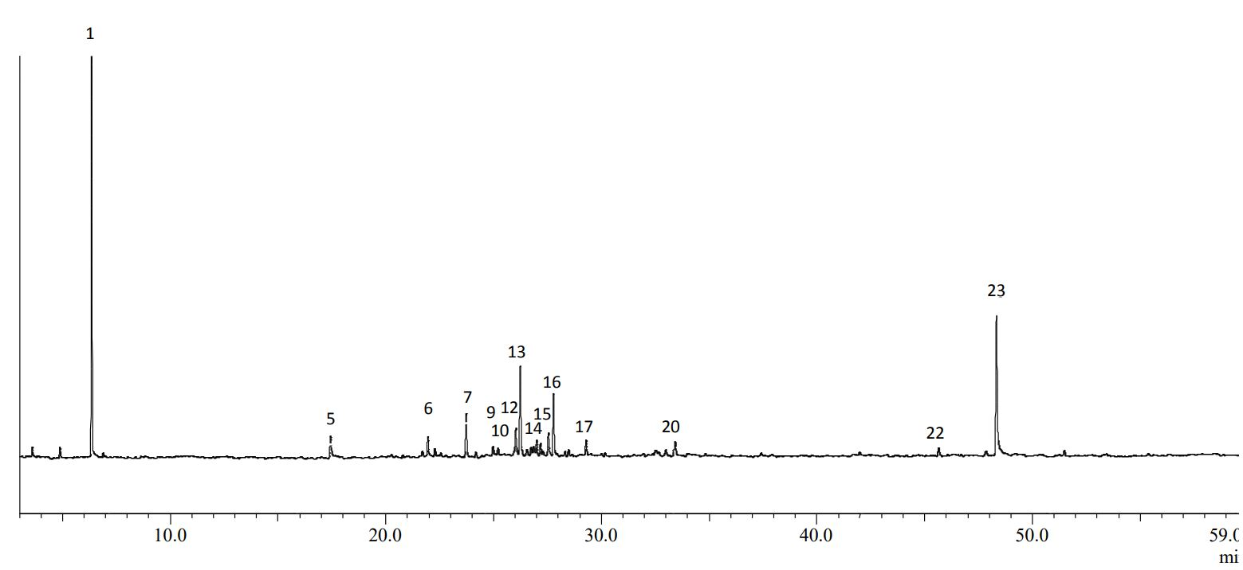
[B]
Supplementary Figure S1. Gas chromatographic profiles of the essential oils of Inflorescence [A] and leaves [B] of H. capitata.
Notes: 1: 1-Octen-3-ol, 2: Linalool, 3: n- Decanal, 4: Hexyl-2 methyl butanoate, 5: Methyl citronellate, 6: α – Copaene, 7: β-Caryophyllene, 8: n-Octyl2-methylbutanoate, 9: Prenyl limonene, 10: α – Humulene, 11: Muurola-4(14),5-diene, 12: β –Acoradiene, 13: Germacrene D, 14: δ-Selinene, 15: δ –Amorphene, 16: δ-Cadinene, 17: Laciniata furanone, 18: Cadinol, 19: α-Cadinol, 20: Pogostol, 21: Farnesyl acetone, 22: Geranyl linalool 23: Methyl linoleate.

