Figure S1 Comparison of the bla_{CMY-2}-carrying regions from plasmids and chromosomes. pS62t (GenBank accession number: KP207590.1) and TN44889 (GenBank accession number: FM246884.1) were derived from plasmids. RUT35755 (GenBank accession number: CP048010.1) was derived from chromosome. Homologous regions are highlighted in gray. IRR: right inverted repeats; IRL: left inverted repeat.
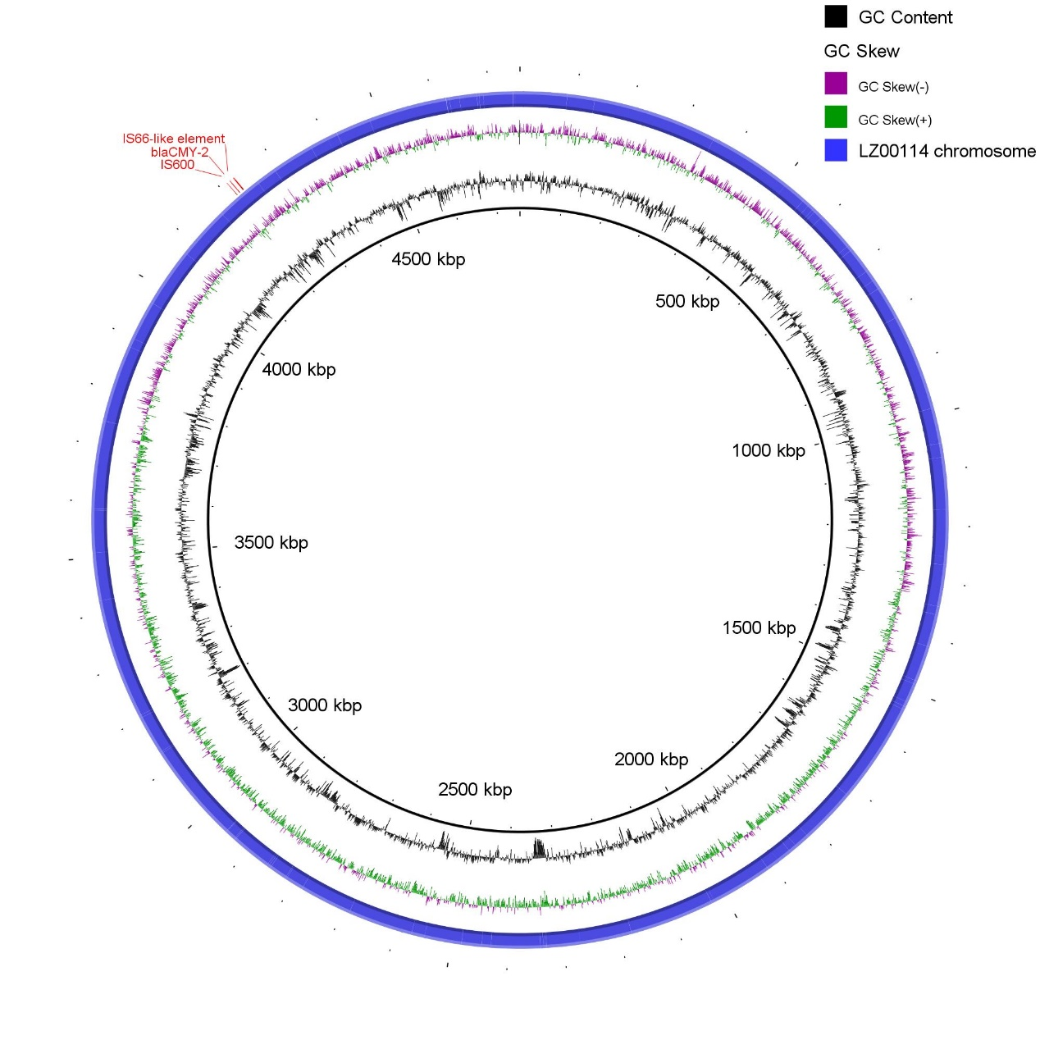
Figure S2 Sketch map of the chromosome genome of LZ00114. The top left corner was marked bla_{CMY-2}, IS600, and IS66-like element in turn
Table S1 PCR and RT-PCR primers used in this study
Genes | For Primer(5’-3’) | Rev Primer(5’-3’) | References
PCR
bla_{KPC} | CATTCAAGGGCTTTCTTGCTGC | ACGACGGCATAGTCATTTGC | 1
bla_{IMP} | CATGGTTTGGTTGTTCTTGT | ATAATTTAGCGGACTTTGGC | 2
bla_{VIM} | TTATGGAGCAGCAACGATGT | CAAAAGTCCCGCTCCAACGA | 2
bla_{NDM} | CGGAATGGCTCATCACGATC | GGTTTGGCGATCTGGTTTTC | 3
bla_{OXA-48} | GCTTGATCGCCCTCGATT | GATTTGCTCCGTGGCCGAAA | 4
mcr-1 | CGGTCAGTCCGTTTGTTC | CTTGGTCGGTCTGTAGGG | 5
pmrA | CTGATTGTTGAAGACGATACGC | AGTTTTCCTCATTCGCGACCA | 6
pmrB | GAATCTGATGCATTTGCGC | TTATATCTGGTTTGCCACGTACTG | 6
phop | ATGCGCGTACTGGTTGTTG | AGTACTACCGCTGCCGTTGCC | 6
phoQ | CAGGGCTATCTGTTCGAATTGCG | ACGGATGCTTAACGTAATGCGTG | 6
pmrD | CGGTGCGCTGGCTAACTCTGCC | AGTAGCCTGTATTATGAGCGGG | 6
RT-PCR
emrA | ACCACGGATATTTACGGCGATGATG | AGGCAGACGCTGAACGACTTTG | This study
emrD | TTGTGCTGGTGTGACCTTCAGTATG | CCAGACCGCCAATCAGCATCAG | This study
emrY | TGGCAGGTTGGCACAAAGAATAGG | AGCACATCAAGATTGGTCGATAGGC | This study
eptA (pmrC) | ACGGCGAATGCTATGACGAAGTG | CTGAGGCGGATAGCGGTTGTAATAG | This study
gapA (internal control) | TCCCAGAACATCATCCCGTCCTC | AACGCCATACCAGTCAGTTTGCC | This study
acrA | CTCTCAGGCAGCTTAGCCCTAA | TGCAGAGGTTCAGTTTTGACTGTT | 7
acrB | AGCTTCCTGATGGTTGTCGG | ACGGCTGATGGCATCTTTCA | 7
acrD | GCCGTGCAGCAAGTACAAAA | GTATCGCCGGTTTTACGCAC | 7
pmrA | CCTTTTGCGCTGGAAGAGT | TCTTTGGGCGTCAGAATCAAC | 8
pmrB | CTGCAAGAAGATGACGGAGC | CTGTGTAATGCGGCTGACAA | 8
dnaE (internal control) | GGACATGAGCACCGAAGATT | GGAAGCCCATCTGGTTGATA | 8

References:
1. Dallenne C, Da Costa A, Decre D, Favier C, Arlet G. Development of a set of multiplex PCR assays for the detection of genes encoding important beta-lactamases in Enterobacteriaceae. J Antimicrob Chemother. 2010;65(3):490-495. doi:10.1093/jac/dkp498
2. Zou H, Jia X, Liu H, Li S, Wu X, Huang S. Emergence of NDM-5-Producing Escherichia coli in a Teaching Hospital in Chongqing, China: IncF-Type Plasmids May Contribute to the Prevalence of bla(NDM-)(5). Front Microbiol. 2020;11. doi:10.3389/fmicb.2020.00334
3. Krishnaraju M, Kamatchi C, Jha AK, et al. Complete sequencing of an IncX3 plasmid carrying bla(NDM-5) allele reveals an early stage in the dissemination of the bla(NDM) gene. Indian J Med Microbiol. 2015;33(1):30-38. doi:10.4103/0255-0857.148373
4. Woodford N, Ellington MJ, Coelho JM, et al. Multiplex PCR for genes encoding prevalent OXA carbapenemases in Acinetobacter spp. Int J Antimicrob Agents. 2006;27(4):351-353. doi:10.1016/j.ijantimicag.2006.01.004
5. Liu Y-Y, Wang Y, Walsh TR, et al. Emergence of plasmid-mediated colistin resistance mechanism MCR-1 in animals and human beings in China: a microbiological and molecular biological study. Lancet Infect Dis. 2016;16(2):161-168. doi:10.1016/s1473-3099(15)00424-7
6. Kim S, Woo JH, Kim N, et al. Characterization Of Chromosome-Mediated Colistin Resistance In Escherichia coli Isolates From Livestock In Korea. Infect Drug Resist. 2019;12:3291-3299. doi:10.2147/idr.S225383
7. Chetri S, Bhowmik D, Paul D, et al. AcrAB-TolC efflux pump system plays a role in carbapenem non-susceptibility in Escherichia coli. BMC Microbiol. 2019;19(1). doi:10.1186/s12866-019-1589-1
8. Huang J, Dai X, Ge L, et al. Sequence Duplication Within pmrB Gene Contribute to High-Level Colistin Resistance in Avian Pathogenic Escherichia coli. Microb Drug Resist. 2020;26(12):1442-1451. doi:10.1089/mdr.2019.0290

Table S2 MICs of transconjugants
Strains | Cefepime | Cefepime | Meropenem | Ciprofloxacin | Tetracycline | Gentamicin | Polymyxin B
E.coli J53 | 1 | 1 | 0.5 | 0.025 | 1 | 2 | 1
E.coli J53+ p25NDM-5 | 256 | 256 | 8 | 0.025 | 1 | 2 | 1

