Supplementary Materials

Identification and validation of a ferroptosis-related signature for predicting prognosis and immune microenvironment in papillary renal cell carcinoma

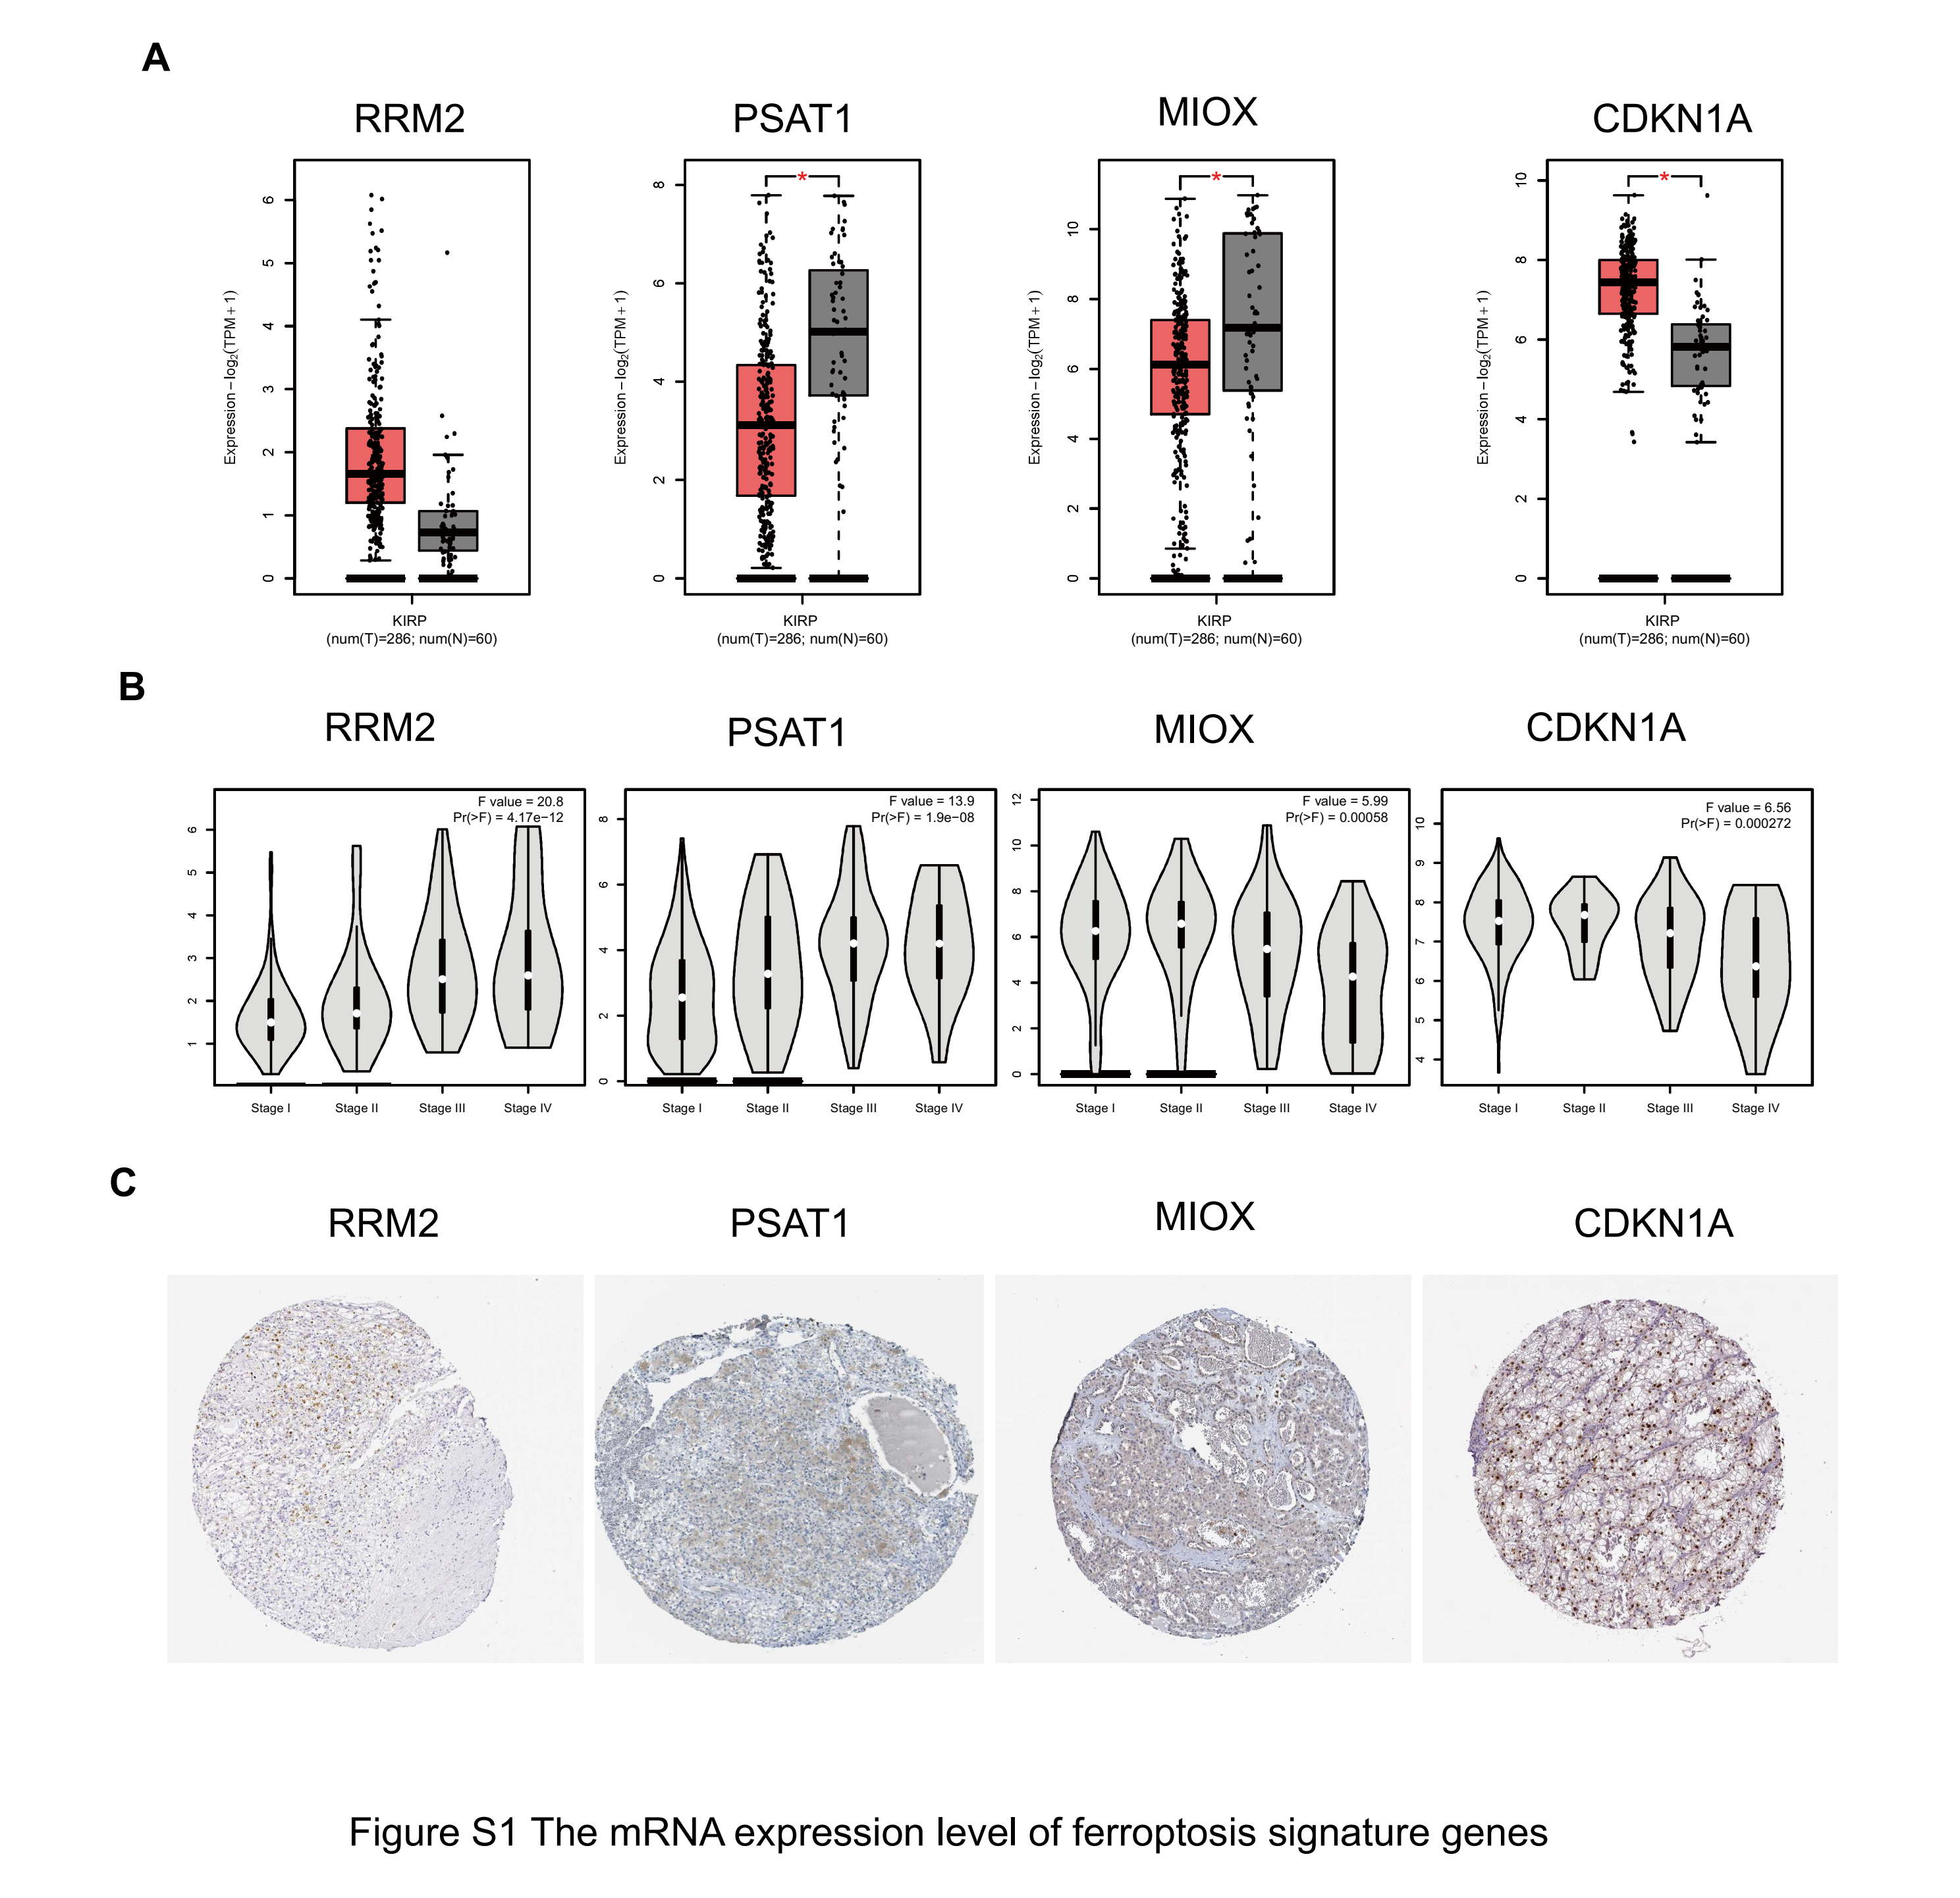
Figure S1 The mRNA expression level of ferroptosis signature genes
A. The expression of ferroptosis signature genes in tumor and normal tissues. B. The expression of ferroptosis signature genes based on clinical stage. C. Immunohistochemistry analysis of the expression of signature in kidney adenocarcinoma. Adjusted P-values were showed as: *, P < 0.01.

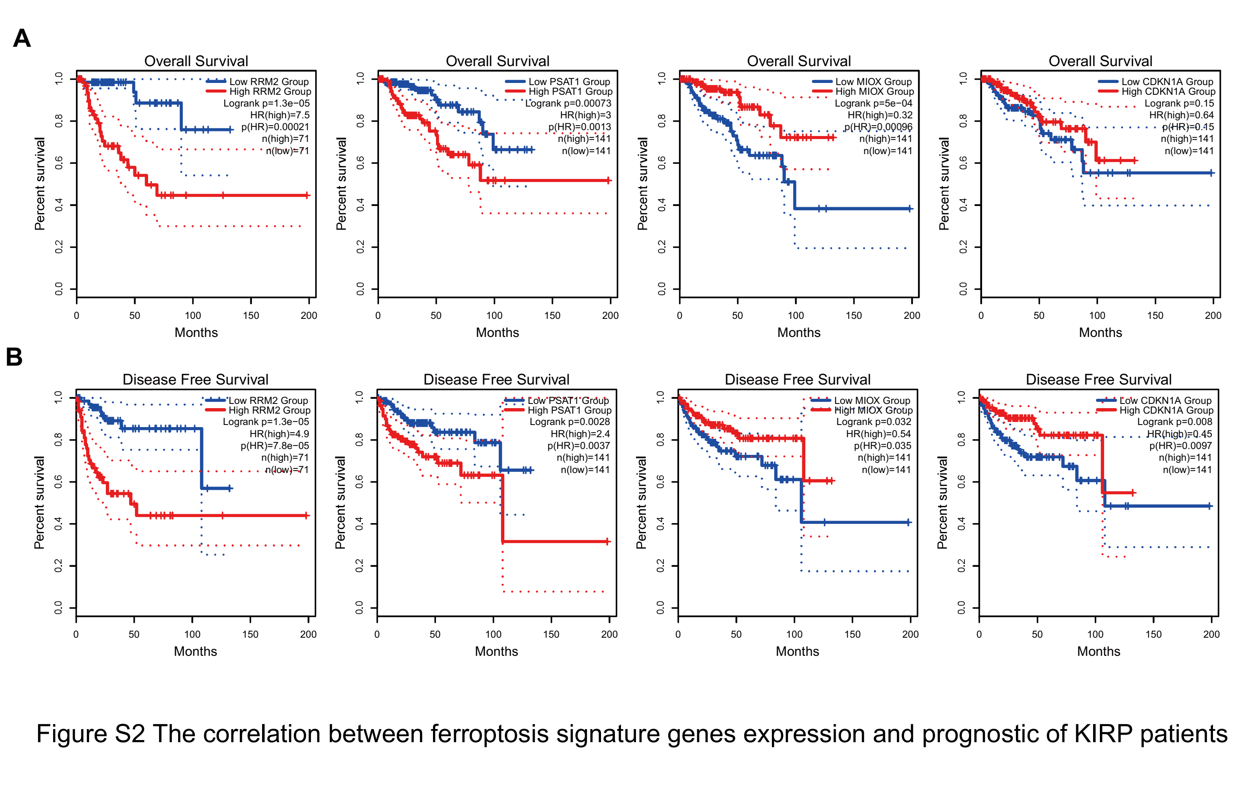
Figure S2 The correlation between ferroptosis signature genes expression and prognostic of KIRP patients
A. Overall survival of 4-ferroptosis signature genes, including RRM2, PSAT1, CDKN1A, and MIOX. B. Disease-free survival of ferroptosis signature genes, including RRM2, PSAT1, CDKN1A, and MIOX. RRM2, ribonucleotide reductase regulatory subunit M2, PSAT1, phosphoserine aminotransferase 1, CDKN1A, cyclin dependent kinase inhibitor 1A, MIOX, myo-inositol oxygenase.

