Supplementary material

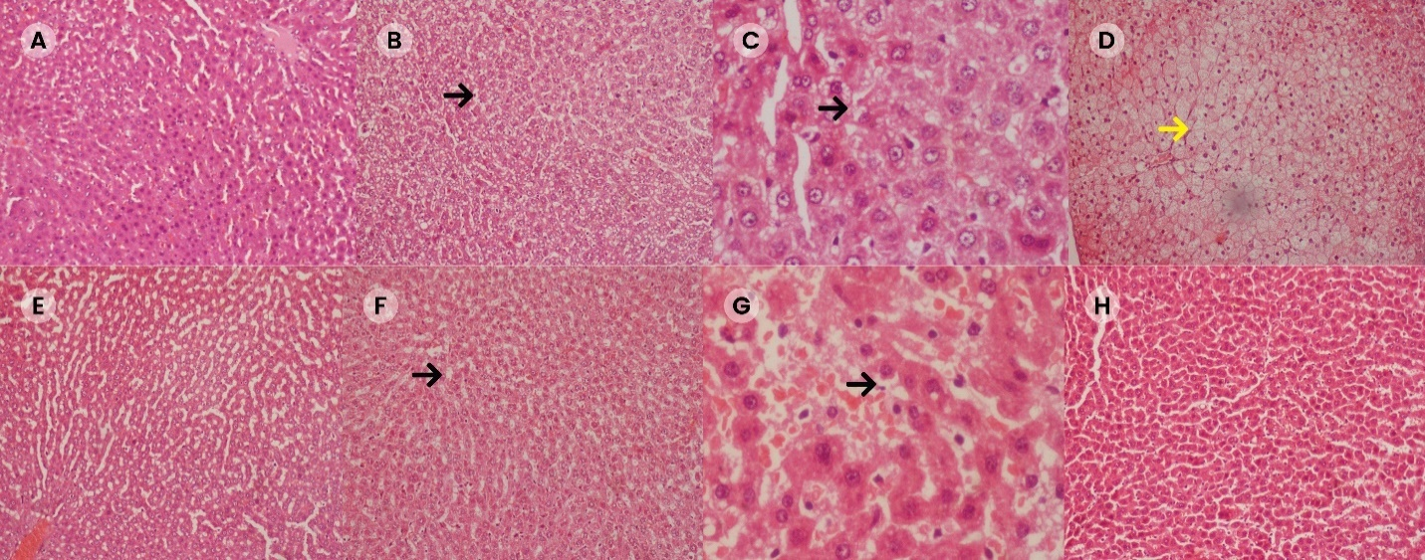
Supplementary Figure S1: Histology images of rat’s liver with macrovesicular and microvesicular steatosis, with some additional images of Figure 7 and high magnification, where black arrows shows the fat droplets and yellow arrow shows the ballooning (A) Liver of normal control group presenting normal hepatocytes (100x); (B-D) Liver of rat fed with HFD showing severe steatosis, fatty degeneration and ballooning of hepatocytes [100x(B&D) and 400x(C)]; (E) Liver of rat treated with standard botanical mixture showing moderate fatty degeneration of hepatocytes (100x); (F-G) Liver sections of rats fed with HFD and treated with safranal 250 mg/kg/day showing moderate fatty degeneration of hepatocytes (100x-F and 400x-G); (H) Liver sections of rats fed with HFD and treated with safranal 500 mg/kg/day with mild fatty deposition (100x).

